|  |  |
| --- | --- |
| logo ngan.png | **MINISTRY OF EDUCATION AND TRAINING** |

|  |
| --- |
| **FPT UNIVERSITY** |
| Capstone Project Document |
| Office Rental Service |
|  |
| |  |  | | --- | --- | | **Group 6** | | | **Group Members** | Lê Xuân Tiến – Team Leader – SE60897  Nguyễn Vũ Hoàng Quốc – Team Member – SE61112  Trương Tiến Thành – Team Member – SE61052  Trần Lê Tuấn – Team Member – 60350 | | **Supervisor** | Mr. Nguyễn Trọng Tài | | **Ext Supervisor** | N/A | | **Capstone Project Code** | ORS | |
| - Hồ Chí Minh City, May 2015 - |

*This page is intentionally left blank*

Table of Contents

A. Report No 1 - Introduction 18

1. Project Information 18

2. Introduction 18

3. Current Situation 18

4. Problem Definition 18

5. Proposed Solution 19

5.1 Feature functions 19

5.2 Advantage and disadvantage 19

6. Functional Requirements 19

7. Role and Responsibility 20

B. Project Management Plan (PMP) 21

1. Problem Definition 21

1.1 Name of this Capstone Project 21

1.2 Problem Abstract 21

1.3 Project Overview 21

2. Project organization 30

2.1 Software Process Model 30

2.2 Roles and Responsibilities 30

2.3 Tools and Techniques 31

3. Project management plan 31

3.1 Software development life cycle 31

3.2 Phase Detail 32

3.3 All Meeting Minutes 34

4. Coding Convention 35

C. Software Requirements Specifications (SRS) 36

1. User Requirement Specification 36

1.1 Guest requirement 36

1.2 Customer requirement 36

1.3 Admin requirement 36

1.4 Manager requirement 36

1.5 Staff requirement 37

1.6 System requirement 37

2. System Requirement Specification 37

2.1 External Interface Requirements 37

2.2 System Overview Use Case: 38

2.3 List of Use Case: 39

3. Software System Attribute 214

3.1 Usability 214

3.2 Reliability 214

3.3 Availability 214

3.4 Security 214

3.5 Maintainability 214

3.6 Portability 214

3.7 Performance 214

4. Conceptual Diagram 214

D. Report 4: Software Design Description 217

1. Design Overview 217

2. System Architectural Design 218

3. Component Diagram 219

4. Detailed Description Explanation 219

4.1 Class Diagram 219

4.2 Interaction Diagram 250

5. User Interface Design 301

5.1 Guest Interface Design 301

5.2 Customer Interface Design 309

5.3 Manager Interface Design 329

5.4 Mobile Interface Design 375

6. Database Design 379

6.1 Logical Diagram 379

6.2 Data Dictionary 381

7. Algorithms 394

7.1 Clustering data 394

7.2 Matching data 396

E. System Implementation & Test (SIT) 398

1. Introduction 398

1.1 System Overview 398

1.2 Test Approach 398

2. Database Relationship Diagram 398

2.1 Physical Diagram 398

2.2 Data Dictionary 400

3. Performance Measures 400

3.1 Clustering Performance 400

3.2 Matching Performance 400

4. Test Plan 400

4.1 Features to be tested 400

4.2 Features not to be tested 400

5. System Testing Test Case 401

5.1 Guest Test Case 404

5.2 Customer Test Case 405

5.3 Manager Test Case 410

5.4 System 423

F. Software User’s Manual 426

1. Installation Guide 426

1.1 Setting up environment at server side 426

1.2 Deployment at server side 426

1.3 Client side environment setting 432

2. User Guide 434

2.1 Guide for customer 434

2.2 Guide for manager on web application 440

2.3 Guide for staff on mobile application 444

G. Appendix 448

**List of Figures**

Figure 1: Proposed System 22

Figure 2: Request appointment flow 23

Figure 3: Request office flow 24

Figure 4: Sign contract flow 25

Figure 5: Request repair flow 26

Figure 6: Request return contract flow 27

Figure 7: Request extend contract flow 28

Figure 8: Software process model 30

Figure 9: Use Case Overview 38

Figure 10: <Guest> Overview Use Case 39

Figure 11: <Guest> Register 39

Figure 12: <Guest> Login 42

Figure 13: <Guest, Customer> Search office 45

Figure 14: <Guest, Customer> View office detail 47

Figure 15: <Customer> Overview Use Case 49

Figure 16: <Customer> View customer info 49

Figure 17: <Customer> Edit customer info 51

Figure 18: <Customer> Change password 54

Figure 19: <Customer> Create appointment request 56

Figure 20: <Customer> View rental request list 58

Figure 21: <Customer> View repair request list 60

Figure 22: <Customer> View repair request history 62

Figure 23: <Customer> Request extend contract 64

Figure 24: <Customer> Request return contract 66

Figure 25: <Customer> View list contract 68

Figure 26: <Customer> View contract 70

Figure 27: <Customer> Request repair 72

Figure 28: <Customer> Request repair 74

Figure 29: <Customer> Create office request 76

Figure 30: <Customer> View Result Request Office 78

Figure 31: <Customer> Log out 80

Figure 32: <Staff> Overview Use Case 82

Figure 33: <Staff> View Assigned Appointment 82

Figure 34: <Staff> View Assigned Appointment 84

Figure 35: <Staff> View Assigned Repair Request 86

Figure 36: <Staff> Change Repair Status 88

Figure 37: <Staff, Manager> Create Office 90

Figure 38: <Staff, Manager> View office detail 94

Figure 39: <Staff, Manager> Edit Office Detail 95

Figure 40: <Staff, Manager, Admin> Logout 98

Figure 41: <Staff, Manager> View rental item list 100

Figure 42: <Staff, Manager> Edit rental item 102

Figure 43: <Staff, Manager> Create rental item 104

Figure 44: <Staff, Manager> View customer profile 106

Figure 45: <Admin> Overview Use Case 107

Figure 46: <Admin> View account list 108

Figure 47: <Admin> Ban account 110

Figure 48: <Admin> Create account 112

Figure 49: <Admin> Delete account 114

Figure 50: <Admin> Update account 116

Figure 51: <Admin> Unban account 118

Figure 52: <Manager> Overview Use Case 121

Figure 53: <Manager> View request extend contract 122

Figure 54: <Manager> Cancel extend request 123

Figure 55: <Manager> Accept extend request 126

Figure 56: <Manager> View request return contract 128

Figure 57: <Manager> Cancel return request 130

Figure 58: <Manager> Accept return request 132

Figure 59: <Manager> View Appointment Request List 135

Figure 60: <Manager> Cancel Appointment request 136

Figure 61: <Manager> Assign Appointment 139

Figure 62: <Manager> View Contract List 141

Figure 63: <Manager> View Contract Detail 142

Figure 64: <Manager> Create Contract 144

Figure 65: <Manager> Edit Contract 147

Figure 66: <Manager> View Repair Request List 149

Figure 67: <Manager> Assign Repair 151

Figure 68: <Manager> Cancel Repair 153

Figure 69: <Manager> View Rental Request List 155

Figure 70: <Manager> Assign Rental 157

Figure 71: <Manager> Cancel Rental Request 159

Figure 72: <Manager> View amenity list 161

Figure 73: <Manager> Create amenity 163

Figure 74: <Manager> View amenity detail 165

Figure 75: <Manager> Edit amenity 167

Figure 76: <Manager> View amenity group list 169

Figure 77: <Manager> Create amenity group 171

Figure 78: <Manager> Edit amenity group 173

Figure 79: <Manager> View Customer Info 175

Figure 80: <Manager> View Calendar 177

Figure 81: <Manager> View Calendar 179

Figure 82: <Manager> View Staff Stastisic 181

Figure 83: <System> Overview Use Case 183

Figure 84: <Staff > View appointment request list 183

Figure 85: <Staff > View repair request list 185

Figure 86: <Staff > View rental request list 187

Figure 87: <Staff > View appointment request detail 189

Figure 88: <Staff > View repair request detail 191

Figure 89: <Staff > View rental request detail 193

Figure 90: <Staff > Confirm appointment request 195

Figure 91: <Staff > Accept/Reject repair request 197

Figure 92: <Staff > Accept/Reject rental request 200

Figure 93: <Staff > Confirm rental request 202

Figure 94: <Staff > Confirm repair request 205

Figure 95: <System> Overview Use Case 207

Figure 96: <System> Suggest Requested Office 207

Figure 97: <System> Check Contract Due Date 209

Figure 98: <System> Suggest Job Schedule 211

Figure 99: System architecture 218

Figure 100: Component Diagram 219

Figure 101: Class Diagram 220

Figure 102: Class Diagram 233

Figure 103: Service Package Class Diagram 239

Figure 104: Class Diagram 244

Figure 105: Mobile Package Class Diagram 247

Figure 106: Login Sequence Diagram 250

Figure 107: Register Sequence Diagram 250

Figure 108: Search Office Sequence Diagram 251

Figure 109: View office detail Sequence Diagram 251

Figure 110: Get office list Sequence Diagram 252

Figure 111: Create Appointment Request Sequence Diagram 252

Figure 112: Create Office Request Sequence Diagram 253

Figure 113: Request Extend Contract Sequence Diagram 253

Figure 114: Request Return Contract Sequence Diagram 254

Figure 115: Create office Sequence Diagram 254

Figure 116: Request Repair Sequence Diagram 255

Figure 117: View Contract Sequence Diagram 255

Figure 118: View Customer Info Sequence Diagram 256

Figure 119: View List Contract Sequence Diagram 256

Figure 120: View List Repair History Sequence Diagram 257

Figure 121: View Rental Request List Sequence Diagram 257

Figure 122: View Repair Request List Sequence Diagram 258

Figure 123: View Result Request Office Sequence Diagram 258

Figure 124: Change Password Sequence Diagram 259

Figure 125: Edit Customer Info Sequence Diagram 259

Figure 126: View Assigned Repair Request List Sequence Diagram 260

Figure 127: Change Repair Status Sequence Diagram 260

Figure 128: View Assigned Rental Request List Sequence Diagram 261

Figure 129: Change Rental Status Sequence Diagram 261

Figure 130: View Assigned Appointment Sequence Diagram 262

Figure 131: Change Appointment Status Sequence Diagram 262

Figure 132: Create New Office Sequence Diagram 263

Figure 133: View Office List Sequence Diagram 263

Figure 134: Edit Office Sequence Diagram 264

Figure 135: Edit Office Sequence Diagram 264

Figure 136: View Customer Profile Sequence Diagram 265

Figure 137: View Appointment Request List Sequence Diagram 265

Figure 138: Assign Appointment Sequence Diagram 266

Figure 139: Cancel Appointment Request Sequence Diagram 266

Figure 140: Create Contract Sequence Diagram 267

Figure 141: View Contract List Sequence Diagram 267

Figure 142: View Contract Detail Sequence Diagram 268

Figure 143: Edit Contract Sequence Diagram 268

Figure 144: View Request Extend List Sequence Diagram 269

Figure 145: Accept Extend Request Sequence Diagram 270

Figure 146: Cancel Extend Request Sequence Diagram 271

Figure 147: View Request Return Contract Sequence Diagram 272

Figure 148: View Request Extend Contract Sequence Diagram 273

Figure 149: Accept Return Request Sequence Diagram 274

Figure 150: Cancel Return Request Sequence Diagram 275

Figure 151: View Repair Request Sequence Diagram 276

Figure 152: Assign Repair Sequence Diagram 276

Figure 153: Cancel Repair Request Sequence Diagram 277

Figure 154: View Rental Request List Sequence Diagram 277

Figure 155: Assign Rental request Sequence Diagram 278

Figure 156: Cancel Rental Request Sequence Diagram 278

Figure 157: View Amenity Group List Sequence Diagram 279

Figure 158: Create Amenity Group Sequence Diagram 280

Figure 159: Create Amenity Sequence Diagram 281

Figure 160: Edit Amenity Group Sequence Diagram 282

Figure 161: View Amenity List Sequence Diagram 283

Figure 162: Edit Amenity Sequence Diagram 284

Figure 163: Delete Amenity Sequence Diagram 285

Figure 164: Create Amenity Sequence Diagram 286

Figure 165: View Calendar Sequence Diagram 287

Figure 166: View Staff Statistic Sequence Diagram 288

Figure 167: View Staff Statistic Sequence Diagram 288

Figure 168: Create Rental Item Sequence Diagram 289

Figure 169: Edit Rental Item Sequence Diagram 290

Figure 170: View Rental Item List Sequence Diagram 291

Figure 171: Logout Sequence Diagram 291

Figure 172: View Account List Sequence Diagram 292

Figure 173: Create Account Sequence Diagram 293

Figure 174: Delete Account Sequence Diagram 294

Figure 175: Edit Account Sequence Diagram 295

Figure 176: Ban Account Sequence Diagram 296

Figure 177: Unban Account Sequence Diagram 297

Figure 178: Check Contract Due Date Sequence Diagram 298

Figure 179: Suggest Request Office Sequence Diagram 298

Figure 180: Clustering Office Sequence Diagram 299

Figure 181: Suggest Assign Job Sequence Diagram 300

Figure 182: Login 301

Figure 183: Register 302

Figure 184: Home 304

Figure 185: Search office list 305

Figure 186: Office detail 307

Figure 187: Request appointment 309

Figure 188: Contract list 310

Figure 189: Contract detail 312

Figure 190: Extend Contract 314

Figure 191: Return contract 315

Figure 192: List request repair history 316

Figure 193: List request repair 317

Figure 194: Profile 318

Figure 195: Profile detail 319

Figure 196: Change password 320

Figure 197: Request repair 322

Figure 198: Rental page 323

Figure 199: Rental cart page 324

Figure 200: Rental list page 326

Figure 201: Request office 327

Figure 202: Result request office page 328

Figure 203: View amenity list 330

Figure 204: Update amenity 331

Figure 205: Delete amenity 332

Figure 206: Create amenity 333

Figure 207: View appointment request list 334

Figure 208: View appointment request detail 336

Figure 209: View amenity group list 337

Figure 210: Add new amenity group 338

Figure 211: Update amenity group 339

Figure 212: View user list 340

Figure 213: Add new user 341

Figure 214: Update user 342

Figure 215: View user profile 344

Figure 216: View rental detail 345

Figure 217: View rental list 347

Figure 218: View rental item list 348

Figure 219 Add new rental item 350

Figure 220 Update rental item 351

Figure 221: Repair list 353

Figure 222: Repair detail 355

Figure 223: View calendar 356

Figure 224: View office list 358

Figure 225: Add new office 361

Figure 226: Office detail 363

Figure 227: Contract page 365

Figure 228: New contract page 366

Figure 229: Contract detail page 367

Figure 230: Edit contract page 368

Figure 231: View request contract page 369

Figure 232: Extend contract page 370

Figure 233: Return contract page 372

Figure 234: Income statistic 373

Figure 235: Staff statistic 374

Figure 236: Login 375

Figure 237: Home 376

Figure 238: Job list 377

Figure 239: Job detail 378

Figure 240: Logical Database Diagram 380

Figure 241: Physical Database Diagram 399

Figure 242: Guest and Customer main flow 401

Figure 243: Manager main flow 402

Figure 244: Staff main flow 403

Figure 245: System main flow 403

Figure 246: Extract Deployment Package (Windows) 426

Figure 247: Extract Deployment Package (Linux) 427

Figure 248: Extract Deployment Package (Linux) 427

Figure 249: Open database script 428

Figure 250: Configure Server (Windows) 428

Figure 251: Configure Server (Linux) 429

Figure 252: Configure hibernate.cfg.xml 429

Figure 253: Copy Unpacked Folder (Windows) 430

Figure 254: Copy Unpacked Folder (Linux) 430

Figure 255: Restart Server (Linux) 430

Figure 256: Restart Server (Linux) 431

Figure 257: Deploy Web Application On Server 431

Figure 258: Configure firewall setting 431

Figure 259: Enable install from Unknown sources 432

Figure 260: Enable install from Unknown sources 433

Figure 261: Enable install from Unknown sources 433

Figure 262: Customer Login Page 434

Figure 263 : Search office 434

Figure 264 : Search office 435

Figure 265 : View office detail 436

Figure 266 : View office detail 436

Figure 267 : Create appointment 437

Figure 268 : Create appointment 438

Figure 269 : Request Office – step 1 438

Figure 270 : Request Office – step 2 438

Figure 271: Request Repair UI 439

Figure 272 : Create Contract – step 1 440

Figure 273 : Create Contract – step 2 440

Figure 274 : Create Contract – step 3 441

Figure 275 : Create Contract – step 4 442

Figure 276 : Assign Appointment 443

Figure 277 : Assign Repair 443

Figure 278 : Login on mobile 444

Figure 279 : Check task list on mobile 445

Figure 280 : Change status of appoinment 446

Figure 281 : Change status of repair/rental 447

**List of Tables**

Table 1: Roles and Responsibilities 20

Table 2: Hardware Requirement for Server 29

Table 3: Hardware Requirement for Web User 29

Table 4: Requirement for mobile app 29

Table 5: Role and Responsibilities 31

Table 6: Software development lifecycle 32

Table 7: Phase 1: Requirement Analysis 33

Table 8: Phase 2: Design 33

Table 9: Phase 3: Implement 34

Table 10: Phase 4: Testing 34

Table 11: Phase 5: Operation and maintenance 34

Table 12: Overall user requirement specification 36

Table 13: <Guest> Register 42

Table 14: <Guest> Login 44

Table 15: <Guest, Customer> Search office 47

Table 16: <Guest, Customer> View office detail 48

Table 17: <Customer> View customer info 51

Table 18: <Customer> Edit customer info 53

Table 19: <Customer> Change password 56

Table 20: <Customer> Create appointment request 58

Table 21: <Customer> View rental request list 59

Table 22: <Customer> View repair request list 61

Table 23: <Customer> View repair request history 63

Table 24: <Customer> Request extend contract 66

Table 25: <Customer> Request return contract 68

Table 26: <Customer> View rental request list 69

Table 27: <Customer> View rental request list 71

Table 28: <Customer> Request repair 74

Table 29: <Customer> Request rental 76

Table 30: <Customer> Create office request 78

Table 31: <Customer> Create office request 80

Table 32: <Customer> Log out 81

Table 33: <Staff> View Assigned Appointment 84

Table 34: <Staff> View Assigned Appointment 86

Table 35: <Staff> View Assigned Repair Request 87

Table 36: <Staff> Change Repair Status 90

Table 37: <Staff> Create Office 93

Table 38: <Staff, Manager> View Office Detail 95

Table 39: <Staff, Manager> Edit Office Detail 98

Table 40: <Staff, Manager, Admin> Logout 100

Table 41: <Staff, Manager> View rental item list 101

Table 42: <Staff, Manager> Edit rental item 103

Table 43: <Staff, Manager> Create rental item 105

Table 44: <Staff, Manager> View customer profile 107

Table 45: <Admin> View account list 109

Table 46: <Admin> Ban account 112

Table 47: <Admin> Create Account 114

Table 48: <Admin>Delete Account 116

Table 49: <Admin> Update account 118

Table 50: <Admin> Unban account 120

Table 51: <Manager> View Request extend contract 123

Table 52: <Manager> Cancel extend request 125

Table 53: <Manager> Accept extend request 128

Table 54: <Manager> View request return contract 130

Table 55: <Manager> Cancel return request 132

Table 56: <Manager> Accept return request 134

Table 57: <Manager> View Appointment request 136

Table 58: <Manager> Cancel Appointment request 139

Table 59: <Manager> Assign Appointment 141

Table 60: <Manager> View Contract List 142

Table 61: <Manager> View Contract Detail 144

Table 62: <Manager> Create Contract 146

Table 63: <Manager> Edit Contract 149

Table 64: <Manager> View Repair Request List 150

Table 65: <Manager> Assign Repair 152

Table 66: <Manager> Cancel Repair 155

Table 67: <Manager> View Rental Request List 156

Table 68: <Manager> Assign Rental 158

Table 69: <Manager> Cancel Rental Request 161

Table 70: <Manager>View amenity list 162

Table 71: <Manager> Create amenity 165

Table 72: <Manager> View amenity detail 166

Table 73: <Manager> Edit amenity 169

Table 74: <Manager> View amenity group list 170

Table 75: <Manager> Create amenity group 173

Table 76: <Manager> Edit amenity group 175

Table 77: <Manager> View Customer Info 177

Table 78: <Manager> View Calendar 178

Table 79: <Manager> View Income statistic 180

Table 80: <Manager> View Staff statistic 182

Table 81: <Staff> View appointment request list 185

Table 82: <Staff> View repair request list 186

Table 83: <Staff> View rental request list 188

Table 84: <Staff> View appointment request detail 190

Table 85: <Staff> View repair request detail 192

Table 86: <Staff> View rental request detail 194

Table 87: <Staff> Confirm appointment request 197

Table 88: <Staff> Accept/Reject rental request 202

Table 89: <Manager> Confirm rental request 204

Table 90: <Staff> Confirm repair request 207

Table 91: <System> Suggest requested office 209

Table 92: <System> Check contract due date 211

Table 93: <System> Suggest Job Schedule 213

Table 94: Search office Test Case 404

Table 95: Make appointment Test Case 405

Table 96: Request Return Contract Test Case 406

Table 97: Request Extend Contract Test Case 407

Table 98: Request Repair Test Case 408

Table 99: Request Rental Test Case 409

Table 100: Request Office Test Case 410

Table 101: Create Office Test Case 411

Table 102: Edit Office Test Case 412

Table 103: Create contract Test Case 412

Table 104: Edit contract Test Case 413

Table 105: Assign Appointment Test Case 415

Table 106: Cancel Appointment Test Case 415

Table 107: Assign Repair Test Case 417

Table 108: Cancel Repair Test Case 417

Table 109: Assign Rental Test Case 419

Table 110: Cancel Rental Test Case 419

Table 111: Extend Contract Test Case 420

Table 112: Return Contract Test Case 420

Table 113: Create Rental Item Test Case 421

Table 114: Income Statistic Test Case 422

Table 115: Staff Statistic Test Case 422

Table 116: Calendar Test Case 423

Table 117: Check request office 423

Table 118: Check contract due date 424

Table 119: Check send SMS 424

Table 120: Login Step 434

Table 121: Search office 435

Table 122: View office detail 436

Table 123: Create appointment 438

Table 124: Request Office – step 1 438

Table 125: Request Office – step 2 439

Table 126: Request Repair Step 439

Table 127: Create Contract – step 1 440

Table 128: Create Contract – step 2 440

Table 129: Create Contract – step 3 441

Table 130: Create Contract – step 4 442

Table 131: Assign Appointment 443

Table 132: Assign Repair 444

Table 133: Staff login on mobile 445

Table 134: Staff login on mobile 445

Table 135: Change status of appoinment 447

Table 136: Change status of appoinment 447

**Definitions, Acronyms, and Abbreviations**

|  |  |
| --- | --- |
| **Name** | **Definition** |
| ORS | Office Rental Service |
| IDE | Integrated Development Environment |
| DBMS | Database Management System |
| WAP | Wireless Application Protocol |
| SRS | Software Requirement Specification |
| Admin | Administrator |
| SMS | Short message service |
| Info | Information |
| FE | Front-end |
| BE | Back-end |

# Report No 1 - Introduction

## Project Information

* Project name: **Office Rental Service**
* Project Code: **ORS**
* Product Type: **Website Application**
* Start Date: **May 11th, 2015**
* End Date: **August 22nd, 2015**

## Introduction

Nowadays, a lot of companies are established every day. When new companies are established or some companies want to expand their companies, they need to find where they put their offices. To find a suitable office for them, they need you to add some equipment they need, repair some equipment… All of that thing will get you a lot of time to do it and it is very complex to make contract with those companies. With this system, you can easily to manage your offices, equipment and contracts and it takes you less time than now.

## Current Situation

In Vietnam, to find a suitable office, company would rather consider the following actions:

* If company has large resource, and require a specific requirement and equipment, they would build a new office. This will takes lots of time and money, only adapted for foreign companies.
* Go to a broker company, fill in the form and ask for help to find a suitable office. This usually takes some days to find and cost fee for broker companies.
* Search the internet for office. There are some website in Vietnam has information about the office for rent. But the information is usually not richly or sometimes outdated.

## Problem Definition

To build a new office requires a lot of time, effort, and spend a lot of costs. Besides, there are many new office building has been built recently, but had not been rented, and many company has unused office space. The matching between the demand and the supply is critical required. But using tradition approach for searching office, we have some limitations:

* There are some classifieds website that put the office information. However, the office information is lack, the search criteria is not very effective, and the information about the amenities is hardly found.
* Every company choose for themselves the best office suite with their company: location, area, office facilities, finding a best match will be take time, costs. This work usually made by a third party broker company, and it will take days to finish and we would pay a fee to that company.
* When company want to rent the office or have a rented office but conditions where infrastructure does not guarantee, the company business will be very difficult to contact the lessors to consider repairing office suite company conditions, causing company to consume resources.

## Proposed Solution

The website support customer to select appropriate and process office rental online. The website also support manager to track their business.

### Feature functions

* Our website offers many methods for customer to search office (by size, price, place, amenities…). When they find approtiate office, our staff will arrange to meet them at that office. After check around, we can make a contract right away. The contract will be tracked by our website for further support.
* If customers request repair something in their office, the website will notify our staff to make sure they will fix that problem as soon as posible.
* Our system also supports the addition of devices such as power sockets, fax machines… at the request of customers.

### Advantage and disadvantage

The advantages and disadvantages of the proposed solution:

* Advantages:
  + User friendly and specialized interface.
  + Providing search engines criteria: price, location, amenities...
  + Providing full information about the office. Support map for customers
  + Easy to make an appointment
  + When a deal is made, the contract is tracked by website, so the office state is update in real time for further search.
  + Can request for repair, or add new equipment based on the contract.
  + The repair request status will be update by notification system
  + The repair request is easily manage by automatic assign system
  + The contract making and repair status update is manage by mobile system so the staff will easy to update when go to the offices.
* Disadvantages:
  + The partner who own the office must contact us to post their information.
  + The mobile system require internet connection.
  + The function of notification system is limited.
  + The matching solution based on location and needs will take more time than search by keyword in traditional approach

## Functional Requirements

The functional requirements of the system are based on five main actor as below:

* Guest
  + Search for office base on places, price, amenities
  + Register/Login
  + View office detail
* Customer:
  + View office detail
  + Search for office base on places, price, amenities
  + View/Edit customer info
  + Create appointment
  + Request extend/return contract
  + Request repair/rental item
  + Create office request
* Admin:
  + Manage account.
  + Ban/unban account
* Manager:
  + Manage contract
  + Manage repair/rental
  + View staff/income statistic
  + Manage amenity
  + Manage rental item
  + Manage appointment
  + View/Create office
* Staff:
  + View/Create office
  + Accept/Reject rental
  + Accept/Reject repair
  + Confirm appointment

## Role and Responsibility

|  |  |  |  |  |
| --- | --- | --- | --- | --- |
| **No** | **Full Name** | **Role** | **Position** | **Contact** |
| 1 | Nguyễn Trọng Tài | Project Manager | Instructor | [taint@fpt.edu.vn](mailto:taint@fpt.edu.vn) |
| 2 | Lê Xuân Tiến | Developer | Team Leader | [tienlxse60897@fpt.edu.vn](mailto:tienlxse60897@fpt.edu.vn) |
| 3 | Nguyễn Vũ Hoàng Quốc | Developer | Team Member | [quocnvhse61112@fpt.edu.vn](mailto:quocnvhse61112@fpt.edu.vn) |
| 4 | Trương Tiến Thành | Developer | Team Member | [thanhttse61052@fpt.edu.vn](mailto:thanhttse61052@fpt.edu.vn) |
| 5 | Trần Lê Tuấn | Developer | Team Member | [tuantl60350@fpt.edu.vn](mailto:tuantl60350@fpt.edu.vn) |

Table : Roles and Responsibilities

# Project Management Plan (PMP)

## Problem Definition

### Name of this Capstone Project

* **Official name**: Office Rental Service
* **Vietnamese name:** Dịch vụ cho thuê văn phòng
* **Abbreviation:** ORS

### Problem Abstract

Nowadays, the way companies find and rent an office, is complex and hard to find a suitable office. It means they need to do many steps before they can rent a suitable office. About the office owner, they have to contact with customer, manage contract, manage repair request… on the paper. It means there is human mistake.

To solve those problems already mentioned above, we need to make the way customer find an office and the way customer manage their request effectively. About the office owner, their contracts, requests for their office… are easy to manage.

### Project Overview

#### Current Situation

There are some current websites such as vanphongthue.com.vn, rongbay.com, timvanphong.vn, etc. All of them have some advantages and disadvantages.

* Advantages:
  + Friendly and specialized interface.
  + Providing search engines criteria.
  + Direct consultation with the manager.
* Disadvantages:
  + Only supply direct meeting, not arrange for a meeting.
  + Not support map.
  + Not provide additional equipment and maintenance.

#### The Proposed SystemC:\Users\Thành\Desktop\Capture.PNG

Figure : Proposed System

In more detail, the system would contain following features:

##### Website

* Guess can search office and view detail. If they want to make appointment, they need to register.
* Customer can review office, request appointment, request office (if they can’t find ones), request rental equipment and request repair.
* Admin can manage staff and manager.
* Manager can create and delete contract. They also can assign staff to repair for customer and view statistic of system.
* Staff can view list, create, update and delete office. When staff finish repair for customer, they can report to manager. They also can approve or delete rental equipment.

##### Mobile Application

* Staff can check appointment task and update status request repair.

**Main flow of the system:**

Input search info

Search result

No

Request office

View

Customer decide

Yes

Search

No

Yes

Request appointment

Manager decide

Notify (Message)

Yes

No

Notify (Message)

Figure : Request appointment flow

Send email

Customer decide

Remove Request Office

Unsubscribe

Accept

Check requested office

Found

Request appointment

(Refer request appointment flow)

Figure : Request office flow

[Staff] Check appointment list

Customer decide

Delete request

No

Create contract

Manager decide

Yes

[Manager] Assign appointment

Manager and Customer check contract

Delete request

No

Yes

Figure : Sign contract flow

Request repair

Manager decide

Notify customer

Reject

Accept

(Date, time, staff…)

OK

Customer decide

[Staff] Report to manager

Accept

Make schedule

[Staff] Check schedule

Staff check office

Repairing…

Reject

Reject

Figure : Request repair flow

Update office status

Staff confirm

[Customer]Cancel contract

Figure : Request return contract flow

Contract about to end?

Notify customer

Yes

Customer decide

Renew

Edit contract

Manager decide

Request renew contract

Delete request

No

Yes

Delete contract when expire

Ignore

Meeting

Figure : Request extend contract flow

#### Boundaries of the System

* The system is intended for customers who want to rent office (such as businessman, medium or small company,…).
* The language of the system is Vietnamese
* The complete product includes:
  + The website, for admin, manager, staff, customers and guest to interactive with the system.
  + Mobile application for staff to check task and update status request repair, rental or appointment.
  + All the process involved document.

#### Development Environment

* **Hardware requirement for server computer**

|  |  |  |
| --- | --- | --- |
| Windows | Minimum Requirements | Recommended |
| Internet Connection | Cable, Wi-Fi (2Mbps) | Cable, Wi-Fi (8 Mbps) |
| Operating System | Window 7 | Window 8.1 |
| Computer Processor | Intel Core i5 | Intel Core i7 |
| Computer Memory | 4GB RAM | 6GB or more |

Table : Hardware Requirement for Server

* **Hardware Requirement for Web User**

|  |  |  |
| --- | --- | --- |
| **Web** | **Minimum Requirements** | **Recommended** |
| **Internet Connection** | 2Mbps | 4Mbps |
| **Web Browser** | Firefox, Chrome, IE 8 | Firefox, Chrome, IE 9 |

Table : Hardware Requirement for Web User

All computers must be connected to the Internet.

* **Hardware requirement for mobile app**

|  |  |  |
| --- | --- | --- |
| Windows | Minimum Requirements | Recommended |
| Internet Connection | Wifi (2Mbps) | Wifi (4Mbps) |
| Operating System | Android 4.0 | Android 4.2 |
| Hardware | Touchscreen | Touchscreen |
| Memory | 512 MB or more | 1 GB or more |

Table : Requirement for mobile app

* **Software requirements**
  + Operating system: Windows 7, or above;
  + Framework: Hibernate with Java Persistence;
  + Modeling Tool: Visual Paradigm Community;
  + IDE: Intellji Idea;
  + DBMS: Microsoft SQL Server;
  + Source Control: GitHub, Git for windows, Tortoise Git.

## Project organization

### Software Process Model

We choose waterfall model.



Figure : Software process model

This model is easy to manage and understand. For our project, we don’t have a lot of time so we use this model to help us release our project on time. This model uses for short project and it suitable for our project, which is small with 4 months and requirements are easy to clear.

### Roles and Responsibilities

|  |  |  |  |
| --- | --- | --- | --- |
| **No** | **Full name** | **Role in Group** | **Responsibilities** |
| **1** | Nguyễn Trọng Tài | Supervisor/ Project manager | * Specify user requirement. * Control the development process. * Support technical and business analysis. * Review document and product application. |
| **2** | Lê Xuân Tiến | Team Leader, Developer, Tester | * Monitor process * Create project plan and distribute tasks * Clarify requirements. * Design database. * Prepare documents. * GUI Design. * Create code guide and form. * Coding. * Testing. * Deploy final product. |
| **3** | Nguyễn Vũ Hoàng Quốc | Developer, Tester | * Clarify requirements. * Prepare documents. * Review Database. * GUI Design. * Create test cases. * Coding. * Testing. |
| **4** | Trương Tiến Thành | Developer, Tester | * Clarify requirements. * Prepare documents. * Review Database. * GUI Design. * Create test cases. * Coding. * Testing. |
| **5** | Trần Lê Tuấn | Developer, Tester | * Clarify requirements. * Prepare documents. * Review Database. * GUI Design. * Create test cases. * Coding. * Testing. |

Table : Role and Responsibilities

### Tools and Techniques

* *Front-end*: CSS3, HTML5, JavaScript, JQuery, Ajax, AngularJS, Java Android, PhoneGap.
* *Back-end*: Java 1.7, Hibernate, Java Persistence.
* *Web Server*: Tomcat 7.
* *Developing Tool*: JetBrains IntelliJ IDEA 14, Android Studio.
* *Database Management System:* Microsoft SQL Server 2008.
* *Source Control:* Git-1.9.5-preview, TortoiseGit-1.8.14.0.
* *Modeling Tool*: Visual Paradigm 12.0 Commnunity.
* *Document Tool*: Microsoft Office 2013.

## Project management plan

### Software development life cycle

|  |  |  |  |  |  |
| --- | --- | --- | --- | --- | --- |
| **Phase** | **Description** | **Deliverables** | **Resource**  **needed** | **Dependencies**  **and Constrains** | **Risks** |
| **Requirement**  **Analysis** | - Collect requirements.  - Analyze requirements  -Identify and clarify requirements for the system in general. | -Introduction of proposed system. (report 1)  -Project Task Plan. (report 2)  -Software requirement specification. (report 3) | 40 man-days | N/A | - Missing requirement  - Unclear scope of project  - Lack of member share  - Time resource not well managed |
| **Design** | - Design database  - Architecture design for the system  - Detail design using top-down break down  - Choose Architecture style | - Software Design Document  - Base code structure  - Architecture notes  (report 4) | 74 man-days | Depend on “Requirement Analysis” | - Lack of experience.  - Not fulfil requirement. |
| **Implement** | - Implement all system functions | - Source code  - Final deploy packet | 120 man-days | - Software requirement specification.  - Software Design Document | - Lack of member experience.  - Different of member skill |
| **Testing** | - Create test plan  - Create test cases  - Perform unit test cases and system integration test | - Test plan  - Test cases  - Test report  (report 5) | 80 man-days | - Coding is finished  - Based on SRS | - Lack of experience leads to lack of test cases  - Time schedule |
| **Operation and maintenance** | - Create user’s manual, includes server deployment and end-user manual | - Report 6: System User’s Manual | 20 man-days | - Testing is finished  - Based on SRS | - Lack of experience can lead to hard-to-understand document for user  - Time deadline |

Table : Software development lifecycle

### Phase Detail

Below are all the major tasks that need to be performed sequentially during the development of the system.

#### Phase 1: Requirement Analysis

|  |  |  |
| --- | --- | --- |
| **Task** | **Description** | **Author** |
| **1. Collect and analyze requirements** | Find the traditional approach for the service, and current IS system for office rental services. Analyze their strengths and weaknesses | TienLX, QuocNVH, ThanhTT, TuanTL |
| **2. Identify and clarify main functions.** | Define main flows which system will build to adapt, and main functions for system. | TienLX, QuocNVH, ThanhTT, TuanTL |
| **3. Create project management plan** | Define the overview of the project  Create project plan | TienLX, QuocNVH |

Table : Phase 1: Requirement Analysis

#### Phase 2: Design

|  |  |  |
| --- | --- | --- |
| **Task** | **Description** | **Author** |
| **1. Defined overall system design** | Design basis system architecture design | TienLX |
| **2. Create entity-relationship diagram** | From the defined use cases, create the ERD for the system | TienLX, QuocNVH |
| **3. Create logical database diagram** | Define the logical database diagram based on ERD | ThanhTT, TuanTL |
| **4. Create class diagrams and definition** | Create the classes with attributes and functions, along with its definition | TienLX, QuocNVH, ThanhTT, TuanTL |
| **5. Create interaction diagrams** | Include sequences diagrams and activity diagrams | TienLX, QuocNVH, ThanhTT, TuanTL |
| **6. Create interface design** | Design the user interface for the system applications | TienLX, QuocNVH, ThanhTT, TuanTL |
| **7. Define main algorithms** | Analyze and define the required algorithms for the system | TienLX, QuocNVH, ThanhTT, TuanTL |

Table : Phase 2: Design

#### Phase 3: Implement

|  |  |  |
| --- | --- | --- |
| **Task** | **Description** | **Author** |
| **1. Design physical database** | Define the physical database design on SQL Server, and create database dictionary | TienLX, QuocNVH, ThanhTT, TuanTL |
| **2. Define base structure** | Define the base structure for the program | TienLX |
| **3. Coding admin functions** | Include manage account | TuanTL |
| **4. Coding manager functions** | Include manage repair list and manage contract list | ThanhTT, QuocNVH |
| **5. Coding staff functions** | Include manage office | TienLX |
| **6. Coding customer functions** |  |  |
| **6.1. Coding request office flow** | Include search office, request office, request appointment | BE: QuocNVH  FE: TienLX |
| **6.2. Coding contract signing flow** | Include the assign flow for manager and view assigned flow for staff | ThanhTT |
| **6.3. Coding contract extend/cancel flow** | Include request extend contract and cancel contract | QuocNVH |
| **6.4. Coding request repair flow** | Include request repair office for customers | TuanTL |
| **7. Coding additional mobile app** | Include view assigned job for staff, view assigned and update the repair job for staff | BE: QuocNVH, TuanTL  FE: TienLX, ThanhTT |

Table : Phase 3: Implement

#### Phase 4: Testing

|  |  |  |
| --- | --- | --- |
| **Task** | **Description** | **Author** |
| **1. Create test plan** | Create the test plan document for the system | TienLX |
| **2. Create unit testing** | Create the test cases for each functions describe in the implementation |  |
| **2.1. For admin functions** | Create test cases for functions in manage account | TienLX |
| **2.2. For manager functions** | Create test cases for functions in manage repair and contract | TuanTL |
| **2.3. For staff functions** | Create test cases for functions in manage office | ThanhTT |
| **2.4. For customer functions** | Create test cases for functions for customer | QuocNVH |
| **2.5. For mobile app** | Create test cases for functions for mobile app | TuanTL |
| **3. Testing and fix bugs** | Base on the test cases, test the functions and fix bugs | TienLX, QuocNVH, ThanhTT, TuanTL |
| **4. System integration test** | Test the overall of the system, measure the performance of the system | TienLX, QuocNVH, ThanhTT, TuanTL |

Table : Phase 4: Testing

#### Phase 5: Operation and maintenance

|  |  |  |
| --- | --- | --- |
| **Task** | **Description** | **Author** |
| **1. Create installation guide** | Define the system requirement for the server and client. document installation guild | TienLX, QuocNVH |
| **2. Create User guide** | Define the user manual for operating the system | TienLX, QuocNVH, ThanhTT, TuanTL |
| **3. Maintenance and fix bugs** | Tracking the system and fix the remains bugs while installation | ThanhTT, TuanTL |

Table : Phase 5: Operation and maintenance

### All Meeting Minutes

Refer to Meeting Minutes folder.

## Coding Convention

**Indentation:**

* Four spaces should be used as the unit of indentation
* Tabs must be set exactly every 8 spaces
* Avoid lines longer than 80 characters
* Break after a comma.

**Declarations:**

* One declaration per line
* Put declarations only at the beginning of blocks
* No space between a method name and the parenthesis "(" starting its parameter list
* Open brace "{" appears at the end of the same line as the declaration statement
* Closing brace "}" starts a line by itself indented to match its corresponding opening statement, except when it is a null statement the "}" should appear immediately after the "{"

**White Space:**

* Between sections of a source file
* Between class and interface definitions
* Between methods

**Naming Conventions:**

* Class names should be noun
* Methods should be verbs

Reference: <http://www.oracle.com/technetwork/java/codeconvtoc-136057.html>

# Software Requirements Specifications (SRS)

## User Requirement Specification

The system has five actors including: guest, customer, staff, admin and system.

|  |  |
| --- | --- |
| **Actor** | **Description** |
| Guest | Person join to website but not login into system. |
| Customer | Person who want to rent offices and logged into system |
| Admin | Person who manage account and ban/ unban account |
| Manager | Person who manage request, contact customer, schedule staff…. |
| Staff | Person who in charge of create office, receive and process the appointment/ repair/ rental/ extend/ return office request |
| System | System will manage the schedule to process contract time, send notification, suggest office for customer |

Table : Overall user requirement specification

### Guest requirement

* **Register:** guest need to register to become member of system.
* **Search office:** guest can search suitable office by criteria such as price and location.
* **Login**: guest uses email and password to login into the system to search or request office.

### Customer requirement

* **Search office:** customer can search suitable office by criteria such as price and location.
* **Send request:** customer can send request about book appointment, repair something in office, rental, request return before expire or request extend the contract.
* **Request office:** customer can send request office if they don’t find a suitable office.
* **Logout:** when finish all activities at website they can log out of system.

### Admin requirement

* **Logout:** when finish all activities at website they can log out of system.
* **Manage account:** admin can add, edit, remove or ban/ unban account.

### Manager requirement

* **Logout:** when finish all activities at website they can log out of system.
* **Contact with customer:** manager can notify customer when task is done.
* **Manage contract:** manager can create, edit contract.
* **Manage request:** manager can confirm about request repair, rental and appointment.
* **Assign staff:** manager can assign staff to contact with customer when request has been approved by manager.

### Staff requirement

* **Logout:** when finish all activities at website they can log out of system.
* **Contact with customer:** staff have to check task list about the appointment with customer and change status of the appointment when finish his task.
* **Manage office:** staff can add or edit office.
* **Check assign request:** staff have to check task list about the request repair amenities and change status of that request after repair complete.

### System requirement

* **Send notification mail:** system will send notification mail to customer when appointment has been approved and scheduled or request repair has been accepted.
* **Send notification SMS (short message service):** system will send notification mail to customer when their contract will be expired in one month.
* **Suggest office:** system will suggest some offices which is nearly suitable with what customer searching.
* **Schedule request:** system will auto schedule all request about appointment and repair when those request has been approved by manager.

## System Requirement Specification

### External Interface Requirements

#### User Interfaces

* User interface must be friendly, simple, display in Vietnamese.
* All functions should be showed clearly and don’t make user confuse.

#### Hardware Interfaces

* The system will use the standard hardware and data communications resources of a standard computer.

#### Software Interfaces

* The website run in Firefox and Chrome browsers.

#### Communications Protocol

* The website uses:
* HTTP/HTTPS protocol for communication between the web browser and the web server.
* TCP/IP network protocol for communication with HTTP protocol.
* WAP protocol for sending message for customer.

### System Overview Use Case:

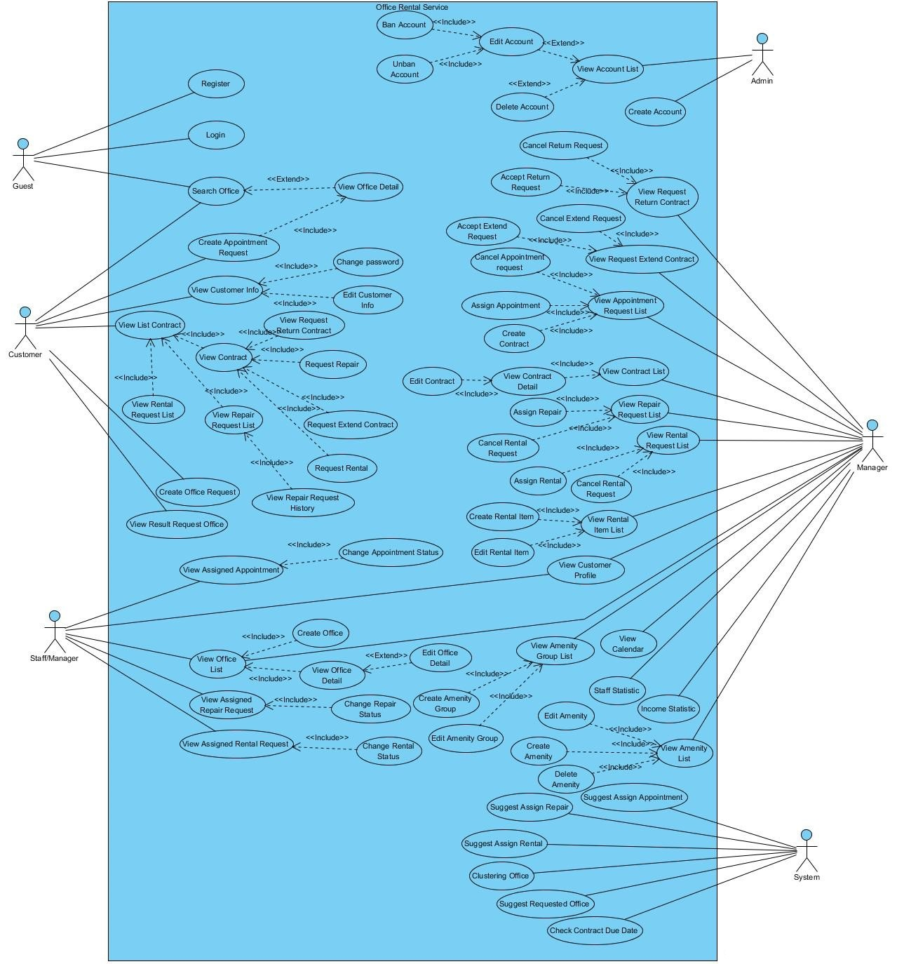

Figure : Use Case Overview

### List of Use Case:

#### <Guest>Overview Use Case



Figure : <Guest> Overview Use Case

##### <Guest> Register

**Use Case Diagram**

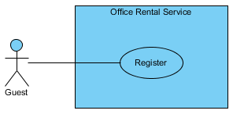

Figure : <Guest> Register

**Use Case Specification**

|  |  |  |  |  |
| --- | --- | --- | --- | --- |
| **USE CASE – REGISTER** | | | | |
| **Use-case No.** | UC001 | **Use-case Version** | | 1.0 |
| **Use-case Name** | Register | | | |
| **Author** | Trương Tiến Thành | | | |
| **Date** | 27/05/2015 | **Priority** | Normal | |
| **Actor:**   * Guest.   **Summary:**   * This use case allows guest create account.   **Goal:**   * Help guest to create new account.   **Trigger:**   * Click “Đăng ký” button.   **Pre-conditions:**   * N/A.   **Post conditions:**   * **Success**: The new account will be added into database. * **Failure**: Cannot create account. System displays error message.   **Main Success Scenario:**   |  |  |  | | --- | --- | --- | | Step | Actor Action | System Response | | 1 | Click “Đăng ký” button. | System show [Register pop-up], contain a register form:   * Tên đăng nhập (*): Textbox (min length: 3, max length: 50).   [Exception 1, 9, 10]   * Mật khẩu (*): Password Filed (min length: 8, max length: 20).   [Exception 2, 10]   * E-mail (*): Textbox (max length: 30).   In e-mail format.  [Exception 3, 10]   * Xưng hô: Drop-down list. * Họ và tên (*): Textbox (min length: 6, max length: 50).   [Exception 4, 10]   * Công ty: Textbox (max length: 50).   [Exception 5]   * Số điện thoại (*): Textbox (min length: 10, max length: 10).   In format: /^[0-9]*$/  [Exception 6, 10]   * Địa chỉ: Textbox (max length: 100).   [Exception 7]   * Ngày sinh: Date time picker.   [Exception 8]   * Captcha: Checkbox. * Đăng ký: Button. * Hủy: Button. | | 2 | Input information.  Clicks “Đăng ký” button.  [Alternative 1] | Close [Register pop-up] and displays message:”Đăng kí thành công. Mời đăng nhập và kiểm tra email để hoàn tất đăng kí”. |   **Alternative Scenario:**   |  |  |  | | --- | --- | --- | |  | Actor Action | System Response | | 1 | Click on the “Hủy” button. | Close [Register pop-up]. |   **Exceptions:**   |  |  |  | | --- | --- | --- | | No. | Actor Action | System Response | | 1 | “Tên đăng nhập” is less than 3 or more than 50 characters. | Display error message “Nhập ít nhất 3 ký tự” or “Số ký tự tối đa là 50”. | | 2 | “Mật khẩu” is less than 8 or more than 20 characters. | Display error message “Nhập ít nhất 8 ký tự” or “Số ký tự tối đa là 20”. | | 3 | “E-mail” is more than 30 characters. | Display error message “Số ký tự tối đa là 30”. | | 4 | “Họ và tên” is less than 6 or more than 50 characters. | Display error message “Nhập ít nhất 6 ký tự” or “Số ký tự tối đa là 50”. | | 5 | “Công ty” is more than 50 characters. | Display error message “Số ký tự tối đa là 50”. | | 6 | “Số điện thoại” is not a number or less than 10 numbers or greater than 11 numbers. | Display error message “Nhập ít nhất 10 ký tự” or “Số ký tự tối đa là 11”. | | 7 | “Địa chỉ” is greater than 100 characters. | Display error message “Số ký tự tối đa là 100”. | | 8 | “Ngày sinh” is invalid. | Display error message “Ngày không hợp lệ”. | | 9 | “Tên đăng nhập” exist in database. | Display message “Tên đăng nhập đã được sử dụng. Hãy chọn tên khác”. | | 10 | “Tên đăng nhập”, “Mật khẩu”, “E-mail”, “Họ và tên”, “Số điện thoại” are empty. | Display error message “Bắt buộc”. |   **Relationships:** N/A.  **Business Rules**:   * The role of new created account is “Customer” and status is “Normal”. * Username must be different from existed username in system. * Use captcha to prevent spammer. * “Số điện thoại” used to contact and receive message when our website find suitable office for customer. | | | | |

Table : <Guest> Register

##### <Guest> Login

**Use Case Diagram**

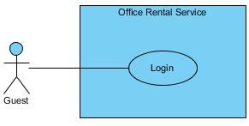

Figure : <Guest> Login

**Use Case Specification**

|  |  |  |  |  |
| --- | --- | --- | --- | --- |
| **USE CASE – LOGIN** | | | | |
| **Use-case No.** | UC002 | **Use-case Version** | | 1.0 |
| **Use-case Name** | Login | | | |
| **Author** | Trương Tiến Thành | | | |
| **Date** | 27/05/2015 | **Priority** | Normal | |
| **Actor:**   * Guest   **Summary:**   * This use case allows user to login to website.   **Goal:**   * Guest can login to website.   **Triggers:**   * Click “Đăng nhập” button on menu bar.   **Preconditions:**   * Guest already has an account on website.   **Post Conditions:**   * **Success:** Guest successfully login into the website. * **Failure:** Guest cannot login.   **Main Success Scenario:**   |  |  |  | | --- | --- | --- | | Step | Actor Action | System Response | | 1 | Click “Đăng nhập” button. | System show [Login pop-up], contain a login form:   * Tên tài khoản: Textbox.   [Exception 1]   * Mật khẩu: Password Filed.   [Exception 2]   * Giữ trạng thái đăng nhập: Checkbox. * Quên mật khẩu: Link. * Đăng nhập: Button.   [Exception 3, 4]   * Hủy: Button. | | 2 | Input username and password.  Click “Đăng Nhập” button.  [Alternative 1, 2, 3] | Close [Login pop-up] and show message “Đăng nhập thành công”. |   **Alternative Scenario:**   |  |  |  | | --- | --- | --- | |  | Actor Action | System Response | | 1 | Click “Giữ trạng thái đăng nhập” checkbox, then click “Đăng Nhập” button. | Close [Login pop-up] and show message “Đăng nhập thành công”. | | 2 | Click “Quên mật khẩu” link. |  | | 3 | Click “Hủy” button. | Close [Login pop-up]. |   **Exceptions:**   |  |  |  | | --- | --- | --- | | No. | Actor Action | System Response | | 1 | “Tên tài khoản” is empty. | Display error message “Vui lòng nhập tên đăng nhập”. | | 2 | “Mật khẩu” is empty. | Display error message “Vui lòng nhập mật khẩu”. | | 3 | Cannot login due to database connection. | Display error message “Có lỗi xảy ra. Xin thử lại”. | | 4 | “Tên tài khoản” or “Mật khẩu” not correct. | Display error message “Tên đăng nhập hoặc mật khẩu không chính xác, xin thử lại”. |   **Relationships:**   * N/A   **Business Rules:**   * N/A | | | | |

Table : <Guest> Login

##### <Guest, Customer> Search office

**Use Case Diagram**



Figure : <Guest, Customer> Search office

**Use Case Specification**

|  |  |  |  |  |
| --- | --- | --- | --- | --- |
| **USE CASE – SEARCH OFFICE** | | | | |
| **Use-case No.** | UC003 | **Use-case Version** | | 2.0 |
| **Use-case Name** | Search office | | | |
| **Author** | Lê Xuân Tiến | | | |
| **Date** | 30/05/2015 | **Priority** | Normal | |
| **Actor:**   * Guest * Customer   **Summary:**   * This use case allows customer search office.   **Goal:**   * Customer can find success an office.   **Trigger:**   * Fill information in text fill or choice some available information. * Click “Tìm kiếm” in home page.   **Pre-conditions:**  **Post conditions:**   * **Success:** Search office successful. * **Fail:** Show message error and show which information error.   **Main Success Scenario:**   |  |  |  | | --- | --- | --- | | Step | Actor Action | System Response | | 1 | Go to home page. | Show the search fields:   * Địa chỉ: auto complete text box of address * Khoảng giá: Number text box * Tìm theo danh sách tiện nghi: List of amenity, each with a check box * Tìm kiếm: button | | 2 | Click “Tìm kiếm” button. | [Exceptions 1, 2]  Show result page, each office include:4   * Image of office * Office name * Short description * Amenity list * Price and price term * Link to office detail |   **Alternative Scenario:**  **N/A**  **Exceptions:**   |  |  |  | | --- | --- | --- | |  | Actor Action | System Response | | 1 | The address is invalid or not valid | Show error message: “Xin nhập vào địa chỉ.” | | 2 | Cannot load search result due to database connection | Show error message: “Có lỗi xảy ra, xin thử lại.” |   **Relationships:** N/A  **Business Rules**:   * The search will perform by relative matching. First based on group of relative place and price. * After get result offices, then filter relatively by amenity by amenity weight. If the match amenity is above 70%, display the result | | | | |

Table : <Guest, Customer> Search office

##### <Guest, Customer> View office detail

**Use Case Diagram**



Figure : <Guest, Customer> View office detail

**Use Case Specification**

|  |  |  |  |  |
| --- | --- | --- | --- | --- |
| **USE CASE – VIEW OFFICE DETAIL** | | | | |
| **Use-case No.** | UC004 | **Use-case Version** | | 2.0 |
| **Use-case Name** | View Office Detail | | | |
| **Author** | Lê Xuân Tiến | | | |
| **Date** | 25/05/2015 | **Priority** | Normal | |
| **Actor:**   * Guest * Customer   **Summary:**   * This use case allows guest and customer view office detail.   **Goal:**   * Display office detail page   **Triggers:**   * Click on a office in office search result * Or click on a office in home page * Or click on a office in relative offices in office detail page   **Preconditions:**  **Post Conditions:**   * **Success**: Display office information. * **Fail:** Cannot show office information.   **Main Success Scenario:**   |  |  |  | | --- | --- | --- | | Step | Actor Action | System Response | | 1 | Click on a office. | Show office information include:   * Office name: text field. * Type of office: text field * “Số tầng”: number of floor, text field * “Diện tích”: area of office, text field * “Địa chỉ”: address of office, text field * “Tiện nghi”: list of amenity, text field * List of office images * “Mô tả”: description of office, text field * Office address map * “Văn phòng tương tự”: list of relative office with link to office detail * “Đặt lịch hẹn xem văn phòng”: button   [Exception 1] |   **Alternative Scenario:**  **N/A**  **Exceptions:**   |  |  |  | | --- | --- | --- | | No. | Actor Action | System Response | | 1 | Cannot load office detail due to database connection | Show error message: “Không thể xem thông tin, vui lòng thử lại sau.” |   **Relationships:** Office  **Business Rules:**   * Relative office is suggest based on the office has the relate place and price of current office | | | | |

Table : <Guest, Customer> View office detail

#### <Customer>Overview Use Case



Figure : <Customer> Overview Use Case

##### <Customer> View customer info

**Use Case Diagram**

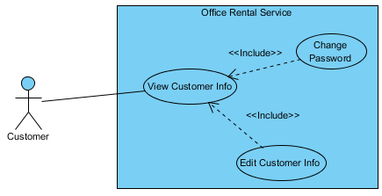

Figure : <Customer> View customer info

**Use Case Specification**

|  |  |  |  |  |
| --- | --- | --- | --- | --- |
| **USE CASE – VIEW CUSTOMER INFO** | | | | |
| **Use-case No.** | UC005 | **Use-case Version** | | 1.0 |
| **Use-case Name** | View customer Info | | | |
| **Author** | Trương Tiến Thành | | | |
| **Date** | 27/05/2015 | **Priority** | Normal | |
| **Actor:**   * Customer.   **Summary:**   * This use case allows customer view customer information.   **Goal:**   * Show profile of customer.   **Triggers:**   * Click “Thông tin cá nhân” in drop-down menu.   **Preconditions:**   * User must login in customer role.   **Post Conditions:**   * **Success**: Customer information is showed successfully. * **Fail:** Cannot view customer information.   **Main Success Scenario:**   |  |  |  | | --- | --- | --- | | Step | Actor Action | System Response | | 1 | Click “Thông tin cá nhân” in drop-down menu. | Show customer information.  Display customer details includes:   * Xưng hô: Text * Họ và tên: Text * Công ty: Text * Số điện thoại: Text * Địa chỉ: Text * Ngày sinh: Text * Sửa thông tin: Button * Sửa mật khẩu: Button |   **Alternative Scenario:**   * N/A   **Exceptions:**   * N/A   **Relationships:** Edit customer info, edit password  **Business Rules:**   * Customer information must exist in database. | | | | |

Table : <Customer> View customer info

##### <Customer> Edit customer info

**Use Case Diagram**

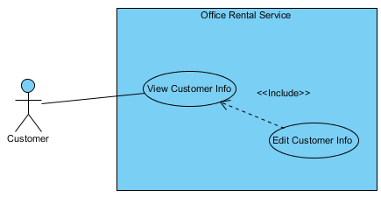

Figure : <Customer> Edit customer info

**Use Case Specification**

|  |  |  |  |  |
| --- | --- | --- | --- | --- |
| **USE CASE – EDIT CUSTOMER INFO** | | | | |
| **Use-case No.** | UC006 | **Use-case Version** | | 1.0 |
| **Use-case Name** | Edit customer info | | | |
| **Author** | Trương Tiến Thành | | | |
| **Date** | 27/05/2015 | **Priority** | Normal | |
| **Actor:**   * Customer   **Summary:**   * This use case allows customer edit information.   **Goal:**   * Customer can edit information.   **Triggers:**   * Click “Thông tin cá nhân” in drop-down menu. * Click “Sửa thông tin” button.   **Preconditions:**   * User must login in customer role.   **Post Conditions:**   * **Success**: customer information is edited successfully. * **Fail:** Cannot edit customer information.   **Main Success Scenario:**   |  |  |  | | --- | --- | --- | | Step | Actor Action | System Response | | 1 | Click “Sửa thông tin” on the screen. | Show customer information, includes:   * Họ và tên (*): Textbox.   [Exception 1, 6]   * Công ty: Textbox.   [Exception 2]   * Số điện thoại (*): Textbox.   [Exception 3, 6]   * Địa chỉ Email: Textbox.   [Exception 4]   * Ngày sinh: Textbox.   [Exception 5]   * Chỉnh sửa: Button. * Hủy: Button. | | 2 | Click “Chỉnh sửa” button.  [Alternative 1] | Show message “Chỉnh sửa thành công” and return to [Profile page]. |   **Alternative Scenario:**   |  |  |  | | --- | --- | --- | | No. | Actor Action | System Response | | 1 | Click “Huỷ” button. | Return to [Profile page]. |   **Exceptions:**   |  |  |  | | --- | --- | --- | | No. | Actor Action | System Response | | 1 | “Họ và tên” is less than 6 or more than 50 characters. | Display error message “Nhập ít nhất 6 ký tự” or “Số ký tự tối đa là 50”. | | 2 | “Công ty” is more than 50 characters. | Display error message “Số ký tự tối đa là 50”. | | 3 | “Số điện thoại” is not a number or less than 10 numbers or greater than 11 numbers. | Display error message “Nhập ít nhất 10 ký tự” or “Số ký tự tối đa là 11”. | | 4 | “Địa chỉ” is more than 100 characters. | Display error message “Số ký tự tối đa là 100”. | | 5 | “Ngày sinh” is invalid. | Display error message “Ngày không hợp lệ”. | | 6 | “Họ và tên” or “Số điện thoại” is empty. | Display error message “Bắt buộc”. |   **Relationships:** View customer info  **Business Rules:**   * Only customer can edit information. | | | | |

Table : <Customer> Edit customer info

##### <Customer> Change password

**Use Case Diagram**

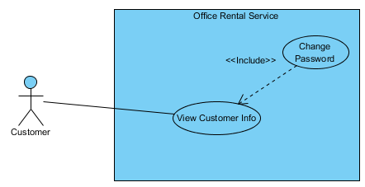

Figure : <Customer> Change password

**Use Case Specification**

|  |  |  |  |  |
| --- | --- | --- | --- | --- |
| **USE CASE – CHANGE PASSWORD** | | | | |
| **Use-case No.** | UC007 | **Use-case Version** | | 1.0 |
| **Use-case Name** | Change password | | | |
| **Author** | Trương Tiến Thành | | | |
| **Date** | 27/05/2015 | **Priority** | Normal | |
| **Actor:**   * Customer   **Summary:**   * This use case allows customer change password.   **Goal:**   * Customer can change password.   **Triggers:**   * Click “Thông tin cá nhân” in drop-down menu. * Click “Sửa mật khẩu” button.   **Preconditions:**   * User must login in customer role.   **Post Conditions:**   * **Success**: password of customer is changed successfully. * **Fail:** Cannot change password.   **Main Success Scenario:**   |  |  |  | | --- | --- | --- | | Step | Actor Action | System Response | | 1 | Click “Sửa mật khẩu” on the screen. | Show information, includes:   * Mật khẩu hiện tại: Password field.   [Exception 1, 4]   * Mật khẩu mới: Password field.   [Exception 2, 4]   * Nhập lại mật khẩu mới: Password field.   [Exception 3, 4]   * Chỉnh sửa: Button. * Hủy: Button. | | 2 | Click “Chỉnh sửa” button.  [Alternative 1] | Show message “Chỉnh sửa thành công” and return to [Profile page]. |   **Alternative Scenario:**   |  |  |  | | --- | --- | --- | | No. | Actor Action | System Response | | 1 | Click “Huỷ” button. | Return to [Profile page]. |   **Exceptions:**   |  |  |  | | --- | --- | --- | | No. | Actor Action | System Response | | 1 | “Mật khẩu hiện tại” is less than 8 or more than 20 characters. | Display error message “Nhập ít nhất 8 ký tự” or “Số ký tự tối đa là 20”. | | 2 | “Mật khẩu mới” is less than 8 or more than 20 characters. | Display error message “Nhập ít nhất 8 ký tự” or “Số ký tự tối đa là 20”. | | 3 | “Nhập lại mật khẩu mới” is less than 8 or more than 20 characters. | Display error message “Nhập ít nhất 8 ký tự” or “Số ký tự tối đa là 20”. | | 4 | “Mật khẩu hiện tại”, “Mật khẩu mới” or “Nhập lại mật khẩu mới” is empty. | Display error message “Bắt buộc”. |   **Relationships:** View customer info  **Business Rules:**   * Only customer can change password. | | | | |

Table : <Customer> Change password

##### <Customer> Create appointment request

**Use Case Diagram**

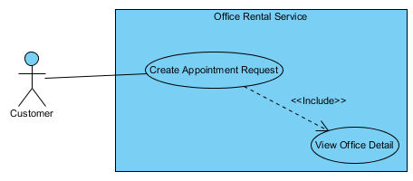

Figure : <Customer> Create appointment request

**Use Case Specification**

|  |  |  |  |  |
| --- | --- | --- | --- | --- |
| **USE CASE – CREATE APPOINTMENT REQUEST** | | | | |
| **Use-case No.** | UC008 | **Use-case Version** | | 1.0 |
| **Use-case Name** | Create appointment request | | | |
| **Author** | Trương Tiến Thành | | | |
| **Date** | 27/05/2015 | **Priority** | Normal | |
| **Actor:**   * Customer.   **Summary:**   * This use case allows customer request appointment.   **Goal:**   * Customer can request appointment after they found suitable office.   **Trigger:**   * After choosing suitable office, click “Gửi yêu cầu”.   **Pre-conditions:**   * User must login in customer role.   **Post conditions:**   * **Success:** Request appointment successful. * **Fail:** Show message error and can’t send request.   **Main Success Scenario:**   |  |  |  | | --- | --- | --- | | Step | Actor Action | System Response | | 1 | Click “Gửi yêu cầu” button. | Redirect to [Request page], contain:   * Thời gian [?]: Date time picker. * Đặt lịch hẹn: Button.   [Exception 1]   * Hủy: Button. | | 2 | Input date and time.  Click “Đặt lịch hẹn” button.  [Alternative 1] | Return to [Detail office page] and displays message:”Đặt lịch hẹn thành công”. |   **Alternative Scenario:**   |  |  |  | | --- | --- | --- | |  | Actor Action | System Response | | 1 | Click “Hủy” button. | Return to [Detail office page]. |   **Exceptions:**   |  |  |  | | --- | --- | --- | |  | Actor action | System Response | | 1 | “Thời gian” is empty | Displays error message:”Không thành công. Có lỗi xảy ra, xin thử lại”. |   **Relationships:** View office detail.  **Business Rules**:   * Customer can request appointment which offices have status available. * Valid time from 8 am to 6 pm. * Valid date from Monday to Friday. | | | | |

Table : <Customer> Create appointment request

##### <Customer> View rental request list

**Use Case Diagram**

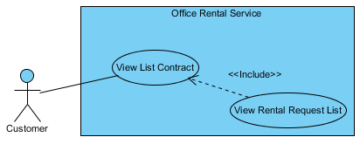

Figure : <Customer> View rental request list

**Use Case Specification**

|  |  |  |  |  |
| --- | --- | --- | --- | --- |
| **USE CASE – VIEW RENTAL REQUEST LIST** | | | | |
| **Use-case No.** | UC009 | **Use-case Version** | | 1.0 |
| **Use-case Name** | View rental request list | | | |
| **Author** | Trương Tiến Thành | | | |
| **Date** | 27/05/2015 | **Priority** | Normal | |
| **Actor:**   * Customer.   **Summary:**   * This use case allows customer view list rental request.   **Goal:**   * Show information about request rental of customer.   **Triggers:**   * Click “Hợp đồng của bạn” in menu bar. * Then click “Danh sách thuê thiết bị”.   **Preconditions:**   * User must login in customer role. * Customer at least has one contract and one request rental.   **Post Conditions:**   * **Success**: List request rental is showed successfully. * **Fail:** Cannot view list rental request.   **Main Success Scenario:**   |  |  |  | | --- | --- | --- | | Step | Actor Action | System Response | | 1 | Click “Danh sách thuê thiết bị” on the screen. | Show list rental request information, includes:   * Tên thiết bị: Text. * Mô tả: Text. * Ngày tạo: Text. * Trạng thái: Text. * Ngày giao thiết bị: Text. |   **Alternative Scenario:**   * N/A   **Exceptions:**   * N/A   **Relationships:** View list contract.  **Business Rules:**   * Only show request has status “Đang xử lý” and “Chờ khách hàng xác nhận”. * Can’t view rental request list of other customer. | | | | |

Table : <Customer> View rental request list

##### <Customer> View repair request list

**Use Case Diagram**

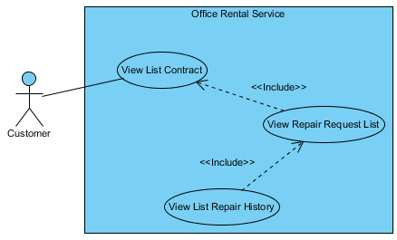

Figure : <Customer> View repair request list

**Use Case Specification**

|  |  |  |  |  |
| --- | --- | --- | --- | --- |
| **USE CASE – VIEW REPAIR REQUEST LIST** | | | | |
| **Use-case No.** | UC010 | **Use-case Version** | | 1.0 |
| **Use-case Name** | View repair request list | | | |
| **Author** | Trương Tiến Thành | | | |
| **Date** | 27/05/2015 | **Priority** | Normal | |
| **Actor:**   * Customer.   **Summary:**   * This use case allows customer view list repair request.   **Goal:**   * Show information about request repair of customer.   **Triggers:**   * Click “Hợp đồng của bạn” in menu bar. * Then click “Danh sách sửa chữa”.   **Preconditions:**   * User must login in customer role. * Customer at least has one contract and one request repair.   **Post Conditions:**   * **Success**: List request repair is showed successfully. * **Fail:** Cannot view list repair request.   **Main Success Scenario:**   |  |  |  | | --- | --- | --- | | Step | Actor Action | System Response | | 1 | Click “Danh sách sửa chữa” on the screen. | Show list repair request information, includes:   * Mô tả: Text. * Ngày tạo: Text. * Tìng trạng: Text. * Ngày đã sửa chữa: Text. * Lịch sử sữa chửa: Button. |   **Alternative Scenario:**   * N/A   **Exceptions:**   * N/A   **Relationships:** View list contract, view list repair history.  **Business Rules:**   * Only show request has status “Đang xử lý” and “Chờ khách hàng xác nhận”. * Can’t view repair request list of other customer. | | | | |

Table : <Customer> View repair request list

##### <Customer> View repair request history

**Use Case Diagram**

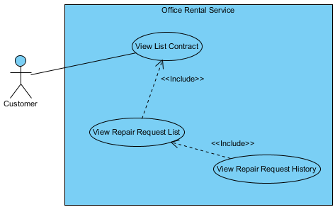

Figure : <Customer> View repair request history

**Use Case Specification**

|  |  |  |  |  |
| --- | --- | --- | --- | --- |
| **USE CASE – VIEW REPAIR REQUEST HISTORY** | | | | |
| **Use-case No.** | UC011 | **Use-case Version** | | 1.0 |
| **Use-case Name** | View repair request history | | | |
| **Author** | Trương Tiến Thành | | | |
| **Date** | 27/05/2015 | **Priority** | Normal | |
| **Actor:**   * Customer.   **Summary:**   * This use case allows customer view list repair request history.   **Goal:**   * Show information about request repair which had repaired.   **Triggers:**   * Click “Hợp đồng của bạn” in menu bar. * Click “Danh sách sửa chữa”. * Click “Lịch sử sửa chữa”.   **Preconditions:**   * User must login in customer role. * Customer at least has one contract and one request repair.   **Post Conditions:**   * **Success**: List repair request history is showed successfully. * **Fail:** Cannot view list repair request history.   **Main Success Scenario:**   |  |  |  | | --- | --- | --- | | Step | Actor Action | System Response | | 1 | Click “Lịch sử sửa chữa” button. | Show list request that had repaired, includes:   * Mô tả: Text. * Ngày tạo: Text. * Tìng trạng: Text. |   **Alternative Scenario:**   * N/A   **Exceptions:**   * N/A   **Relationships:** View repair request list.  **Business Rules:**   * Show request has status “Hoàn thành” and “Hủy”. * Can’t view repair request list of other customer. | | | | |

Table : <Customer> View repair request history

##### <Customer> Request extend contract

**Use Case Diagram**

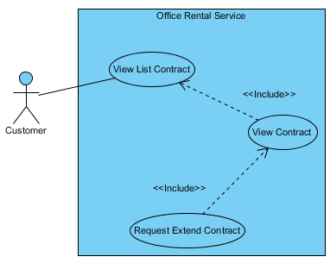

Figure : <Customer> Request extend contract

**Use Case Specification**

|  |  |  |  |  |
| --- | --- | --- | --- | --- |
| **USE CASE – REQUEST EXTEND CONTRACT** | | | | |
| **Use-case No.** | UC012 | **Use-case Version** | | 1.0 |
| **Use-case Name** | Request extend contract | | | |
| **Author** | Trương Tiến Thành | | | |
| **Date** | 27/05/2015 | **Priority** | Normal | |
| **Actor:**   * Customer.   **Summary:**   * This use case allows customer request extend the contract.   **Goal:**   * Customer can request extend the contract if they want to continue hiring.   **Triggers:**   * Click “Hợp đồng của bạn” in menu bar. * Click “Chi tiết”. * Then click link “Gia hạn”   **Preconditions:**   * User must login in customer role. * Customer at least has one contract.   **Post Conditions:**   * **Success**: Send request extend successfully. * **Fail:** Cannot send request extend.   **Main Success Scenario:**   |  |  |  | | --- | --- | --- | | Step | Actor Action | System Response | | 1 | Click link “Gia hạn” in line “Ngày hết hạn”. | System show [Contract extend pop-up], contain:   * Bạn đang yêu cầu gia hạn hợp đồng. Chúng tôi sẽ sớm liên lạc với bạn để xác nhận. Nhấn "Đồng ý" để xác nhận: Text. * Đồng ý: Button. * Hủy: Button. | | 2 | Click “Đồng ý” button.  [Alternative 1] | Close [Contract extend pop-up] and show message: “Đã gửi yêu cầu gia hạn hợp đồng” |   **Alternative Scenario:**   |  |  |  | | --- | --- | --- | | No. | Actor Action | System Response | | 1 | Click “Hủy” button. | Close [Contract extend pop-up] and return to [Contract detail page] |   **Exceptions:**   * N/A   **Relationships:** View contract.  **Business Rules:**   * After receive request, manager will contact with customer and edit contract. * If customer send request extend, they can’t send request return until manager check. | | | | |

Table : <Customer> Request extend contract

##### <Customer> Request return contract

**Use Case Diagram**

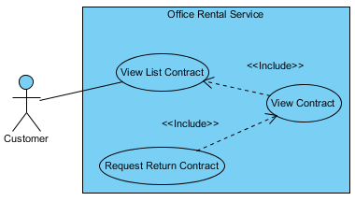

Figure : <Customer> Request return contract

**Use Case Specification**

|  |  |  |  |  |
| --- | --- | --- | --- | --- |
| **USE CASE – REQUEST RETURN CONTRACT** | | | | |
| **Use-case No.** | UC013 | **Use-case Version** | | 1.0 |
| **Use-case Name** | Request return contract | | | |
| **Author** | Trương Tiến Thành | | | |
| **Date** | 27/05/2015 | **Priority** | Normal | |
| **Actor:**   * Customer.   **Summary:**   * This use case allows customer request return the contract.   **Goal:**   * Customer can request return the contract if they want to stop hiring.   **Triggers:**   * Click “Hợp đồng của bạn” in menu bar. * Click “Chi tiết”. * Then click link “Hủy hợp đồng trước hạn”   **Preconditions:**   * User must login in customer role. * Customer at least has one contract.   **Post Conditions:**   * **Success**: Send request return successfully. * **Fail:** Cannot send request return.   **Main Success Scenario:**   |  |  |  | | --- | --- | --- | | Step | Actor Action | System Response | | 1 | Click link “Trả trước hạn” in line “Ngày hết hạn”. | System show [Contract return pop-up], contain:   * Bạn đang yêu cầu hủy hợp đồng trước hạn. Chúng tôi sẽ liên lạc với bạn để xác nhận và bàn giao văn phòng trong thời gian sớm nhất. Nhấn "Đồng ý" để xác nhận: Text. * Đồng ý: Button. * Hủy: Button. | | 2 | Click “Đồng ý” button.  [Alternative 1] | Close [Contract return pop-up] and show message: “Đã gửi yêu cầu hủy hợp đồng trước hạn”. |   **Alternative Scenario:**   |  |  |  | | --- | --- | --- | | No. | Actor Action | System Response | | 1 | Click “Hủy” button. | Close [Contract return pop-up] and return to [Contract detail page] |   **Exceptions:**   * N/A   **Relationships:** View contract.  **Business Rules:**   * After staff contact with customer to check the office, manager accept the request. * If customer send request return, they can’t send request extend until manager check. | | | | |

Table : <Customer> Request return contract

##### <Customer> View list contract

**Use Case Diagram**

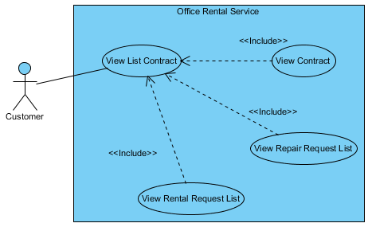

Figure : <Customer> View list contract

**Use Case Specification**

|  |  |  |  |  |
| --- | --- | --- | --- | --- |
| **USE CASE – VIEW LIST CONTRACT** | | | | |
| **Use-case No.** | UC014 | **Use-case Version** | | 1.0 |
| **Use-case Name** | View list contract | | | |
| **Author** | Trương Tiến Thành | | | |
| **Date** | 27/05/2015 | **Priority** | Normal | |
| **Actor:**   * Customer.   **Summary:**   * This use case allows customer view list contract.   **Goal:**   * Show information about contract of customer.   **Triggers:**   * Click “Hợp đồng của bạn” in menu bar.   **Preconditions:**   * User must login in customer role. * Customer at least has one contract.   **Post Conditions:**   * **Success**: List contract is showed successfully. * **Fail:** Cannot view list contract.   **Main Success Scenario:**   |  |  |  | | --- | --- | --- | | Step | Actor Action | System Response | | 1 | Click “Hợp đồng của bạn” in menu bar. | Show list contract information, includes:   * Tên văn phòng: Text. * Ngày bắt đầu: Text. * Ngày kết thúc: Text. * Giá (VNĐ): Text. * Thời hạn thanh toán: Text. * Chi tiết: Button. * Danh sách sửa chữa: Button. * Danh sách thuê thiết bị: Button. |   **Alternative Scenario:**   * N/A   **Exceptions:**   * N/A   **Relationships:** View contract, view rental request list, view repair request list  **Business Rules:**   * Only show list contract of customer who is logging. | | | | |

Table : <Customer> View rental request list

##### <Customer> View contract

**Use Case Diagram**

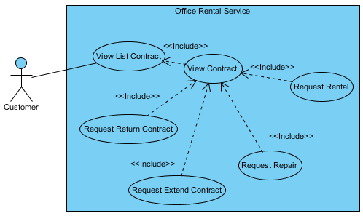

Figure : <Customer> View contract

**Use Case Specification**

|  |  |  |  |  |
| --- | --- | --- | --- | --- |
| **USE CASE – VIEW CONTRACT** | | | | |
| **Use-case No.** | UC015 | **Use-case Version** | | 1.0 |
| **Use-case Name** | View contract | | | |
| **Author** | Trương Tiến Thành | | | |
| **Date** | 27/05/2015 | **Priority** | Normal | |
| **Actor:**   * Customer.   **Summary:**   * This use case allows customer view detail contract.   **Goal:**   * Show information about contract of customer.   **Triggers:**   * Click “Hợp đồng của bạn” in menu bar. * Click “Chi tiết” button.   **Preconditions:**   * User must login in customer role. * Customer at least has one contract.   **Post Conditions:**   * **Success**: Contract information is showed successfully. * **Fail:** Cannot view list contract.   **Main Success Scenario:**   |  |  |  | | --- | --- | --- | | Step | Actor Action | System Response | | 1 | Click “Chi tiết” in the screen. | Show contract information, includes:   * Tên văn phòng: Text. * Yêu cầu sửa chữa: Link. * Ngày bắt đầu: Text. * Ngày hết hạn: Text. * Hủy hợp đồng trước hạn: Link. * Gia hạn hợp đồng: Link * Điều khoản giá: Text. * Danh sách thuê tết bị hiện tại:   Tên thiết bị: Text.  Mô tả: Text.  Giá thuê (VNĐ): Text.  Số lượng (cái): Text.  Thành tiền (VNĐ): Text.  Tổng cộng (VNĐ): Text.   * Yêu câu thuê thiết bị: Button. |   **Alternative Scenario:**   * N/A   **Exceptions:**   * N/A   **Relationships:** Request extend contract, request return contract, request repair, request rental, view list contract.  **Business Rules:**   * Can’t view contract of other customer. * If contract expire, customer can’t view it. | | | | |

Table : <Customer> View rental request list

##### <Customer> Request repair

**Use Case Diagram**

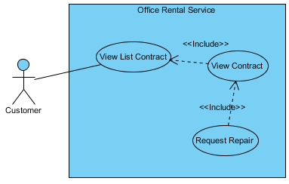

Figure : <Customer> Request repair

**Use Case Specification**

|  |  |  |  |  |
| --- | --- | --- | --- | --- |
| **USE CASE – REQUEST REPAIR** | | | | |
| **Use-case No.** | UC016 | **Use-case Version** | | 1.0 |
| **Use-case Name** | Request repair | | | |
| **Author** | Trương Tiến Thành | | | |
| **Date** | 27/05/2015 | **Priority** | Normal | |
| **Actor:**   * Customer   **Summary:**   * This use case allows customer to send request repair.   **Goal:**   * Customer can send request repair.   **Triggers:**   * Click “Hợp đồng của bạn” in menu bar. * Click “Chi tiết” button. * Then click “Yêu cầu sửa chữa” link.   **Preconditions:**   * User must login in customer role. * Customer at least has one contract. * The status of contract can not be expire or in the condition of being requested for return   **Post Conditions:**   * **Success**: Request repair is sent successfully. * **Fail:** Cannot send request repair.   **Main Success Scenario:**   |  |  |  | | --- | --- | --- | | Step | Actor Action | System Response | | 1 | Click “Yêu cầu sửa chữa” link on the screen. | Show [Request repair page], includes:   * Tên văn phòng: Text. * Địa chỉ văn phòng: Text. * Chủ văn phòng: Text. * Điện thoại: Text. * Sữa chữa: List checkbox. * Mô tả yêu cầu sửa chữa: Text area.   [Exception 1]   * Gửi yêu cầu: Button.   [Exception 2]   * Hủy: Button. | | 2 | Click “Gửi” button on screen.  [Alternative 1] | Show message “Thành công. Đã gửi yêu cầu sửa chữa” and return to [Contract list page]. |   **Alternative Scenario:**   |  |  |  | | --- | --- | --- | | No. | Actor Action | System Response | | 1 | Click “Hủy” button. | Return to [Contract list page]. |   **Exceptions:**   |  |  |  | | --- | --- | --- | | No. | Actor Action | System Response | | 1 | “Mô tả yêu cầu sửa chữa” is empty. | Show error message: “Vui lòng điền mô tả”. | | 2 | Not click checkbox in “Sửa chữa”. | Show error message: “Vui lòng chọn ít nhất một tiện nghi để sửa”. |   **Relationships:** View contract  **Business Rules:**   * Status of request repair is “Chờ xử lý”. | | | | |

Table : <Customer> Request repair

##### <Customer> Request rental

**Use Case Diagram**

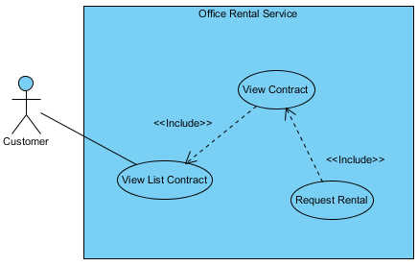

Figure : <Customer> Request repair

**Use Case Specification**

|  |  |  |  |  |
| --- | --- | --- | --- | --- |
| **USE CASE – REQUEST REPAIR** | | | | |
| **Use-case No.** | UC017 | **Use-case Version** | | 1.0 |
| **Use-case Name** | Request repair | | | |
| **Author** | Trương Tiến Thành | | | |
| **Date** | 27/05/2015 | **Priority** | Normal | |
| **Actor:**   * Customer   **Summary:**   * This use case allows customer to send request rental.   **Goal:**   * Customer can choose rental item and send request rental.   **Triggers:**   * Click “Hợp đồng của bạn” in menu bar. * Click “Chi tiết” button. * Then click “Yêu cầu thuê thiết bị” link.   **Preconditions:**   * User must login in customer role. * Customer at least has one contract. * The status of contract can not be expire or in the condition of being requested for return.   **Post Conditions:**   * **Success**: Request rental is sent successfully. * **Fail:** Cannot send request rental.   **Main Success Scenario:**   |  |  |  | | --- | --- | --- | | Step | Actor Action | System Response | | 1 | Click “Yêu cầu thuê thiết bị” button on the screen. | Show [Rental item page], includes:   * Xem giỏ hàng: Button. * Số lượng: Number (> 0).   [Exception 1]   * Thuê: Button. | | 2 | Choose quantity of the item you want to hire.  Click “Thuê” button on screen. | List item will update on left screen. | | 3 | Click “Xem giỏ hàng” button. | Redirect to [Request rental page]. | | 4 | Click “Gửi yêu cầu” button.  [Alternative 1] | Show message “Gửi yêu cầu thành công” and redirect to [Home page]. |   **Alternative Scenario:**   |  |  |  | | --- | --- | --- | | No. | Actor Action | System Response | | 1 | Click “Quay về”. | Return to [Rental item page]. |   **Exceptions:**   |  |  |  | | --- | --- | --- | | No. | Actor Action | System Response | | 1 | Input number < 0. | User can not input number < 0. |   **Relationships:** View contract  **Business Rules:**   * Status of request rental is “Chờ xử lý”. | | | | |

Table : <Customer> Request rental

##### <Customer> Create office request

**Use Case Diagram**

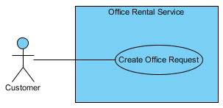

Figure : <Customer> Create office request

**Use Case Specification**

|  |  |  |  |  |
| --- | --- | --- | --- | --- |
| **USE CASE – CREATE OFFICE REQUEST** | | | | |
| **Use-case No.** | UC018 | **Use-case Version** | | 1.0 |
| **Use-case Name** | Create office request | | | |
| **Author** | Trương Tiến Thành | | | |
| **Date** | 27/05/2015 | **Priority** | Normal | |
| **Actor:**   * Customer.   **Summary:**   * This use case allows customer request office.   **Goal:**   * Customer can request office if they can’t find suitable office.   **Trigger:**   * Click “Đặt yêu cầu văn phòng” at home page.   **Pre-conditions:**   * User must login in customer role.   **Post conditions:**   * **Success:** Request office successful. * **Fail:** Show message error and can’t send request.   **Main Success Scenario:**   |  |  |  | | --- | --- | --- | | Step | Actor Action | System Response | | 1 | Click “Đặt yêu cầu văn phòng” button. | Redirect to [Request office page], contain:   * Loại văn phòng: Drop-down list. * Giá (VNĐ): Number.   [Exception 1]   * Diện tích (m2): Number.   [Exception 1]   * Quận: Textbox.   [Exception 1]   * Danh sách tiện nghi: Textbox. * Thêm: Button. * Đặt văn phòng: Button.   [Exception 2]   * Hủy: Button. | | 2 | Input information and click “Đặt văn phòng” button.  [Alternative 1] | Return to [Home page] and displays message:”Đặt lịch hẹn thành công”. |   **Alternative Scenario:**   |  |  |  | | --- | --- | --- | |  | Actor Action | System Response | | 1 | Click “Hủy” button. | Return to [Home page]. |   **Exceptions:**   |  |  |  | | --- | --- | --- | |  | Actor action | System Response | | 1 | “Giá”, “Diện tích” and “Quận” are empty. | Display error message “Bắt buộc”. | | 2 | “Loại văn phòng” is empty | Button “Đặt văn phòng” is disable. |   **Relationships:** N/A  **Business Rules**:   * “Loại văn phòng”, “Giá”, “Diện tích” and “Quận” can’t empty. | | | | |

Table : <Customer> Create office request

##### <Customer> View Result Request Office

**Use Case Diagram**

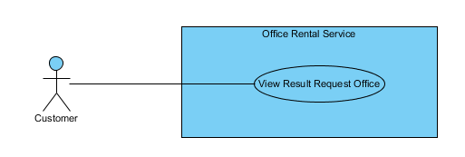

Figure : <Customer> View Result Request Office

**Use Case Specification**

|  |  |  |  |  |
| --- | --- | --- | --- | --- |
| **USE CASE VIEW RESULT REQUEST OFFICE** | | | | |
| **Use-case No.** | UC019 | **Use-case Version** | | 2.0 |
| **Use-case Name** | View Result Request Office | | | |
| **Author** | Nguyễn Vũ Hoàng Quốc | | | |
| **Date** | 31/05/2015 | **Priority** | Normal | |
| **Actor:**   * Customer   **Summary:**   * This use case allows customer to see all his/her requests office and offices that is suggest for them   **Goal:**   * All request office and suggest office of customer are shown   **Triggers:**   * Click “Yêu cầu văn phòng của bạn” in menu after login.   **Preconditions:**   * Customer must have an available request office.   **Post Conditions:**   * **Success**: All request and office suggest of this customer will be shown. * **Fail:** Cannot load request and office.   **Main Success Scenario:**   |  |  |  | | --- | --- | --- | | Step | Actor Action | System Response | | 1 | Click “Yêu cầu văn phòng của bạn” in menu after login. | Show page display all request and  office includes:   * Details of request: * Loại văn phòng [text] * Diện tích [number] * Giá [number] * Địa chỉ [text] * Ngày tạo [Date] * “Hủy yêu cầu” button * List of office that suitable of the request   [Exception 1], [Exception 2] | |  |  |  |   **Alternative Scenario:**   * **N/A**   **Exceptions:**   |  |  |  | | --- | --- | --- | | No. | Actor Action | System Response | | 1 | Cannot get request office | Show error message: “Có lỗi xảy ra, xin thử lại.” | | 2 | Cannot get suggest office | Show error message: “Có lỗi xảy ra, xin thử lại.” |   **Relationships:** RequestOffice  **Business Rules:**   * Customer can see all request office themselves and suggest offices that suitable with their request. * Customer also can remove their request. | | | | |

Table : <Customer> Create office request

##### <Customer> Log out

**Use Case Diagram**

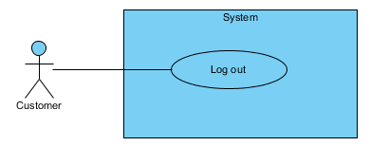

Figure : <Customer> Log out

**Use Case Specification**

|  |  |  |  |  |
| --- | --- | --- | --- | --- |
| **USE CASE – LOG OUT** | | | | |
| **Use-case No.** | UC020 | **Use-case Version** | | 2.0 |
| **Use-case Name** | Log out | | | |
| **Author** | Lê Xuân Tiến | | | |
| **Date** | 31/05/2015 | **Priority** | Normal | |
| **Actor:**   * Customer   **Summary:**   * This use case allows customer to log out of the system   **Goal:**   * Customer will log out and remove from the session   **Triggers:**   * Click “Đăng xuất” from the User function drop down   **Preconditions:**   * Customer has logged in.   **Post Conditions:**   * **Success**: User relative function will disappear, the page is display like guest role. * **Fail:** Display error   **Main Success Scenario:**   |  |  |  | | --- | --- | --- | | Step | Actor Action | System Response | | 1 | Click “Đăng xuất” in user menu. | Log out of the system  [Exception 1], [Exception 2] |   **Alternative Scenario:**   * **N/A**   **Exceptions:**   |  |  |  | | --- | --- | --- | | No. | Actor Action | System Response | | 1 | Cannot log out due to connectivity or database connection | Show error message: “Có lỗi xảy ra, xin thử lại.” |   **Relationships:** N/A  **Business Rules:**   * The front end display of user relative function (Office list, My request list, Customer info) is hide from the user, * If the user relative function still display in other tab of browser, refresh page will show the message “Xin đăng nhập để xem thông tin” * The customer info will be removed from the session | | | | |

Table : <Customer> Log out

#### <Staff> Overview Use Case

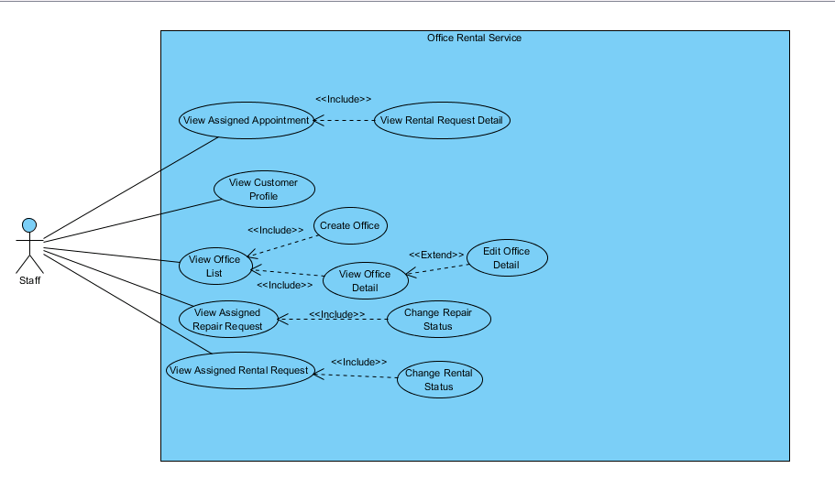

Figure : <Staff> Overview Use Case

##### <Staff> View Assigned Appointment

**Use Case Diagram**

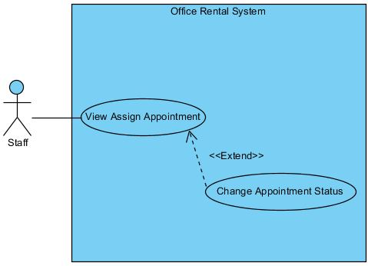

Figure : <Staff> View Assigned Appointment

**Use Case Specification**

|  |  |  |  |
| --- | --- | --- | --- |
| **USE CASE VIEW ASSIGNED APPOINTMENT** | | | |
| **Use Case No.** | UC021 | **Use Case Version** | 1.0 |
| **Use Case Name** | View Assigned Appointment | | |
| **Author** | Trương Tiến Thành | | |
| **Date** | 29/05/2015 | **Priority** | Normal |
| **Actor:**   * Staff   **Summary:**   * This use case allows staff to view time to meet customer at the office they want to rent.   **Goal:**   * Staff can view time to meet customer.   **Triggers:**   * Click “Xem công việc” in menu. * Choose “Lịch gặp khách hàng” in drop down menu.   **Preconditions:**   * User must log in the system with Staff role.   **Post Conditions:**   * **Success:** Display appointment list. * **Fail:** Cannot load appointment list.   **Main Success Scenario:**   |  |  |  | | --- | --- | --- | | Step | Actor Action | System Response | | 1 | Choose “Lịch gặp khách hàng” in drop down menu at staff page. | Display all appointment with status.  [Alternative 1] [Exception 1] |   **Alternative Scenario:**   |  |  |  | | --- | --- | --- | | No | Actor Action | System Response | | 1 | Choose “Lịch gặp khách hàng” in drop down menu at staff page. | Display message: “Không có lịch gặp khách hàng.” |   **Exceptions:**   |  |  |  | | --- | --- | --- | | No | Actor Action | System Response | | 1 | Cannot view list appointment to database connection. | Display error message: “Không thể tải lịch gặp khách hàng. Vui lòng thử lại sau.” |   **Relationships:** Change Appointment Status  **Business Rules:**   * List of appointment is sorted by status with the status “Incomplete” on top of list. | | | |

Table : <Staff> View Assigned Appointment

##### <Staff> Change Appointment Status

**Use Case Diagram**

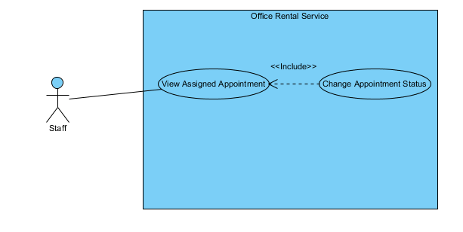

Figure : <Staff> View Assigned Appointment

**Use Case Specification**

|  |  |  |  |
| --- | --- | --- | --- |
| **USE CASE CHANGE APPOINTMENT STATUS** | | | |
| **Use Case No.** | UC022 | **Use Case Version** | 1.0 |
| **Use Case Name** | Change Appintment Status | | |
| **Author** | Trương Tiến Thành | | |
| **Date** | 29/05/2015 | **Priority** | Normal |
| **Actor:**   * Staff   **Summary:**   * This use case allows staff to change status of appointment when they finish meeting customer at office.   **Goal:**   * Staff change status from incomplete to complete.   **Triggers:**   * Click “Xem công việc” in menu. * Choose “Lịch gặp khách hàng” in drop down menu. * Click “Hoàn thành” button.   **Preconditions:**   * User must log in the system with Staff role. * Staff can change status after they meet customer. * At least there is one appointment with customer.   **Post Conditions:**   * **Success:** Appointment’s status is changed to “Hoàn thành”. * **Fail:** Appointment’s status isn’t updated in database.   **Main Success Scenario:**   |  |  |  | | --- | --- | --- | | Step | Actor Action | System Response | | 1 | On appointment page, clicks “Hoàn thành” button next to the appointment that he/she finished. | Display message “Đã thay đổi trang thái sang hoàn thành.”  [Exception 1] |   **Alternative Scenario:** N/A  **Exceptions:**   |  |  |  | | --- | --- | --- | | No | Actor Action | System Response | | 1 | Cannot change status due to database connection. | Display error message: “Không thể thay đổi trang thái. Vui lòng thử lại sau.” |   **Relationships:** View Assigned Appointment.  **Business Rules:**   * Cannot change status “Hoàn thành” to “Chưa hoàn thành”. * Staff should notify to manage before change status. | | | |

Table : <Staff> View Assigned Appointment

##### <Staff>View Assigned Repair Request

**Use Case Diagram**

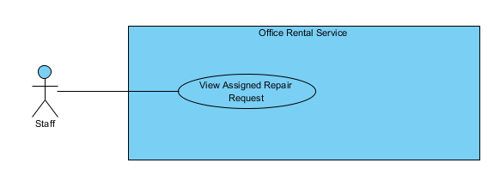

Figure : <Staff> View Assigned Repair Request

**Use Case Specification**

|  |  |  |  |
| --- | --- | --- | --- |
| **USE CASE VIEW ASSIGNED REPAIR REQUEST** | | | |
| **Use Case No.** | UC023 | **Use Case Version** | 1.0 |
| **Use Case Name** | View Assigned Repair Request | | |
| **Author** | Trương Tiến Thành | | |
| **Date** | 28/05/2015 | **Priority** | Normal |
| **Actor:**   * Staff   **Summary:**   * This use case allows staff to view task repairing that manager assign after customers request.   **Goal:**   * Staff can view task repairing.   **Triggers:**   * Click “Xem công việc” in menu. * Choose “Sửa chữa” in drop down menu.   **Preconditions:**   * User must log in the system with Staff role.   **Post Conditions:**   * **Success:** Display repair request. * **Fail:** Cannot load repair request.   **Main Success Scenario:**   |  |  |  | | --- | --- | --- | | Step | Actor Action | System Response | | 1 | Choose “Sửa chữa” in drop down menu at staff page. | Display all repair request with status in repairing page.  Display details includes:   * Tên văn phòng: Label * Khách hàng: Label * Ngày sửa chữa: Label * Mô tả: Label * “Xem chi tiết”: Link   [Alternative 1] [Exception 1] |   **Alternative Scenario:**   |  |  |  | | --- | --- | --- | | No | Actor Action | System Response | | 1 | Choose “Sửa chữa” in drop down menu at staff page. | Display message: “Không có yêu cầu sửa chữa nào.” |   **Exceptions:**   |  |  |  | | --- | --- | --- | | No | Actor Action | System Response | | 1 | Cannot view repair request due to database connection. | Display error message: “Không thể tải yêu cầu sửa chữa. Vui lòng thử lại sau.” |   **Relationships:** Change Repair Status  **Business Rules:**   * List of repair request is sorted by status with the status “Incomplete” on top of list. | | | |

Table : <Staff> View Assigned Repair Request

##### <Staff> Change Repair Status

**Use Case Diagram**

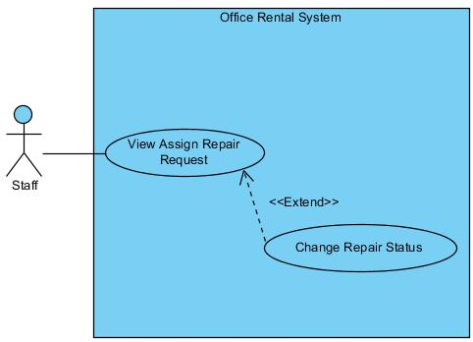

Figure : <Staff> Change Repair Status

**Use Case Specification**

|  |  |  |  |
| --- | --- | --- | --- |
| **USE CASE CHANGE REPAIR STATUS** | | | |
| **Use Case No.** | UC024 | **Use Case Version** | 1.0 |
| **Use Case Name** | Change Repair Status | | |
| **Author** | Trương Tiến Thành | | |
| **Date** | 28/05/2015 | **Priority** | Normal |
| **Actor:**   * Staff   **Summary:**   * This use case allows staff to change status of request when they finish repair.   **Goal:**   * Staff can change status after they complete task repairing. * Staff change status from incomplete to complete.   **Triggers:**   * Click “Xem công việc” in menu. * Choose “Sửa chữa” in drop down menu. * Click “Hoàn thành” button.   **Preconditions:**   * User must log in the system with Staff role. * At least there is one request repair from customer.   **Post Conditions:**   * **Success:** Repair request’s status is changed to “Hoàn thành”. * **Fail:** Repair request’s status isn’t updated in database.  |  |  |  | | --- | --- | --- | | Step | Actor Action | System Response | | 1 | Click “Xem chi tiết” in submenu | Show page detail  Display details includes:   * Tên văn phòng: Label * Khách hàng: Label * Ngày tạo: Label * Mô tả: Label * Ngày sửa chữa: Label * Tình trạng: Label * “Đồng ý sửa” : Button * “Không đồng ý sửa” : Button | | 2 | Click “Đồng ý sửa” button  [Alternative 1] | Show successful message “Chấp nhận yêu cầu thành công.” on screen.  [Exception 1] |   **Alternative Scenario:**   |  |  |  | | --- | --- | --- | | No. | Actor Action | System Response | | 1 | Click “Không đồng ý sửa” button | Show successful message “Chập nhận yêu cầu thành công.” on screen.  [Exception 1] |   **Exceptions:**   |  |  |  | | --- | --- | --- | | No. | Actor Action | System Response | | 1 | Cannot send request due to database connection | Show error message: “Không thể gửi yêu cầu, vui lòng thử lại sau.” |   **Relationships:** View Assigned Repair Request  **Business Rules:**   * Cannot change status “Hoàn thành” to “Chưa hoàn thành”. * Staff should notify to manager after change status. | | | |

Table : <Staff> Change Repair Status

##### <Staff, Manager> Create office

**Use Case Diagram**



Figure : <Staff, Manager> Create Office

**Use Case Specification**

|  |  |  |  |  |
| --- | --- | --- | --- | --- |
| **USE CASE – CREATE OFFICE** | | | | |
| **Use-case No.** | UC025 | **Use-case Version** | | 2.0 |
| **Use-case Name** | Create Office | | | |
| **Author** | Lê Xuân Tiến | | | |
| **Date** | 25/05/2015 | **Priority** | Normal | |
| **Actor:**   * Staff * Manager   **Summary:**   * This usecase allow staff to create a new office.   **Goal**:   * Staff can add new office to system.   **Triggers:**   * Click “Thêm mới văn phòng” button.   **Preconditions:**   * User logged in successfully with Staff or Manager role.   **Post Conditions:**   * **Success:** A successful message will be displayed, new office will be added. After reloaded staff page, new row of office will be display. * **Fail:** Display error message and cannot add new office to database.   **Main Success Scenario:**   |  |  |  | | --- | --- | --- | | Step | Actor Action | System Response | | 1 | Clicks “Thêm mới văn phòng” button on staff page. | Show the page with title “Thêm mới văn phòng”. The create office page includes:   * Tên văn phòng: Text box (Name, length [3, 50], required)   [Exception 2]   * Địa chỉ: Text box (Address, min length: 6, required) * Detail of address, include district and city, and the map of current adress * Hình ảnh: Add image button * List of image, each of image added has the “Xóa” button * Mô tả văn phòng: Text area (Description, length [3, 500], required)   [Exception 3]   * Loại văn phòng: Drop down list (Category, required) * Giá thuê: Text box (Price, type number, required)   [Exception 4]   * Đơn vị giá: Drop down list (PriceTerm, require) * Số tầng: Text box (Floor, type number, required)   [Exception 5]   * Tiện ích: Tags with typeahead input * Tổng diện tích: Text box (Area, type number, min: 10, required) * Thời gian thuê tối thiểu (tháng): Text box (area, type number, min 0, required) * Diện tích thuê tối thiểu: Text box (Min area, type number, min 0, max equal Area, required)   [Exception 6, 7, 9, 10]   * Tên người đại diện: Text box (Owner Name, [5-150] characters, required) * Địa chỉ người đại diện: Text box (owner addres, [5-150] characters, required) * Số điện thoại người đại diện: Text box (owner phone, [9-11] characters, required) * Lợi nhuận tính theo hoa hồng (5%): check box, checked. If uncheck display:   + Giá thuê gốc: text box, base price, number input, required * Tạo mới: button   [Exception 1, 8]   * Hủy: button | | 2 | Inputs information into all fields and clicks “Tạo mới” button.  [Alternative 1] | Show successfully message: “Đã thêm thành công văn phòng!” and redirect office detail page. |   **Alternative Scenario:**   |  |  |  | | --- | --- | --- | | No | Actor Action | System Response | | 1 | Staff clicks “Hủy” button. | The data in all fields will be reset and redirect to staff page. |   **Exceptions:**   |  |  |  | | --- | --- | --- | | No | Actor Action | System Response | | 1 | “Tên văn phòng”, “Địa chỉ”, “Hình ảnh”, “Trạng thái”, “Mô tả văn phòng”, “Giá thuê”, “Đơn vị giá”, “Số tầng”, “Loại văn phòng”, “Tiện ích”, “Tổng diện tích” are empty. | Shows error message “Vui lòng nhập đầy đủ thông tin yêu cầu!” | | 2 | Name is less than 3 characters or more than 50 characters. | Shows error message “Tên văn phòng từ 3 đến 50 ký tự!” | | 3 | Description is less than 3 characters or more than 500 characters. | Shows error message “Mổ tả văn phòng từ 3 đến 500 ký tự!” | | 4 | Price is not a number. | Shows error message “Giá thuê không hợp lệ!” | | 5 | Floor is not a number. | Shows error message “Số tầng không hợp lệ!” | | 6 | Area is smaller than 10. | Shows error message “Tổng diện tích tối thiểu cho thuê là 10m2!” | | 7 | Area is not a number. | Shows error message “Tổng diện tích không hợp lệ!” | | 8 | Cannot create new office | Shows error message “Không thể thêm mới văn phòng. Vui lòng thử lại sau” | | 9 | Min area is smaller than 0 or large than total area | Shows error message “Diện tích thuê tối thiểu phải nhỏ hơn tổng diện tích” | | 10 | Min time is smaller than 0 | Shows error message “Thời gian thuê tối thiểu không hợp lệ” |   **Relationships:** View Office Detail  **Business Rules:**   * The input number fields cannot input non-number characters * When select office type “Văn phòng nguyên căn”, the price term available “Nguyên căn” and “Liên hệ”, while type “Tòa nhà văn phòng”, the price term available: “/m2” , “/người”, and “Liên hệ” * Staffs can add new office to system when there is a new office for lease contact with us. * Office name should be different from existed office of system. | | | | |

Table : <Staff> Create Office

##### <Staff, Manager> View Office Detail

**Use Case Diagram**

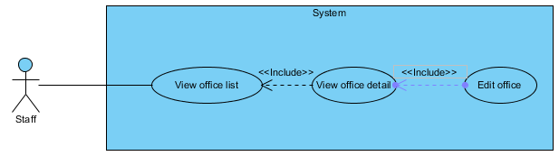

Figure : <Staff, Manager> View office detail

**Use Case Specification**

|  |  |  |  |
| --- | --- | --- | --- |
| **USE CASE VIEW OFFICE DETAIL** | | | |
| **Use Case No.** | UC026 | **Use Case Version** | 1.0 |
| **Use Case Name** | View Office Detail | | |
| **Author** | Lê Xuân Tiến | | |
| **Date** | 28/05/2015 | **Priority** | Normal |
| **Actor:**   * Staff, manager   **Summary:**   * This use case allows staff or manager to view information of office.   **Goal:**   * Staff or manager can view information of office.   **Triggers:**   * Click “Xem văn phòng” in menu. * Click “Xem chi tiết văn phòng” button.   **Preconditions:**   * User must log in the system with Staff role. * At least there is one office in database.   **Post Conditions:**   * **Success:** Display detail information of office. * **Fail:** Cannot load information of office.   **Main Success Scenario:**   |  |  |  | | --- | --- | --- | | Step | Actor Action | System Response | | 1 | Click “Xem chi tiết văn phòng” button next to the office that user want to view. | Display office detail page.  [Exception 1] |   **Alternative Scenario:** N/A  **Exceptions:**   |  |  |  | | --- | --- | --- | | No | Actor Action | System Response | | 1 | Cannot view detail of office due to database connection. | Display error message: “Không thể tải trang chi tiết văn phòng. Vui lòng thử lại sau.” |   **Relationships:** View Office List, Edit Office Detail, Delete Comment.  **Business Rules:**   * The display is different from the customer view | | | |

Table : <Staff, Manager> View Office Detail

##### <Staff, Manager> Edit Office Detail

**Use Case Diagram**

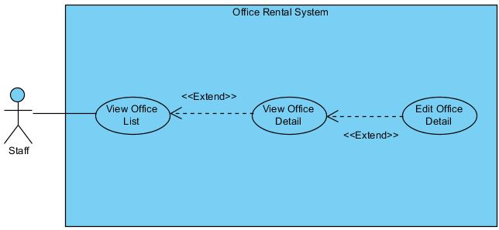

Figure : <Staff, Manager> Edit Office Detail

**Use Case Specification**

|  |  |  |  |
| --- | --- | --- | --- |
| **USE CASE EDIT OFFICE DETAIL** | | | |
| **Use Case No.** | UC027 | **Use Case Version** | 1.0 |
| **Use Case Name** | Edit Office Detail | | |
| **Author** | Trương Tiến Thành | | |
| **Date** | 28/05/2015 | **Priority** | Normal |
| **Actor:**   * Staff, Manager   **Summary:**   * This use case is used to edit information of office.   **Goal:**   * Staff or manager can edit information of a office.   **Triggers:**   * Click “Xem văn phòng” in menu. * Click “Xem chi tiết văn phòng” button. * Click “Cập nhật văn phòng” button   **Preconditions:**   * User must be logged in the system with Staff/Manager role. * At least there is one office in database.   **Post Conditions:**   * **Success:** New information of office is updated. * **Fail:** Cannot update information of office.   **Main Success Scenario:**   |  |  |  | | --- | --- | --- | | Step | Actor Action | System Response | | 1 | Clicks “Cập nhật văn phòng” button on the row of office that he/she wants to edit. | Redirect to update office page. It includes:   * Tên văn phòng: Text box (Name, length [3, 50], required)   [Exception 2]   * Địa chỉ: Text box (Address, min length: 6, required). * Quận: Drop down list (District, required) * Hình ảnh: Button (Image] * Trạng thái: Drop down list (Status, required) * Mô tả văn phòng: Text area (Description, length [3, 500], required)   [Exception 3]   * Giá thuê: Text box (Price, type number, required)   [Exception 4]   * Đơn vị giá: Drop down list (PriceTerm, require) * Số tầng: Text box (Floor, type number, required)   [Exception 5]   * Loại văn phòng: Drop down list (Category, required) * Tiện ích: Check box (Amenity) * Tổng diện tích: Text box (Area, type number, min length: 50, required)   [Exception 6, 7]   * Cập nhật: button   [Exception 1, 8]   * Hủy: button | | 3 | Edit information and clicks on “Cập nhật” button.  [Alternative 1] | Show popup:   * “Cập nhập thành công” message. * “Đóng” button | | 4 | Clicks on “Đóng” button | Redirect to office detail page. |   **Alternative Scenario:**   |  |  |  | | --- | --- | --- | | No | Actor Action | System Response | | 1 | Clicks on “Hủy” button | Redirect to office detail page. |   **Exceptions:**   |  |  |  | | --- | --- | --- | | No | Actor Action | System Response | | 1 | Cannot update office. | Shows error message “Không thể cập nhật văn phòng. Vui lòng thử lại sau” | | 2 | Name is less than 3 characters or more than 50 characters. | Shows error message “Tên văn phòng từ 3 đến 50 ký tự!”. | | 3 | Description is less than 3 characters or more than 500 characters. | Shows error message “Mổ tả văn phòng từ 3 đến 500 ký tự!”. | | 4 | Price is not a number. | Shows error message “Giá thuê không hợp lệ!” | | 5 | Floor is not a number. | Shows error message “Số tầng không hợp lệ!” | | 6 | Area is smaller than 50. | Shows error message “Tổng diện tích tối thiểu cho thuê là 50m2!” | | 7 | Area is not a number. | Shows error message “Tổng diện tích không hợp lệ!” | | 8 | “Tên văn phòng”, “Địa chỉ”, “Hình ảnh”, “Trạng thái”, “Mô tả văn phòng”, “Giá thuê”, “Đơn vị giá”, “Số tầng”, “Loại văn phòng”, “Tiện ích”, “Tổng diện tích” are empty. | Shows error message “Vui lòng nhập đầy đủ thông tin yêu cầu!” |   **Relationships:** View Office Detail  **Business Rules:**   * Information of office should be clearly and correctly. | | | |

Table : <Staff, Manager> Edit Office Detail

##### <Staff, Manager, Admin> Logout

**Use Case Diagram**

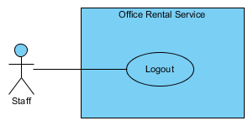

Figure : <Staff, Manager, Admin> Logout

**Use Case Specification**

|  |  |  |  |  |
| --- | --- | --- | --- | --- |
| **USE CASE – LOGIN** | | | | |
| **Use-case No.** | UC028 | **Use-case Version** | | 1.0 |
| **Use-case Name** | Logout | | | |
| **Author** | Trương Tiến Thành | | | |
| **Date** | 27/05/2015 | **Priority** | Normal | |
| **Actor:**   * Staff, manager, admin   **Summary:**   * This use case allows manager, staff or admin to logout.   **Goal:**   * Manager, staff or admin can logout.   **Triggers:**   * Click “Đăng xuất” button on drop-down menu.   **Preconditions:**   * Manager, staff or admin already login in system.   **Post Conditions:**   * **Success:** Manager, staff or admin successfully logout. * **Failure:** Manager, staff or admin cannot logout.   **Main Success Scenario:**   |  |  |  | | --- | --- | --- | | Step | Actor Action | System Response | | 1 | Click “Đăng xuất” button. | Return to [Admin login page]. |   **Alternative Scenario:**   * N/A   **Exceptions:**   * N/A   **Relationships: N/A**  **Business Rules:**   * N/A | | | | |

Table : <Staff, Manager, Admin> Logout

##### <Staff, Manager> View rental item list

**Use Case Diagram**

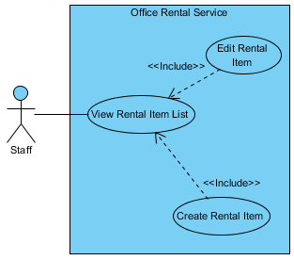

Figure : <Staff, Manager> View rental item list

**Use Case Specification**

|  |  |  |  |  |
| --- | --- | --- | --- | --- |
| **USE CASE – VIEW RENTAL ITEM LIST** | | | | |
| **Use-case No.** | UC029 | **Use-case Version** | | 1.0 |
| **Use-case Name** | View rental item list | | | |
| **Author** | Trương Tiến Thành | | | |
| **Date** | 27/05/2015 | **Priority** | Normal | |
| **Actor:**   * Manager, Staff.   **Summary:**   * This use case allows manager or staff view list rental item.   **Goal:**   * Show list rental item.   **Triggers:**   * Click “Quản lý thiết bị” in menu.   **Preconditions:**   * User must login in staff or manager role. * At least has one item.   **Post Conditions:**   * **Success**: List rental item is showed successfully. * **Fail:** Cannot view list rental item.   **Main Success Scenario:**   |  |  |  | | --- | --- | --- | | Step | Actor Action | System Response | | 1 | Click “Quản lý thiết bị” in menu. | Show list rental information, includes:   * Tên thiết bị: Text. * Mô tả: Text. * Giá (VNĐ): Text. * Số lượng (cái): Text. * Chỉnh sửa: Link |   **Alternative Scenario:**   * N/A   **Exceptions:**   * N/A   **Relationships:** Edit rental item, create rental item.  **Business Rules:**   * Only manager and staff can view list rental item. | | | | |

Table : <Staff, Manager> View rental item list

##### <Staff, Manager> Edit rental item

**Use Case Diagram**

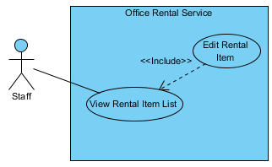

Figure : <Staff, Manager> Edit rental item

**Use Case Specification**

|  |  |  |  |  |
| --- | --- | --- | --- | --- |
| **USE CASE – EDIT RENTAL ITEM** | | | | |
| **Use-case No.** | UC030 | **Use-case Version** | | 1.0 |
| **Use-case Name** | Edit rental item | | | |
| **Author** | Trương Tiến Thành | | | |
| **Date** | 27/05/2015 | **Priority** | Normal | |
| **Actor:**   * Staff, manager   **Summary:**   * This use case allows staff or manager edit rental item.   **Goal:**   * Staff or manager can edit rental item.   **Triggers:**   * Click “Quản lý thiết bị” in menu. * Click “Chỉnh sửa” link.   **Preconditions:**   * User must login in manager or staff role. * At least has one item.   **Post Conditions:**   * **Success**: Rental item information is edited successfully. * **Fail:** Cannot edit rental item information.   **Main Success Scenario:**   |  |  |  | | --- | --- | --- | | Step | Actor Action | System Response | | 1 | Click “Chỉnh sửa” on the screen. | Show rental item information, includes:   * Tên: Textbox. * Mô tả: Text area. * Hình ảnh: Textbox. * Giá: Textbox. * Số lượng: Textbox. * Lưu: Button. * Quay về: Button. | | 2 | Click “Lưu” button.  [Alternative 1] | Return to [List rental item page]. |   **Alternative Scenario:**   |  |  |  | | --- | --- | --- | | No. | Actor Action | System Response | | 1 | Click “Quay về” button. | Return to [List rental item page]. |   **Exceptions:**   * N/A   **Relationships:** View rental item list  **Business Rules:**   * Only manager and staff can edit rental item. | | | | |

Table : <Staff, Manager> Edit rental item

##### <Staff, Manager> Create rental item

**Use Case Diagram**



Figure : <Staff, Manager> Create rental item

**Use Case Specification**

|  |  |  |  |  |
| --- | --- | --- | --- | --- |
| **USE CASE – CREATE RENTAL ITEM** | | | | |
| **Use-case No.** | UC031 | **Use-case Version** | | 1.0 |
| **Use-case Name** | Create rental item | | | |
| **Author** | Trương Tiến Thành | | | |
| **Date** | 27/05/2015 | **Priority** | Normal | |
| **Actor:**   * Staff, manager.   **Summary:**   * This use case allows manager or staff add rental item.   **Goal:**   * Manager or staff can add new rental item.   **Trigger:**   * Click “Quản lý thiết bị” in menu. * Click “Thêm mới thiết bị” link.   **Pre-conditions:**   * User must login in manager or staff role.   **Post conditions:**   * **Success:** Add new rental item successful. * **Fail:** Can’t add rental item to database.   **Main Success Scenario:**   |  |  |  | | --- | --- | --- | | Step | Actor Action | System Response | | 1 | Click “Thêm mới thiết bị” on the srceen. | Redirect to [New rentalItem page], contain:   * Tên: Textbox.   [Exception 1]   * Mô tả: Text area.   [Exception 1]   * Hình ảnh: Textbox. * Giá: Textbox.   [Exception 1]   * Số lượng: Textbox.   [Exception 1]   * Tạo mới: Button. * Hủy: Button. | | 2 | Input information and click “Tạo mới” button.  [Alternative 1] | Return to [List rental item page]. |   **Alternative Scenario:**   |  |  |  | | --- | --- | --- | |  | Actor Action | System Response | | 1 | Click “Hủy” button. | Return to [List rental item page]. |   **Exceptions:**   |  |  |  | | --- | --- | --- | |  | Actor action | System Response | | 1 | “Tên”, “Mô tả”, “Giá” or “Số lượng” are empty | Displays message:”Vui long điền vào trường này”. |   **Relationships:** View rental item list.  **Business Rules**:   * Only manager and staff can edit rental item. | | | | |

Table : <Staff, Manager> Create rental item

##### <Staff, Manager> View customer profile

**Use Case Diagram**

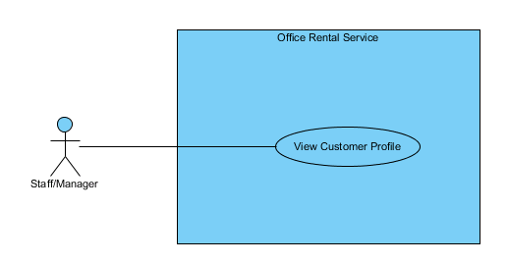

Figure : <Staff, Manager> View customer profile

**Use Case Specification**

|  |  |  |  |  |
| --- | --- | --- | --- | --- |
| **USE CASE – VIEW CUSTOMER PROFILE** | | | | |
| **Use-case No.** | UC032 | **Use-case Version** | | 1.0 |
| **Use-case Name** | View customer profile | | | |
| **Author** | Trương Tiến Thành | | | |
| **Date** | 27/05/2015 | **Priority** | Normal | |
| **Actor:**   * Staff, manager.   **Summary:**   * This use case allows manager or staff view customer profile.   **Goal:**   * Manager or staff can view customer profile.   **Trigger:**   * Click on name of customer.   **Pre-conditions:**   * User must login in manager or staff role.   **Post conditions:**   * **Success:** View customer profile. * **Fail:** Can’t view customer profile.   **Main Success Scenario:**   |  |  |  | | --- | --- | --- | | Step | Actor Action | System Response | | 1 | Click on name of customer. | Redirect to [profile page], contain:   * Họ và tên: Label.` * Danh xưng: Label. * Email: Label. * Tình trạng: Label. * Công ty: Label. * Địa chỉ: Label. * Ngày sinh: Label. * Quay lại: Button. |   **Alternative Scenario: N/A**  **Exceptions:N/A**  **Relationships:** account profile  **Business Rules**:   * Profile of customer must exist in database system. | | | | |

Table : <Staff, Manager> View customer profile

#### <Admin> Overview Use Case



Figure : <Admin> Overview Use Case

##### <Admin> View account list

**Use Case Diagram**

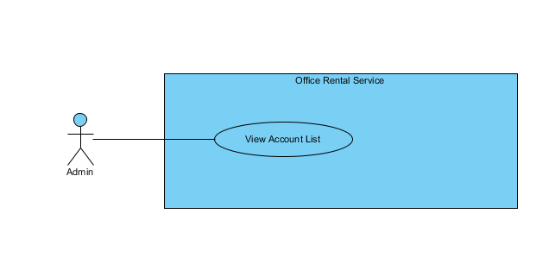

Figure : <Admin> View account list

**Use Case Specification**

|  |  |  |  |  |
| --- | --- | --- | --- | --- |
| **USE CASE – VIEW ACCOUNT LIST** | | | | |
| **Use-case No.** | UC032 | **Use-case Version** | | 2.0 |
| **Use-case Name** | View Account List | | | |
| **Author** | Trần Lê Tuấn | | | |
| **Date** | 25/05/2015 | **Priority** | Normal | |
| **Actor:**   * Admin   **Summary:**   * This use case allows admin to view account list.   **Goal:**   * Admin can view account list successful.   **Triggers:**   * Click “Người dùng” in menu.   **Preconditions:**   * User must login in system.   **Post Conditions:**   * **Success**: create view account list successfully. * **Fail:** Cannot view account list   **Main Success Scenario:**   |  |  |  | | --- | --- | --- | | Step | Actor Action | System Response | | 1 | Click “Người dùng” on menu. | Show page account management  Display account details includes:   * Thêm mới tài khoản: Link * Tên đăng nhập: Label * Email: Password * Chức vụ: Dropdown list * Tình trạng: Label * Tác vụ:   + “Xoá”: Button  +”Sửa”: Button  [Exception 1] | |  |  |  |   **Alternative Scenario: N/A**  **Exceptions:**   |  |  |  | | --- | --- | --- | | No. | Actor Action | System Response | | 1 | Cannot send request due to database connection | Show error message: “Không thể gửi yêu cầu, vui lòng thử lại sau.” |   **Relationships:** Role Account  **Business Rules:**   * The account display only account which has state of available or banned * Not display deleted account | | | | |

Table : <Admin> View account list

##### <Admin> Ban account

**Use Case Diagram**



Figure : <Admin> Ban account

**Use Case Specification**

|  |  |  |  |  |
| --- | --- | --- | --- | --- |
| **USE CASE – BAN ACCOUNT** | | | | |
| **Use-case No.** | UC033 | **Use-case Version** | | 2.0 |
| **Use-case Name** | Request repair | | | |
| **Author** | Trần Lê Tuấn | | | |
| **Date** | 25/05/2015 | **Priority** | Normal | |
| **Actor:**   * Admin   **Summary:**   * This use case allows admin to ban an account.   **Goal:**   * Admin can ban an account successful.   **Triggers:**   * Click “Người dùng” in menu. * Click “Sửa” icon in menu. * Click “Khoá tài khoản” button.   **Preconditions:**   * User must login in system.   **Post Conditions:**   * **Success**: account has been banned successfully. * **Fail:** Cannot ban account.   **Main Success Scenario:**   |  |  |  | | --- | --- | --- | | Step | Actor Action | System Response | | 1 | Click “Sửa” icon on submenu. | Show page account detail  Display account details includes:   * Tên tài khoản: Label * Mật khẩu: Password * Email: Textbox * Chức vụ: Dropdown list   “Huỷ” : button  “Cập nhật” : button  “Khoá tài khoản” : button | | 2 | Click “Khoá tài khoản” button on screen.  [Alternative 1] | Show successful message “Khoá tài khoản thành công.” on screen.  [Exception 1] |   **Alternative Scenario:**   |  |  |  | | --- | --- | --- | | No. | Actor Action | System Response | | 1 | Click “Huỷ” button. | Close page and go to account management page. |   **Exceptions:**   |  |  |  | | --- | --- | --- | | No. | Actor Action | System Response | | 1 | Cannot send request due to database connection | Show error message: “Không thể gửi yêu cầu, vui lòng thử lại sau.” |   **Relationships:** View Account List, Edit Account  **Business Rules:**   * The status of banned account is “Customer/Manager/Staff” and status is “Banned”. * Admin cannot ban admin role account * The banned accounts will get the notification that account has been banned when they login | | | | |

Table : <Admin> Ban account

##### <Admin> Create account

**Use Case Diagram**

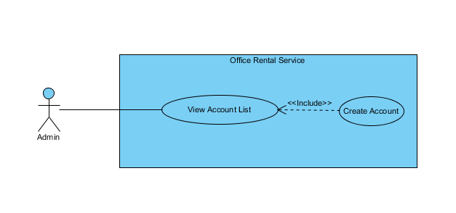

Figure : <Admin> Create account

**Use Case Specification**

|  |  |  |  |  |
| --- | --- | --- | --- | --- |
| **USE CASE – CREATE ACCOUNT** | | | | |
| **Use-case No.** | UC034 | **Use-case Version** | | 2.0 |
| **Use-case Name** | Create Account | | | |
| **Author** | Trần Lê Tuấn | | | |
| **Date** | 25/05/2015 | **Priority** | Normal | |
| **Actor:**   * Admin   **Summary:**   * This use case allows admin to create account.   **Goal:**   * Admin can create account successful.   **Triggers:**   * Click “Người dùng” in menu. * Click “Thêm mới tài khoản” in menu.   **Preconditions:**   * User must login in system.   **Post Conditions:**   * **Success**: create account successfully. * **Fail:** Cannot create account   **Main Success Scenario:**   |  |  |  | | --- | --- | --- | | Step | Actor Action | System Response | | 1 | Click “Người dùng” on menu. | Show page account management  Display account details includes:   * Thêm mới tài khoản: Link * Tên đăng nhập: Label * Email: Password * Chức vụ: Dropdown list * Tình trạng: Label * Tác vụ:   + “Xoá”: Button  +”Sửa”: Button | | 2 | Click “Thêm mới tài khoản” on menu. | Show page account management  Display account details includes:   * Tên tài khoản: Label * Mật khẩu: Password * Email: Textbox * Chức vụ: Dropdown list   “Huỷ” : Button  “Tạo mới” : Button | | 3 | Click “Tạo mới” button on screen.  [Alternative 1] | Show successful message “Tạo tài khoản thành công.” on screen.  [Exception 1] | |  |  |  |   **Alternative Scenario:**   |  |  |  | | --- | --- | --- | | No. | Actor Action | System Response | | 1 | Click “Huỷ” button. | Close page and go to account management page. |   **Exceptions:**   |  |  |  | | --- | --- | --- | | No. | Actor Action | System Response | | 1 | Cannot send request due to database connection | Show error message: “Không thể gửi yêu cầu, vui lòng thử lại sau.” |   **Relationships:** View Account List  **Business Rules:**   * Admin can only create admin, manager and staff role account * The role of new created account is “Manager/Staff/Customer” and status is “Active”. | | | | |

Table : <Admin> Create Account

##### <Admin> Delete account

**Use Case Diagram**

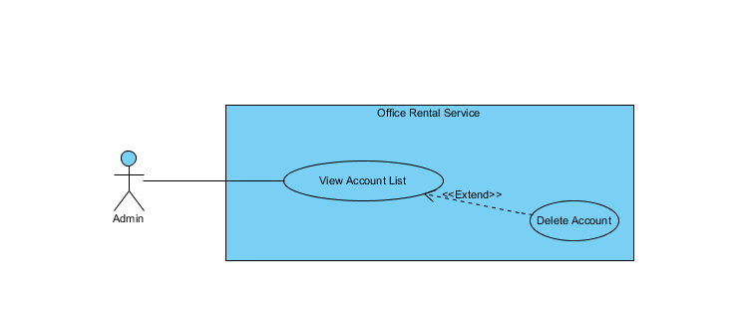

Figure : <Admin> Delete account

**Use Case Specification**

|  |  |  |  |  |
| --- | --- | --- | --- | --- |
| **USE CASE – DELETE ACCOUNT** | | | | |
| **Use-case No.** | UC035 | **Use-case Version** | | 2.0 |
| **Use-case Name** | Delete Account | | | |
| **Author** | Trần Lê Tuấn | | | |
| **Date** | 25/05/2015 | **Priority** | Normal | |
| **Actor:**   * Admin   **Summary:**   * This use case allows admin to delete account.   **Goal:**   * Admin can delete account successful.   **Triggers:**   * Click “Người dùng” in menu. * Click “Xoá tài khoản” in menu.   **Preconditions:**   * User must login in system.   **Post Conditions:**   * **Success**: delete account successfully. * **Fail:** Cannot delete account   **Main Success Scenario:**   |  |  |  | | --- | --- | --- | | Step | Actor Action | System Response | | 1 | Click “Người dùng” on menu. | Show page account management  Display account details includes:   * Tên đăng nhập: Label * Email: Label * Chức vụ: Label * Tình trạng: Label * Tác vụ: Label   “Xoá” : Button  “Sửa” : Button | | 2 | Click “Xoá” button on screen. | Show successful message “Xoá tài khoản thành công.” on screen.  [Exception 1] |   **Alternative Scenario:** N/A  **Exceptions:**   |  |  |  | | --- | --- | --- | | No. | Actor Action | System Response | | 1 | Cannot send request due to database connection | Show error message: “Không thể gửi yêu cầu, vui lòng thử lại sau.” |   **Relationships:** View Account List  **Business Rules:**   * Admin cannot delete admin role account * The deleted account is mark as status “Deleted” and will not display on account list | | | | |

Table : <Admin>Delete Account

##### <Admin> Update account

**Use Case Diagram**

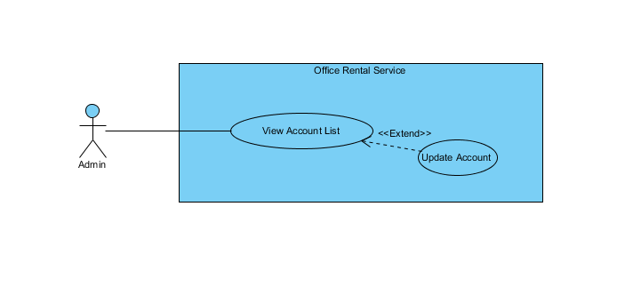

Figure : <Admin> Update account

**Use Case Specification**

|  |  |  |  |  |
| --- | --- | --- | --- | --- |
| **USE CASE – UPDATE ACCOUNT** | | | | |
| **Use-case No.** | UC036 | **Use-case Version** | | 2.0 |
| **Use-case Name** | Update Account | | | |
| **Author** | Trần Lê Tuấn | | | |
| **Date** | 25/05/2015 | **Priority** | Normal | |
| **Actor:**   * Admin   **Summary:**   * This use case allows admin to edit account.   **Goal:**   * Admin can edit account successful.   **Triggers:**   * Click “Người dùng” in menu. * Click “Sửa” in menu.   **Preconditions:**   * User must login in system.   **Post Conditions:**   * **Success**: create account successfully. * **Fail:** Cannot create account   **Main Success Scenario:**   |  |  |  | | --- | --- | --- | | Step | Actor Action | System Response | | 1 | Click “Người dùng” on menu. | Show page account management  Display account details includes:   * Tên đăng nhập: Label * Email: Label * Chức vụ: Label * Tình trạng: Label * Tác vụ: Label   “Xoá” : Button  “Sửa” : Button | | 2 | Click “Sửa” on menu. | Show page account management  Display account details includes:   * Tên tài khoản: Label * Mật khẩu: Password * Email: Textbox * Chức vụ: Dropdown list   “Huỷ” : Button  “Tạo mới” : Button | | 3 | Click “Cập nhật” button on screen.  [Alternative 1] | Show successful message “Cập nhật tài khoản thành công.” on screen.  [Exception 1] | |  |  |  |   **Alternative Scenario:**   |  |  |  | | --- | --- | --- | | No. | Actor Action | System Response | | 1 | Click “Huỷ” button. | Close page and go to account management page. |   **Exceptions:**   |  |  |  | | --- | --- | --- | | No. | Actor Action | System Response | | 1 | Cannot send request due to database connection | Show error message: “Không thể gửi yêu cầu, vui lòng thử lại sau.” |   **Relationships:** View Account List  **Business Rules:**   * Cannot change username. | | | | |

Table : <Admin> Update account

##### <Admin> Unban account

**Use Case Diagram**

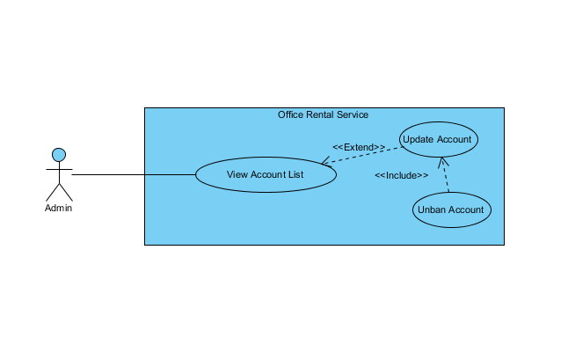

Figure : <Admin> Unban account

**Use Case Specification**

|  |  |  |  |  |
| --- | --- | --- | --- | --- |
| **USE CASE – UNBAN ACCOUNT** | | | | |
| **Use-case No.** | UC037 | **Use-case Version** | | 2.0 |
| **Use-case Name** | Unban Account | | | |
| **Author** | Trần Lê Tuấn | | | |
| **Date** | 25/05/2015 | **Priority** | Normal | |
| **Actor:**   * Admin   **Summary:**   * This use case allows admin to unban an account.   **Goal:**   * Admin can unban an account successful.   **Triggers:**   * Click “Người dùng” in menu. * Click “Sửa” icon in menu. * Click “Mở tài khoản” button.   **Preconditions:**   * User must login in system.   **Post Conditions:**   * **Success**: account has been banned successfully. * **Fail:** Cannot ban account.   **Main Success Scenario:**   |  |  |  | | --- | --- | --- | | Step | Actor Action | System Response | | 1 | Click “Mở tài khoản” button on edit account page.  [Alternative 1] | Show successful message “Mở tài khoản thành công.” on screen.  [Exception 1] |   **Alternative Scenario:**   |  |  |  | | --- | --- | --- | | No. | Actor Action | System Response | | 1 | Click “Huỷ” button. | Close page and go to account management page. |   **Exceptions:**   |  |  |  | | --- | --- | --- | | No. | Actor Action | System Response | | 1 | Cannot send request due to database connection | Show error message: “Không thể gửi yêu cầu, vui lòng thử lại sau.” |   **Relationships:** View Account List, Update account  **Business Rules:**   * The unban account can access system normally * The status of un banned account is “Customer/Manager/Staff” and status is “Active”. | | | | |

Table : <Admin> Unban account

#### <Manager> Overview Use Case



Figure : <Manager> Overview Use Case

##### <Manager> View request extend contract

**Use Case Diagram**



Figure : <Manager> View request extend contract

**Use Case Specification**

|  |  |  |  |  |
| --- | --- | --- | --- | --- |
| **USE CASE – VIEW REQUEST EXTEND CONTRACT** | | | | |
| **Use-case No.** | UC038 | **Use-case Version** | | 2.0 |
| **Use-case Name** | View Request Extend Contract | | | |
| **Author** | Trần Lê Tuấn | | | |
| **Date** | 25/05/2015 | **Priority** | Normal | |
| **Actor:**   * Manager   **Summary:**   * This use case allows user to view request extend contract list.   **Goal:**   * User can view request extend contract list successful.   **Triggers:**   * Click “Yêu cầu khách hàng” in menu. * Click “Gia hạn” in submenu   **Preconditions:**   * User must login in system.   **Post Conditions:**   * **Success**: Request extend contract list has been viewed successfully. * **Fail:** Cannot view request extend contract list.   **Main Success Scenario:**   |  |  |  | | --- | --- | --- | | Step | Actor Action | System Response | | 1 | Click “Hợp đồng” on menu. |  | | 2 | Click “Gia hạn” in submenu | Show page detail  Display details includes:   * Khách hàng: Label * Văn phòng: Label * Ngày bắt đầu: Label * Ngày kết thúc: Label * Giá: Label * Thời hạn thanh toán * “Xem chi tiết”: Link   [Exception 1] |   **Alternative Scenario:** N/A  **Exceptions:**   |  |  |  | | --- | --- | --- | | No. | Actor Action | System Response | | 1 | Cannot get request due to database connection | Show error message: “Không thể gửi yêu cầu, vui lòng thử lại sau.” |   **Relationships:** Contract  **Business Rules:**   * The contract should be re create after contact with customer | | | | |

Table : <Manager> View Request extend contract

##### <Manager> Cancel extend request

**Use Case Diagram**

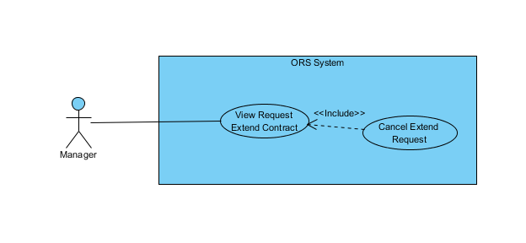

Figure : <Manager> Cancel extend request

**Use Case Specification**

|  |  |  |  |  |
| --- | --- | --- | --- | --- |
| **USE CASE – CANCEL EXTEND REQUEST** | | | | |
| **Use-case No.** | UC039 | **Use-case Version** | | 2.0 |
| **Use-case Name** | Cancel Extend Request | | | |
| **Author** | Trần Lê Tuấn | | | |
| **Date** | 25/05/2015 | **Priority** | Normal | |
| **Actor:**   * Manager   **Summary:**   * This use case allows manager to cancel request.   **Goal:**   * Manager can cancel request successful.   **Triggers:**   * Click “Yêu cầu của khách hàng” in menu. * Click “Xem chi tiết” icon in menu. * Click “Huỷ yêu cầu” button.   **Preconditions:**   * User must login in system.   **Post Conditions:**   * **Success**: contract has been canceled successfully. * **Fail:** Cannot cancel request.   **Main Success Scenario:**   |  |  |  | | --- | --- | --- | | Step | Actor Action | System Response | | 1 | Click “Yêu cầu khách hàng” on menu. |  | | 2 | Click “Gia hạn” on submenu. | Show page request detail  Display request details includes:   * Khách hàng: Label * Văn phòng: Label * Ngày bắt đầu: Label * Ngày kết thúc: Label * Giá: Label * Thời hạn thanh toán: Label * Xem chi tiết: Link | | 3 | Click “Xem chi tiết” link on screen. | Display request details includes:   * Khách hàng: Label * Văn phòng: Label * Ngày kết thúc: Textbox * Thời hạn thanh toán: Dropdown list * Giá: Textbox   “Xác nhận” : button  “Huỷ yêu cầu” : button  “Quay về” : button | | 4 | Click “Huỷ yêu cầu” button on screen.  [Alternative 1] | Show successful message “Huỷ yêu cầu thành công.” on screen.  [Exception 1] |   **Alternative Scenario:**   |  |  |  | | --- | --- | --- | | No. | Actor Action | System Response | | 1 | Click “Quay về” button. | Close request page and go to management page. |   **Exceptions:**   |  |  |  | | --- | --- | --- | | No. | Actor Action | System Response | | 1 | Cannot send request due to database connection | Show error message: “Không thể gửi yêu cầu, vui lòng thử lại sau.” |   **Relationships:** Contract  **Business Rules:**   * Manager cancel extend request by customer meeting if the price and contract term not meets | | | | |

Table : <Manager> Cancel extend request

##### <Manager> Accept extend request

**Use Case Diagram**

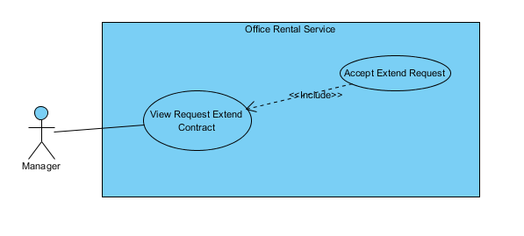

**Figure 55: <Manager> Accept extend request**

**Use Case Specification**

|  |  |  |  |  |
| --- | --- | --- | --- | --- |
| **USE CASE – ACCEPT EXTEND REQUEST** | | | | |
| **Use-case No.** | UC040 | **Use-case Version** | | 2.0 |
| **Use-case Name** | Accept Extend Request | | | |
| **Author** | Trần Lê Tuấn | | | |
| **Date** | 25/05/2015 | **Priority** | Normal | |
| **Actor:**   * Manager   **Summary:**   * This use case allows manager to edit extend contract.   **Goal:**   * Manager can edit extend contract successful.   **Triggers:**   * Click “Yêu cầu của khách hàng” in menu. * Click “Xem chi tiết” icon in menu. * Click “Xác nhận” button.   **Preconditions:**   * User must login in system.   **Post Conditions:**   * **Success**: contract has been edited successfully. * **Fail:** Cannot edit contract.   **Main Success Scenario:**   |  |  |  | | --- | --- | --- | | Step | Actor Action | System Response | | 1 | Click “Yêu cầu khách hàng” on menu. |  | | 2 | Click “Gia hạn” on submenu. | Show page request detail  Display request details includes:   * Khách hàng: Label * Văn phòng: Label * Ngày bắt đầu: Label * Ngày kết thúc: Label * Giá: Label * Thời hạn thanh toán: Label * Xem chi tiết: Link | | 3 | Click “Xem chi tiết” link on screen. | Display request details includes:   * Khách hàng: Label * Văn phòng: Label * Ngày kết thúc: Textbox * Thời hạn thanh toán: Dropdown list * Giá: Textbox   “Xác nhận” : button  “Huỷ yêu cầu” : button  “Quay về” : button | | 4 | Click “Xác nhận” button on screen.  [Alternative 1] | Show successful message “Gia hạn thành công.” on screen.  [Exception 1] |   **Alternative Scenario:**   |  |  |  | | --- | --- | --- | | No. | Actor Action | System Response | | 1 | Click “Quay về” button. | Close request page and go to management page. |   **Exceptions:**   |  |  |  | | --- | --- | --- | | No. | Actor Action | System Response | | 1 | Cannot send request due to database connection | Show error message: “Không thể gửi yêu cầu, vui lòng thử lại sau.” |   **Relationships:** Contract  **Business Rules:**   * Accept extend request must exist in database system. * Extend contract will update after accept extend request. * Contract that accept extend request for must exist in database. | | | | |

Table : <Manager> Accept extend request

##### <Manager> View request return contract

**Use Case Diagram**

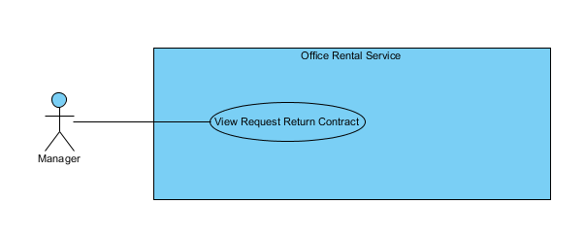

Figure : <Manager> View request return contract

**Use Case Specification**

|  |  |  |  |  |
| --- | --- | --- | --- | --- |
| **USE CASE – VIEW REQUEST RETURN CONTRACT** | | | | |
| **Use-case No.** | UC041 | **Use-case Version** | | 2.0 |
| **Use-case Name** | View Request Return Contract | | | |
| **Author** | Trần Lê Tuấn | | | |
| **Date** | 25/05/2015 | **Priority** | Normal | |
| **Actor:**   * Manager   **Summary:**   * This use case allows user to view request return contract list.   **Goal:**   * User can view request return contract list successful.   **Triggers:**   * Click “Yêu cầu khách hàng” in menu. * Click “Huỷ trước hạn” in submenu   **Preconditions:**   * User must login in system.   **Post Conditions:**   * **Success**: Return request contract list has been viewed successfully. * **Fail:** Cannot view return request contract list.   **Main Success Scenario:**   |  |  |  | | --- | --- | --- | | Step | Actor Action | System Response | | 1 | Click “Hợp đồng” on menu. |  | | 2 | Click “Huỷ trước hạn” in submenu | Show page detail  Display details includes:   * Khách hàng: Label * Văn phòng: Label * Ngày bắt đầu: Label * Ngày kết thúc: Label * Giá: Label * Thời hạn thanh toán: Label * “Xem chi tiet”: Link   [Exception 1] |   **Alternative Scenario:**  N/A  **Exceptions:**   |  |  |  | | --- | --- | --- | | No. | Actor Action | System Response | | 1 | Cannot send request due to database connection | Show error message: “Không thể gửi yêu cầu, vui lòng thử lại sau.” |   **Relationships:** Contract  **Business Rules:**   * Request information must exist in database system. | | | | |

Table : <Manager> View request return contract

##### <Manager> Cancel return request

**Use Case Diagram**

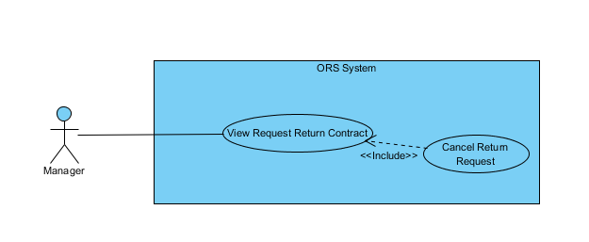

Figure : <Manager> Cancel return request

**Use Case Specification**

|  |  |  |  |  |
| --- | --- | --- | --- | --- |
| **USE CASE – CANCEL RETURN REQUEST** | | | | |
| **Use-case No.** | UC042 | **Use-case Version** | | 2.0 |
| **Use-case Name** | Cancel Return Request | | | |
| **Author** | Trần Lê Tuấn | | | |
| **Date** | 25/05/2015 | **Priority** | Normal | |
| **Actor:**   * Manager   **Summary:**   * This use case allows manager to cancel request.   **Goal:**   * Manager can cancel request successful.   **Triggers:**   * Click “Yêu cầu của khách hàng” in menu. * Click “Xem chi tiết” icon in menu. * Click “Huỷ yêu cầu” button.   **Preconditions:**   * User must login in system.   **Post Conditions:**   * **Success**: contract has been canceled successfully. * **Fail:** Cannot cancel request.   **Main Success Scenario:**   |  |  |  | | --- | --- | --- | | Step | Actor Action | System Response | | 1 | Click “Yêu cầu khách hàng” on menu. |  | | 2 | Click “Huỷ trước hạn” on submenu. | Show page request detail  Display request details includes:   * Khách hàng: Label * Văn phòng: Label * Ngày bắt đầu: Label * Ngày kết thúc: Label * Giá: Label * Thời hạn thanh toán: Label * Xem chi tiết: Link | | 3 | Click “Xem chi tiết” link on screen. | Display request details includes:   * Khách hàng: Label * Văn phòng: Label * Ngày kết thúc: Textbox * Thời hạn thanh toán: Dropdown list * Giá: Textbox   “Xác nhận” : button  “Huỷ yêu cầu” : button  “Quay về” : button | | 4 | Click “Huỷ yêu cầu” button on screen.  [Alternative 1] | Show successful message “Huỷ yêu cầu thành công.” on screen.  [Exception 1] |   **Alternative Scenario:**   |  |  |  | | --- | --- | --- | | No. | Actor Action | System Response | | 1 | Click “Quay về” button. | Close request page and go to management page. |   **Exceptions:**   |  |  |  | | --- | --- | --- | | No. | Actor Action | System Response | | 1 | Cannot send request due to database connection | Show error message: “Không thể gửi yêu cầu, vui lòng thử lại sau.” |   **Relationships:** Contract  **Business Rules:** | | | | |

Table : <Manager> Cancel return request

##### <Manager> Accept return request

**Use Case Diagram**

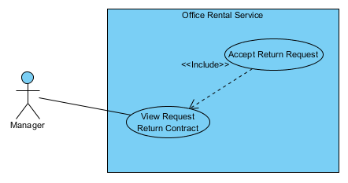

Figure : <Manager> Accept return request

**Use Case Specification**

|  |  |  |  |  |
| --- | --- | --- | --- | --- |
| **USE CASE – ACCEPT RETURN REQUEST** | | | | |
| **Use-case No.** | UC042 | **Use-case Version** | | 2.0 |
| **Use-case Name** | Accept Return Request | | | |
| **Author** | Trần Lê Tuấn | | | |
| **Date** | 25/05/2015 | **Priority** | Normal | |
| **Actor:**   * Manager   **Summary:**   * This use case allows manager to accept return contract.   **Goal:**   * Manager can accept return contract successful.   **Triggers:**   * Click “Yêu cầu của khách hàng” in menu. * Click “Xem chi tiết” icon in menu. * Click “Xác nhận” button.   **Preconditions:**   * User must login in system.   **Post Conditions:**   * **Success**: contract has been edited successfully. * **Fail:** Cannot edit contract.   **Main Success Scenario:**   |  |  |  | | --- | --- | --- | | Step | Actor Action | System Response | | 1 | Click “Yêu cầu khách hàng” on menu. |  | | 2 | Click “Huỷ trước hạn” on submenu. | Show page request detail  Display request details includes:   * Khách hàng: Label * Văn phòng: Label * Ngày bắt đầu: Label * Ngày kết thúc: Label * Giá: Label * Thời hạn thanh toán: Label * Xem chi tiết: Link | | 3 | Click “Xem chi tiết” link on screen. | Display request details includes:   * Khách hàng: Label * Văn phòng: Label * Ngày kết thúc: Textbox * Thời hạn thanh toán: Dropdown list * Giá: Textbox   “Xác nhận” : button  “Huỷ yêu cầu” : button  “Quay về” : button | | 4 | Click “Xác nhận” button on screen.  [Alternative 1] | Show successful message “Gia hạn thành công.” on screen.  [Exception 1] |   **Alternative Scenario:**   |  |  |  | | --- | --- | --- | | No. | Actor Action | System Response | | 1 | Click “Quay về” button. | Close request page and go to management page. |   **Exceptions:**   |  |  |  | | --- | --- | --- | | No. | Actor Action | System Response | | 1 | Cannot send request due to database connection | Show error message: “Không thể gửi yêu cầu, vui lòng thử lại sau.” |   **Relationships:** Contract  **Business Rules:**   * Accept return request must exist in database system. * Contract will update status after accept return request. * Contract that accept return request must exist in database. | | | | |

Table : <Manager> Accept return request

##### <Manager> View Appointment Request List

**Use Case Diagram**



Figure : <Manager> View Appointment Request List

**Use Case Specification**

|  |  |  |  |
| --- | --- | --- | --- |
| **USE CASE VIEW APPOINTMENT REQUEST LIST** | | | |
| **Use Case No.** | UC043 | **Use Case Version** | 1.0 |
| **Use Case Name** | View Appointment Request List | | |
| **Author** | Nguyễn Vũ Hoàng Quốc | | |
| **Date** | 31/05/2015 | **Priority** | Normal |
| **Actor:**   * Manager   **Summary:**   * This use case allows manager see all appointment request   **Goal:**   * Show all appointment request   **Triggers:**   * From the menu bar on admin page:   + Select “Lịch hẹn” menu.   **Preconditions:**   * There are at least request appointment from customer * Requests from customers are valid and send successful   **Post Conditions:**   * **Success:** All appointment request are shown * **Fail:** Cannot get appointment list from database.   **Main Success Scenario:**   |  |  |  | | --- | --- | --- | | Step | Actor Action | System Response | | 1 | Click “Appointment” button from menu bar on admin page | * Show all request appointment list in which includes:   + Khách hàng   + Văn phòng   + Thời gian gặp   + Đề xuất nhân viên   [Exception 1] |   **Alternative Scenario:** N/A  **Exceptions:**   |  |  |  | | --- | --- | --- | | No | Actor Action | System Response | | 1 | Cannot load appointment list from database | Display error message: “Cannot get request appointment list. Please try again” |   **Relationships:** Delete Appointment request, Assign Appointment, View Customer Info  **Business Rules:**   * Manager can view all list appointment from customer’s request. * On list appointment system will suggest staff suitable. | | | |

Table : <Manager> View Appointment request

##### <Manager> Cancel Appointment request

**Use Case Diagram**

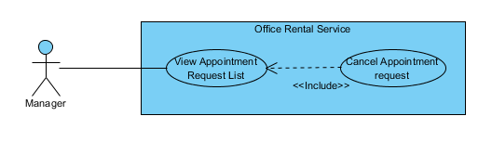

Figure : <Manager> Cancel Appointment request

**Use Case Specification**

|  |  |  |  |
| --- | --- | --- | --- |
| **USE CASE CANCEL APPOINTMENT REQUEST** | | | |
| **Use Case No.** | UC044 | **Use Case Version** | 1.0 |
| **Use Case Name** | Cancel Appointment request | | |
| **Author** | Nguyễn Vũ Hoàng Quốc | | |
| **Date** | 31/05/2015 | **Priority** | Normal |
| **Actor:**   * Manager   **Summary:**   * This use case allows manager cancel appointment request which is not suitable.   **Goal:**   * Cancel appointment request successful * Customer receive SMS with reject message   **Triggers:**   * From the menu bar:   + Select “Lịch hẹn” menu.   + Choose appointment   + Click “Hủy lịch hẹn” button on appointment detail page   **Preconditions:**   * There are request appointment from customer * Requests from customers are valid and send successful * Status of request is ‘Chờ xử lý’ or ‘Chấp nhận’   **Post Conditions:**   * **Success:** Appointment request is cancel successful * **Fail:** Cancel error.   **Main Success Scenario:**   |  |  |  | | --- | --- | --- | | Step | Actor Action | System Response | | 1 | Click “Lịch hẹn” button from menu bar on admin page | * Show all request appointment list   + Khách hàng   + Văn phòng   + Thời gian gặp   + Đề xuất nhân viên   [Exception 1] | | 2 | Choose the appointment in appointment list. | * Show detail of this appointment   + Khách hàng   + Tên văn phòng   + Nhân viên được giao   + Thời gian gặp   + Tình trạng   [Exception 2] | | 3 | Click “Hủy lịch hẹn” button on appointment detail page | * Show popup input comment | | 4 | Input comment and click “Yes” button on warning popup  [Alternative 1] | * Return to appointment list   [Exception 3] |   **Alternative Scenario:**   |  |  |  | | --- | --- | --- | | No | Actor Action | System Response | | 1 | Click “No” button on warning popup | * Close comment popup |   **Exceptions:**   |  |  |  | | --- | --- | --- | | No | Actor Action | System Response | | 1 | Cannot load appointment list from database | Display error message: “Cannot get request appointment list. Please try again” | | 2 | Cannot get detail of chosen appointment from database | Display error message: “Cannot get data this appointment. Please try again” | | 3 | Delete error | Display error message: “Cannot delete this appointment. Please try again” |   **Relationships:** Appointment Request List  **Business Rules:**   * Manager can cancel appointment from customer’s request if there are some error with customer’s error. * When cancel, system will send sms to customer. * Manager only cancel appointment which is have status ‘Chờ xử lý’ or ‘Chấp nhận’ | | | |

Table : <Manager> Cancel Appointment request

##### <Manager> Assign Appointment

**Use Case Diagram**



Figure : <Manager> Assign Appointment

**Use Case Specification**

|  |  |  |  |
| --- | --- | --- | --- |
| **USE CASE ASSIGN APPOINTMENT** | | | |
| **Use Case No.** | UC045 | **Use Case Version** | 1.0 |
| **Use Case Name** | Assign Appointment | | |
| **Author** | Nguyễn Vũ Hoàng Quốc | | |
| **Date** | 31/05/2015 | **Priority** | Normal |
| **Actor:**   * Manager   **Summary:**   * This use case allows manager assign appointment request to staff   **Goal:**   * Assign appointment to staff successful   **Triggers:**   * From the menu bar:   + Select “Lịch hẹn” menu.   + Click “Giao việc”   **Preconditions:**   * There are request appointment from customer * Requests from customers are valid and send successful * Manager checked the appointment is suitable   **Post Conditions:**   * **Success:** Appointment request is assign successful * **Fail:** Assign error.   **Main Success Scenario:**   |  |  |  | | --- | --- | --- | | Step | Actor Action | System Response | | 1 | Click “Lịch hẹn” button from menu bar on admin page | * Schedule staff who suitable * Show all request appointment list   + Khách hàng   + Văn phòng   + Thời gian gặp   + Đề xuất nhân viên   [Exception 1] | | 2 | Click “Giao việc” button on each row of appointment | [Exception 2] |   **Alternative Scenario:**   |  |  |  | | --- | --- | --- | | No | Actor Action | System Response | | 1 | Click “close” button on list staff | * Show appointment detail page |   **Exceptions:**   |  |  |  | | --- | --- | --- | | No | Actor Action | System Response | | 1 | Cannot load appointment list from database | Display error message: “Cannot get request appointment list. Please try again” | | 2 | Cannot get detail of chosen appointment from database | Display error message: “Cannot get data this appointment. Please try again” | | 3 | Assign error | Display error message: “Cannot assign this appointment to staff. Please try again” |   **Relationships:** Appointment Request List  **Business Rules:**   * Manager can assign appointment from customer’s request to staff if the request is suitable. * When assign, system will send email to staff’ and add the request to staff’s task list. | | | |

Table : <Manager> Assign Appointment

##### <Manager> View Contract List

**Use Case Diagram**

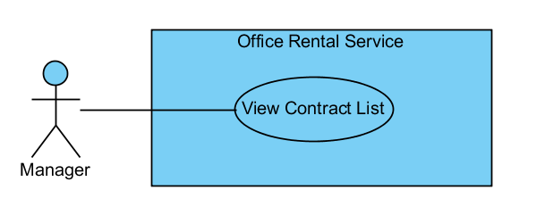

Figure : <Manager> View Contract List

**Use Case Specification**

|  |  |  |  |
| --- | --- | --- | --- |
| **USE CASE VIEW CONTRACT LIST** | | | |
| **Use Case No.** | UC046 | **Use Case Version** | 1.0 |
| **Use Case Name** | View Contract List | | |
| **Author** | Nguyễn Vũ Hoàng Quốc | | |
| **Date** | 31/05/2015 | **Priority** | Normal |
| **Actor:**   * Manager   **Summary:**   * This use case allows manager view contract list   **Goal:**   * Show all contract list   **Triggers:**   * From the menu bar on admin page:   + Click “Lịch hẹn” menu.   **Preconditions:**   * Login as manager role * There is at least one contract create successful   **Post Conditions:**   * **Success:** Show all contracts in database * **Fail:** Cannot get data of the contract in database.   **Main Success Scenario:**   |  |  |  | | --- | --- | --- | | Step | Actor Action | System Response | | 1 | Click “Lịch hẹn” button on menu bar of manager role | * Show all contract in list:   + Khách hàng [text]   + Văn phòng [text]   + Ngày bắt đầu [Date]   + Ngày kết thúc [Date]   + Giá [Number]   + Thời hạn thanh toán [text]   [Exception 1] |   **Alternative Scenario:** N/A  **Exceptions:**   |  |  |  | | --- | --- | --- | | No | Actor Action | System Response | | 1 | Cannot load contract list from database | Display error message: “Cannot get contract list. Please try again” |   **Relationships:** Contract  **Business Rules:**   * Only manager can see all contracts in database | | | |

Table : <Manager> View Contract List

##### <Manager> View Contract Detail

**Use Case Diagram**

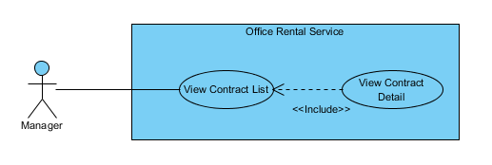

Figure : <Manager> View Contract Detail

**Use Case Specification**

|  |  |  |  |
| --- | --- | --- | --- |
| **USE CASE VIEW CONTRACT DETAIL** | | | |
| **Use Case No.** | UC047 | **Use Case Version** | 1.0 |
| **Use Case Name** | View Contract Detail | | |
| **Author** | Nguyễn Vũ Hoàng Quốc | | |
| **Date** | 31/05/2015 | **Priority** | Normal |
| **Actor:**   * Manager   **Summary:**   * This use case allows manager view contract detail   **Goal:**   * Show contract detail   **Triggers:**   * From the menu bar:   + Select “Lịch hẹn” menu.   + Click button “Thông tin” on each row   **Preconditions:**   * Contract is not out of date   **Post Conditions:**   * **Success:** Show detail of chosen contract * **Fail:** Cannot get data of the contract in database.   **Main Success Scenario:**   |  |  |  | | --- | --- | --- | | Step | Actor Action | System Response | | 1 | Click “Lịch hẹn” button on menu bar of manager role | * Show all contract in list   [Exception 1] | | 2 | Choose contract in contract list and click button “Thông tin” | * Show all detail of the contract includes:   + Khách hàng [text]   + Văn phòng [text]   + Ngày bắt đầu [Date]   + Ngày kết thúc [Date]   + Giá [Number]   + Thời hạn thanh toán [text]   [Exception 2] |   **Alternative Scenario:** N/A  **Exceptions:**   |  |  |  | | --- | --- | --- | | No | Actor Action | System Response | | 1 | Cannot load contract list from database | Display error message: “Cannot get contract list. Please try again” | | 2 | Cannot load data of the chosen contract | Display error message: “Cannot get data of this contract. Please try again” |   **Relationships:** Contract  **Business Rules:**   * Manager can see detail of the contract * The contract is still have time if not system will change status of contract in database and send email to customer | | | |

Table : <Manager> View Contract Detail

##### <Manager> Create Contract

**Use Case Diagram**



Figure : <Manager> Create Contract

**Use Case Specification**

|  |  |  |  |
| --- | --- | --- | --- |
| **USE CASE CREATE CONTRACT** | | | |
| **Use Case No.** | UC049 | **Use Case Version** | 1.0 |
| **Use Case Name** | Create Contract | | |
| **Author** | Nguyễn Vũ Hoàng Quốc | | |
| **Date** | 31/05/2015 | **Priority** | Normal |
| **Actor:**   * Manager   **Summary:**   * This use case allows manager create contract   **Goal:**   * Contract is create and add to database   **Triggers:**   * From the menu bar:   + Click “Lịch hẹn” on menu.   + On “Chấp nhận” tab click “Đến kí/ hủy hợp đồng”   + Click “Tạo hợp đồng” button   + Click “Tạo mới” button after input information   **Preconditions:**   * Appointment has been accepted by customer and status is accepted   **Post Conditions:**   * **Success:** Contract is saved to database * **Fail:** Create fail   **Main Success Scenario:**   |  |  |  | | --- | --- | --- | | Step | Actor Action | System Response | | 1 | Click “Lịch hẹn” on menu | * Show all appointment list   [Exception 1] | | 2 | On “Chấp nhận” tab click “Đến kí/ hủy hợp đồng” | * Show detail of the appointment   + Khách hàng [text]   + Văn phòng [text]   + Nhân viên được giao [text]   + Thời gian gặp [Date]   + Tình trạng [Text] * Group button:   + Tạo hợp đồng   + Hủy lịch hẹn [Alternative 1]   + Quay về [Alternative 2] | | 3 | Click “Tạo hợp đồng” | * Show input field and detail of contract:   + Khách hàng [text]   + Văn phòng [text]   + Ngày bắt đầu [Date]   + Ngày kết thúc [Date]   + Giá [Number]   + Thời hạn thanh toán [text] * Button “Tạo mới” | | 4 | Input information and click “Tạo mới” button | * Validate input data [Exception 2] * Show successful message [Exception 3] |   **Alternative Scenario:**   |  |  |  | | --- | --- | --- | | No | Actor Action | System Response | | 1 | Click “Hủy lịch hẹn” button | * Show popup input comment and return to appointment list page after manager input comment | | 2 | Click “Quay về” button | * Return to appointment list page |     **Exceptions:**   |  |  |  | | --- | --- | --- | | No | Actor Action | System Response | | 1 | Cannot load contract list from database | Display error message: “Cannot get contract list. Please try again” | | 2 | From date > End Date | Display error message: “From date or end date is invalid. Please check again” | | 3 | Cannot save new contract to database |  |   **Relationships:** Contract  **Business Rules:**   * Manager will meet customer after customer decide to rent office * Manager will create contract after the meeting | | | |

Table : <Manager> Create Contract

##### <Manager> Edit Contract

**Use Case Diagram**

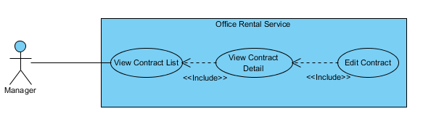

Figure : <Manager> Edit Contract

**Use Case Specification**

|  |  |  |  |
| --- | --- | --- | --- |
| **USE CASE EDIT CONTRACT** | | | |
| **Use Case No.** | UC050 | **Use Case Version** | 1.0 |
| **Use Case Name** | Edit Contract | | |
| **Author** | Nguyễn Vũ Hoàng Quốc | | |
| **Date** | 31/05/2015 | **Priority** | Normal |
| **Actor:**   * Manager   **Summary:**   * This use case allows manager edit contract   **Goal:**   * Contract is edited   **Triggers:**   * Click “Chỉnh sửa” button on contract detail page   **Preconditions:**   * Contract is not out of date   **Post Conditions:**   * **Success:** Edit contract successful * **Fail:** Edit error   **Main Success Scenario:**   |  |  |  | | --- | --- | --- | | Step | Actor Action | System Response | | 1 | Click “thông tin” button on contract list page | * Show all detail of the contract   + Khách hàng [text]   + Văn phòng [text]   + Ngày bắt đầu [Date]   + Ngày kết thúc [Date]   + Giá [Number]   + Thời hạn thanh toán [text]   [Exception 1] | | 2 | Click “Chỉnh sửa” button | * Show field to edit information   + Khách hàng [text]   + Văn phòng [text]   + Ngày bắt đầu [Date]   + Ngày kết thúc [Date]   + Giá [Number]   + Thời hạn thanh toán [text] * Button group:   + Cập nhật   + Hủy [Alternative 1] | | 3 | Edit contract info | * Validate input show error if data invalid   [Exception 2] | | 4 | Click “Cập nhật” button | * Save to database * Return to contract list |   **Alternative Scenario:**   |  |  |  | | --- | --- | --- | | No | Actor Action | System Response | | 1 | Click “Hủy” button | * Return to contract list page |   **Exceptions:**   |  |  |  | | --- | --- | --- | | No | Actor Action | System Response | | 1 | Cannot load contract list from database | Display error message: “Cannot get contract list. Please try again” | | 2 | Cannot load data of the chosen contract | Display error message: “Cannot get data of this contract. Please try again” | | 3 | From date > End Date | Display error message: “From date or end date is invalid. Please check again” |   **Relationships:** Contract  **Business Rules:**   * Manager edit contract when there is error in contract. * Manager only edit contract which is not expired. | | | |

Table : <Manager> Edit Contract

##### <Manager> View Repair Request List

**Use Case Diagram**



Figure : <Manager> View Repair Request List

**Use Case Specification**

|  |  |  |  |
| --- | --- | --- | --- |
| **USE CASE VIEW REPAIR LIST** | | | |
| **Use Case No.** | UC051 | **Use Case Version** | 1.0 |
| **Use Case Name** | View Repair Request List | | |
| **Author** | Nguyễn Vũ Hoàng Quốc | | |
| **Date** | 31/05/2015 | **Priority** | Normal |
| **Actor:**   * Manager   **Summary:**   * This use case allows manager see all repair requests   **Goal:**   * Show suggest staff and suggest time * Show all repair request   **Triggers:**   * From the menu bar on admin page:   + Select “ Sửa chữa ” on the menu.   **Preconditions:**   * At lease exist one repair request in database   **Post Conditions:**   * **Success:** All request repair are shown * **Fail:** Cannot get repair list from database.   **Main Success Scenario:**   |  |  |  | | --- | --- | --- | | Step | Actor Action | System Response | | 1 | Click “Sửa chữa” button on menu bar of manager role | * Show all repair requests list in which includes:   + Tên văn phòng [text]   + Khách hàng [text]   + Ngày tạo yêu cầu [Date]   + Mô tả [text]   + Đề xuất nhân viên [dropdown list]   + Đề xuât thời gian [Date]   [Exception 1]   * Button group   + Giao việc   + Chi tiết |   **Alternative Scenario:** N/A  **Exceptions:**   |  |  |  | | --- | --- | --- | | No | Actor Action | System Response | | 1 | Cannot load repair request list from database | Display error message: “Không lấy được dữ liệu toàn bộ yêu cầu sửa chữa. Xin vui lòng thử lại” |   **Relationships:** Request repair  **Business Rules:**   * Manager can view all request repair for assigning to staff | | | |

Table : <Manager> View Repair Request List

##### <Manager> Assign Repair

**Use Case Diagram**

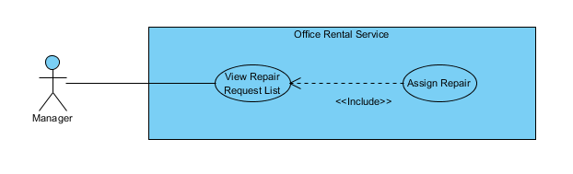

Figure : <Manager> Assign Repair

**Use Case Specification**

|  |  |  |  |
| --- | --- | --- | --- |
| **USE CASE ASSIGN REPAIR** | | | |
| **Use Case No.** | UC052 | **Use Case Version** | 1.0 |
| **Use Case Name** | Assign Repair | | |
| **Author** | Nguyễn Vũ Hoàng Quốc | | |
| **Date** | 31/05/2015 | **Priority** | Normal |
| **Actor:**   * Manager   **Summary:**   * This use case allows manager assign repair to staff   **Goal:**   * Show suggest staff and suggest time * Request is assigned to staff successful   **Triggers:**   * From the menu bar on admin page:   + Select “Sửa chữa ” on the menu.   + Click “Giao việc” button   **Preconditions:**   * At lease exist one repair request in database * At lease exist one staff in database   **Post Conditions:**   * **Success:** Request is assigned to staff successful * **Fail:** Assign failed   **Main Success Scenario:**   |  |  |  | | --- | --- | --- | | Step | Actor Action | System Response | | 1 | Click “Sửa chữa” button on menu bar of manager role | * Show all repair requests list in which includes:   + Tên văn phòng [text]   + Khách hàng [text]   + Ngày tạo yêu cầu [Date]   + Mô tả [text]   + Đề xuất nhân viên [dropdown list]   + Đề xuât thời gian [Date]   [Exception 1]   * Button group   + Giao việc   + Chi tiết | | 2 | Click “Giao việc” button | * Change status of request repair * Change detail of request repair   [Exception 2] |   **Alternative Scenario:** N/A  **Exceptions:**   |  |  |  | | --- | --- | --- | | No | Actor Action | System Response | | 1 | Cannot load repair request list from database | Display error message: “Không lấy được dữ liệu toàn bộ yêu cầu sửa chữa. Xin vui lòng thử lại” | | 2 | Cannot assign to staff | Display error message: “Không giao việc được, xin thử lại” |   **Relationships:** Request repair  **Business Rules:**   * Manager can view staff is suggested for the repair request and can change staff manually | | | |

Table : <Manager> Assign Repair

##### <Manager> Cancel Repair

**Use Case Diagram**

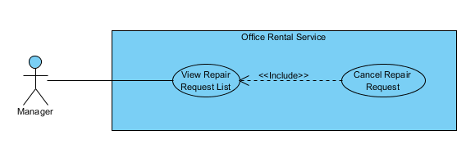

Figure : <Manager> Cancel Repair

**Use Case Specification**

|  |  |  |  |
| --- | --- | --- | --- |
| **USE CASE CANCEL REPAIR** | | | |
| **Use Case No.** | UC053 | **Use Case Version** | 1.0 |
| **Use Case Name** | Cancel Repair | | |
| **Author** | Nguyễn Vũ Hoàng Quốc | | |
| **Date** | 31/05/2015 | **Priority** | Normal |
| **Actor:**   * Manager   **Summary:**   * This use case allows manager cancel repair request   **Goal:**   * The request has been canceled.   **Triggers:**   * From the menu bar on admin page:   + Select “ Sửa chữa ” on the menu.   + Choose one request   + Click “Từ chối sửa chữa” button on repair detail page   **Preconditions:**   * At lease exist one repair request in database * The request status is “Cần giao việc”   **Post Conditions:**   * **Success:** Request is assigned to staff successful * **Fail:** Assign failed   **Main Success Scenario:**   |  |  |  | | --- | --- | --- | | Step | Actor Action | System Response | | 1 | Click “Sửa chữa” button on menu bar of manager role | * Show all repair requests list in which includes:   + Tên văn phòng [text]   + Khách hàng [text]   + Ngày tạo yêu cầu [Date]   + Mô tả [text]   + Đề xuất nhân viên [dropdown list]   + Đề xuât thời gian [Date]   [Exception 1]   * Button group   + Giao việc   + Chi tiết | | 2 | Click “Chi tiết” button | * Show detail of repair request:   + Tên văn phòng [text]   + Khách hàng [text]   + Ngày tạo yêu cầu [Date]   + Mô tả [text]   + Đề xuất nhân viên [dropdown list]   + Đề xuât thời gian [Date] * Button group:   + Giao việc   + Từ chối sửa chữa   + Quay về [Alternative 1] | | 3 | Click “Từ chối sửa chữa” button | * Change status of request repair * Return to request repair list page |   **Alternative Scenario:**   |  |  |  | | --- | --- | --- | | No | Actor Action | System Response | | 1 | Click “Quay về” button | * Return to request repair list page |   **Exceptions:**   |  |  |  | | --- | --- | --- | | No | Actor Action | System Response | | 1 | Cannot load repair request list from database | Display error message: “Không lấy được dữ liệu toàn bộ yêu cầu sửa chữa. Xin vui lòng thử lại” | | 2 | Cannot cancel request | Display error message: “Không hủy yêu cầu được lúc này, xin thử lại” |   **Relationships:** Request repair  **Business Rules:**   * Manager can cancel request repair if the request has invalid info. | | | |

Table : <Manager> Cancel Repair

##### <Manager> View Rental Request List

**Use Case Diagram**

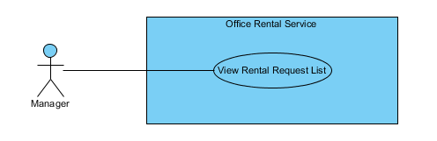

Figure : <Manager> View Rental Request List

**Use Case Specification**

|  |  |  |  |
| --- | --- | --- | --- |
| **USE CASE VIEW RENTAL REQUEST LIST** | | | |
| **Use Case No.** | UC054 | **Use Case Version** | 1.0 |
| **Use Case Name** | View Rental Request List | | |
| **Author** | Nguyễn Vũ Hoàng Quốc | | |
| **Date** | 31/05/2015 | **Priority** | Normal |
| **Actor:**   * Manager   **Summary:**   * This use case allows manager see all rental requests   **Goal:**   * Show suggest staff and suggest time * Show all rental request   **Triggers:**   * From the menu bar on admin page:   + Select “Thuê thiết bị” on the menu.   **Preconditions:**   * At lease exist one rental request in database   **Post Conditions:**   * **Success:** All request rental are shown * **Fail:** Cannot get rental request list from database.   **Main Success Scenario:**   |  |  |  | | --- | --- | --- | | Step | Actor Action | System Response | | 1 | Click “Thuê thiết bị” button on menu of manager role | * Show all rental requests list in which includes:   + Tên văn phòng [text]   + Khách hàng [text]   + Ngày tạo yêu cầu [Date]   + Mô tả [text]   + Đề xuất nhân viên [dropdown list]   + Đề xuât thời gian [Date]   [Exception 1]   * Button group   + Giao việc   + Chi tiết |   **Alternative Scenario:** N/A  **Exceptions:**   |  |  |  | | --- | --- | --- | | No | Actor Action | System Response | | 1 | Cannot load rental request list from database | Display error message: “Không lấy được dữ liệu toàn bộ yêu cầu thuê thiết bị. Xin vui lòng thử lại” |   **Relationships:** Rental, Rental Detail, Rental Item, Rental Status  **Business Rules:**   * Manager can view all request rental for assigning to staff | | | |

Table : <Manager> View Rental Request List

##### <Manager> Assign Rental

**Use Case Diagram**

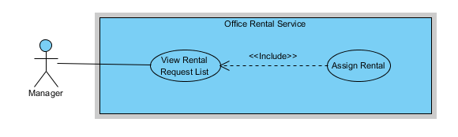

Figure : <Manager> Assign Rental

**Use Case Specification**

|  |  |  |  |
| --- | --- | --- | --- |
| **USE CASE ASSIGN RENTAL** | | | |
| **Use Case No.** | UC055 | **Use Case Version** | 1.0 |
| **Use Case Name** | Assign Rental | | |
| **Author** | Nguyễn Vũ Hoàng Quốc | | |
| **Date** | 31/05/2015 | **Priority** | Normal |
| **Actor:**   * Manager   **Summary:**   * This use case allows manager assign rental request to staff   **Goal:**   * Show suggest staff and suggest time * Request is assigned to staff successful   **Triggers:**   * From the menu bar on admin page:   + Select “Thuê thiết bị ” on the menu.   + Click “Giao việc” button   **Preconditions:**   * At lease exist one rental request in database * At lease exist one staff in database   **Post Conditions:**   * **Success:** Request is assigned to staff successful * **Fail:** Assign failed   **Main Success Scenario:**   |  |  |  | | --- | --- | --- | | Step | Actor Action | System Response | | 1 | Click “Thuê Thiết bị” button on menu bar of manager role | * Show all rental requests list in which includes:   + Tên văn phòng [text]   + Khách hàng [text]   + Ngày tạo yêu cầu [Date]   + Mô tả [text]   + Đề xuất nhân viên [dropdown list]   + Đề xuât thời gian [Date]   [Exception 1]   * Button group   + Giao việc   + Chi tiết | | 2 | Click “Giao việc” button | * Change status of request rental * Change detail of request rental   [Exception 2] |   **Alternative Scenario:** N/A  **Exceptions:**   |  |  |  | | --- | --- | --- | | No | Actor Action | System Response | | 1 | Cannot load repair request list from database | Display error message: “Không lấy được dữ liệu toàn bộ yêu cầu thuê thiết bị. Xin vui lòng thử lại” | | 2 | Cannot assign to staff |  |   **Relationships:** Rental, Rental Detail, Rental Item, Rental Status  **Business Rules:**   * Manager can view staff is suggested for the rental request and assign staff for the rental request | | | |

Table : <Manager> Assign Rental

##### <Manager> Cancel Rental Request

**Use Case Diagram**

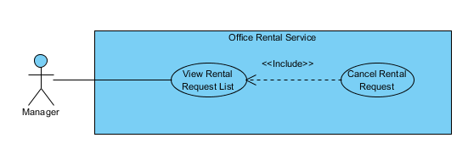

Figure : <Manager> Cancel Rental Request

**Use Case Specification**

|  |  |  |  |
| --- | --- | --- | --- |
| **USE CASE CANCEL RENTAL REQUEST** | | | |
| **Use Case No.** | UC056 | **Use Case Version** | 1.0 |
| **Use Case Name** | Cancel Rental Request | | |
| **Author** | Nguyễn Vũ Hoàng Quốc | | |
| **Date** | 31/05/2015 | **Priority** | Normal |
| **Actor:**   * Manager   **Summary:**   * This use case allows manager cancel rental request   **Goal:**   * The rental request has been canceled.   **Triggers:**   * From the menu bar on admin page:   + Select “Thuê thiết bị” on the menu.   + Choose one request   + Click “Từ chối” button on rental detail page   **Preconditions:**   * At lease exist one rental request in database * The request status is “Cần giao việc”   **Post Conditions:**   * **Success:** Request is assigned to staff successful * **Fail:** Assign failed   **Main Success Scenario:**   |  |  |  | | --- | --- | --- | | Step | Actor Action | System Response | | 1 | Click “Thuê thiết bị” button on menu of manager role | * Show all rental requests list in which includes:   + Tên văn phòng [text]   + Khách hàng [text]   + Ngày tạo yêu cầu [Date]   + Mô tả [text]   + Đề xuất nhân viên [dropdown list]   + Đề xuât thời gian [Date]   [Exception 1]   * Button group   + Giao việc   + Chi tiết | | 2 | Click “Chi tiết” button | * Show detail of rental request:   + Tên văn phòng [text]   + Khách hàng [text]   + Ngày tạo yêu cầu [Date]   + Mô tả [text]   + Đề xuất nhân viên [dropdown list]   + Đề xuât thời gian [Date] * Button group:   + Giao việc   + Từ chối   + Quay về [Alternative 1] | | 3 | Click “Từ chối” button | * Change status of rental repair * Return to rental repair list page |   **Alternative Scenario:**   |  |  |  | | --- | --- | --- | | No | Actor Action | System Response | | 1 | Click “Quay về” button | * Return to rental request list page |   **Exceptions:**   |  |  |  | | --- | --- | --- | | No | Actor Action | System Response | | 1 | Cannot load repair request list from database | Display error message: “Không lấy được dữ liệu toàn bộ yêu cầu thuê thiết bị. Xin vui lòng thử lại” | | 2 | Cannot cancel request |  |   **Relationships:** Rental, Rental Detail, Rental Item, Rental Status  **Business Rules:**   * Manager can cancel rental request if that request has invalid info. | | | |

Table : <Manager> Cancel Rental Request

##### <Manager> View amenity list

**Use Case Diagram**

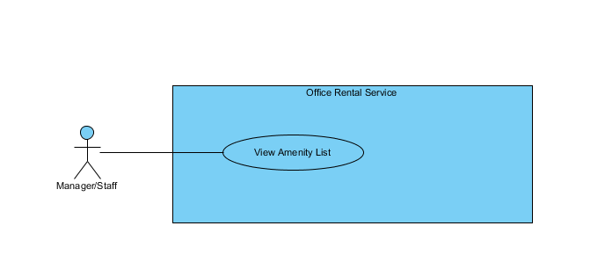

Figure : <Manager> View amenity list

**Use Case Specification**

|  |  |  |  |  |
| --- | --- | --- | --- | --- |
| **USE CASE – VIEW AMENITY LIST** | | | | |
| **Use-case No.** | UC057 | **Use-case Version** | | 2.0 |
| **Use-case Name** | View Amenity List | | | |
| **Author** | Trần Lê Tuấn | | | |
| **Date** | 25/05/2015 | **Priority** | Normal | |
| **Actor:**   * Manager   **Summary:**   * This use case allows user to view amenity list.   **Goal:**   * User can view amenity list successful.   **Triggers:**   * Click “Quản lí tiện nghi” in menu.   **Preconditions:**   * User must login in system.   **Post Conditions:**   * **Success**: Amenity list has been viewed successfully. * **Fail:** Cannot view amenity list.   **Main Success Scenario:**   |  |  |  | | --- | --- | --- | | Step | Actor Action | System Response | | 1 | Click “Quản lý tiện nghi” on menu. | Show page detail  Display details includes:   * Tên tiện nghi: Label * Mô tả: Label * Trọng số: Label * Độ ưu tiên: Label   “Cập nhật” : button  [Exception 1] |   **Alternative Scenario: N/A**  **Exceptions:**   |  |  |  | | --- | --- | --- | | No. | Actor Action | System Response | | 1 | Cannot send request due to database connection | Show error message: “Không thể gửi yêu cầu, vui lòng thử lại sau.” |   **Relationships:** Amenity AmenityGroup  **Business Rules:** | | | | |

Table : <Manager>View amenity list

##### <Manager> Create amenity

**Use Case Diagram**

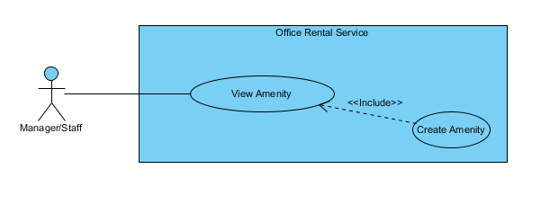

Figure : <Manager> Create amenity

**Use Case Specification**

|  |  |  |  |  |
| --- | --- | --- | --- | --- |
| **USE CASE – CREATE AMENITY** | | | | |
| **Use-case No.** | UC058 | **Use-case Version** | | 2.0 |
| **Use-case Name** | Create Amenity | | | |
| **Author** | Trần Lê Tuấn | | | |
| **Date** | 25/05/2015 | **Priority** | Normal | |
| **Actor:**   * Manager, Staff   **Summary:**   * This use case allows user to create amenity.   **Goal:**   * User can create amenity successful.   **Triggers:**   * Click “Quản lý tiện nghi” in menu. * Click “Thêm mới tiện nghi” in menu. * Fill amenity information. * Click “Tạo mới” button.   **Preconditions:**   * User must login in system.   **Post Conditions:**   * **Success**: Amenity has been created successfully. * **Fail:** Cannot create new amenity.   **Main Success Scenario:**   |  |  |  | | --- | --- | --- | | Step | Actor Action | System Response | | 1 | Click “Quản lý tiện nghi” on menu. | Show page detail  Display details includes:   * Thêm mới tiện nghi: Link * Tên tiện nghi: Label * Mô tả: Label * Trọng số: Label * Độ ưu tiên: Label   “Cập nhật” : button | | 2 | Click “Thêm mới tiện nghi” on menu. | Show page detail  Display details includes:   * Tên tiện nghi: Textbox * Mô tả: Textbox * Trọng số: Textbox * Độ ưu tiên: Textbox * Nhóm thiết bị: Dropdown List   “Huỷ” : button  “Tạo mới” : button | | 3 | Click “Tạo mới” button on screen.  [Alternative 1] | Show successful message “Thêm thiết bị thành công.” on screen.  [Exception 1] |   **Alternative Scenario:**   |  |  |  | | --- | --- | --- | | No. | Actor Action | System Response | | 1 | Click “Huỷ” button. | Close page and go to management page. |   **Exceptions:**   |  |  |  | | --- | --- | --- | | No. | Actor Action | System Response | | 1 | Cannot send request due to database connection | Show error message: “Không thể gửi yêu cầu, vui lòng thử lại sau.” |   **Relationships:** Amenity AmenityGroup  **Business Rules:** | | | | |

Table : <Manager> Create amenity

##### <Manager> View amenity detail

**Use Case Diagram**

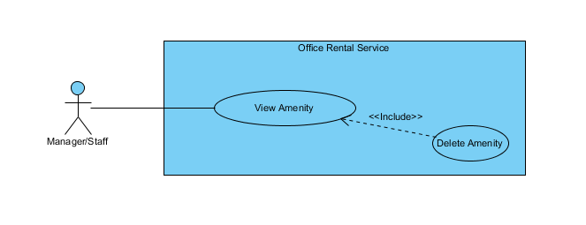

Figure : <Manager> View amenity detail

**Use Case Specification**

|  |  |  |  |  |
| --- | --- | --- | --- | --- |
| **USE CASE – DELETE AMENITY** | | | | |
| **Use-case No.** | UC059 | **Use-case Version** | | 2.0 |
| **Use-case Name** | Delete Amenity | | | |
| **Author** | Trần Lê Tuấn | | | |
| **Date** | 25/05/2015 | **Priority** | Normal | |
| **Actor:**   * Manager, Staff   **Summary:**   * This use case allows user to delete amenity.   **Goal:**   * User can delete amenity successful.   **Triggers:**   * Click “Quản lý tiện nghi” in menu. * Click “Xoá” button.   **Preconditions:**   * User must login in system.   **Post Conditions:**   * **Success**: Amenity has been created successfully. * **Fail:** Cannot create new amenity.   **Main Success Scenario:**   |  |  |  | | --- | --- | --- | | Step | Actor Action | System Response | | 1 | Click “Quản lý tiện nghi” on menu. | Show page detail  Display details includes:   * Thêm mới tiện nghi: Link * Tên tiện nghi: Label * Mô tả: Label * Trọng số: Label * Độ ưu tiên: Label   “Xoá” : button  “Cập nhật” : button | | 2 | Click “Xoá” button on screen. | Show successful message “Xoá thiết bị thành công.” on screen.  [Exception 1] |   **Alternative Scenario: N/A**  **Exceptions:**   |  |  |  | | --- | --- | --- | | No. | Actor Action | System Response | | 1 | Cannot send request due to database connection | Show error message: “Không thể gửi yêu cầu, vui lòng thử lại sau.” |   **Relationships:** Amenity AmenityGroup  **Business Rules:** | | | | |

Table : <Manager> View amenity detail

##### <Manager> Edit amenity

**Use Case Diagram**

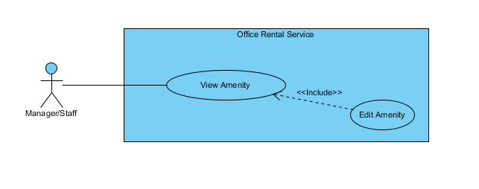

Figure : <Manager> Edit amenity

**Use Case Specification**

|  |  |  |  |  |
| --- | --- | --- | --- | --- |
| **USE CASE – EDIT AMENITY** | | | | |
| **Use-case No.** | UC060 | **Use-case Version** | | 2.0 |
| **Use-case Name** | Edit Amenity | | | |
| **Author** | Trần Lê Tuấn | | | |
| **Date** | 25/05/2015 | **Priority** | Normal | |
| **Actor:**   * Manager, Staff   **Summary:**   * This use case allows user to edit amenity.   **Goal:**   * User can edit amenity successful.   **Triggers:**   * Click “Quản lý tiện nghi” in menu. * Click “Cập nhật” in menu. * Fill amenity group information. * Click “Cập nhật” button.   **Preconditions:**   * User must login in system.   **Post Conditions:**   * **Success**: Amenity has been created successfully. * **Fail:** Cannot create new amenity.   **Main Success Scenario:**   |  |  |  | | --- | --- | --- | | Step | Actor Action | System Response | | 1 | Click “Quản lý tiện nghi” on menu. | Show page detail  Display details includes:   * Thêm mới tiện nghi: Link * Tên tiện nghi: Label * Mô tả: Label * Trọng số: Label * Độ ưu tiên: Label   “Cập nhật” : button | | 2 | Click “Thêm mới tiện nghi” on menu. | Show page request detail  Display request details includes:   * Tên tiện nghi: Label * Mô tả: Textbox * Trọng số: Textbox * Độ ưu tiên: Textbox   “Huỷ” : button  “Cập nhật” : button | | 3 | Click “Cập nhật” button on screen.  [Alternative 1] | Show successful message “Cập nhật thiết bị thành công.” on screen.  [Exception 1] |   **Alternative Scenario:**   |  |  |  | | --- | --- | --- | | No. | Actor Action | System Response | | 1 | Click “Huỷ” button. | Close page and go to management page. |   **Exceptions:**   |  |  |  | | --- | --- | --- | | No. | Actor Action | System Response | | 1 | Cannot send request due to database connection | Show error message: “Không thể gửi yêu cầu, vui lòng thử lại sau.” |   **Relationships:** Amenity AmenityGroup  **Business Rules:** | | | | |

Table : <Manager> Edit amenity

##### <Manager> View amenity group list

**Use Case Diagram**

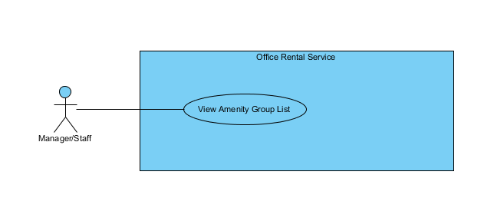

Figure : <Manager> View amenity group list

**Use Case Specification**

|  |  |  |  |  |
| --- | --- | --- | --- | --- |
| **USE CASE – VIEW AMENITY GROUP LIST** | | | | |
| **Use-case No.** | UC061 | **Use-case Version** | | 2.0 |
| **Use-case Name** | View Amenity Group List | | | |
| **Author** | Trần Lê Tuấn | | | |
| **Date** | 25/05/2015 | **Priority** | Normal | |
| **Actor:**   * Manager, Staff   **Summary:**   * This use case allows user to view amenity group list.   **Goal:**   * User can view amenity group list successful.   **Triggers:**   * Click “Quản lý nhóm tiện nghi” in menu.   **Preconditions:**   * User must login in system.   **Post Conditions:**   * **Success**: Amenity list has been viewed successfully. * **Fail:** Cannot view amenity list.   **Main Success Scenario:**   |  |  |  | | --- | --- | --- | | Step | Actor Action | System Response | | 1 | Click “Quản lý nhóm tiện nghi” on menu. | Show page detail  Display details includes:   * Tên nhóm: Label * Mô tả: Label   “Xoá” : button  “Cập nhật” : button  [Exception 1] | |  |  |  |   **Alternative Scenario:**   |  |  |  | | --- | --- | --- | | No. | Actor Action | System Response | |  |  |  |   **Exceptions:**   |  |  |  | | --- | --- | --- | | No. | Actor Action | System Response | | 1 | Cannot send request due to database connection | Show error message: “Không thể gửi yêu cầu, vui lòng thử lại sau.” |   **Relationships:** Amenity AmenityGroup  **Business Rules:** | | | | |

Table : <Manager> View amenity group list

##### <Manager> Create amenity group

**Use Case Diagram**

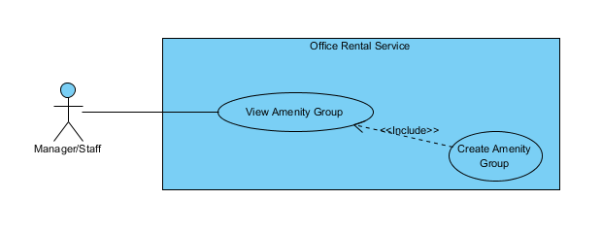

Figure : <Manager> Create amenity group

**Use Case Specification**

|  |  |  |  |  |
| --- | --- | --- | --- | --- |
| **USE CASE – CREATE AMENITY GROUP** | | | | |
| **Use-case No.** | UC062 | **Use-case Version** | | 2.0 |
| **Use-case Name** | Create Amenity Group | | | |
| **Author** | Trần Lê Tuấn | | | |
| **Date** | 25/05/2015 | **Priority** | Normal | |
| **Actor:**   * Manager, Staff   **Summary:**   * This use case allows user to create amenity group.   **Goal:**   * User can create amenity group successful.   **Triggers:**   * Click “Quản lý nhóm tiện nghi” in menu. * Click “Thêm mới nhóm tiện nghi” in menu. * Fill amenity group information. * Click “Tạo mới” button.   **Preconditions:**   * User must login in system.   **Post Conditions:**   * **Success**: Amenity has been created successfully. * **Fail:** Cannot create new amenity.   **Main Success Scenario:**   |  |  |  | | --- | --- | --- | | Step | Actor Action | System Response | | 1 | Click “Quản lý nhóm tiện nghi” on menu. |  | | 2 | Click “Thêm mới tiện nghi” on menu. | Show page detail  Display details includes:   * Tên tiện nghi: Textbox * Mô tả: Textbox   “Huỷ” : button  “Tạo mới” : button | | 3 | Click “Tạo mới” button on screen.  [Alternative 1] | Show successful message “Thêm nhóm thiết bị thành công.” on screen.  [Exception 1] |   **Alternative Scenario:**   |  |  |  | | --- | --- | --- | | No. | Actor Action | System Response | | 1 | Click “Huỷ” button. | Close page and go to management page. |   **Exceptions:**   |  |  |  | | --- | --- | --- | | No. | Actor Action | System Response | | 1 | Cannot send request due to database connection | Show error message: “Không thể gửi yêu cầu, vui lòng thử lại sau.” |   **Relationships:** Amenity AmenityGroup  **Business Rules:** | | | | |

Table : <Manager> Create amenity group

##### <Manager> Edit amenity group

**Use Case Diagram**

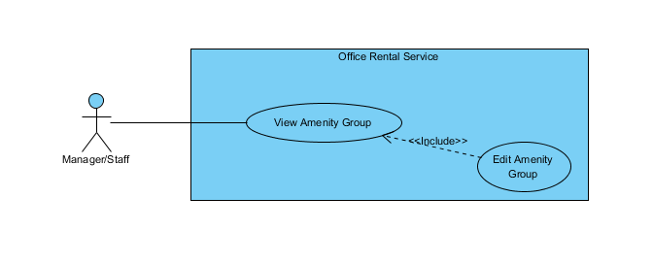

Figure : <Manager> Edit amenity group

**Use Case Specification**

|  |  |  |  |  |
| --- | --- | --- | --- | --- |
| **USE CASE – EDIT AMENITY GROUP** | | | | |
| **Use-case No.** | UC063 | **Use-case Version** | | 2.0 |
| **Use-case Name** | Edit Amenity Group | | | |
| **Author** | Trần Lê Tuấn | | | |
| **Date** | 25/05/2015 | **Priority** | Normal | |
| **Actor:**   * Manager, Staff   **Summary:**   * This use case allows user to create amenity group.   **Goal:**   * User can create amenity group successful.   **Triggers:**   * Click “Quản lý nhóm tiện nghi” in menu. * Click “Cập nhật” in menu. * Fill amenity group information. * Click “Cập nhật” button.   **Preconditions:**   * User must login in system.   **Post Conditions:**   * **Success**: Amenity has been created successfully. * **Fail:** Cannot create new amenity.   **Main Success Scenario:**   |  |  |  | | --- | --- | --- | | Step | Actor Action | System Response | | 1 | Click “Quản lý nhóm tiện nghi” on menu. | Show page detail  Display details includes:   * Thêm mới nhóm tiện nghi: Link * Tên nhóm: Label * Mô tả: Label   “Xoá” : button  “Cập nhật” : button  [Exception 1] | | 2 | Click “Cập nhật” on menu. | Show page request detail  Display request details includes:   * Tên tiện nghi: Label * Mô tả: Textbox   “Huỷ” : button  “Cập nhật” : button | | 3 | Click “Cập nhật” button on screen.  [Alternative 1] | Show successful message “Cập nhật nhóm thiết bị thành công.” on screen.  [Exception 1] |   **Alternative Scenario:**   |  |  |  | | --- | --- | --- | | No. | Actor Action | System Response | | 1 | Click “Huỷ” button. | Close page and go to management page. |   **Exceptions:**   |  |  |  | | --- | --- | --- | | No. | Actor Action | System Response | | 1 | Cannot send request due to database connection | Show error message: “Không thể gửi yêu cầu, vui lòng thử lại sau.” |   **Relationships:** Amenity AmenityGroup  **Business Rules:** | | | | |

Table : <Manager> Edit amenity group

##### <Manager> View Customer Info

**Use Case Diagram**

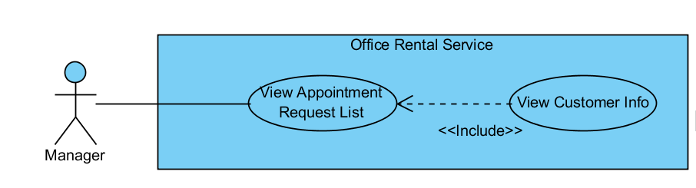

Figure : <Manager> View Customer Info

**Use Case Specification**

|  |  |  |  |
| --- | --- | --- | --- |
| **USE CASE VIEW CUSTOMER INFO** | | | |
| **Use Case No.** | UC064 | **Use Case Version** | 1.0 |
| **Use Case Name** | View Customer Info | | |
| **Author** | Nguyễn Vũ Hoàng Quốc | | |
| **Date** | 31/05/2015 | **Priority** | Normal |
| **Actor:**   * Manager   **Summary:**   * This use case allows manager view customer info from appointment list   **Goal:**   * View customer profile   **Triggers:**   * From the menu bar:   + Select “Appointment” menu.   + Choose appointment   + Click to customer’s name in appointment detail page   **Preconditions:**   * There are request appointment from customer * Requests from customers are valid and send successful   **Post Conditions:**   * **Success:** Show customer profile * **Fail:** Cannot get data of the customer in database.   **Main Success Scenario:**   |  |  |  | | --- | --- | --- | | Step | Actor Action | System Response | | 1 | Click “Appointment” button on menu bar of manager role | * Show all request appointment list   [Exception 1] | | 2 | Choose the appointment in appointment list. | * Show detail of this appointment   [Exception 2] | | 3 | Click to name of customer in appointment detail page | * Show customer profile includes:   + Username   + Email   + Phone   + Address   [Exception 3] |   **Alternative Scenario:** N/A  **Exceptions:**   |  |  |  | | --- | --- | --- | | No | Actor Action | System Response | | 1 | Cannot load appointment list from database | Display error message: “Cannot get request appointment list. Please try again” | | 2 | Cannot get detail of chosen appointment from database | Display error message: “Cannot get data this appointment. Please try again” | | 3 | Cannot get detail of chosen customer from database | Display error message: “Cannot get data this customer. Please try again” |   **Relationships:** Appointment Request List  **Business Rules:**   * Manager can find customer profile base on appointment request list | | | |

Table : <Manager> View Customer Info

##### <Manager> View Calendar

**Use Case Diagram**

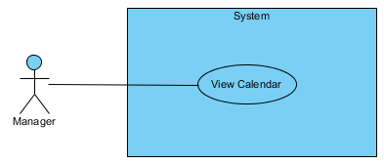

Figure : <Manager> View Calendar

**Use Case Specification**

|  |  |  |  |
| --- | --- | --- | --- |
| **USE CASE VIEW CALENDAR** | | | |
| **Use Case No.** | UC065 | **Use Case Version** | 1.0 |
| **Use Case Name** | View Calendar | | |
| **Author** | Lê Xuân Tiến | | |
| **Date** | 31/05/2015 | **Priority** | Normal |
| **Actor:**   * Manager   **Summary:**   * This use case allows manager to overview of staff’s job by calendar view   **Goal:**   * View the calendar with job overview   **Triggers:**   * From the menu bar:   + Select “Calendar” menu.   **Preconditions:**   * There are available appointments, rentals or repairs that has been assigned to staff   **Post Conditions:**   * **Success:** Show calendar with job information by date * **Fail:** Show error.   **Main Success Scenario:**   |  |  |  | | --- | --- | --- | | Step | Actor Action | System Response | | 1 | Click “Calendar” button on menu bar of manager role | * Show the calendar with following fields   + Legends: color and username of staff   + Calendar view with staff’s job. Each job display by date in calendar as a frame which has the color of staff, the name of job and the time of job.   + The calendar can be transfer between months   [Exception 1] | | 2 | Click an job | * Show the job detail |   **Alternative Scenario:**  **N/A**  **Exceptions:**   |  |  |  | | --- | --- | --- | | No | Actor Action | System Response | | 1 | Cannot load job list from database | Display error message: “Không tải được lịch lúc này. Xin thử lại” |   **Relationships:** Appointment detail, Repair detail, Rental detail  **Business Rules:**   * Manager can change the job’s assigner and date base on the overview which show on calendar page | | | |

Table : <Manager> View Calendar

##### <Manager> View Income Stastisic

**Use Case Diagram**



Figure : <Manager> View Calendar

**Use Case Specification**

|  |  |  |  |
| --- | --- | --- | --- |
| **USE CASE VIEW INCOME STATISTIC** | | | |
| **Use Case No.** | UC066 | **Use Case Version** | 1.0 |
| **Use Case Name** | View Income statistic | | |
| **Author** | Lê Xuân Tiến | | |
| **Date** | 31/05/2015 | **Priority** | Normal |
| **Actor:**   * Manager   **Summary:**   * This use case allows manager to overview of income statistic of the company   **Goal:**   * View statistic of income   **Triggers:**   * From the menu bar:   + Select “Thống kê” then “Thống kê doanh thu” menu.   **Preconditions:**   * There are available office and contract on the system   **Post Conditions:**   * **Success:** Show income statistic of system * **Fail:** Show error.   **Main Success Scenario:**   |  |  |  | | --- | --- | --- | | Step | Actor Action | System Response | | 1 | Click “Thống kê doanh thu” button on menu bar of manager role | * Show the statistic with the filter information:   + Năm: drop down, the year for statistic   + Quận: drop down, the district for statistic. The default is “Tất cả”   + Lọc: Button | | 2 | Choose year and district, click “Lọc” | * Show the column chart with information   + Tilte: “Thống kê doanh thu theo tháng (Ước tính)”   + x-axis: month in year   + y-axis: total income   + Column value: total income in month   [Exception 1] |   **Alternative Scenario:** **N/A**  **Exceptions:**   |  |  |  | | --- | --- | --- | | No | Actor Action | System Response | | 1 | Cannot load contract information from database | Display error message: “Không tải được thống kê lúc này. Xin thử lại” |   **Relationships:** N/A  **Business Rules:**   * The income statistic is calculated by contract and rental information. The contract for calculation is the contract has the begin date before selected month, and end date after current month, include total of:   + If the office in contract is income percent type, the income will include 5% of contract value of current month.   + If the office is not income percent, the income will include the different between contract value and office base price value of current month.   + Plus the 5% value of rental price of the rental of contract | | | |

Table : <Manager> View Income statistic

##### <Manager> View Staff Stastisic

**Use Case Diagram**



Figure : <Manager> View Staff Stastisic

**Use Case Specification**

|  |  |  |  |
| --- | --- | --- | --- |
| **USE CASE VIEW STAFF STASTISIC** | | | |
| **Use Case No.** | UC044 | **Use Case Version** | 1.0 |
| **Use Case Name** | View Staff Stastisic | | |
| **Author** | Lê Xuân Tiến | | |
| **Date** | 31/05/2015 | **Priority** | Normal |
| **Actor:**   * Manager   **Summary:**   * This use case allows manager to overview of income statistic of the company   **Goal:**   * View statistic of staff’s job   **Triggers:**   * From the menu bar:   + Select “Thống kê” then “Thống kê việc nhân viên” menu.   **Preconditions:**   * There are available job for staff   **Post Conditions:**   * **Success:** Show staff statistic of system * **Fail:** Show error.   **Main Success Scenario:**   |  |  |  | | --- | --- | --- | | Step | Actor Action | System Response | | 1 | Click “Thống kê việc nhân viên” button on menu bar of manager role | * Show the statistic with the filter information:   + Từ ngày: date input. Start date of statistic   + Đến ngày: date input, end date ò statistic   + Lọc: Button | | 2 | Choose year and district, click “Lọc” | * Show the line chart, each line is the information of 1 staff with information   + Tilte: “Thống kê việc của nhân viên”   + x-axis: week in selected range   + y-axis: total job   + Line value: total job in week of the staff   [Exception 1] |   **Alternative Scenario:**  **N/A**  **Exceptions:**   |  |  |  | | --- | --- | --- | | No | Actor Action | System Response | | 1 | Cannot load job information from database | Display error message: “Không tải được thống kê lúc này. Xin thử lại” |   **Relationships:** N/A  **Business Rules:**   * The job include appointment, repair and rental * The staff job statistic is calculated by total of job in week of the staff. The calculated job is in the state: done, cancel. * The on going job is not calculate (in state assigned, waiting confirm) | | | |

Table : <Manager> View Staff statistic

#### <Staff> Mobile Overview Use Case

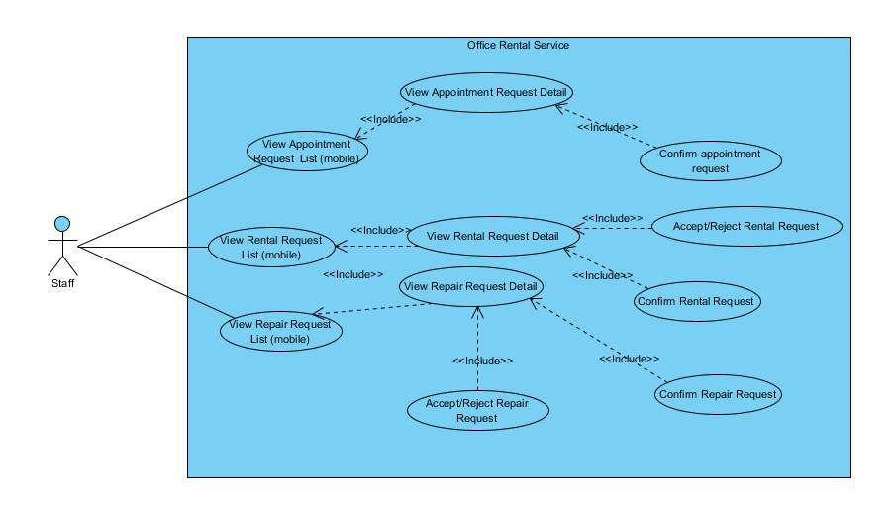

Figure : <System> Overview Use Case

##### < Staff > View appointment request list (mobile)

**Use case diagram**

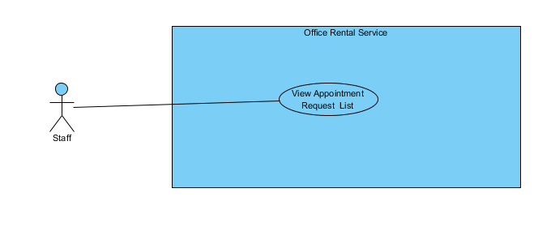

**Figure 84: <Staff > View appointment request list**

**Use Case Specification**

|  |  |  |  |  |
| --- | --- | --- | --- | --- |
| **USE CASE – VIEW APPOINTMENT REQUEST LIST (mobile)** | | | | |
| **Use-case No.** | UC067 | **Use-case Version** | | 2.0 |
| **Use-case Name** | View Appointment Request List | | | |
| **Author** | Trần Lê Tuấn | | | |
| **Date** | 25/05/2015 | **Priority** | Normal | |
| **Actor:**   * Staff   **Summary:**   * This use case allows staff to view appointment request list.   **Goal:**   * Staff can view appointment request list successful.   **Triggers:**   * In home page, staff clicks “Danh sách lịch hẹn” on menu.   **Preconditions:**   * User must login in system.   **Post Conditions:**   * **Success**: view appointment request list successfully. * **Fail:** Cannot view appointment request list   **Main Success Scenario:**   |  |  |  | | --- | --- | --- | | Step | Actor Action | System Response | | 1 | Click “Danh sách lịch hẹn” on menu. | Show page appointment list management  Display list details includes:   * Address of office: label * Name of customer: Label * Create time: Label   [Exception 1] |   **Alternative Scenario: N/A**  **Exceptions:**   |  |  |  | | --- | --- | --- | | No. | Actor Action | System Response | | 1 | Cannot send request due to database connection | Show error message: “Không thể gửi yêu cầu, vui lòng thử lại sau.” |   **Relationships:** Appointment  **Business Rules:**   * Appointment information must exist in database system. * Staff cannot view appointment request of other staff. | | | | |

Table : <Staff> View appointment request list

##### < Staff > View repair request list (mobile)

**Use case diagram**

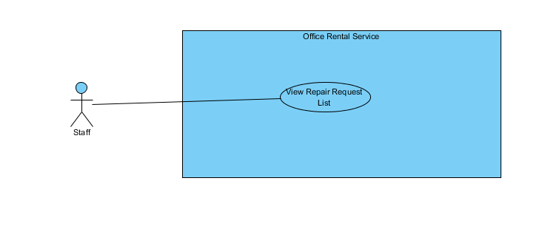

**Figure 85: <Staff > View repair request list**

**Use Case Specification**

|  |  |  |  |  |
| --- | --- | --- | --- | --- |
| **USE CASE – VIEW REPAIR REQUEST LIST (mobile)** | | | | |
| **Use-case No.** | UC068 | **Use-case Version** | | 2.0 |
| **Use-case Name** | View Repair Request List | | | |
| **Author** | Trần Lê Tuấn | | | |
| **Date** | 25/05/2015 | **Priority** | Normal | |
| **Actor:**   * Staff   **Summary:**   * This use case allows staff to view repair request list.   **Goal:**   * Staff can view repair request list successful.   **Triggers:**   * In home page, staff clicks “Danh sách sửa chữa” on menu.   **Preconditions:**   * User must login in system.   **Post Conditions:**   * **Success**: view repair request list successfully. * **Fail:** Cannot view repair request list   **Main Success Scenario:**   |  |  |  | | --- | --- | --- | | Step | Actor Action | System Response | | 1 | Click “Danh sách sửa chữa” on menu. | Show page appointment list management  Display list details includes:   * Address of office: label * Name of customer: Label * Create time: Label   [Exception 1] |   **Alternative Scenario: N/A**  **Exceptions:**   |  |  |  | | --- | --- | --- | | No. | Actor Action | System Response | | 1 | Cannot send request due to database connection | Show error message: “Không thể gửi yêu cầu, vui lòng thử lại sau.” |   **Relationships:** Repair  **Business Rules:**   * Repair request information must exist in database system. * Staff cannot view repair request of other staff. | | | | |

Table : <Staff> View repair request list

##### < Staff > View rental request list (mobile)

**Use case diagram**

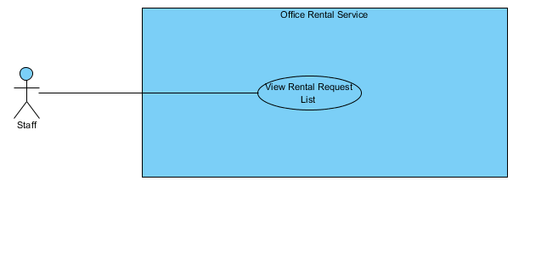

**Figure 86: <Staff > View rental request list**

**Use Case Specification**

|  |  |  |  |  |
| --- | --- | --- | --- | --- |
| **USE CASE – VIEW RENTAL REQUEST LIST (mobile)** | | | | |
| **Use-case No.** | UC069 | **Use-case Version** | | 2.0 |
| **Use-case Name** | View Rental Request List | | | |
| **Author** | Trần Lê Tuấn | | | |
| **Date** | 25/05/2015 | **Priority** | Normal | |
| **Actor:**   * Staff   **Summary:**   * This use case allows staff to view rental request list.   **Goal:**   * Staff can view rental request list successful.   **Triggers:**   * In home page, staff clicks “Danh sách thuê thiết bị” on menu.   **Preconditions:**   * User must login in system.   **Post Conditions:**   * **Success**: view rental request list successfully. * **Fail:** Cannot view rental request list   **Main Success Scenario:**   |  |  |  | | --- | --- | --- | | Step | Actor Action | System Response | | 1 | Click “Danh sách thuê thiết bị” on menu. | Show page appointment list management  Display list details includes:   * Address of office: label * Name of customer: Label * Create time: Label   [Exception 1] |   **Alternative Scenario: N/A**  **Exceptions:**   |  |  |  | | --- | --- | --- | | No. | Actor Action | System Response | | 1 | Cannot send request due to database connection | Show error message: “Không thể gửi yêu cầu, vui lòng thử lại sau.” |   **Relationships:** Rental  **Business Rules:**   * Rental request information must exist in database system. * Staff cannot view rental request of other staff. | | | | |

Table : <Staff> View rental request list

##### < Staff > View appointment request detail (mobile)

**Use case diagram**

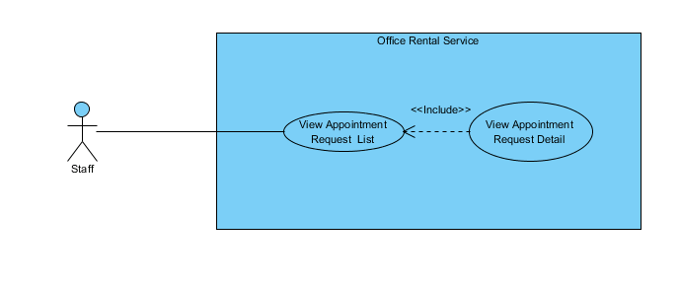

**Figure 87: <Staff > View appointment request detail**

**Use Case Specification**

|  |  |  |  |  |
| --- | --- | --- | --- | --- |
| **USE CASE – VIEW APPOINTMENT REQUEST DETAIL (mobile)** | | | | |
| **Use-case No.** | UC070 | **Use-case Version** | | 2.0 |
| **Use-case Name** | View Appointment Request Detail | | | |
| **Author** | Trần Lê Tuấn | | | |
| **Date** | 25/05/2015 | **Priority** | Normal | |
| **Actor:**   * Staff   **Summary:**   * This use case allows staff to view appointment request detail.   **Goal:**   * Staff can view view appointment request detail successful.   **Triggers:**   * In home page, staff clicks “Danh sách sửa chữa” on menu. * Click on a tab of appointment request.   **Preconditions:**   * User must login in system.   **Post Conditions:**   * **Success**: view appointment request detail successfully. * **Fail:** Cannot view appointment request detail.   **Main Success Scenario:**   |  |  |  | | --- | --- | --- | | Step | Actor Action | System Response | | 1 | Click “Danh sách lịch hẹn” on menu. | Show page appointment list management  Display list details includes:   * Address of office: Label * Name of customer: Label * Create time: Label   [Exception 1] | | 2 | Click on a tab of appointment request. | Show page appointment detail.  Display list details includes:   * Tên văn phòng: Label * Địa chỉ: Label * Mở ứng dụng bản đồ: Link * Khách hàng: Label * Thời gian: Label * Trạng thái: Label   “Khách hàng muốn kí hợp đồng”: Button  “Khách hàng không muốn kí hợp đồng” Button |   **Alternative Scenario: N/A**  **Exceptions:**   |  |  |  | | --- | --- | --- | | No. | Actor Action | System Response | | 1 | Cannot send request due to database connection | Show error message: “Không thể gửi yêu cầu, vui lòng thử lại sau.” |   **Relationships:** Appointment  **Business Rules:**   * Appointment request information must exist in database system. * Staff cannot view appointment request of other staff. * Office must be in avaiable status. | | | | |

Table : <Staff> View appointment request detail

##### < Staff > View repair request detail (mobile)

**Use case diagram**

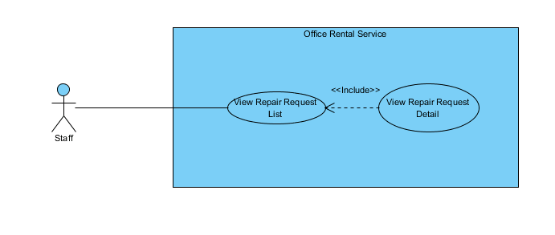

**Figure 88: <Staff > View repair request detail**

**Use Case Specification**

|  |  |  |  |  |
| --- | --- | --- | --- | --- |
| **USE CASE – VIEW REPAIR REQUEST DETAIL (mobile)** | | | | |
| **Use-case No.** | UC071 | **Use-case Version** | | 2.0 |
| **Use-case Name** | View Repair Request Detail | | | |
| **Author** | Trần Lê Tuấn | | | |
| **Date** | 25/05/2015 | **Priority** | Normal | |
| **Actor:**   * Staff   **Summary:**   * This use case allows staff to view repair request detail.   **Goal:**   * Staff can view view repair request detail successful.   **Triggers:**   * In home page, staff clicks “Danh sách sửa chữa” on menu. * Click on a tab of repair request.   **Preconditions:**   * User must login in system.   **Post Conditions:**   * **Success**: view repair request detail successfully. * **Fail:** Cannot view repair request detail.   **Main Success Scenario:**   |  |  |  | | --- | --- | --- | | Step | Actor Action | System Response | | 1 | Click “Danh sách sửa chữa” on menu. | Show page repair list management  Display list details includes:   * Address of office: Label * Name of customer: Label * Create time: Label   [Exception 1] | | 2 | Click on a tab of repair request. | Show page repair detail.  Display list details includes:   * Tên văn phòng: Label * Địa chỉ: Label * Mở ứng dụng bản đồ: Link * Khách hàng: Label * Chi tiết sửa chữa: Label * Thời gian: Label * Danh sách sửa chữa: Label * Trạng thái: Label   “Đồng ý sửa”: Button  “Không đồng ý sửa” Button  [Exception 1] |   **Alternative Scenario: N/A**  **Exceptions:**   |  |  |  | | --- | --- | --- | | No. | Actor Action | System Response | | 1 | Cannot send request due to database connection | Show error message: “Không thể gửi yêu cầu, vui lòng thử lại sau.” |   **Relationships:** Appointment  **Business Rules:**   * Repair request information must exist in database system. * Staff cannot view repair request of other staff. | | | | |

Table : <Staff> View repair request detail

##### < Staff > View rental request detail (mobile)

**Use case diagram**

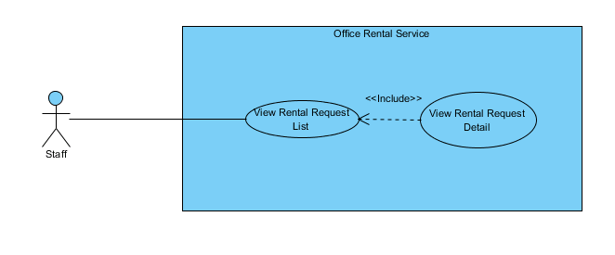

**Figure 89: <Staff > View rental request detail**

**Use Case Specification**

|  |  |  |  |  |
| --- | --- | --- | --- | --- |
| **USE CASE – VIEW RENTAL REQUEST DETAIL (mobile)** | | | | |
| **Use-case No.** |  | **Use-case Version** | | 2.0 |
| **Use-case Name** | View Rental Request Detail | | | |
| **Author** | Trần Lê Tuấn | | | |
| **Date** | 25/05/2015 | **Priority** | Normal | |
| **Actor:**   * Staff   **Summary:**   * This use case allows staff to view rental request detail.   **Goal:**   * Staff can view view rental request detail successful.   **Triggers:**   * In home page, staff clicks “Danh sách thuê thiết bị” on menu. * Click on a tab of rental request.   **Preconditions:**   * User must login in system.   **Post Conditions:**   * **Success**: view rental request detail successfully. * **Fail:** Cannot view rental request detail.   **Main Success Scenario:**   |  |  |  | | --- | --- | --- | | Step | Actor Action | System Response | | 1 | Click “Danh sách thuê thiết bị” on menu. | Show page rental list management  Display list details includes:   * Address of office: Label * Name of customer: Label * Create time: Label | | 2 | Click on a tab of rental request. | Show page rental detail.  Display list details includes:   * Tên văn phòng: Label * Địa chỉ: Label * Mở ứng dụng bản đồ: Link * Khách hàng: Label * Chi tiết thuê thiết bị: Label * Thời gian: Label * Danh sách thuê thiết bị: Label * Trạng thái: Label   “Đồng ý giao hàng”: Button  “Không đồng ý” Button  [Exception 1] |   **Alternative Scenario: N/A**  **Exceptions:**   |  |  |  | | --- | --- | --- | | No. | Actor Action | System Response | | 1 | Cannot send request due to database connection | Show error message: “Không thể gửi yêu cầu, vui lòng thử lại sau.” |   **Relationships:** Appointment  **Business Rules:**   * Rental request information must exist in database system. * Staff cannot view rental request of other staff. | | | | |

Table : <Staff> View rental request detail

##### < Staff > Confirm appointment request (mobile)

**Use case diagram**

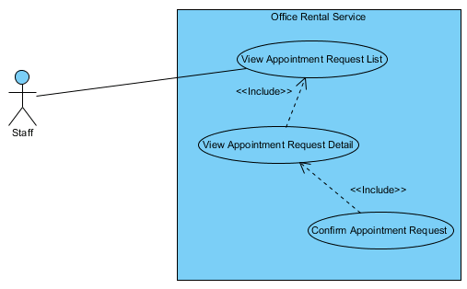

**Figure 90: <Staff > Confirm appointment request**

**Use Case Specification**

|  |  |  |  |  |
| --- | --- | --- | --- | --- |
| **USE CASE – ACCEPT/REJECT APPOINTMENT REQUEST (mobile)** | | | | |
| **Use-case No.** | UC072 | **Use-case Version** | | 2.0 |
| **Use-case Name** | Accept/Reject appointment request | | | |
| **Author** | Trần Lê Tuấn | | | |
| **Date** | 25/05/2015 | **Priority** | Normal | |
| **Actor:**   * Staff   **Summary:**   * This use case allows staff to accept/reject appointment request   **Goal:**   * Staff can accept/reject appointment request successful.   **Triggers:**   * In home page, staff clicks “Danh sách lịch hẹn” on menu. * Click on a tab of appointment request. * Click “Khách hàng muốn kí hợp đồng” or “Khách hàng không muốn kí hợp đồng”   **Preconditions:**   * User must login in system.   **Post Conditions:**   * **Success**: Accept/Reject appointment request successfully. * **Fail:** Cannot accept/reject appointment request.   **Main Success Scenario:**   |  |  |  | | --- | --- | --- | | Step | Actor Action | System Response | | 1 | Click “Danh sách lịch hẹn” on menu. | Show page appointment list management  Display list details includes:   * Address of office: Label * Name of customer: Label * Create time: Label | | 2 | Click on a tab of appointment request. | Show page appointment detail.  Display list details includes:   * Tên văn phòng: Label * Địa chỉ: Label * Mở ứng dụng bản đồ: Link * Khách hàng: Label * Thời gian: Label * Trạng thái: Label   “Khách hàng muốn kí hợp đồng”: Button  “Khách hàng không muốn kí hợp đồng” Button | | 3 | Click “Khách hàng muốn kí hợp đồng”  [Alternative 1] | Show successful message “Nhập ý kiến khách hàng” on popup.  “OK”: Button  “Cancel”:Button  [Exception 1] | |  |  |  |   **Alternative Scenario:**   |  |  |  | | --- | --- | --- | | No. | Actor Action | System Response | | 1 | Click “Khách hàng không muốn kí hợp đồng” button | Show successful message “Nhập ý kiến khách hàng” on popup.  “OK”: Button  “Cancel”:Button  [Exception 1] |   **Exceptions:**   |  |  |  | | --- | --- | --- | | No. | Actor Action | System Response | | 1 | Cannot send request due to database connection | Show error message: “Không thể gửi yêu cầu, vui lòng thử lại sau.” |   **Relationships:** Appointment  **Business Rules:**   * Appointment request information must exist in database system. * Staff cannot accept/reject appointment request of other staff. | | | | |

Table : <Staff> Confirm appointment request

##### < Staff > Accetp/Reject repair request (mobile)

**Use case diagram**

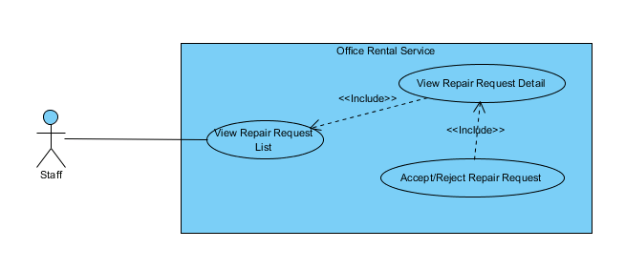

**Figure 91: <Staff > Accept/Reject repair request**

**Use Case Specification**

|  |  |  |  |  |
| --- | --- | --- | --- | --- |
| **USE CASE – ACCEPT/REJECT REPAIR REQUEST (mobile)** | | | | |
| **Use-case No.** | UC073 | **Use-case Version** | | 2.0 |
| **Use-case Name** | Accept/Reject repair request | | | |
| **Author** | Trần Lê Tuấn | | | |
| **Date** | 25/05/2015 | **Priority** | Normal | |
| **Actor:**   * Staff   **Summary:**   * This use case allows staff to accept/reject repair request   **Goal:**   * Staff can accept/reject repair request successful.   **Triggers:**   * In home page, staff clicks “Danh sách sửa chữa” on menu. * Click on a tab of appointment request. * Click “Đồng ý sửa” or “Không đồng ý sửa”   **Preconditions:**   * User must login in system.   **Post Conditions:**   * **Success**: Accept/Reject repair request successfully. * **Fail:** Cannot accept/reject repair request.   **Main Success Scenario:**   |  |  |  | | --- | --- | --- | | Step | Actor Action | System Response | | 1 | Click “Danh sách sửa chữa” on menu. | Show page repair list management  Display list details includes:   * Address of office: Label * Name of customer: Label * Create time: Label   [Exception 1] | | 2 | Click on a tab of repair request. | Show page repair detail.  Display list details includes:   * Tên văn phòng: Label * Địa chỉ: Label * Mở ứng dụng bản đồ: Link * Khách hàng: Label * Chi tiết sửa chữa: Label * Thời gian: Label * Danh sách sửa chữa: Label * Trạng thái: Label   “Đồng ý sửa”: Button  “Không đồng ý sửa” Button | | 3 | Click “Đồng ý sửa chữa”  [Alternative 1] | Show successful message “Nhập ý kiến khách hàng” on popup.  “OK”: Button  “Cancel”:Button  [Exception 1] |   **Alternative Scenario:**   |  |  |  | | --- | --- | --- | | No. | Actor Action | System Response | | 1 | Click “Không đồng ý sửa chữa” button | Show successful message “Nhập ý kiến khách hàng” on popup.  “OK”: Button  “Cancel”:Button  [Exception 1] |   **Exceptions:**   |  |  |  | | --- | --- | --- | | No. | Actor Action | System Response | | 1 | Cannot send request due to database connection | Show error message: “Không thể gửi yêu cầu, vui lòng thử lại sau.” |   **Relationships:** Repair  **Business Rules:**   * Repair request information must exist in database system. * Staff cannot accept/reject repair request of other staff. | | | | |

Staff

##### < Staff > Accept/Reject rental request (mobile)

**Use case diagram**

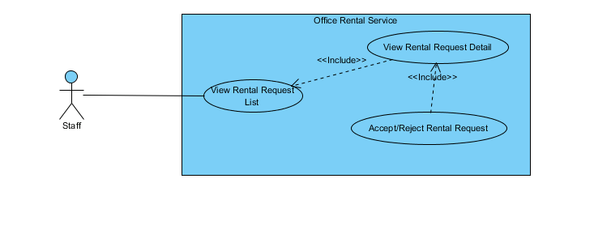

**Figure 92: <Staff > Accept/Reject rental request**

**Use Case Specification**

|  |  |  |  |  |
| --- | --- | --- | --- | --- |
| **USE CASE – CHANGE RENTAL REQUEST STATUS (mobile)** | | | | |
| **Use-case No.** | UC074 | **Use-case Version** | | 2.0 |
| **Use-case Name** | Accept/Reject rental request | | | |
| **Author** | Trần Lê Tuấn | | | |
| **Date** | 25/05/2015 | **Priority** | Normal | |
| **Actor:**   * Staff   **Summary:**   * This use case allows staff to accept/reject rental request   **Goal:**   * Staff can accept/reject rental request successful.   **Triggers:**   * In home page, staff clicks “Danh sách thuê thiết bị” on menu. * Click on a tab of rental request. * Click “Đồng ý giao” or “Không đồng ý”   **Preconditions:**   * User must login in system.   **Post Conditions:**   * **Success**: Accept/Reject rental request successfully. * **Fail:** Cannot accept/reject rental request.   **Main Success Scenario:**   |  |  |  | | --- | --- | --- | | Step | Actor Action | System Response | | 1 | Click “Danh sách thuê thiết bị” on menu. | Show page rental list management  Display list details includes:   * Address of office: Label * Name of customer: Label * Create time: Label | | 2 | Click on a tab of rental request. | Show page rental detail.  Display list details includes:   * Tên văn phòng: Label * Địa chỉ: Label * Mở ứng dụng bản đồ: Link * Khách hàng: Label * Chi tiết thuê thiết bị: Label * Thời gian: Label * Danh sách thuê thiết bị: Label * Trạng thái: Label   “Đồng ý giao hàng”: Button  “Không đồng ý” Button | | 3 | Click “Đồng ý giao hàng”  [Alternative 1] | Show successful message “Nhập ý kiến khách hàng” on popup.  “OK”: Button  “Cancel”:Button  [Exception 1] |   **Alternative Scenario:**   |  |  |  | | --- | --- | --- | | No. | Actor Action | System Response | | 1 | Click “Không đồng ý” button | Show successful message “Nhập ý kiến khách hàng” on popup.  “OK”: Button  “Cancel”:Button  [Exception 1] |   **Exceptions:**   |  |  |  | | --- | --- | --- | | No. | Actor Action | System Response | | 1 | Cannot send request due to database connection | Show error message: “Không thể gửi yêu cầu, vui lòng thử lại sau.” |   **Relationships:** Repair  **Business Rules:**   * Rental request information must exist in database system. * Staff cannot accept/reject rental request of other staff. | | | | |

Table : <Staff> Accept/Reject rental request

##### < Staff > Confirm rental request (mobile)

**Use case diagram**

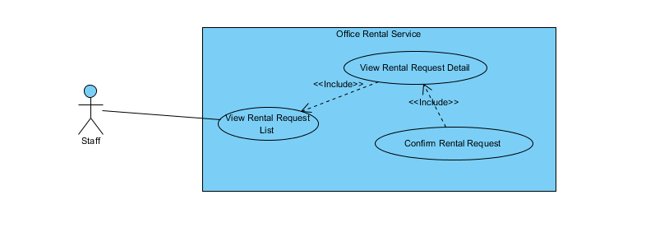

**Figure 93: <Staff > Confirm rental request**

**Use Case Specification**

|  |  |  |  |  |
| --- | --- | --- | --- | --- |
| **USE CASE – CONFIRM RENTAL REQUEST (mobile)** | | | | |
| **Use-case No.** | UC075 | **Use-case Version** | | 2.0 |
| **Use-case Name** | Confirm rental request | | | |
| **Author** | Trần Lê Tuấn | | | |
| **Date** | 25/05/2015 | **Priority** | Normal | |
| **Actor:**   * Staff   **Summary:**   * This use case allows staff to confirm rental request.   **Goal:**   * Staff can change rental request status successful.   **Triggers:**   * In home page, staff clicks “Danh sách thuê thiết bị” on menu. * Click on a tab of rental request. * Click “Khách hàng hài lòng” or “Khách hàng không hài lòng”   **Preconditions:**   * User must login in system.   **Post Conditions:**   * **Success**: Confirm rental request successfully. * **Fail:** Cannot confirm rental request.   **Main Success Scenario:**   |  |  |  | | --- | --- | --- | | Step | Actor Action | System Response | | 1 | Click “Danh sách thuê thiết bị” on menu. | Show page rental list management  Display list details includes:   * Address of office: Label * Name of customer: Label * Create time: Label | | 2 | Click on a tab of rental request. | Show page rental detail.  Display list details includes:   * Tên văn phòng: Label * Địa chỉ: Label * Mở ứng dụng bản đồ: Link * Khách hàng: Label * Chi tiết thuê thiết bị: Label * Thời gian: Label * Danh sách thuê thiết bị: Label * Trạng thái: Label   “Khách hàng hài lòng”: Button  “Khách hàng không hài lòng”: Button | | 3 | Click “Khách hàng hài lòng” button  [Alternative 1] | Return to home page.  [Exception 1] |   **Alternative Scenario:**   |  |  |  | | --- | --- | --- | | No. | Actor Action | System Response | | 1 | Click “Khách hàng không hài lòng” button | Return to home page.  [Exception 1] |   **Exceptions:**   |  |  |  | | --- | --- | --- | | No. | Actor Action | System Response | | 1 | Cannot send request due to database connection | Show error message: “Không thể gửi yêu cầu, vui lòng thử lại sau.” |   **Relationships:** Rental  **Business Rules:**   * Rental request information must exist in database system. * Staff cannot confirm rental request of other staff. * Rental request must be approve before confirm. | | | | |

Table : <Manager> Confirm rental request

##### < Staff > Confirm repair request (mobile)

**Use case diagram**

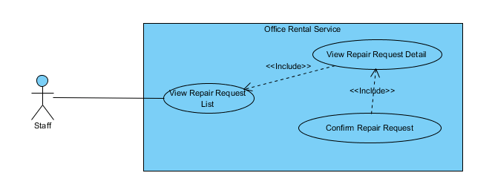

**Figure 94: <Staff > Confirm repair request**

**Use Case Specification**

|  |  |  |  |  |
| --- | --- | --- | --- | --- |
| **USE CASE – CONFIRM REPAIR REQUEST (mobile)** | | | | |
| **Use-case No.** | UC076 | **Use-case Version** | | 2.0 |
| **Use-case Name** | Confirm repair request | | | |
| **Author** | Trần Lê Tuấn | | | |
| **Date** | 25/05/2015 | **Priority** | Normal | |
| **Actor:**   * Staff   **Summary:**   * This use case allows staff to confirm rental request.   **Goal:**   * Staff can confirm repair request successful.   **Triggers:**   * In home page, staff clicks “Danh sách sửa chữa” on menu. * Click on a tab of repair request. * Click “Khách hàng hài lòng” or “Khách hàng không hài lòng”   **Preconditions:**   * User must login in system.   **Post Conditions:**   * **Success**: Confirm repair request successfully. * **Fail:** Cannot confirm repair request.   **Main Success Scenario:**   |  |  |  | | --- | --- | --- | | Step | Actor Action | System Response | | 1 | Click “Danh sách sửa chữa” on menu. | Show page repair list management  Display list details includes:   * Address of office: Label * Name of customer: Label * Create time: Label   [Exception 1] | | 2 | Click on a tab of repair request. | Show page repair detail.  Display list details includes:   * Tên văn phòng: Label * Địa chỉ: Label * Mở ứng dụng bản đồ: Link * Khách hàng: Label * Chi tiết sửa chữa: Label * Thời gian: Label * Danh sách sửa chữa: Label * Trạng thái: Label   “Khách hàng hài lòng”: Button  “Khách hàng không hài lòng” Button | | 3 | Click “Khách hàng hài lòng” button  [Alternative 1] | Return to home page.  [Exception 1] |   **Alternative Scenario:**   |  |  |  | | --- | --- | --- | | No. | Actor Action | System Response | | 1 | Click “Khách hàng không hài lòng” button | Return to home page.  [Exception 1] |   **Exceptions:**   |  |  |  | | --- | --- | --- | | No. | Actor Action | System Response | | 1 | Cannot send request due to database connection | Show error message: “Không thể gửi yêu cầu, vui lòng thử lại sau.” |   **Relationships:** Repair  **Business Rules:**   * Repair request information must exist in database system. * Staff cannot confirm repair request of other staff. * Repair request must be approve before confirm. | | | | |

Table : <Staff> Confirm repair request

#### <System>Overview Use Case



Figure : <System> Overview Use Case

##### <System> Suggest Requested Office

**Use Case Diagram**



Figure : <System> Suggest Requested Office

**Use Case Specification**

|  |  |  |  |
| --- | --- | --- | --- |
| **USE CASE SUGGEST REQUESTED OFFICE** | | | |
| **Use Case No.** | UC077 | **Use Case Version** | 1.0 |
| **Use Case Name** | Suggest Requested Office | | |
| **Author** | Nguyễn Vũ Hoàng Quốc | | |
| **Date** | 31/05/2015 | **Priority** | Normal |
| **Actor:**   * System   **Summary:**   * This use case show system find offices that suitable with customer’s requests.   **Goal:**   * Find offices that suitable with customer’s requests.   **Triggers:**   * Schedule start   **Preconditions:**   * There are at least one request office from customer * There are at least one office in database   **Post Conditions:**   * **Success:** Office that suitable with customer’s requests is saved to database. * **Fail:** Cannot find office although there is the office suitable.   **Main Success Scenario:**   |  |  |  | | --- | --- | --- | | Step | Actor Action | System Response | | 1 | Start schedule | * Find all office in database * Find all request office in database * Check office with request * Find office that suitable * Save id of office to request office |   **Alternative Scenario:**   |  |  |  | | --- | --- | --- | | No | Actor Action | System Response | |  |  |  |   **Exceptions:**   |  |  |  | | --- | --- | --- | | No | Actor Action | System Response | |  |  |  |   **Relationships:** RequestOffice, Office  **Business Rules:**   * System will automatic check all requests office of customer and find which office in database suitable. * System will check 5 criteria:   + Amenity:     - If there is one request amenity in request, system will find if office which has that amenity will be suitable.     - If there are two or more request amenities, system will find if office which has two or more amenities in request will be suitable.   + Category:     - System will find which office suitable with request’s category.   + Price:     - System will find which office’s price is in range of request’s price: from (request’s price * 80%) to (request’s price * 120%)   + Area:     - If request category is “Văn phòng nguyên căn”: office’s area in range is suitable: from (request’s area * 80%) to (request’s area * 120%)     - If request category is “Tòa nhà văn phòng”: office’s area is larger than request’s area is suitable   + District:     - System will check which office in district of customer’s request | | | |

Table : <System> Suggest requested office

##### <System> Check Contract Due Date

**Use Case Diagram**



Figure : <System> Check Contract Due Date

**Use Case Specification**

|  |  |  |  |
| --- | --- | --- | --- |
| **USE CASE CHECK CONTRACT DUE DATE** | | | |
| **Use Case No.** | UC078 | **Use Case Version** | 1.0 |
| **Use Case Name** | Check Contract Due Date | | |
| **Author** | Nguyễn Vũ Hoàng Quốc | | |
| **Date** | 31/05/2015 | **Priority** | Normal |
| **Actor:**   * System   **Summary:**   * This use case show system check contract and send notification mail to customer.   **Goal:**   * Find contract which nearly expired and contract is expired in day and send mail to customer.   **Triggers:**   * Schedule start   **Preconditions:**   * There are at least one contract in database   **Post Conditions:**   * **Success:** Customer receive mail that notify about their contract will be expired of expired. * **Fail:** Send mail failed.   **Main Success Scenario:**   |  |  |  | | --- | --- | --- | | Step | Actor Action | System Response | | 1 | Start schedule | * Find all contract in database * Check contract with is nearly or expired in day * Send notification mail to customer |   **Alternative Scenario:**   |  |  |  | | --- | --- | --- | | No | Actor Action | System Response | |  |  |  |   **Exceptions:**   |  |  |  | | --- | --- | --- | | No | Actor Action | System Response | |  |  |  |   **Relationships:** Contract, account  **Business Rules:**   * System check if contract has 7 days before expired will send mail to customer base on customer info. * If contract is due date it will auto change status to expired and send mail to customer. | | | |

Table : <System> Check contract due date

##### <System> Suggest Job Schedule

**Use Case Diagram**

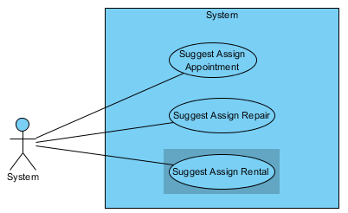

Figure : <System> Suggest Job Schedule

**Use Case Specification**

|  |  |  |  |
| --- | --- | --- | --- |
| **USE CASE SUGGEST JOB SCHEDULE** | | | |
| **Use Case No.** | UC079 | **Use Case Version** | 1.0 |
| **Use Case Name** | Suggest Job Schedule | | |
| **Author** | Lê Xuân Tiến | | |
| **Date** | 31/05/2015 | **Priority** | Normal |
| **Actor:**   * System   **Summary:**   * This use case show system suggest staff with available for the job (appointment/ repair/ rental).   **Goal:**   * Suggest staff and time in appointment/ repair/ rental page.   **Triggers:**   * View the appointment/ repair/ rental list   **Preconditions:**   * There are jobs in the job list page   **Post Conditions:**   * **Success:** Display suggest staff and date for each job in job list page. * **Fail:** Display “Không có đề xuất” in job list page.   **Main Success Scenario:**   |  |  |  | | --- | --- | --- | | Step | Actor Action | System Response | | 1 | Go to job list page | * If the page is appointment, suggest the staff only * If the page is repair and rental, suggest the staff and assign time * If system cannot suggest, ouput “Không có đề xuất” as response   [Exception 1] |   **Alternative Scenario:**  **N/A**  **Exceptions:**   |  |  |  | | --- | --- | --- | | Step | Actor Action | System Response | | 1 | Cannot load job from database | * “Không có đề xuất” as response |   **Relationships:** Appointment List, Repair List, Rental List  **Business Rules:**   * Step 1: suggest the assign time (repair and rental only) base on:   + If the repair has the amenity that have high priority (example electricity, internet…), the system will suggest the date after the current time   + Else the system will suggest the time on the weekend   + If the type is appointment, suggest date is the appointment date * Step 2: suggest the staff   + Step 2.1: Calculate number of job of each staff in the suggest date. If staff has less than 4 jobs, the staff is in suggest list. If there is no staff available in suggest list, repeat step 1 with the date after last suggest date   + Step 2.2: If there is staff in suggest date, system will suggest the staff which has least job in week. If they has same number of job, suggest first staff. The suggest staff is also add to the temporary job list to calculate at step 1 and 2 | | | |

Table : <System> Suggest Job Schedule

## Software System Attribute

### Usability

* Staff should need less than one training week to interact with system.

### Reliability

* Information should be updated every day.

### Availability

* System uptime at about 95%

### Security

* All input data should be validated before saving to database.
* User should be authenticated and authorized when accessing to the system.

### Maintainability

* The system should be divided into modules and code. It would be easy to maintain and upgrade.

### Portability

* N/A

### Performance

* All requests should be response in no more than 1 minute.

## Conceptual Diagram

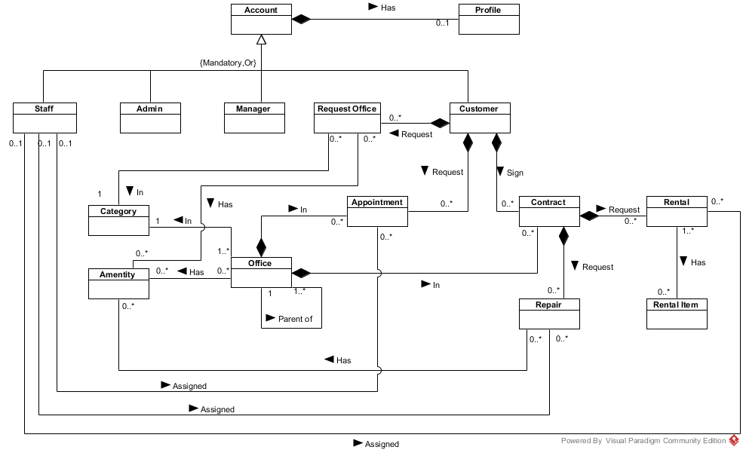

**Data dictionary:**

|  |  |
| --- | --- |
| **Entity Data dictionary: describe content of all entities** | |
| **Entity Name** | **Description** |
| Account | Describe account of user of system. |
| Staff | Describe account type staff |
| Admin | Describe account type admin |
| Manager | Describe account type manager |
| Customer | Describe account type customer |
| Profile | Describe the contact information for customer |
| Office | Describe information of the office |
| Category | Describe the category of the office |
| Amenity | Describe the amenities of the office |
| Appointment | Describe the information of the appointment of customer for the office |
| Contract | Describe the information of contract between customer and office |
| Request Office | Describe the stored office request of customer |
| Repair | Describe the repair request for each contract |
| Rental | Describe the rental request for contract |
| Rental Item | Describe the rental items which available for rental request |

# Report 4: Software Design Description

## Design Overview

This document describes the technical and user interface design of ORS System. It includes the architectural design, the detailed design of common functions and business functions and the design of database model.

The architectural design describes the overall architecture of the system and the architecture of each main component and subsystem.

The detailed design describes static and dynamic structure for each component and functions. It includes class diagrams, class explanations and sequence diagrams for each use cases.

The database design describes the relationships between entities and details of each entity.

Document overview:

* Section 2: gives an overall description of the system architecture design.
* Section 3: gives component diagrams that describe the connection and integration of the system.
* Section 4: gives the detail design description which includes class diagram, class explanation, and sequence diagram to details the application functions.
* Section 5: overview some main user interface of system.
* Section 6: describe fully attributed ERD.
* Section 7: describe in details all algorithms used in the system.

## System Architectural Design

The system is developed using MVC architecture, combine with front end – back end RESTful Web service interface architecture.

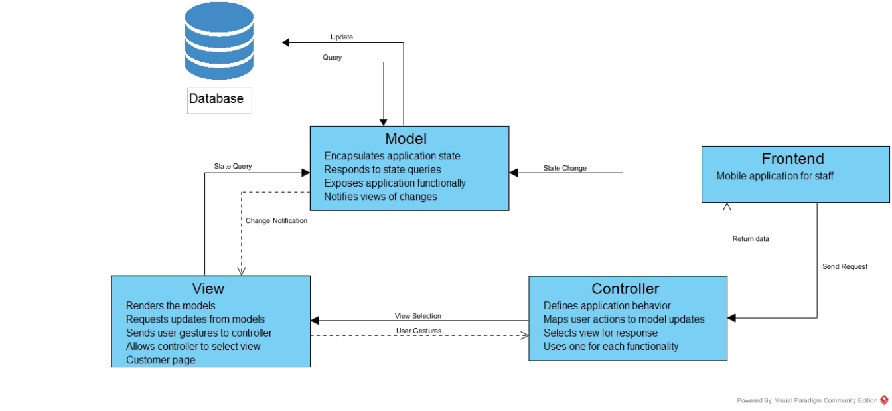

Figure : System architecture

* **Model:** The model manages the behavior and data of the application domain, responds to requests for information about its state (usually from the view), and responds to instructions to change state (usually from the controller).
* **View:** The view manages the display of information.
* **Controller**: The controller interprets the mouse and keyboard inputs from the user, informing the model and/or the view to change as appropriate.
* **Frontend**: Mobile application for staffs send and receive request through controller.

[<http://msdn.microsoft.com/en-us/library/ff649643.aspx> ]

## Component Diagram

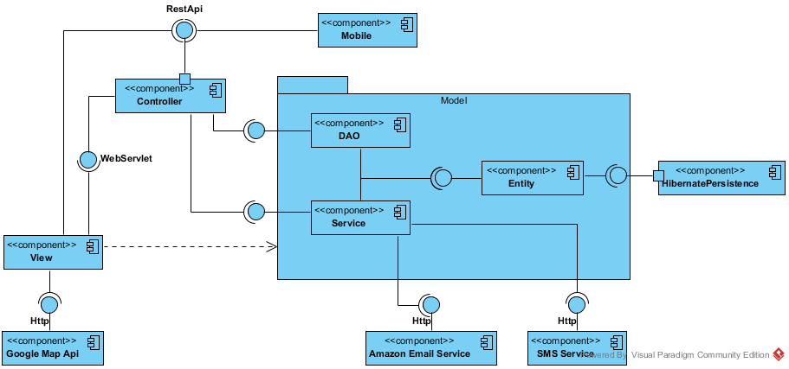

Figure : Component Diagram

|  |  |
| --- | --- |
| **Component dictionary: describe component** | |
| **Component Name** | **Description** |
| HibernatePersistence | Component provide by Hibernate to establish database connection |
| Entity | The database mapping classes component |
| DAO | Data Access Classes component, provide function to manipulate data |
| Service | Provice additional data manipulation and external data manipulation |
| Controller | Receive and handle the request from View, then call DAO/ Service to manipulate |
| View | Render the view for user |
| Mobile | The mobile application component |
| Google Map Api | The map component provide by Google |
| Amazon Email Service | The email service component provide by Amazon |
| SMS Service | The SMS service component provide by ESMS (<http://esms.vn/>) |

## Detailed Description Explanation

### Class Diagram

#### Entity Package Class Diagram

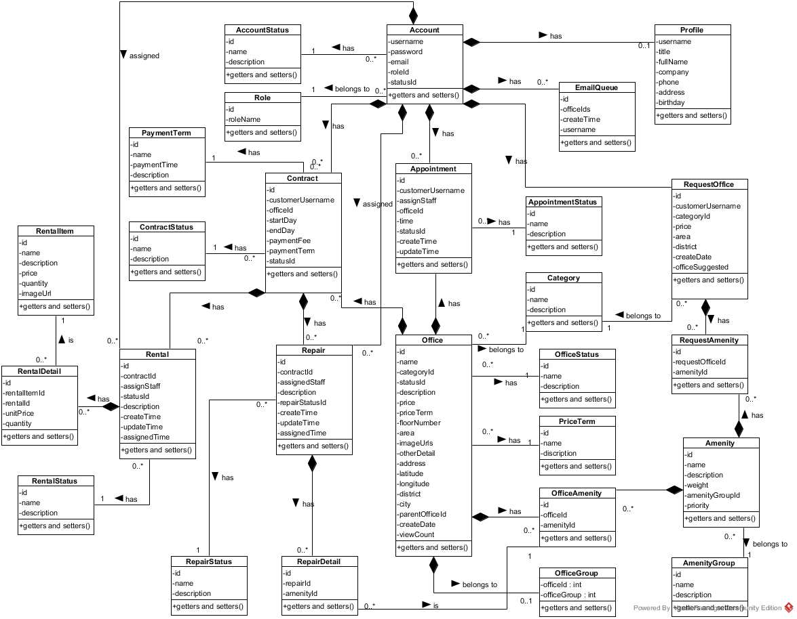

Figure : Class Diagram

**Class Diagram Explanation**

##### RepairStatus

Attribute

|  |  |  |  |
| --- | --- | --- | --- |
| **Attribute** | **Type** | **Visibility** | **Description** |
| id | int | private | The id of the status of repair |
| name | String | private | The name of the status of repair |
| description | String | private | The description of the status of repair |

Method

|  |  |  |  |
| --- | --- | --- | --- |
| **Attribute** | **Type** | **Visibility** | **Description** |
| getters | attribute type | public | Get the respective attribute value |
| setters | void | public | Set the respective attribute with the value |

##### RepairDetail

Attribute

|  |  |  |  |
| --- | --- | --- | --- |
| **Attribute** | **Type** | **Visibility** | **Description** |
| id | int | private | The id of the repair detail |
| repairId | int | private | The id of the repair |
| amenityId | int | private | The id of the amenity |

Method

|  |  |  |  |
| --- | --- | --- | --- |
| **Attribute** | **Type** | **Visibility** | **Description** |
| getters | attribute type | public | Get the respective attribute value |
| setters | void | public | Set the respective attribute with the value |

##### Repair

Attribute

|  |  |  |  |
| --- | --- | --- | --- |
| **Attribute** | **Type** | **Visibility** | **Description** |
| id | int | private | The id of the repair |
| contractId | int | private | The id of the repair |
| assignedStaff | String | private | Username of staff who responsibility for this repair request |
| repairStatusId | int | private | The id of the status of repair |
| description | String | private | The description of the repair request |
| createTime | Timestamp | private | Time when customer create this repair request |
| updateTime | Timestamp | private | Time when manger or staff change status |
| assignedTime | Timestamp | private | Time when manager assign to staff |

Method

|  |  |  |  |
| --- | --- | --- | --- |
| **Attribute** | **Type** | **Visibility** | **Description** |
| getters | attribute type | public | Get the respective attribute value |
| setters | void | public | Set the respective attribute with the value |

##### PaymentTerm

Attribute

|  |  |  |  |
| --- | --- | --- | --- |
| **Attribute** | **Type** | **Visibility** | **Description** |
| id | int | private | The id of the payment term |
| name | String | private | The name of the payment term |
| paymentTime | int | private | Number months of the payment |
| description | String | private | The description of payment term |

Method

|  |  |  |  |
| --- | --- | --- | --- |
| **Attribute** | **Type** | **Visibility** | **Description** |
| getters | attribute type | public | Get the respective attribute value |
| setters | void | public | Set the respective attribute with the value |

##### ContractStatus

Attribute

|  |  |  |  |
| --- | --- | --- | --- |
| **Attribute** | **Type** | **Visibility** | **Description** |
| id | int | private | The id of the contract status |
| name | String | private | The name of the contract status |
| description | String | private | The description of the contract status |

Method

|  |  |  |  |
| --- | --- | --- | --- |
| **Attribute** | **Type** | **Visibility** | **Description** |
| getters | attribute type | public | Get the respective attribute value |
| setters | void | public | Set the respective attribute with the value |

##### Contract

Attribute

|  |  |  |  |
| --- | --- | --- | --- |
| **Attribute** | **Type** | **Visibility** | **Description** |
| id | int | private | The id of the contract |
| customerUsername | String | private | Username of customer |
| officeId | int | private | The id of the office |
| startDate | date | private | Date when contract starts |
| endDate | date | private | Date when contract ends |
| paymentFee | int | private | Payment fee for the contract |
| paymentTerm | int | private | Payment term for the contract |
| statusId | int | private | The id of contract status |

Method

|  |  |  |  |
| --- | --- | --- | --- |
| **Attribute** | **Type** | **Visibility** | **Description** |
| getters | attribute type | public | Get the respective attribute value |
| setters | void | public | Set the respective attribute with the value |

##### OfficeStatus

Attribute

|  |  |  |  |
| --- | --- | --- | --- |
| **Attribute** | **Type** | **Visibility** | **Description** |
| id | int | private | The id of the office status |
| name | String | private | The name of the office status |
| description | String | private | The description of the office status |

Method

|  |  |  |  |
| --- | --- | --- | --- |
| **Attribute** | **Type** | **Visibility** | **Description** |
| getters | attribute type | public | Get the respective attribute value |
| setters | void | public | Set the respective attribute with the value |

##### OfficeGroup

Attribute

|  |  |  |  |
| --- | --- | --- | --- |
| **Attribute** | **Type** | **Visibility** | **Description** |
| officeId | int | private | The id of the office |
| officeGroup | int | private | Group of office for searching |

Method

|  |  |  |  |
| --- | --- | --- | --- |
| **Attribute** | **Type** | **Visibility** | **Description** |
| getters | attribute type | public | Get the respective attribute value |
| setters | void | public | Set the respective attribute with the value |

##### PriceTerm

Attribute

|  |  |  |  |
| --- | --- | --- | --- |
| **Attribute** | **Type** | **Visibility** | **Description** |
| id | int | private | The id of the price term |
| name | String | private | The name of the price term |
| description | String | private | The description of the price term |

Method

|  |  |  |  |
| --- | --- | --- | --- |
| **Attribute** | **Type** | **Visibility** | **Description** |
| getters | attribute type | public | Get the respective attribute value |
| setters | void | public | Set the respective attribute with the value |

##### EmailQueue

Attribute

|  |  |  |  |
| --- | --- | --- | --- |
| **Attribute** | **Type** | **Visibility** | **Description** |
| id | int | private | The id of the email queue |
| username | String | private | Username of the customer |
| officeIds | String | private | The id of list office that system suggests to customer |
| createTime | date | private | Time when customer create request |

Method

|  |  |  |  |
| --- | --- | --- | --- |
| **Attribute** | **Type** | **Visibility** | **Description** |
| getters | attribute type | public | Get the respective attribute value |
| setters | void | public | Set the respective attribute with the value |

##### Office

Attribute

|  |  |  |  |
| --- | --- | --- | --- |
| **Attribute** | **Type** | **Visibility** | **Description** |
| id | int | private | The id of the office |
| name | String | private | The name of the office |
| categoryId | int | private | The id of the category |
| statusId | int | private | The id of the status office |
| description | String | private | The description of the office |
| price | long | private | The price of the office |
| priceTerm | int | private | The price term of the office |
| floorNumber | int | private | The number of floor in the office |
| area | double | private | The area of the office |
| imageUrls | String | private | Link of the images of office |
| otherDetail | String | private | Some detail of the office |
| address | String | private | The address of the office |
| latitude | Double | private | Latitude of the office |
| longitude | Double | private | Longitude of the office |
| district | String | private | The district of the office |
| city | String | private | The city of the office |
| parentOfficeId | int | private | The parent office id of the office |
| createDate | Timestamp | private | Date when office create in database |
| viewCount | int | private | Number views when customer see detail of office |

Method

|  |  |  |  |
| --- | --- | --- | --- |
| **Attribute** | **Type** | **Visibility** | **Description** |
| getters | attribute type | public | Get the respective attribute value |
| setters | void | public | Set the respective attribute with the value |

##### Appointment

Attribute

|  |  |  |  |
| --- | --- | --- | --- |
| **Attribute** | **Type** | **Visibility** | **Description** |
| id | int | private | The id of the appointment |
| customerUsername | String | private | The username of customer |
| assignedStaff | String | private | Staff who is responsibility for the appointment |
| officeId | int | private | Office where customer want to make appointment |
| time | Timestamp | private | Time for appointment |
| statusId | int | private | The status of the appointment |
| createTime | Timestamp | private | Time when customer create appointment |
| updateTime | Timestamp | private | Time when manager update the appointment |

Method

|  |  |  |  |
| --- | --- | --- | --- |
| **Attribute** | **Type** | **Visibility** | **Description** |
| getters | attribute type | public | Get the respective attribute value |
| setters | void | public | Set the respective attribute with the value |

##### Account

Attribute

|  |  |  |  |
| --- | --- | --- | --- |
| **Attribute** | **Type** | **Visibility** | **Description** |
| username | String | private | Unique identifier of an account |
| password | String | private | Password for login to system |
| email | String | private | Email of this account |
| roleId | int | private | Role of this account |
| statusId | int | private | Status of this account |

Method

|  |  |  |  |
| --- | --- | --- | --- |
| **Attribute** | **Type** | **Visibility** | **Description** |
| getters | attribute type | public | Get the respective attribute value |
| setters | void | public | Set the respective attribute with the value |

##### AccountStatus

Attribute

|  |  |  |  |
| --- | --- | --- | --- |
| **Attribute** | **Type** | **Visibility** | **Description** |
| id | int | private | The id of an account status |
| name | String | private | The name of this status |
| description | String | private | The description for this status |

Method

|  |  |  |  |
| --- | --- | --- | --- |
| **Attribute** | **Type** | **Visibility** | **Description** |
| getters | attribute type | public | Get the respective attribute value |
| setters | void | public | Set the respective attribute with the value |

##### Role

Attribute

|  |  |  |  |
| --- | --- | --- | --- |
| **Attribute** | **Type** | **Visibility** | **Description** |
| id | int | private | The id of a role |
| roleName | String | private | The name of role |

Method

|  |  |  |  |
| --- | --- | --- | --- |
| **Attribute** | **Type** | **Visibility** | **Description** |
| getters | attribute type | public | Get the respective attribute value |
| setters | void | public | Set the respective attribute with the value |

##### Profile

Attribute

|  |  |  |  |
| --- | --- | --- | --- |
| **Attribute** | **Type** | **Visibility** | **Description** |
| username | String | private | The id of an account |
| title | String | private | Gender of the profile |
| fullName | String | private | Full name of this profile |
| company | String | private | Company of this profile |
| phone | String | private | Phone of this profile |
| address | String | private | Address of this profile |
| birthday | Timestamp | private | Birthday of this profile |

Method

|  |  |  |  |
| --- | --- | --- | --- |
| **Attribute** | **Type** | **Visibility** | **Description** |
| getters | attribute type | public | Get the respective attribute value |
| setters | void | public | Set the respective attribute with the value |

##### AppointmentStatus

Attribute

|  |  |  |  |
| --- | --- | --- | --- |
| **Attribute** | **Type** | **Visibility** | **Description** |
| id | int | private | The id of an appointment status |
| name | String | private | The name of appointment status |
| description | String | private | The description for appointment status |

Method

|  |  |  |  |
| --- | --- | --- | --- |
| **Attribute** | **Type** | **Visibility** | **Description** |
| getters | attribute type | public | Get the respective attribute value |
| setters | void | public | Set the respective attribute with the value |

##### Category

Attribute

|  |  |  |  |
| --- | --- | --- | --- |
| **Attribute** | **Type** | **Visibility** | **Description** |
| id | int | private | The id of category |
| name | String | private | The name of category |
| description | String | private | The description of category |

Method

|  |  |  |  |
| --- | --- | --- | --- |
| **Attribute** | **Type** | **Visibility** | **Description** |
| getters | attribute type | public | Get the respective attribute value |
| setters | void | public | Set the respective attribute with the value |

##### OfficeAmentity

Attribute

|  |  |  |  |
| --- | --- | --- | --- |
| **Attribute** | **Type** | **Visibility** | **Description** |
| id | int | private | The id of office amenity |
| officeId | int | private | The id of office |
| amentityId | int | private | The id of amenity |

Method

|  |  |  |  |
| --- | --- | --- | --- |
| **Attribute** | **Type** | **Visibility** | **Description** |
| getters | attribute type | public | Get the respective attribute value |
| setters | void | public | Set the respective attribute with the value |

##### Rental

Attribute

|  |  |  |  |
| --- | --- | --- | --- |
| **Attribute** | **Type** | **Visibility** | **Description** |
| id | int | private | The id of rental |
| contractId | int | private | The id of contract |
| assignStaff | String | private | Username of staff who responsibility for this rental request |
| statusId | int | private | The status id of this rental request |
| description | String | private | The description of rental |
| createTime | Timestamp | private | Time when customer create this rental request |
| updateTime | Timestamp | private | Time when manger or staff change status |
| assignedTime | Timestamp | private | Time when manager assign to staff |

Method

|  |  |  |  |
| --- | --- | --- | --- |
| **Attribute** | **Type** | **Visibility** | **Description** |
| getters | attribute type | public | Get the respective attribute value |
| setters | void | public | Set the respective attribute with the value |

##### RequestOffice

Attribute

|  |  |  |  |
| --- | --- | --- | --- |
| **Attribute** | **Type** | **Visibility** | **Description** |
| id | int | private | The id of the request office |
| customerUsername | String | private | Username of customer |
| categoryId | int | private | The id of category |
| price | int | private | Price of the office |
| area | int | private | Area of the office |
| district | int | private | District of the office |
| createTime | Timestamp | private | Time when customer create this rental request |
| scheduleDate | Timestamp | private | Date when system check this request |
| OfficeSuggested | String | private | List offices that are suitable with request |

Method

|  |  |  |  |
| --- | --- | --- | --- |
| **Attribute** | **Type** | **Visibility** | **Description** |
| getters | attribute type | public | Get the respective attribute value |
| setters | void | public | Set the respective attribute with the value |

##### RequestAmenity

Attribute

|  |  |  |  |
| --- | --- | --- | --- |
| **Attribute** | **Type** | **Visibility** | **Description** |
| id | int | private | The id of request amenity |
| requestOfficeId | int | private | The id of request office |
| amentityId | int | private | The id of amenity |
|  |  |  |  |

Method

|  |  |  |  |
| --- | --- | --- | --- |
| **Attribute** | **Type** | **Visibility** | **Description** |
| getters | attribute type | public | Get the respective attribute value |
| setters | void | public | Set the respective attribute with the value |

##### Amenity

Attribute

|  |  |  |  |
| --- | --- | --- | --- |
| **Attribute** | **Type** | **Visibility** | **Description** |
| id | int | private | The id of amenity |
| name | String | private | Name of this amenity |
| description | String | private | Description for this amenity |
| weight | int | private | Weight of amenity in one group |
| amenityGroupId | int | private | Group of this amenity |
| priority | int | private | Priority of amenity in one group |

Method

|  |  |  |  |
| --- | --- | --- | --- |
| **Attribute** | **Type** | **Visibility** | **Description** |
| getters | attribute type | public | Get the respective attribute value |
| setters | void | public | Set the respective attribute with the value |

##### AmenityGroup

Attribute

|  |  |  |  |
| --- | --- | --- | --- |
| **Attribute** | **Type** | **Visibility** | **Description** |
| id | int | private | The id of amenity group |
| name | String | private | Name of amenity group |
| description | String | private | Description for amenity group |
|  |  |  |  |

Method

|  |  |  |  |
| --- | --- | --- | --- |
| **Attribute** | **Type** | **Visibility** | **Description** |
| getters | attribute type | public | Get the respective attribute value |
| setters | void | public | Set the respective attribute with the value |

##### RentalStatus

Attribute

|  |  |  |  |
| --- | --- | --- | --- |
| **Attribute** | **Type** | **Visibility** | **Description** |
| id | int | private | The id of the status of rental |
| name | String | private | The name of the status of rental |
| description | String | private | The description of the status of rental |

Method

|  |  |  |  |
| --- | --- | --- | --- |
| **Attribute** | **Type** | **Visibility** | **Description** |
| getters | attribute type | public | Get the respective attribute value |
| setters | void | public | Set the respective attribute with the value |

##### RentalItem

Attribute

|  |  |  |  |
| --- | --- | --- | --- |
| **Attribute** | **Type** | **Visibility** | **Description** |
| id | int | private | The id of rental item |
| name | String | private | Name of the item |
| description | String | private | Description for the item |
| price | double | private | Price of the item |
| quantity | int | private | Quantity of the item |
| imageUrl | String | private | Link image of the item |

Method

|  |  |  |  |
| --- | --- | --- | --- |
| **Attribute** | **Type** | **Visibility** | **Description** |
| getters | attribute type | public | Get the respective attribute value |
| setters | void | public | Set the respective attribute with the value |

##### RentalDetail

Attribute

|  |  |  |  |
| --- | --- | --- | --- |
| **Attribute** | **Type** | **Visibility** | **Description** |
| id | int | private | The id of rental detail |
| rentalItemId | int | private | Item rental for the rental request |
| rentalId | int | private | Id of request rental |
| unitPrice | double | private | Price of one item |
| quantity | int | private | Quantity of rental item for the rental request |

Method

|  |  |  |  |
| --- | --- | --- | --- |
| **Attribute** | **Type** | **Visibility** | **Description** |
| getters | attribute type | public | Get the respective attribute value |
| setters | void | public | Set the respective attribute with the value |

#### DAO Package Class Diagram

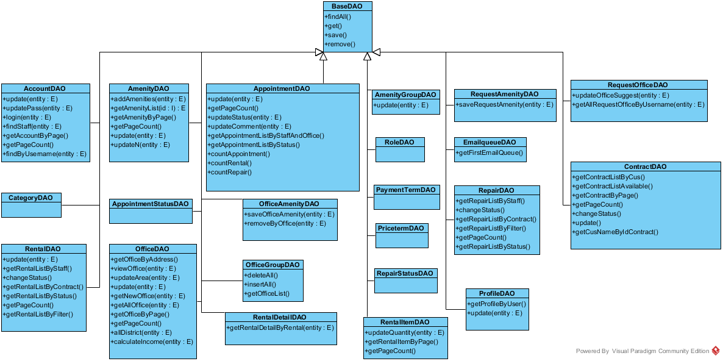

Figure : Class Diagram

**Class Diagram Explanation**

##### Class BaseDAO

Method

|  |  |  |  |
| --- | --- | --- | --- |
| **Attribute** | **Type** | **Visibility** | **Description** |
| findAll() | List<E> | public | Get all record on the equivalent entity class E of DAO class |
| get(I) | E | public | Get the instance of entity E which has the id I |
| save(E) | boolean | public | Save the instace of entity E to database. Return true if save success |
| remove(E) | boolean | public | Remove the object E from database. Return true if remove success |

##### Class AccountDAO

Method

|  |  |  |  |
| --- | --- | --- | --- |
| **Attribute** | **Type** | **Visibility** | **Description** |
| update() | void | public | Update all information of exist account. |
| updatePass() | boolean | public | Update password of exist account |
| delete() | boolen | public | Delete an exist account |
| login() | Account | public | Login into system with exist account |
| findStaff() | List<Account> | public | List array of staff account |
| getAccountByPage() | List<Account> | public | Get a list of account |
| getPageCount() | int | public | Count number of page |

##### Class AmenityDAO

Method

|  |  |  |  |
| --- | --- | --- | --- |
| **Attribute** | **Type** | **Visibility** | **Description** |
| addAmenities() | boolean | public | Add amenity into database |
| getAmenityList() | List<Amenity> | public | Get a list of amenity |
| getPageCount() | int | public | Count number of page |
| update() | Boolean | public | Update amenity information |
| updateN() | Boolean | public | Update amenity information |
| getAmenityByPage() | List<Amenity> | public | Get a list of amenity |

##### Class AmenityGroupDAO

Method

|  |  |  |  |
| --- | --- | --- | --- |
| **Attribute** | **Type** | **Visibility** | **Description** |
| update() | boolean | public | update amenity group information |

##### Class AppointmentDAO

Method

|  |  |  |  |
| --- | --- | --- | --- |
| **Attribute** | **Type** | **Visibility** | **Description** |
| countAppointment() | int | public | count number of appointment |
| getAppointmentListByStatus() | List<Appointment> | public | Get appointment list which available in current time |
| getPageCount() | int | public | Get number of page |
| update() | void | public | Update information of appointment |
| updateStatus() | Boolean | public | Update status of appointment |
| updateComment() | Boolean | public | Update comment of appointment |
| getAppointmentListByStaffAndOffice () | List<Appointment> | public | Get appointment list follow staff and office |
| countRental() | int | public | Count number of rental |
| countRepair() | int | public | Coun number of repair |

##### Class ContractDAO

Method

|  |  |  |  |
| --- | --- | --- | --- |
| **Attribute** | **Type** | **Visibility** | **Description** |
| getContractListByCus() | List<Contract> | public | Get list of contract follow name of customer |
| getContractListAvailable() | List<Contract> | public | Get list of contract follow status |
| getContractByPage() | int | public | Get list of contract |
| getPageCount() | int | public | Get number of page |
| changeStatus() | boolean | public | Change status of contract |
| update() | void | public | Update information of contract |
| getCusNameByIdContract() | Object | public | Get name of customer follow contract |

##### Class OfficeAmenityDAO

Method

|  |  |  |  |
| --- | --- | --- | --- |
| **Attribute** | **Type** | **Visibility** | **Description** |
| saveOfficeAmenity() | boolean | public | Add new amenity into office |
| removeByOffice() | boolean | public | delete amenity in office |

##### Class OfficeDAO

Method

|  |  |  |  |
| --- | --- | --- | --- |
| **Attribute** | **Type** | **Visibility** | **Description** |
| getOfficeByAddress() | List<Office> | public | Get list of office by address |
| viewOffice() | Office | public | Get information about office and give to view |
| updateArea() | boolean | public | Update information of area |
| update() | boolean | public | update information of office |
| getNewOffice() | List<Office> | public | Get 5 office have the largest of number of view |
| getAllOffice() | List<Office> | public | Get a list of office |
| getOfficeByPage() | List<Office> | public | Get a list of office |

##### Class OfficeGroupDAO

Method

|  |  |  |  |
| --- | --- | --- | --- |
| **Attribute** | **Type** | **Visibility** | **Description** |
| deleteAll() | int | public |  |
| insertAll() | boolean | public |  |
| getOfficeList() | List<OfficeGroup> | public |  |

##### Class ProfileDAO

Method

|  |  |  |  |
| --- | --- | --- | --- |
| **Attribute** | **Type** | **Visibility** | **Description** |
| getProfileByUser() | Object | public | Get information of profile by name of user |
| update() | boolean | public | Update profile of user |

##### Class RentalDAO

Method

|  |  |  |  |
| --- | --- | --- | --- |
| **Attribute** | **Type** | **Visibility** | **Description** |
| update() | void | public | Update information if rental |
| getRentalListByStaff() | List<Rental> | public | Get a list of rental by staff name |
| changeStatus() | boolean | public | Change status of rental |
| getRentalListByContract() | List<Rental> | public | Get a list of rental by contract |
| getRentalListByStatus() | List<Rental> | public | Get a list of rental by status |
| getPageCount() | int | public | Get number of page |
| getRentalListByFilter() | List<Rental> | public | Get a list of rental by information in filter |

##### Class RentalDetailDAO

Method

|  |  |  |  |
| --- | --- | --- | --- |
| Attribute | Type | Visibility | Description |
| getRentalDetailByRental() | List<RentalDetail> | public | Get a list of rental detail by rental name |

##### Class RentalItemDAO

Method

|  |  |  |  |
| --- | --- | --- | --- |
| Attribute | Type | Visibility | Description |
| update() | void | public | Update information of rental item |
| updateQuantity() | void | public | Update quantity of rental item |
| getRentalItemByPage() | List<RentalItem> | public | Get a list of rental item |
| getPageCount() | int | public | Get number of page |

##### Class RepairDAO

Method

|  |  |  |  |
| --- | --- | --- | --- |
| Attribute | Type | Visibility | Description |
| update() | void | public | Update information of repair |
| getRepairListByStaff() | List<Repair> | public | Get a list of repair by staff |
| changeStatus() | boolean | public | Change status of repair |
| getRepairListByContract() | List<Repair> | public | Get a list of repair by contract |
| getRepairListByFilter() | List<Repair> | public | Get a list of repair by information in filter |
| getRepairListByFilter() | List<Repair> | public | Get a list of repair by information in filter |
| getPageCount() | int | public | Get number of page |
| getRepairListByStatus() | List<Repair> | public | Get a list of repair by current status of repair |

##### Class RepairDetailDAO

Method

|  |  |  |  |
| --- | --- | --- | --- |
| **Attribute** | **Type** | **Visibility** | **Description** |
| saveRepairDetail() | boolean | public | Save information of repair detail |

##### Class RequestAmenityDAO

Method

|  |  |  |  |
| --- | --- | --- | --- |
| **Attribute** | **Type** | **Visibility** | **Description** |
| saveRequestAmenity() | boolean | public | Save information of request amenity |

##### Class RequestOfficeDAO

Method

|  |  |  |  |
| --- | --- | --- | --- |
| **Attribute** | **Type** | **Visibility** | **Description** |
| updateOfficeSuggest() | boolean | public | Update information of office suggest |
| getAllRequestOfficeByUsername() | List<RequestOffice> | public | Get a list off request office by username |

##### Class AppointmentStatusDAO

<No attribute and method>

##### Class CategoryDAO

<No attribute and method>

##### Class PaymentTermDAO

<No attribute and method>

##### Class PriceTermDAO

<No attribute and method>

##### Class RepairStatusDAO

<No attribute and method>

##### Class RoleDAO

<No attribute and method>

#### Service Package Class Diagram

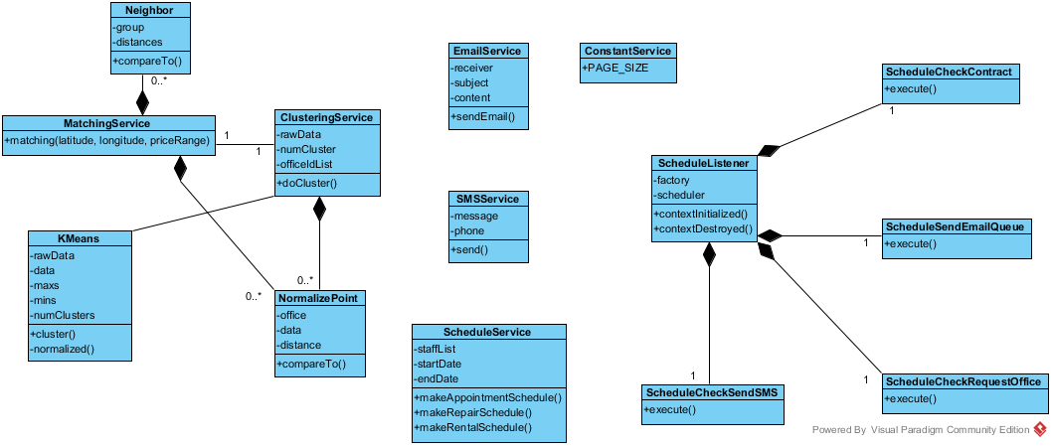

Figure : Service Package Class Diagram

**Class Diagram Explanation**

##### EmailService

Attribute

|  |  |  |  |
| --- | --- | --- | --- |
| **Attribute** | **Type** | **Visibility** | **Description** |
| receiver | String | private | The recipient of the email |
| subject | String | private | The subject of the email |
| content | String | private | The content of the email |

Method

|  |  |  |  |
| --- | --- | --- | --- |
| **Attribute** | **Type** | **Visibility** | **Description** |
| sendEmail | boolean | public | Send the email with the subject and content to the receiver |

##### SMSService

Attribute

|  |  |  |  |
| --- | --- | --- | --- |
| **Attribute** | **Type** | **Visibility** | **Description** |
| message | String | private | The SMS message will be sent |
| phone | String | private | The phone number of the recipient |

Method

|  |  |  |  |
| --- | --- | --- | --- |
| **Attribute** | **Type** | **Visibility** | **Description** |
| send() | String | public | Send the SMS message to the recipient. Return “SUCCESS” if sent success, otherwise return the error message form the service provider |

##### ConstantService

Attribute

|  |  |  |  |
| --- | --- | --- | --- |
| **Attribute** | **Type** | **Visibility** | **Description** |
| PAGE_SIZE | int | public | The constant for the page size of the list in admin pages |

##### ScheduleService

Attribute

|  |  |  |  |
| --- | --- | --- | --- |
| **Attribute** | **Type** | **Visibility** | **Description** |
| staffList | List<Staff> | private | The list of all staff for the service |
| startDate | DateTime | private | The start date of the week for the schedule |
| endDate | DateTime | private | The end date of the week for the schedule |

Method

|  |  |  |  |
| --- | --- | --- | --- |
| **Attribute** | **Type** | **Visibility** | **Description** |
| makeAppointmentSchedule() | Map | public | Return the schedule hash map with appointment id and staff username for the unassigned appointment |
| makeRepairSchedule() | Map | public | Return the schedule hash map with repair id and pre-arranged repair for the unassigned repair |
| makeRentalSchedule() | Map | public | Return the schedule hash map with rental id and pre-arranged rental for the unassigned rental |

##### KMeans

Attribute

|  |  |  |  |
| --- | --- | --- | --- |
| **Attribute** | **Type** | **Visibility** | **Description** |
| rawData | double[][] | private | The raw data for k-means algorithm |
| data | double[][] | private | The normalized data for k-means algorithm |
| maxs | double[] | private | The array for max value of each dimension of k-means |
| mins | double[] | private | The array for min value of each dimension of k-means |
| numClusters | int | private | The number of cluster (k) in k-means algorithm |

Method

|  |  |  |  |
| --- | --- | --- | --- |
| **Attribute** | **Type** | **Visibility** | **Description** |
| cluster | double[] | public | Do the k-means algorithm. Return the array of group id for each of input data |
| normalized | double[][] | private | Normalize the raw data |

##### ClusteringService

Attribute

|  |  |  |  |
| --- | --- | --- | --- |
| **Attribute** | **Type** | **Visibility** | **Description** |
| rawData | double[][] | private | The input raw data of all office |
| numCluster | int | private | The calculated k-means number |
| officeIdList | int[] | private | List of all office id |

Method

|  |  |  |  |
| --- | --- | --- | --- |
| **Attribute** | **Type** | **Visibility** | **Description** |
| doCluster | int[] | public | Do the k-means clustering for all office. The result is saved to database also return the array of office group by all office |

##### NormalizePoint

Attribute

|  |  |  |  |
| --- | --- | --- | --- |
| **Attribute** | **Type** | **Visibility** | **Description** |
| office | Office | private | Use to store the office for clustering service |
| data | double[] | private | The normalize data for current office |
| distance | double | private | The distance between the data point and query point in MatchingService |

Method

|  |  |  |  |
| --- | --- | --- | --- |
| **Attribute** | **Type** | **Visibility** | **Description** |
| compareTo() | int | public | Return the compare result of 2 NormalizePoint |

##### MatchingService

Method

|  |  |  |  |
| --- | --- | --- | --- |
| **Attribute** | **Type** | **Visibility** | **Description** |
| matching() | List<Office> | public | Do the matching group for the input office point and the all office data. Return the list of matched office group sort by relevant |

##### Neighbor

Attribute

|  |  |  |  |
| --- | --- | --- | --- |
| **Attribute** | **Type** | **Visibility** | **Description** |
| group | int | private | The index of the office group |
| distances | List<Double> | private | The list of distance of query point and office in group for the KNN matching service |

Method

|  |  |  |  |
| --- | --- | --- | --- |
| **Attribute** | **Type** | **Visibility** | **Description** |
| compareTo() | int | public | Compare distance between query point and two list of data |

##### ScheduleListener

Attribute

|  |  |  |  |
| --- | --- | --- | --- |
| **Attribute** | **Type** | **Visibility** | **Description** |
| factory | SchedulerFactory | private | The factory for initiate the scheduler |
| scheduler | Scheduler | private | The class contain the instance of the scheduler factory |

Method

|  |  |  |  |
| --- | --- | --- | --- |
| **Attribute** | **Type** | **Visibility** | **Description** |
| contextInitialized() | void | public | Override context listener when the app initialized |
| contextDestroyed() | void | public | O Override context listener when the app destroyed |

##### ScheduleCheckContract

Method

|  |  |  |  |
| --- | --- | --- | --- |
| **Attribute** | **Type** | **Visibility** | **Description** |
| execute | void | public | Execute the schedule for check the contract due date. Cancel the contract if the contract at due date |

##### ScheduleCheckRequestOffice

Method

|  |  |  |  |
| --- | --- | --- | --- |
| **Attribute** | **Type** | **Visibility** | **Description** |
| execute | void | public | Execute the schedule for check the Request office. Stored the found office and queue to send an email to customer |

##### ScheduleCheckSendSMS

Method

|  |  |  |  |
| --- | --- | --- | --- |
| **Attribute** | **Type** | **Visibility** | **Description** |
| execute | void | public | Execute the schedule for check the appointment date. Send a SMS to user if the appointment date is near |

##### ScheduleCheckEmailQueue

Method

|  |  |  |  |
| --- | --- | --- | --- |
| **Attribute** | **Type** | **Visibility** | **Description** |
| execute | void | public | Execute the schedule for check the email in queue to send |

#### Controller Package Class Diagram

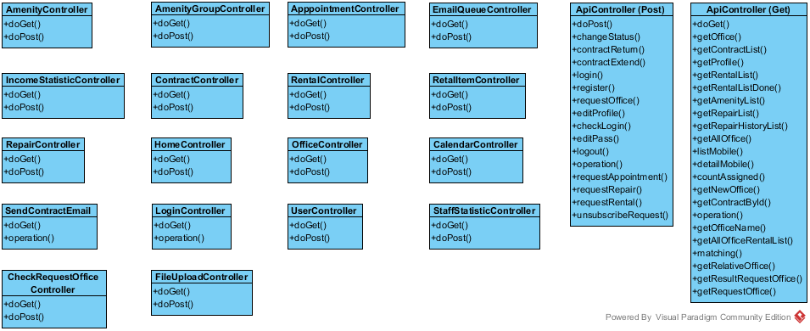

Figure : Class Diagram

**Class Diagram Explanation**

##### Controller

Method

|  |  |  |  |
| --- | --- | --- | --- |
| **Attribute** | **Type** | **Visibility** | **Description** |
| doGet() | void | public | Hanlde the get request from user |
| doPost | void | public | Handle the post request from user |

##### ApiController

Method

|  |  |  |  |
| --- | --- | --- | --- |
| **Attribute** | **Type** | **Visibility** | **Description** |
| getOffice() | void | public | Get the office json object by office id |
| getContractList() | void | public | Get the contract list json object by customer in session |
| getProfile() | void | public | Get the profile json object by customer in session |
| getRentalList() | void | public | Get the rental list json object by office id |
| getRentalListDone() | void | public | Get the rental list json object by office id where status is done |
| getAmenityList() | void | public | Get all the amenity list |
| getRepairList() | void | public | Get the repair list json object by office id |
| getRepairHistoryList() | void | public | Get the repair list json object by office id where status is done |
| getAllOffice() | void | public | Get list json of all office |
| listMobile() | void | public | Get the list of job json for mobile app |
| detailMobile() | void | public | Get the detail of job json for mobile app |
| countAssigned() | void | public | Count the assigned job for mobile |
| searchOfficeByAddress() | void | public | Get the office list filter by address |
| getNewOffice() | void | public | Get the office list has most viewed |
| getContractById() | void | public | Get the contract json by id |
| amenity() | void | public | Get the amenity list |
| officeName() | void | public | Get the list of all office name |
| getAllOfficeRentalList() | void | public | Get the list of all rental json by office |
| matching() | void | public | Get the matching office list by search criteria |
| getRelativeOffice() | void | public | Get the relative office by current office |
| getResultRequestOffice() | void | public | Get the result office list that had requested |
| getRequestOffice() | void | public | Get the list of request office by customer |
| changeStatus() | void | public | Change the status of the job in mobile app |
| contractReturn() | void | public | Request return office |
| contractExtend() | void | public | Request extend contract |
| login() | void | public | Request login in front end app |
| register() | void | public | Request register in front end app |
| requestOffice() | void | public | Request office |
| editProfile() | void | public | Edit profile |
| checkLogin() | void | public | Check the status login in current session |
| editPass() | void | public | Change password of current customer |
| logout() | void | public | Customer log out |
| requestAppointment() | void | public | Request appointment by customer |
| requestRepair() | void | public | Request repair by customer |
| requestRental() | void | public | Request rental by customer |
| unsubscribeRequest() | void | public | Unsubscribe the office request |

#### Mobile Package Class Diagram

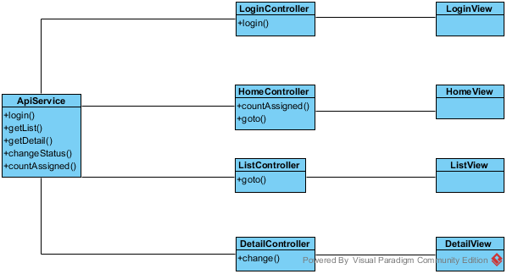

Figure : Mobile Package Class Diagram

**Class Diagram Explanation**

##### ApiService

Method

|  |  |  |  |
| --- | --- | --- | --- |
| **Attribute** | **Type** | **Visibility** | **Description** |
| login() | function | public | Call the login api and return the result. |
| getList() | function | public | Call the getList api to return the list of job for current staff (appointment/rental/repair) |
| getDetail() | function | public | Call the getDetail api to return the detail of current job |
| countAssigned() | function | public | Call the countAssigned api to return the number of assigned for current job |
| changeStatus() | function | public | Call the changeStatus api to change the status of current job |

##### LoginController

Attribute

|  |  |  |  |
| --- | --- | --- | --- |
| **Attribute** | **Type** | **Visibility** | **Description** |
| username | string | private | The inputted username |
| password | string | private | The inputted password |

Method

|  |  |  |  |
| --- | --- | --- | --- |
| **Attribute** | **Type** | **Visibility** | **Description** |
| login() | function | private | Call the login function of ApiService |

##### LoginView

This is the presentation view of LoginController

##### HomeController

Attribute

|  |  |  |  |
| --- | --- | --- | --- |
| **Attribute** | **Type** | **Visibility** | **Description** |
| title | string | private | The title of the job (appointment/rental/repair) |
| badge | Array | private | The array of number of assigned job |

Method

|  |  |  |  |
| --- | --- | --- | --- |
| **Attribute** | **Type** | **Visibility** | **Description** |
| countAssigned() | function | private | Call the countAssigned function of ApiService to get the job number |
| goto() | function | private | Go to the list page of the job |

##### HomeView

This is the presentation view of HomeController

##### ListController

Attribute

|  |  |  |  |
| --- | --- | --- | --- |
| **Attribute** | **Type** | **Visibility** | **Description** |
| title | string | private | The title of the job (appointment/rental/repair) |
| data | Array | private | The array of the detail of job |

Method

|  |  |  |  |
| --- | --- | --- | --- |
| **Attribute** | **Type** | **Visibility** | **Description** |
| goto() | function | private | Go to the detail page of the job |

##### ListView

This is the presentation view of ListController

##### DetailController

Attribute

|  |  |  |  |
| --- | --- | --- | --- |
| **Attribute** | **Type** | **Visibility** | **Description** |
| title | string | private | The title of the job (appointment/rental/repair) |
| data | object | private | The detail of job |

Method

|  |  |  |  |
| --- | --- | --- | --- |
| **Attribute** | **Type** | **Visibility** | **Description** |
| change() | function | private | Call the api to change the status of the job |

##### DetailView

This is the presentation view of DetailController

### Interaction Diagram

#### Guest Sequence Diagram

##### <Guest> Login

**Summary:** This diagram used to describe the process of guest login

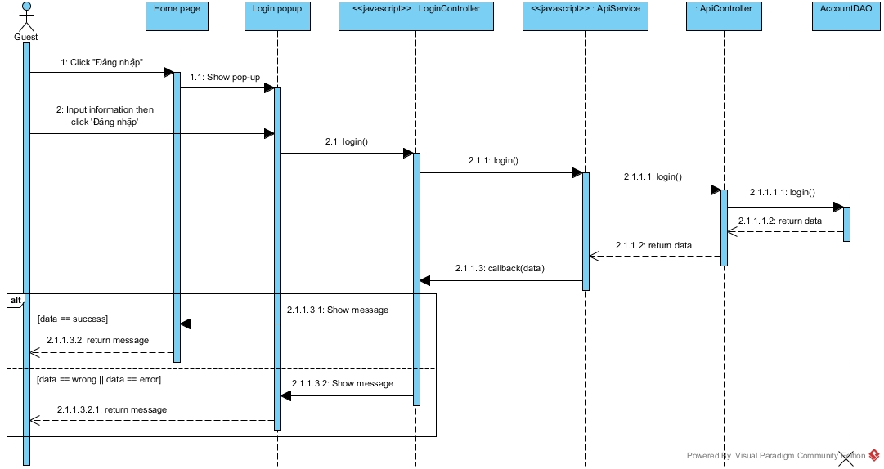

Figure : Login Sequence Diagram

##### <Guest> Register

**Summary:** This diagram used to describe the process of guest register account

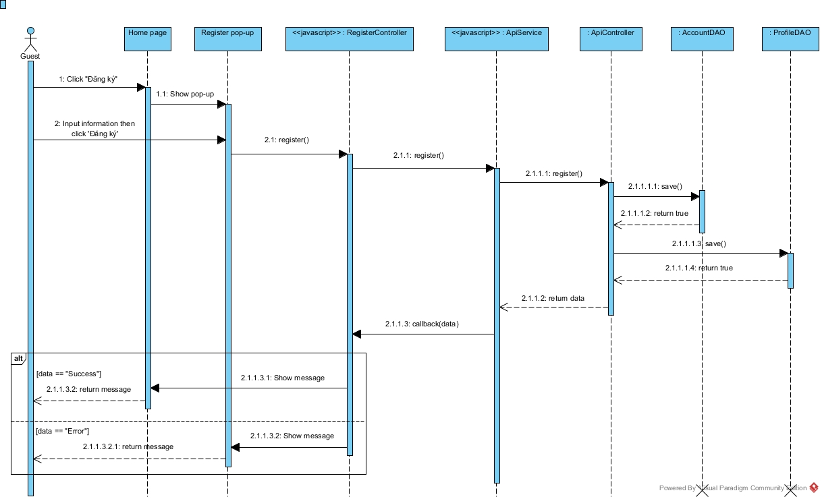

Figure : Register Sequence Diagram

##### <Guest, Customer> Search office

**Summary:** This diagram used to describe the process of guest search for offices

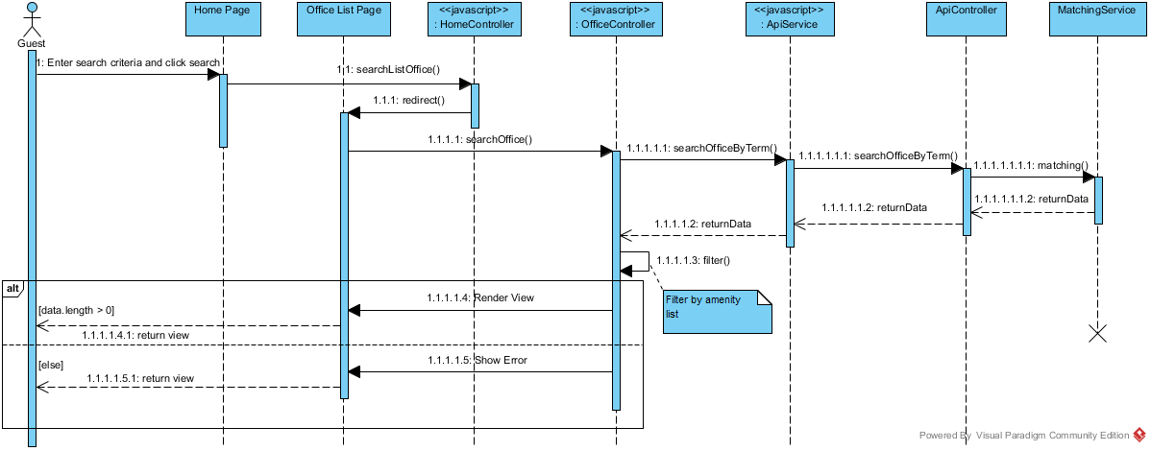

Figure : Search Office Sequence Diagram

##### <Guest, Customer > View office detail

**Summary:** This diagram used to describe the process of guest search for offices

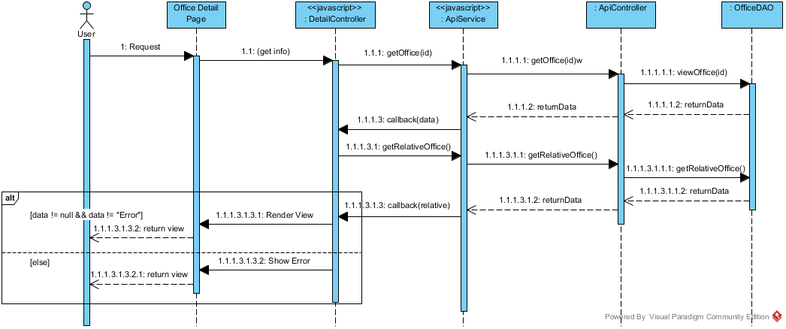

Figure : View office detail Sequence Diagram

#### Customer Sequence Diagrams

##### <Customer> Get Office List

**Summary:** This diagram used to describe the process of customer request repair office

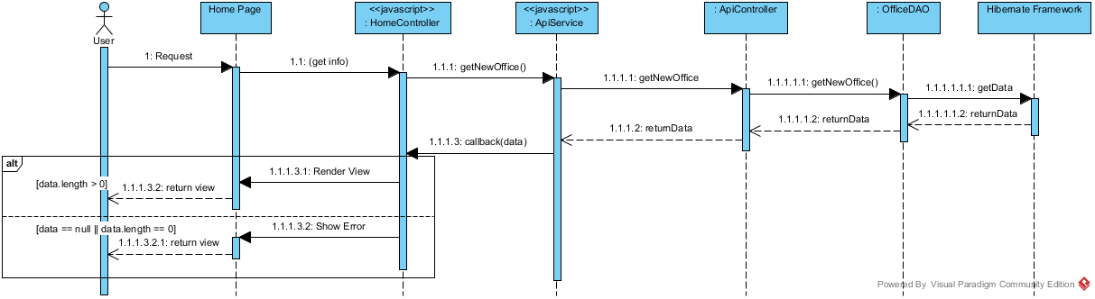

Figure : Get office list Sequence Diagram

##### <Customer> Create Appointment Request

**Summary:** This diagram used to describe the process of customer request an appointment.



Figure : Create Appointment Request Sequence Diagram

##### <Customer> Create Office Request

**Summary:** This diagram used to describe the process of customer create office request

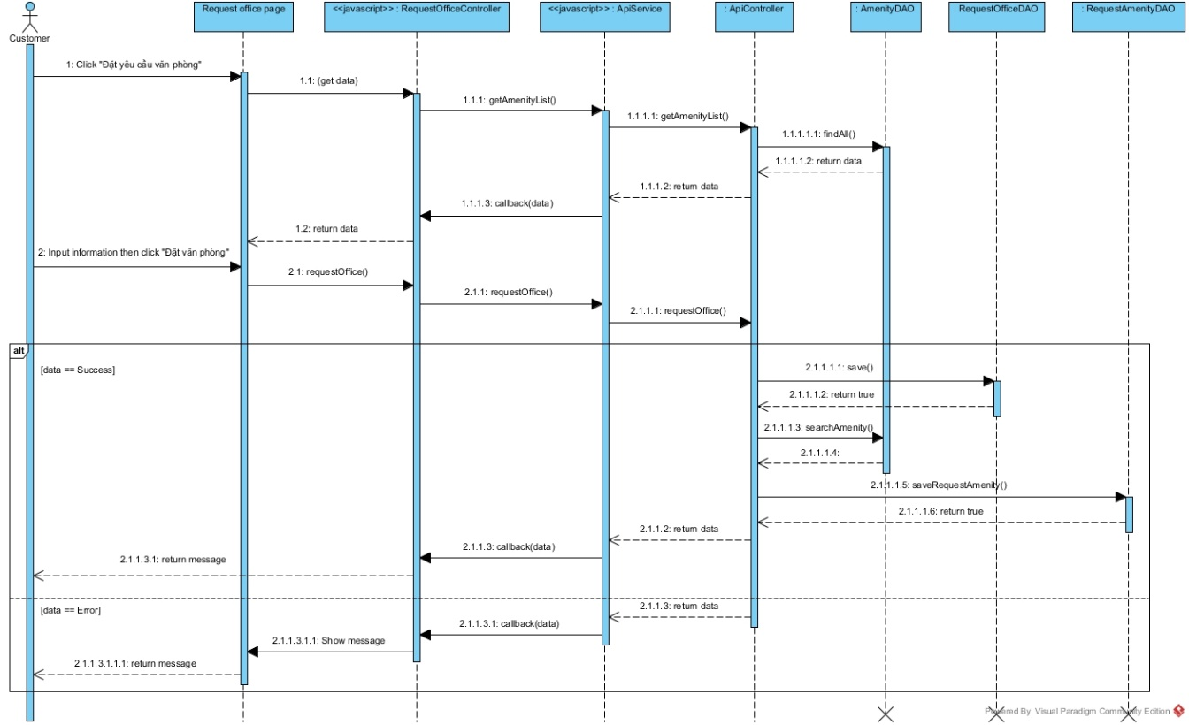

Figure : Create Office Request Sequence Diagram

##### <Customer> Request Extend Contract

**Summary:** This diagram used to describe the process of customer request extend contract

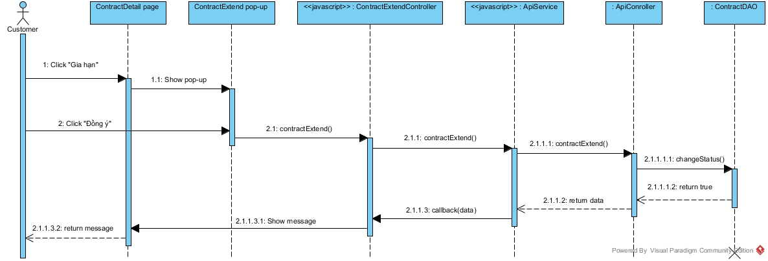

Figure : Request Extend Contract Sequence Diagram

##### <Customer> Request Return Contract

**Summary:** This diagram used to describe the process of customer request return contract

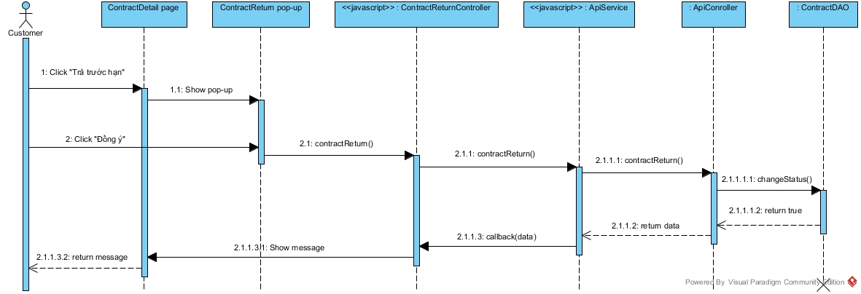

Figure : Request Return Contract Sequence Diagram

##### <Customer> Request Rental

**Summary:** This diagram used to describe the process of customer request rental



Figure : Create office Sequence Diagram

##### <Customer> Request Repair

**Summary:** This diagram used to describe the process of customer request repair office

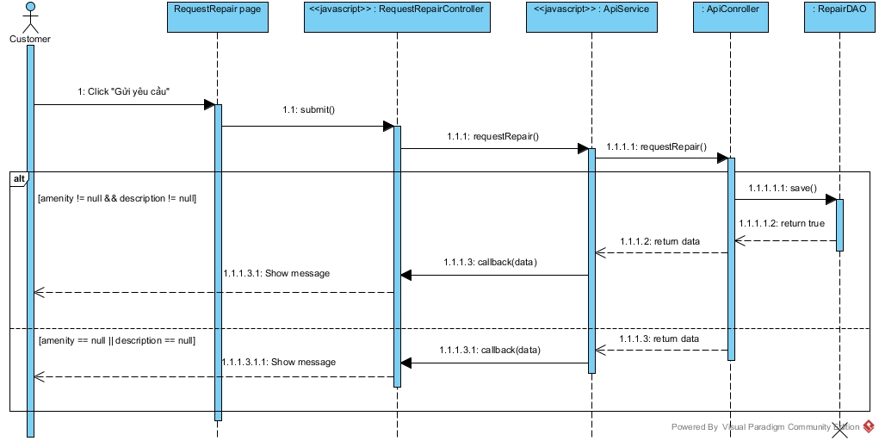

Figure : Request Repair Sequence Diagram

##### <Customer> View contract

**Summary:** This diagram used to describe the process of customer view contract

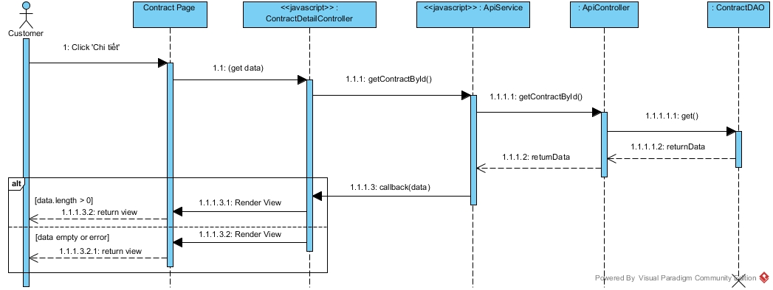

Figure : View Contract Sequence Diagram

##### <Customer> View Customer Info

**Summary:** This diagram used to describe the process of customer view profile

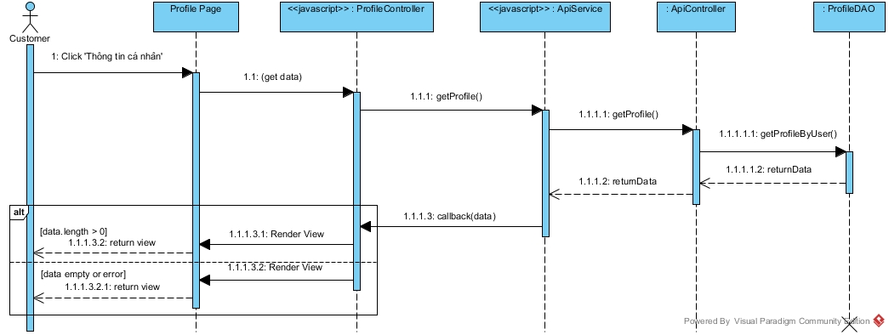

Figure : View Customer Info Sequence Diagram

##### <Customer> View List Contract

**Summary:** This diagram used to describe the process of customer view list contract

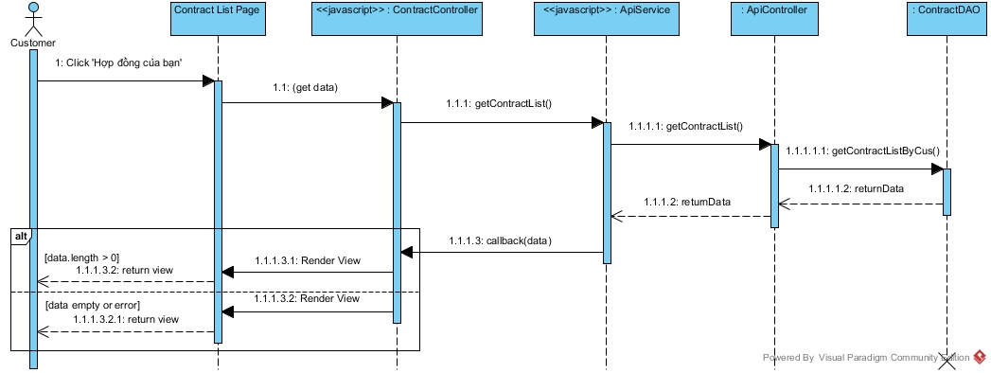

Figure : View List Contract Sequence Diagram

##### <Customer> View List Repair History

**Summary:** This diagram used to describe the process of customer view list repair history

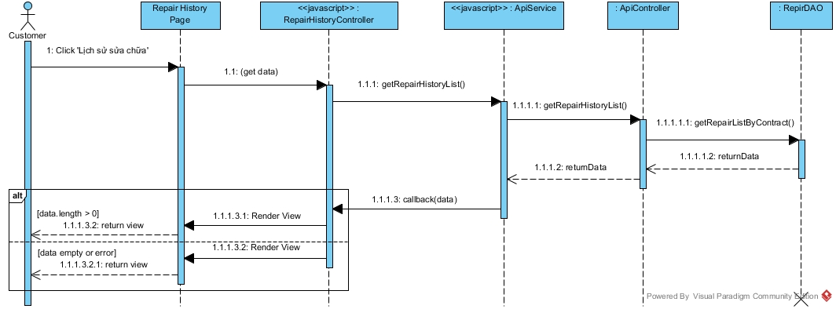

Figure : View List Repair History Sequence Diagram

##### <Customer> View Rental Request List

**Summary:** This diagram used to describe the process of customer view rental request list

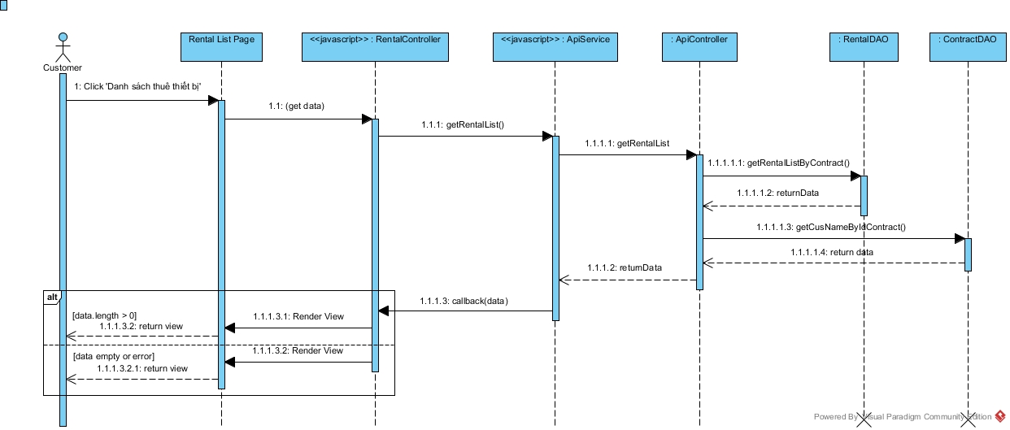

Figure : View Rental Request List Sequence Diagram

##### <Customer> View Repair Request List

**Summary:** This diagram used to describe the process of customer view repair request list

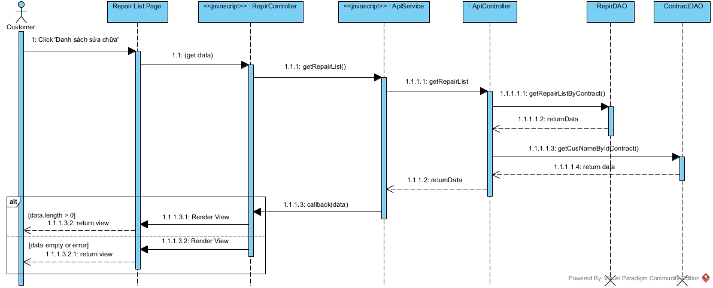

Figure : View Repair Request List Sequence Diagram

##### <Customer> View Result Request Office

**Summary:** This diagram used to describe the process of customer view result request office.

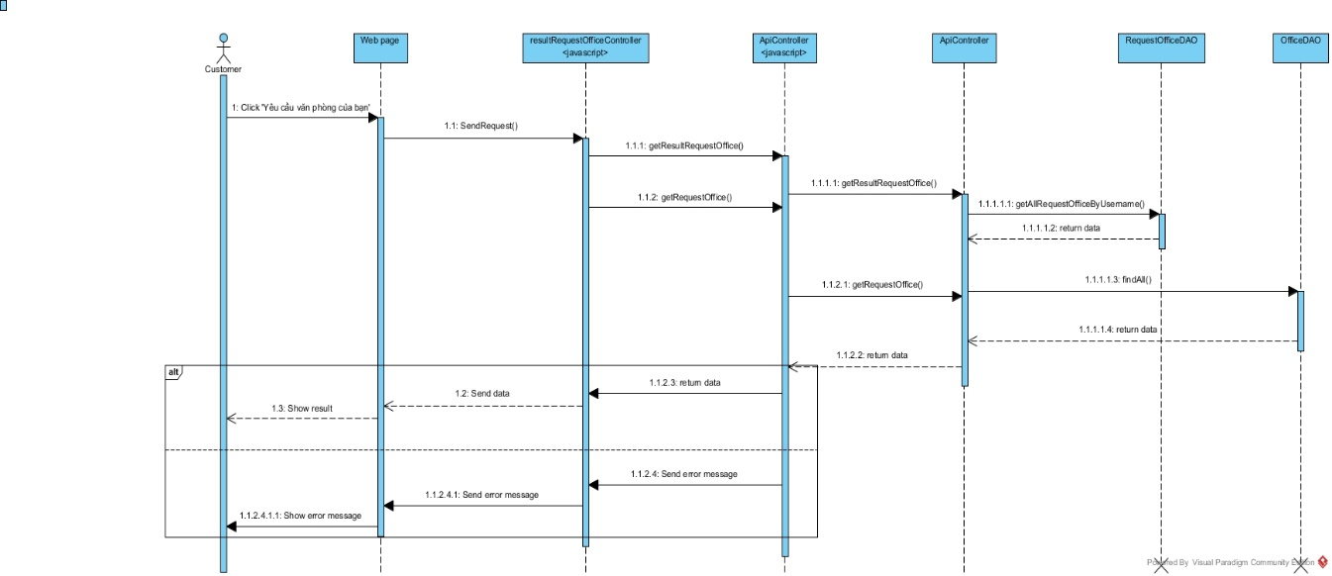

Figure : View Result Request Office Sequence Diagram

##### <Customer> Change Password

**Summary:** This diagram used to describe the process of customer change password

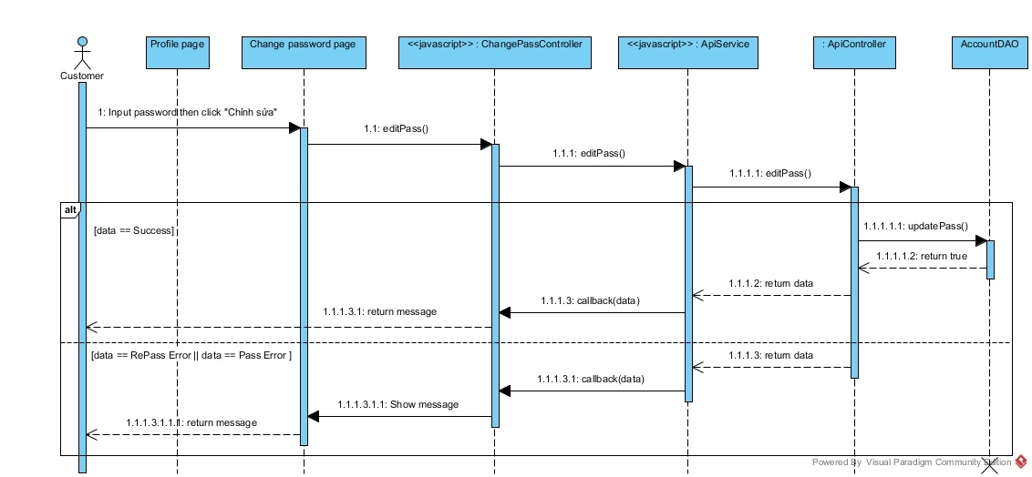

Figure : Change Password Sequence Diagram

##### <Customer> Edit Customer Info

**Summary:** This diagram used to describe the process of customer edit profile

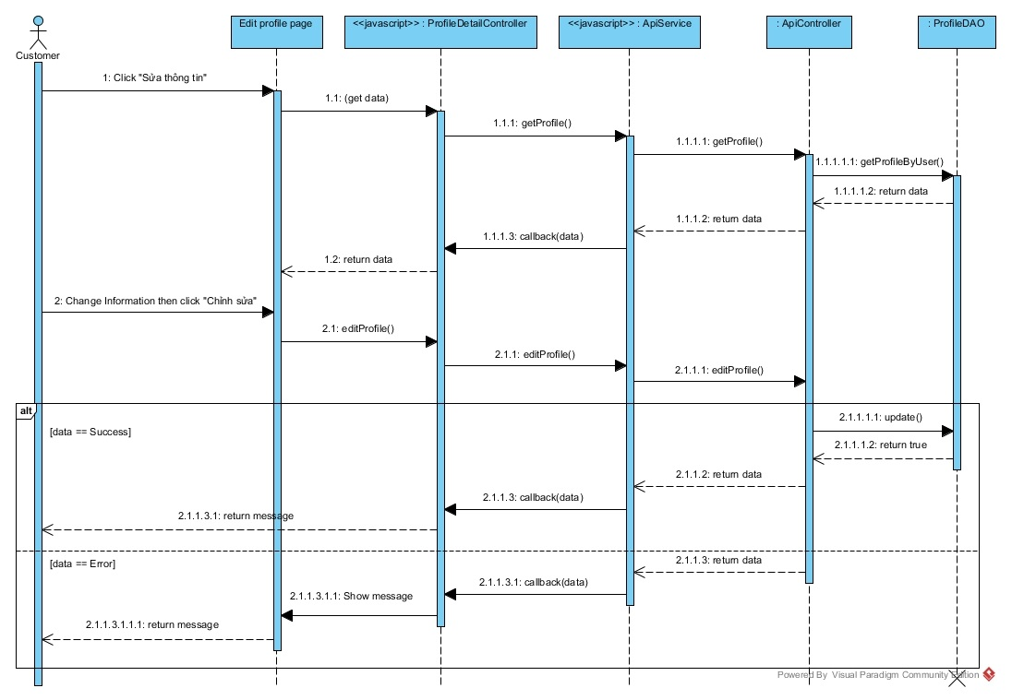

Figure : Edit Customer Info Sequence Diagram

#### Staff Sequence Diagram

##### <Staff> View Assigned Repair Request List

**Summary:** This diagram used to describe the process of staff view assigned repair request.

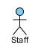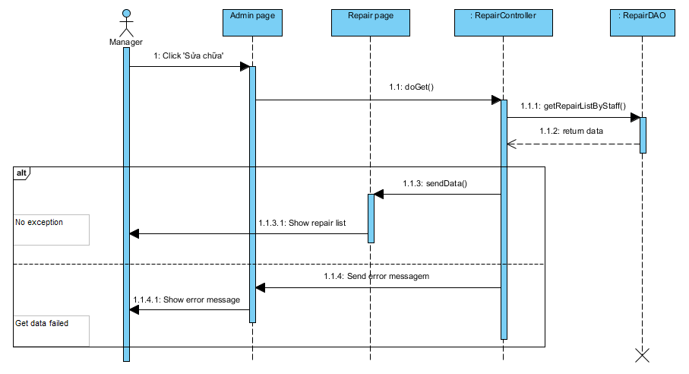

Figure : View Assigned Repair Request List Sequence Diagram

##### <Staff> Change Repair Status

**Summary:** This diagram used to describe the process of staff view assigned repair request.

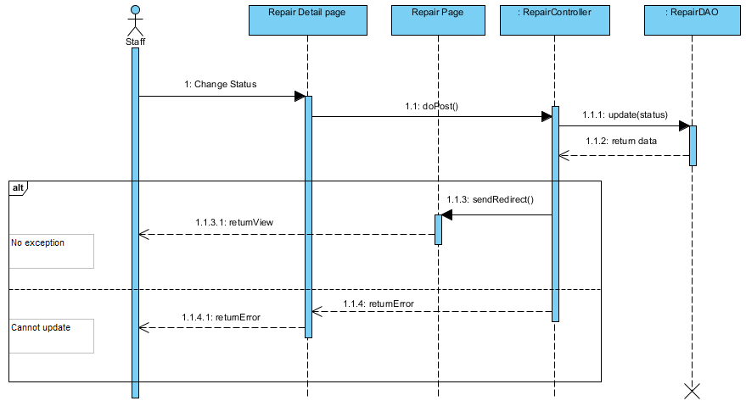

Figure : Change Repair Status Sequence Diagram

##### <Staff> View Assigned Rental Request List

**Summary:** This diagram used to describe the process of staff view assigned repair request.

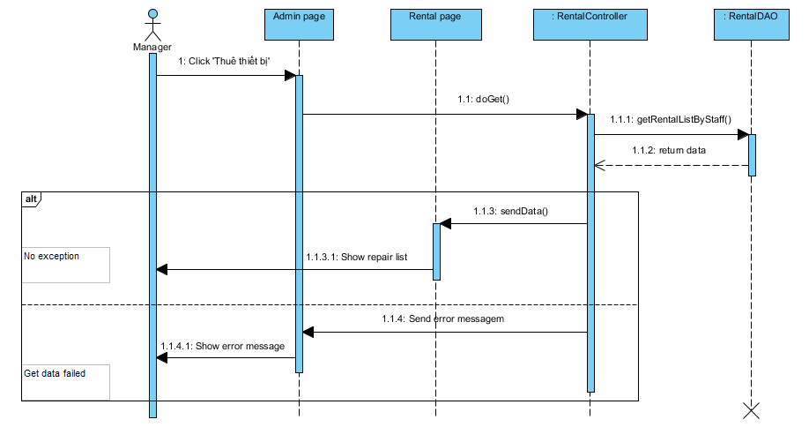

Figure : View Assigned Rental Request List Sequence Diagram

##### <Staff> Change Rental Status

**Summary:** This diagram used to describe the process of staff view assigned repair request.

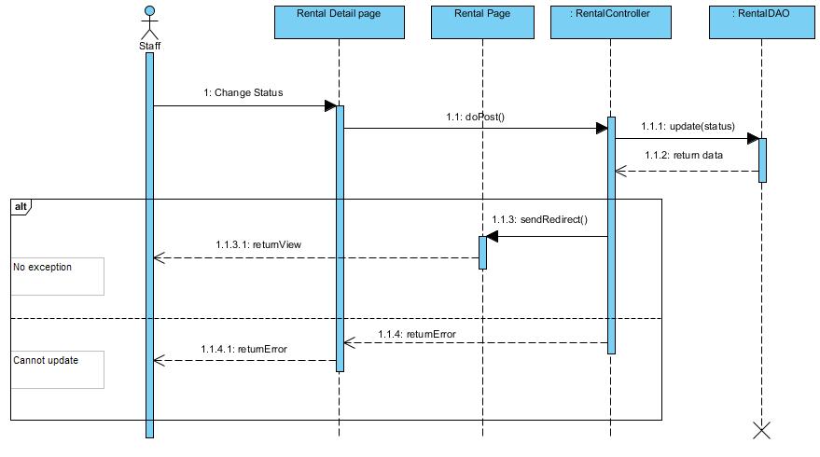

Figure : Change Rental Status Sequence Diagram

##### <Staff> View Assigned Appointment

**Summary:** This diagram used to describe the process of staff view assigned repair request.

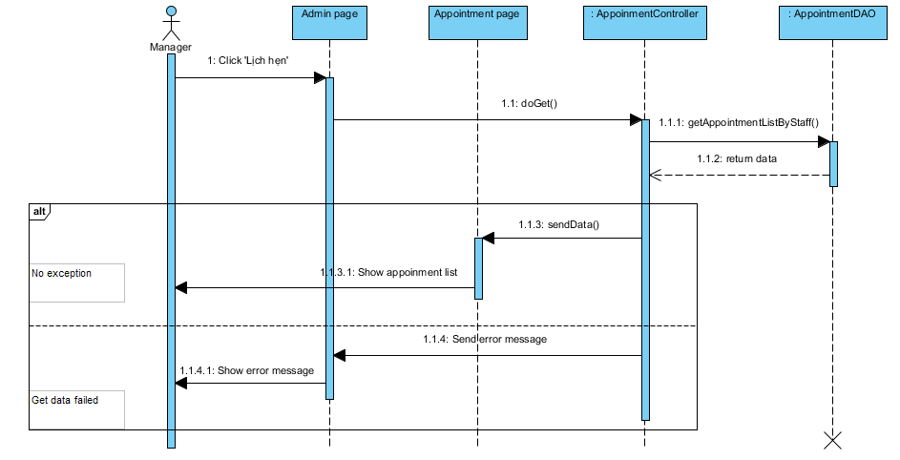

Figure : View Assigned Appointment Sequence Diagram

##### <Staff> Change Appointment Status

**Summary:** This diagram used to describe the process of staff view assigned repair request.

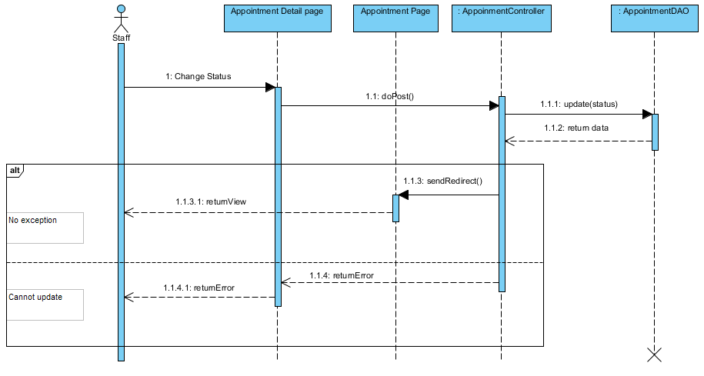

Figure : Change Appointment Status Sequence Diagram

##### <Staff, Manager> Create New Office

**Summary:** This diagram used to describe the process of staff create new office.

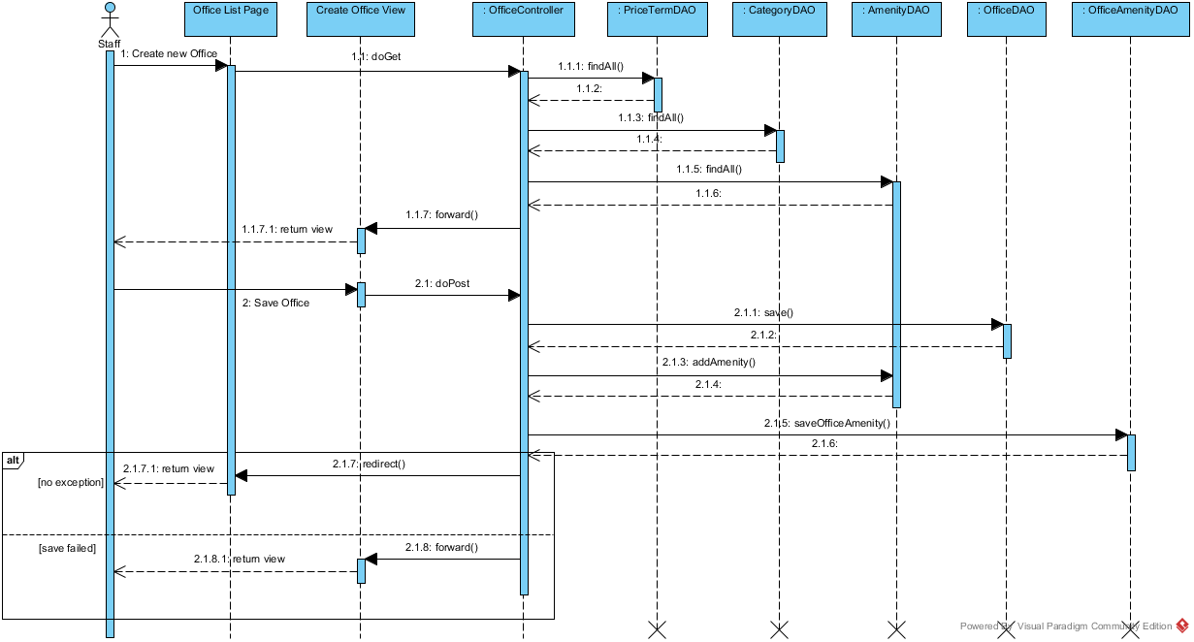

Figure : Create New Office Sequence Diagram

##### <Staff, Manager> View Office List

**Summary:** This diagram used to describe the process of staff edit office detail.

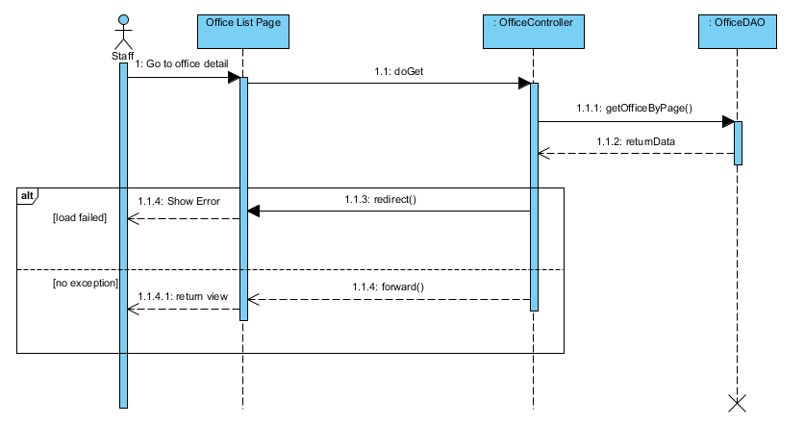

Figure : View Office List Sequence Diagram

##### <Staff, Manager> View Office Detail

**Summary:** This diagram used to describe the process of staff edit office detail.

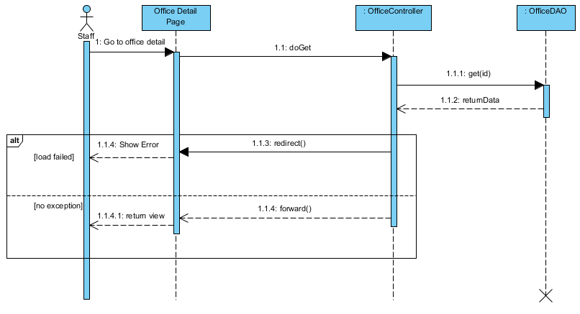

Figure : Edit Office Sequence Diagram

##### <Staff, Manager> Edit Office

**Summary:** This diagram used to describe the process of staff edit office detail.

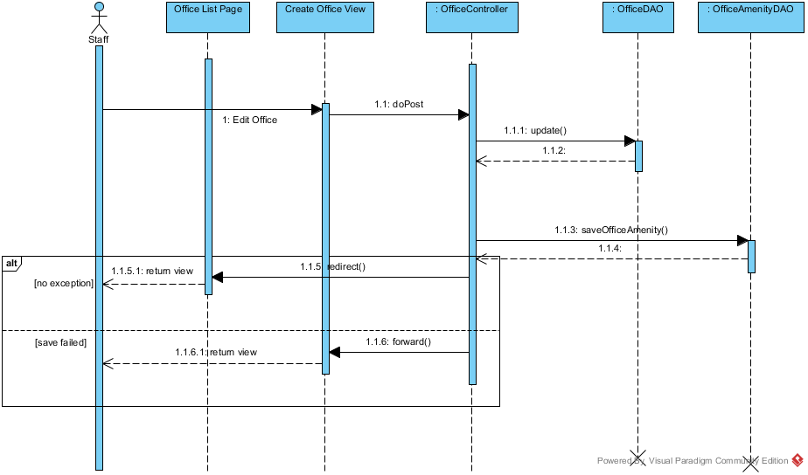

Figure : Edit Office Sequence Diagram

##### <Staff, Manager> View customer profile

**Summary:** This diagram used to describe the process of view customer profile.

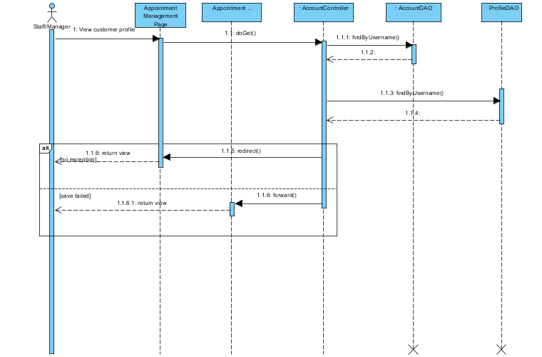

Figure : View Customer Profile Sequence Diagram

#### Manager Sequence Diagram

##### <Manager> View Appointment Request List

**Summary:** This diagram used to describe the process of manager view all appointment requests.

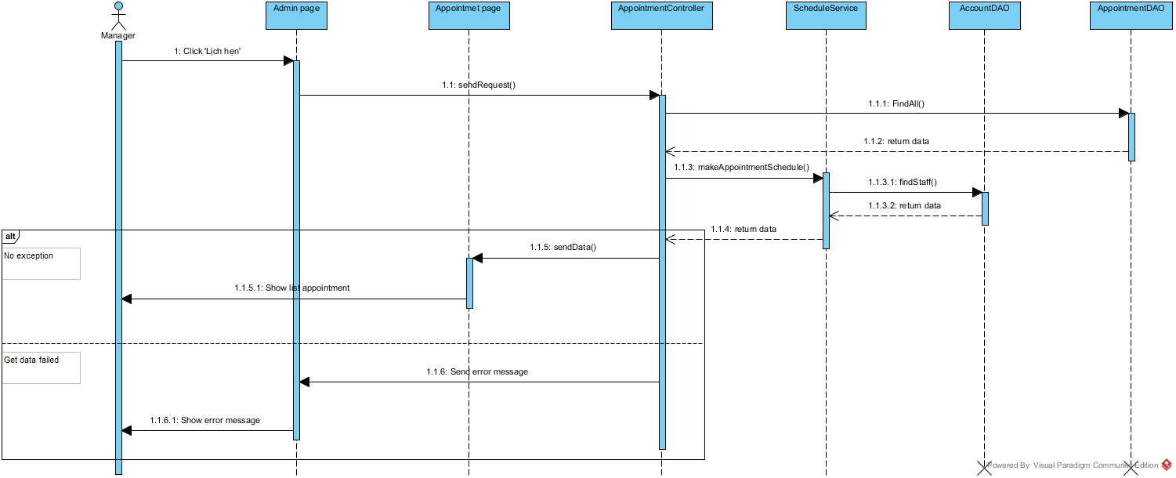

Figure : View Appointment Request List Sequence Diagram

##### <Manager> Assign Appointment

**Summary:** This diagram used to describe the process of manager assign appointment requests to staff.



Figure : Assign Appointment Sequence Diagram

##### <Manager> Cancel Appointment Request

**Summary:** This diagram used to describe the process of manager cancel appointment request.

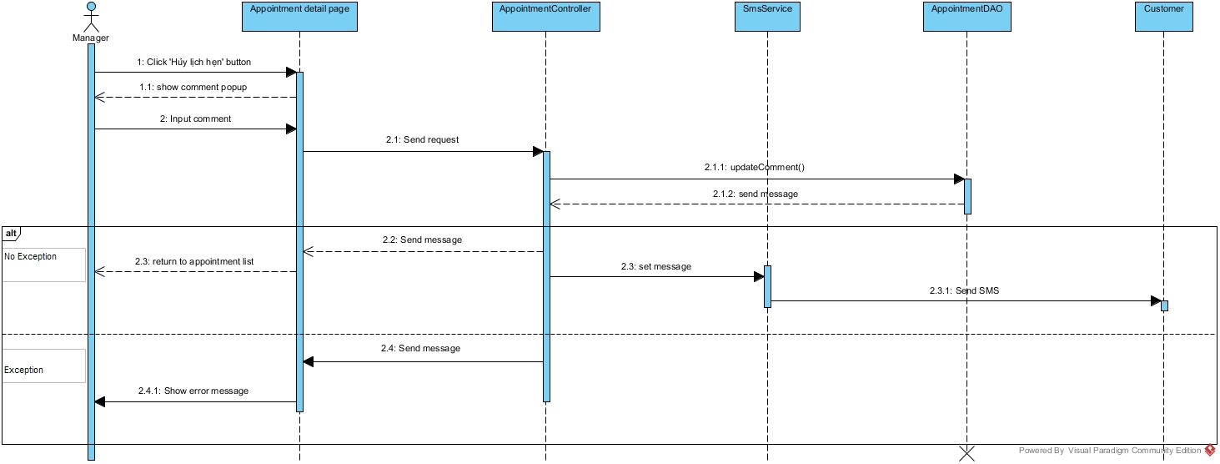

Figure : Cancel Appointment Request Sequence Diagram

##### <Manager> Create Contract

**Summary:** This diagram used to describe the process of manager create contract



Figure : Create Contract Sequence Diagram

##### <Manager> View Contract List

**Summary:** This diagram used to describe the process of manager view contract list

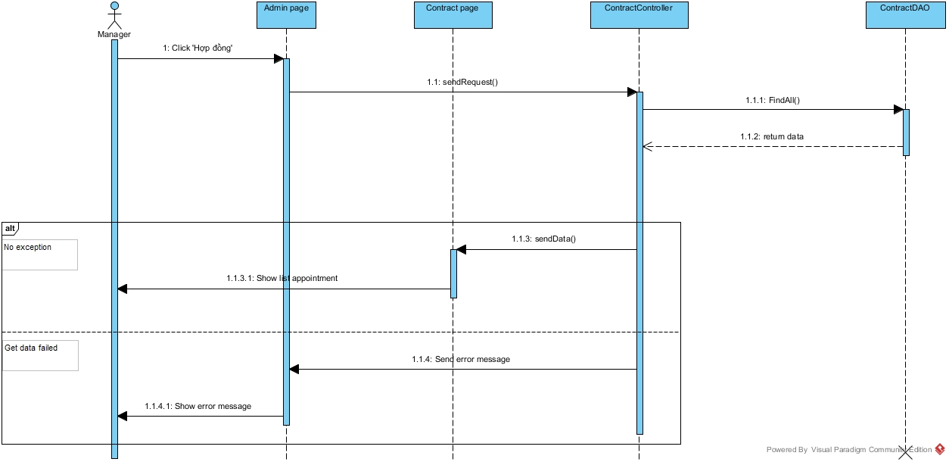

Figure : View Contract List Sequence Diagram

##### <Manager> View Contract Detail

**Summary:** This diagram used to describe the process of manager view contract detail

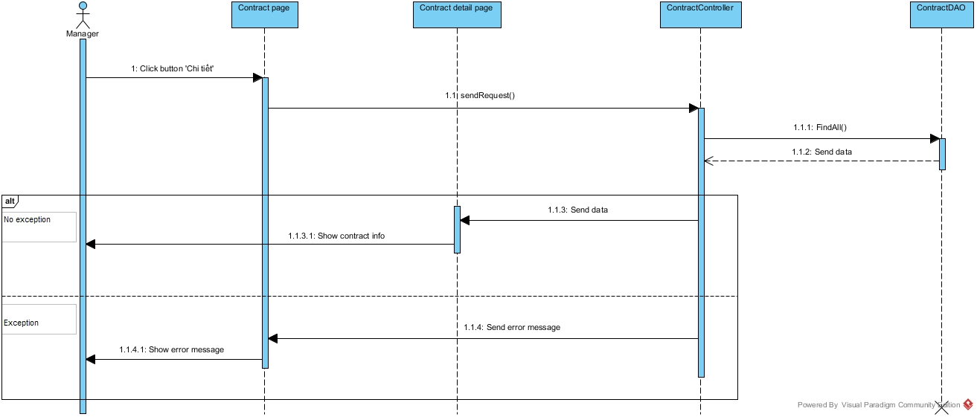

Figure : View Contract Detail Sequence Diagram

##### <Manager> Edit Contract

**Summary:** This diagram used to describe the process of manager edit contract.

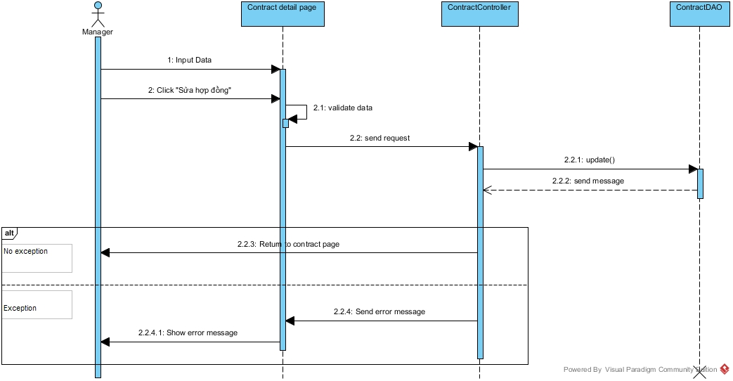

Figure : Edit Contract Sequence Diagram

##### <Manager> View Request Extend List

**Summary:** This diagram used to describe the process of view request extend list.

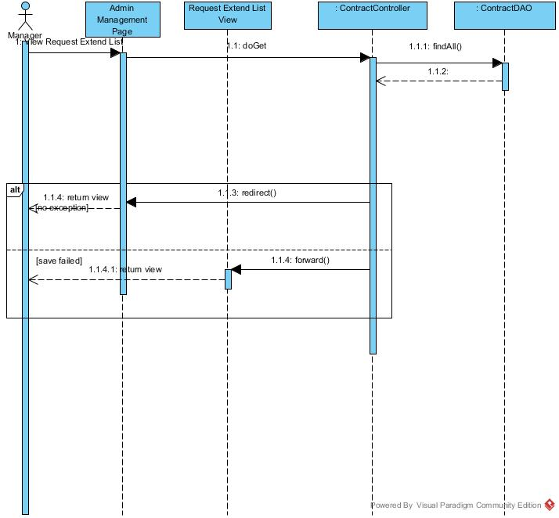

Figure : View Request Extend List Sequence Diagram

##### <Manager> Accept Extend Request

**Summary:** This diagram used to describe the process of manager accept extend request

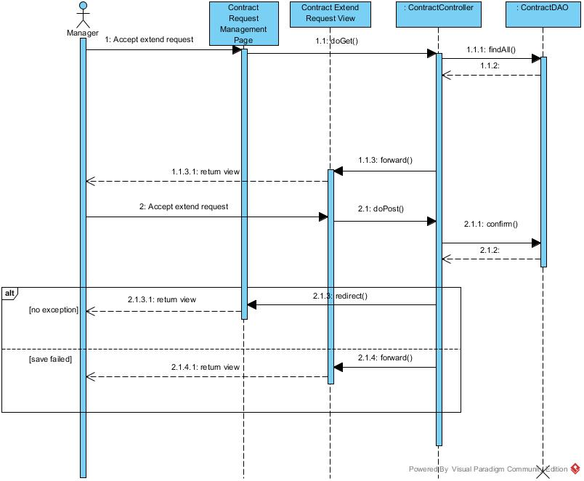

Figure : Accept Extend Request Sequence Diagram

##### <Manager> Cancel Extend Request

**Summary:** This diagram used to describe the process of manager cancel request extend contract.

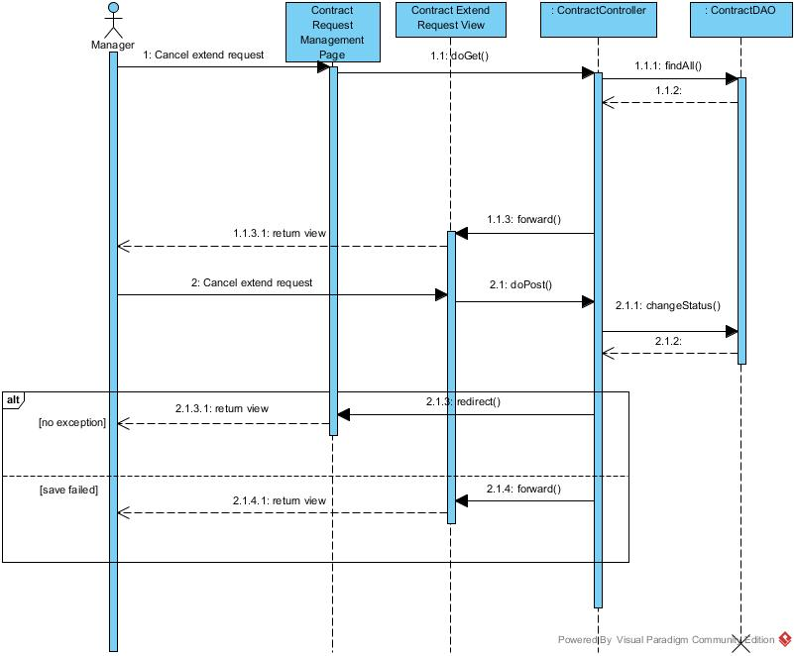

Figure : Cancel Extend Request Sequence Diagram

##### <Manager> View Request Return Contract

**Summary:** This diagram used to describe the process of manager view request return contract

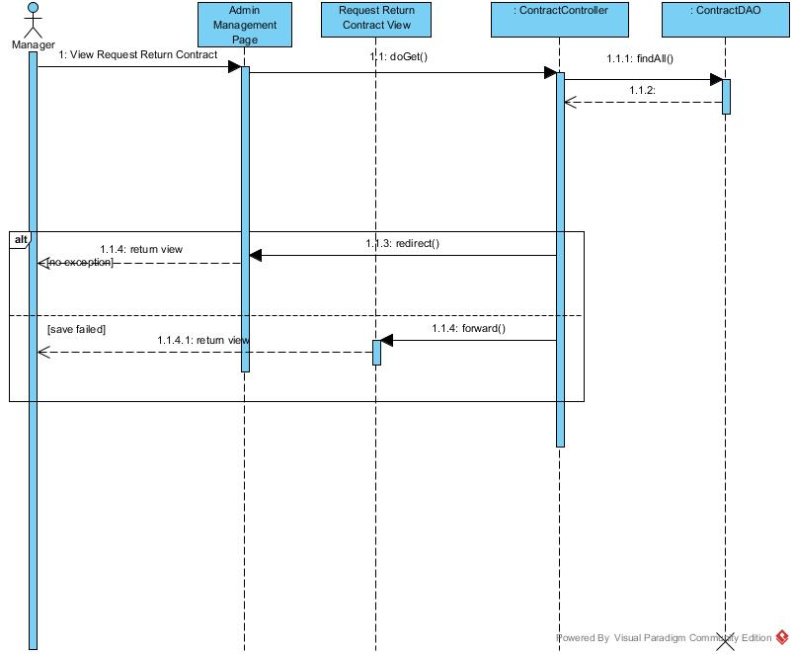

Figure : View Request Return Contract Sequence Diagram

##### <Manager> View Request Extend Contract

**Summary:** This diagram used to describe the process of manager view request extend contract

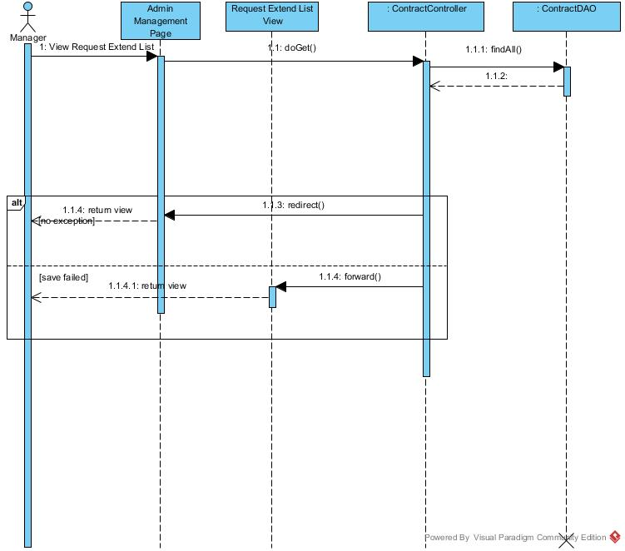

Figure : View Request Extend Contract Sequence Diagram

##### <Manager> Accept Return Request

**Summary:** This diagram used to describe the process of manager accept return request

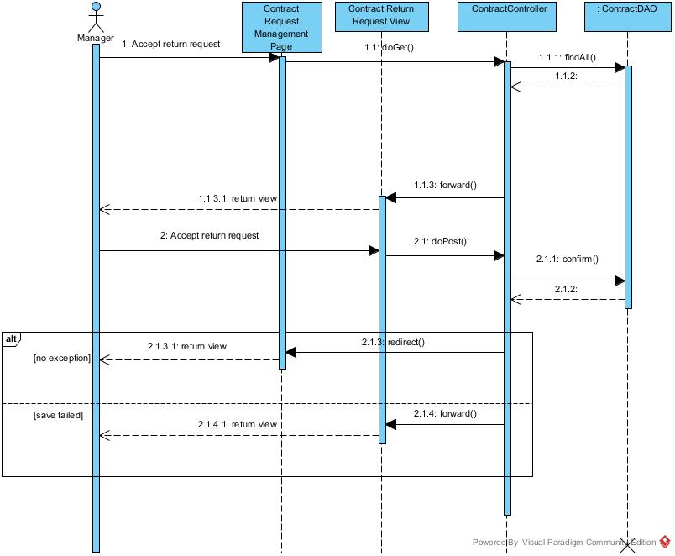

Figure : Accept Return Request Sequence Diagram

##### <Manager> Cancel Return Request

**Summary:** This diagram used to describe the process of manager cancel return request

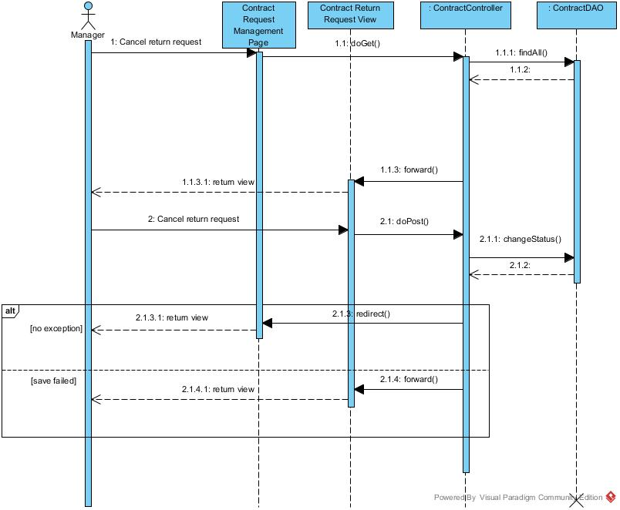

Figure : Cancel Return Request Sequence Diagram

##### <Manager> View Repair Request List

**Summary:** This diagram used to describe the process of manager view repair requests.

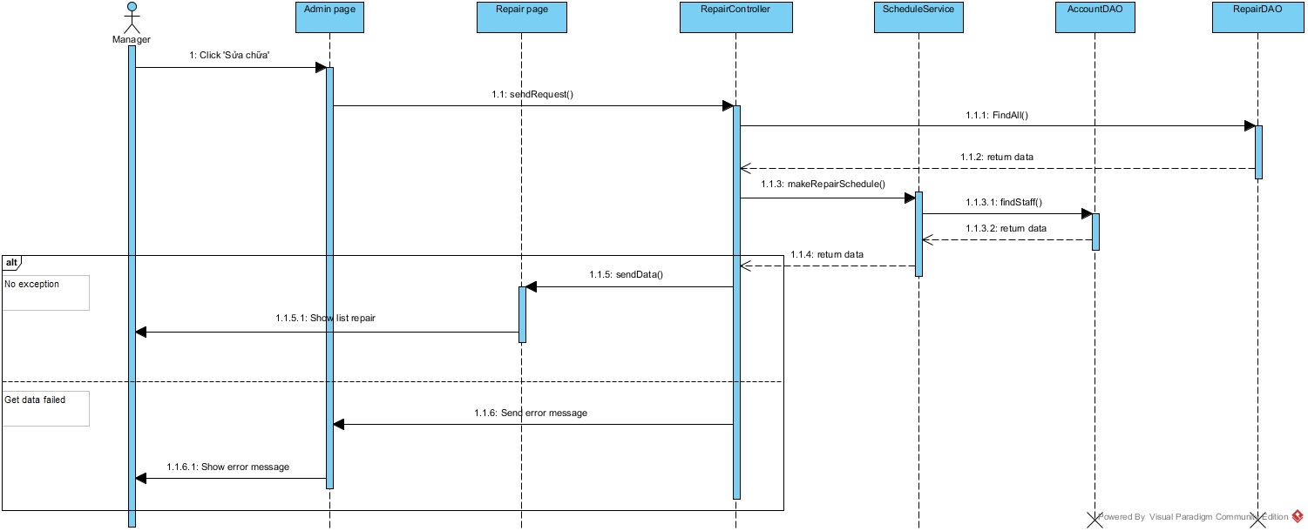

Figure : View Repair Request Sequence Diagram

##### <Manager> Assign Repair

**Summary:** This diagram used to describe the process of manager assign repair requests to staff.

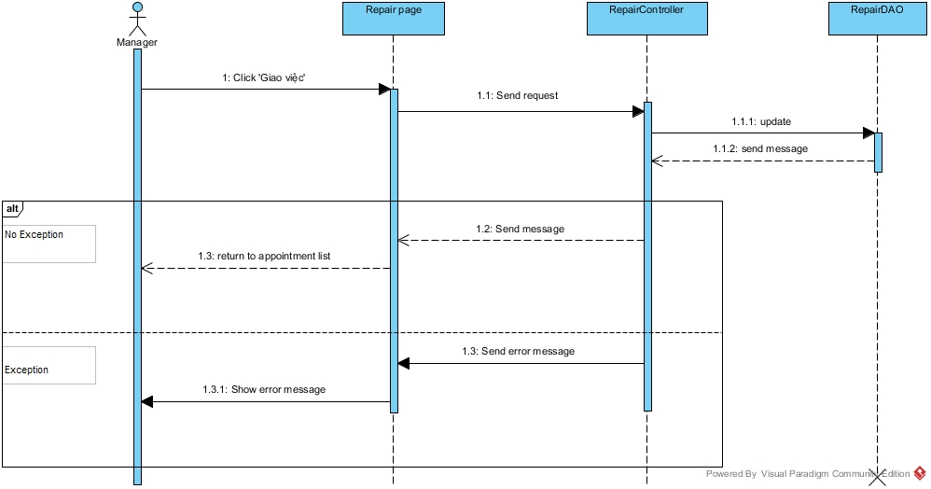

Figure : Assign Repair Sequence Diagram

##### <Manager> Cancel Repair Request

**Summary:** This diagram used to describe the process of manager cancel repair requests.

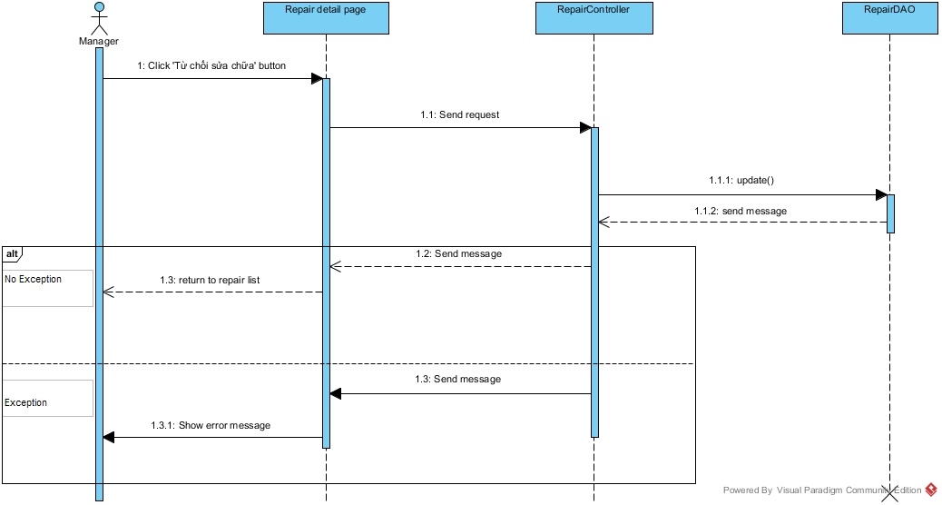

Figure : Cancel Repair Request Sequence Diagram

##### <Manager> View Rental Request List

**Summary:** This diagram used to describe the process of manager view rental requests.

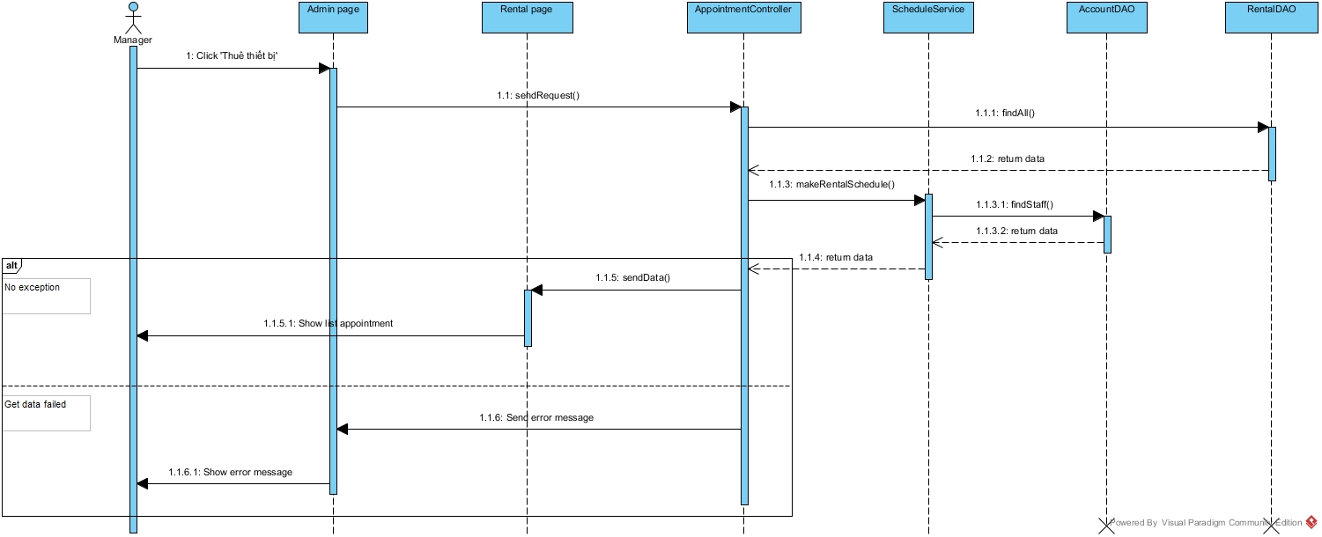

Figure : View Rental Request List Sequence Diagram

##### <Manager> Assign Rental

**Summary:** This diagram used to describe the process of manager assign rental requests to staff.

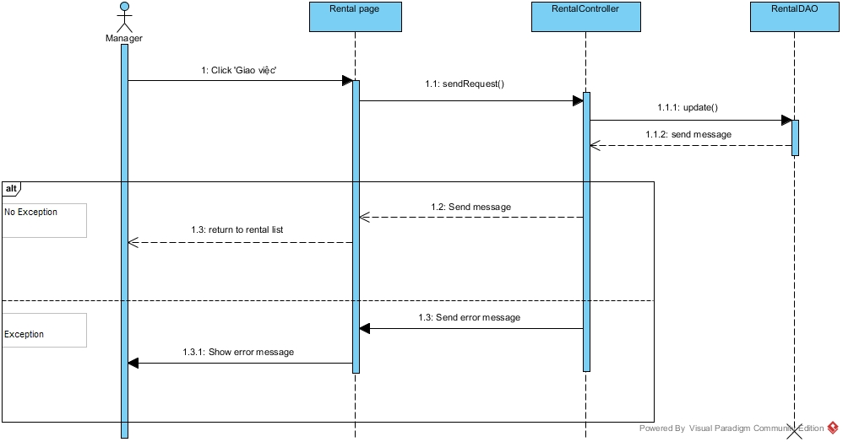

Figure : Assign Rental request Sequence Diagram

##### <Manager> Cancel Rental Request

**Summary:** This diagram used to describe the process of manager cancel rental request.

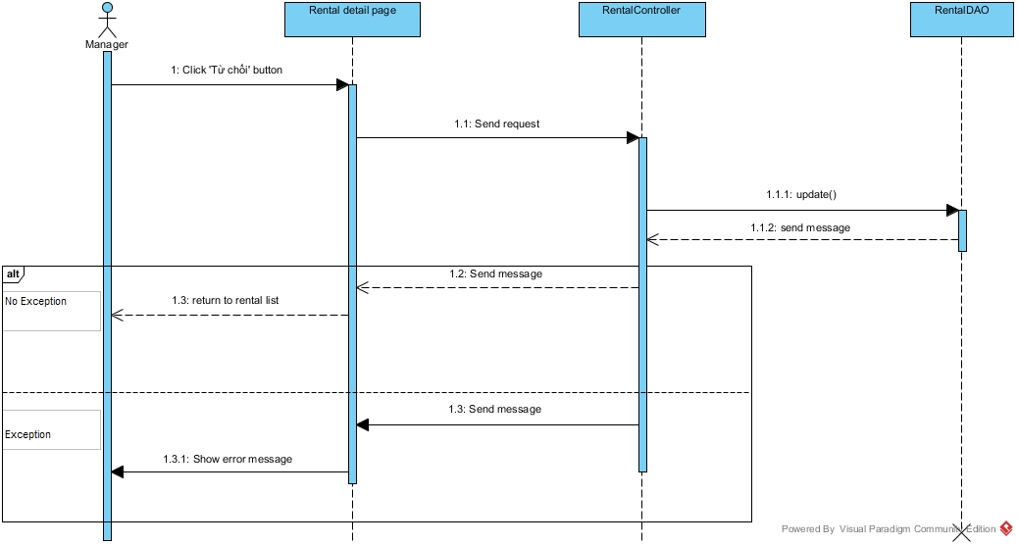

Figure : Cancel Rental Request Sequence Diagram

##### <Manager> View Amenity Group List

**Summary:** This diagram used to describe the process of manager view amenity group list.

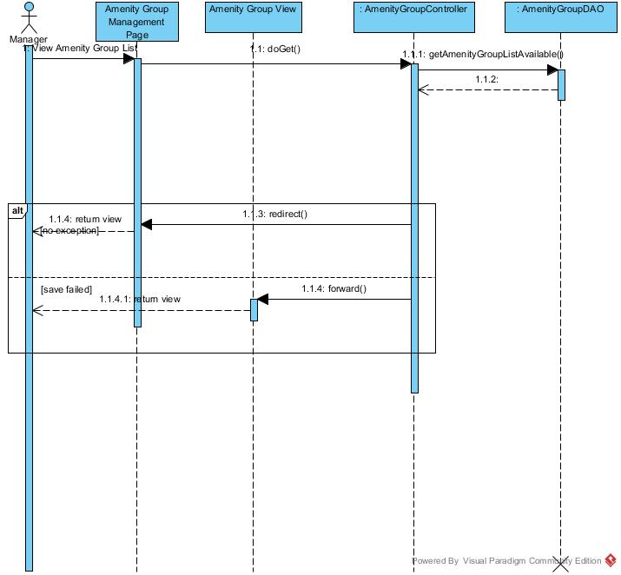

Figure : View Amenity Group List Sequence Diagram

##### <Manager> Create Amenity Group

**Summary:** This diagram used to describe the process of manager creates amenity group.

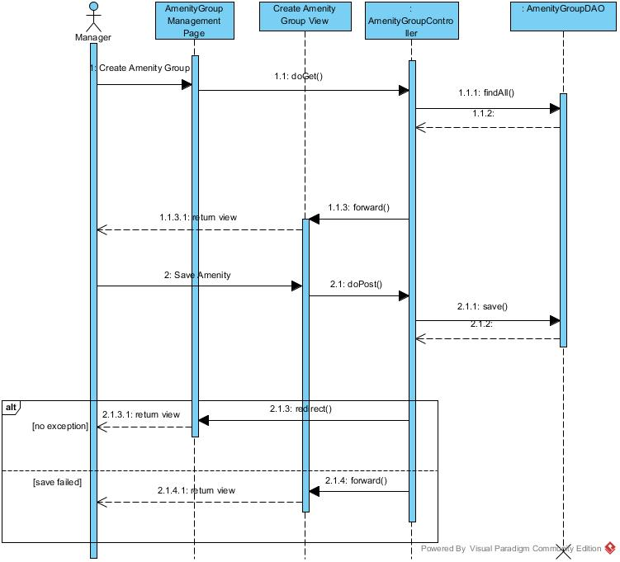

Figure : Create Amenity Group Sequence Diagram

##### <Manager> Create Amenity

**Summary:** This diagram used to describe the process of manager creates amenity.

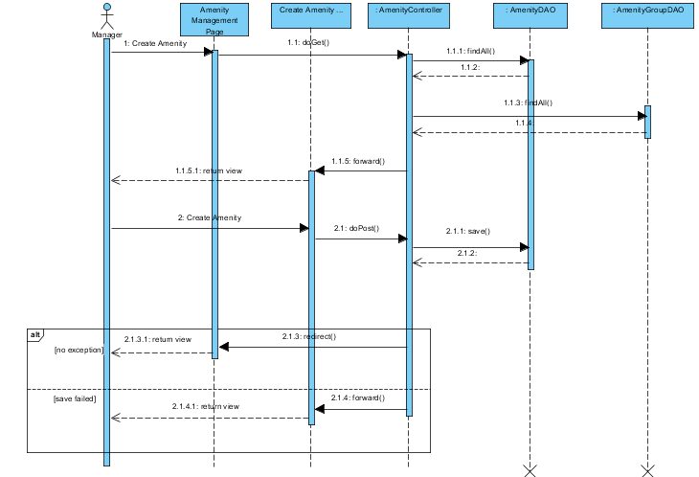

Figure : Create Amenity Sequence Diagram

##### <Manager> Edit Amenity Group

**Summary:** This diagram used to describe the process of manager edit amenity group

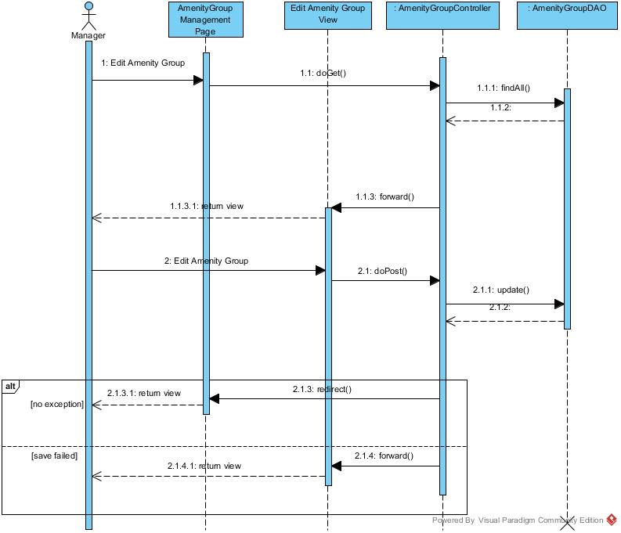

Figure : Edit Amenity Group Sequence Diagram

##### <Manager> View Amenity List

**Summary:** This diagram used to describe the process of manager view amenity list

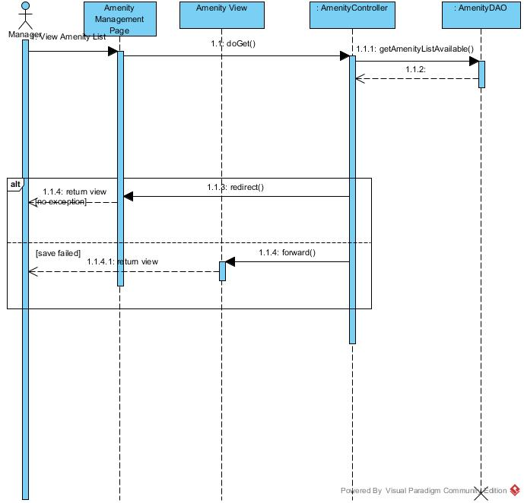

Figure : View Amenity List Sequence Diagram

##### <Manager> Edit Amenity

**Summary:** This diagram used to describe the process of manager edit amenity.

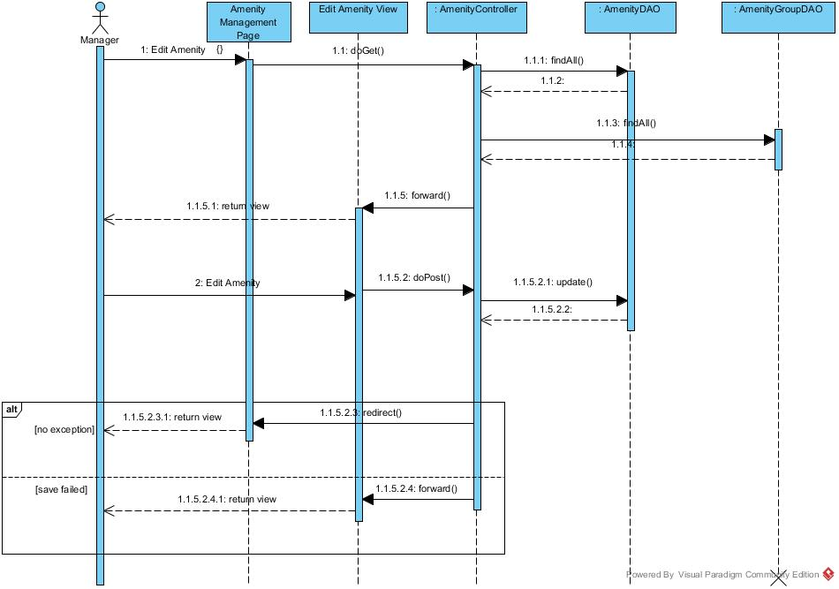

Figure : Edit Amenity Sequence Diagram

##### <Manager> Delete Amenity

**Summary:** This diagram used to describe the process of manager delete amenity.

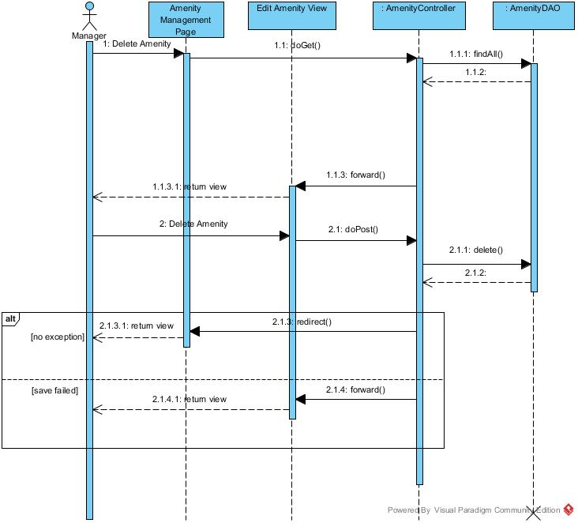

Figure : Delete Amenity Sequence Diagram

##### <Manager> Create Amenity Sequence Diagram

**Summary:** This diagram used to describe the process of manager or staff creates amenity.

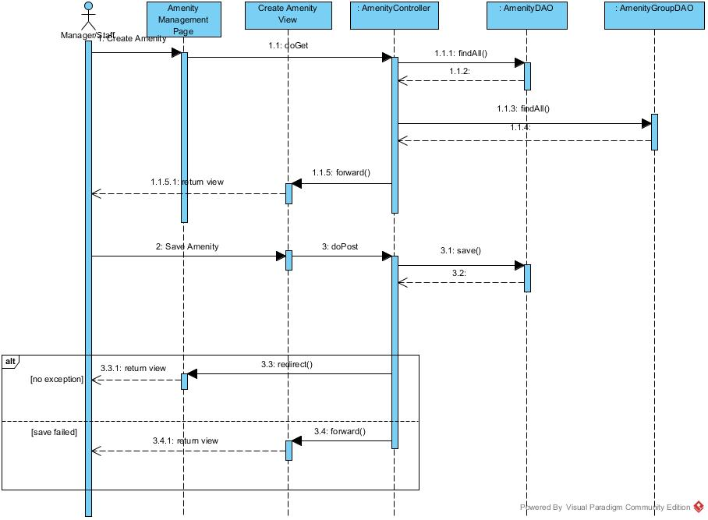

Figure : Create Amenity Sequence Diagram

##### <Manager> View Calendar

**Summary:** This diagram used to describe the process of system suggest request office to customer.

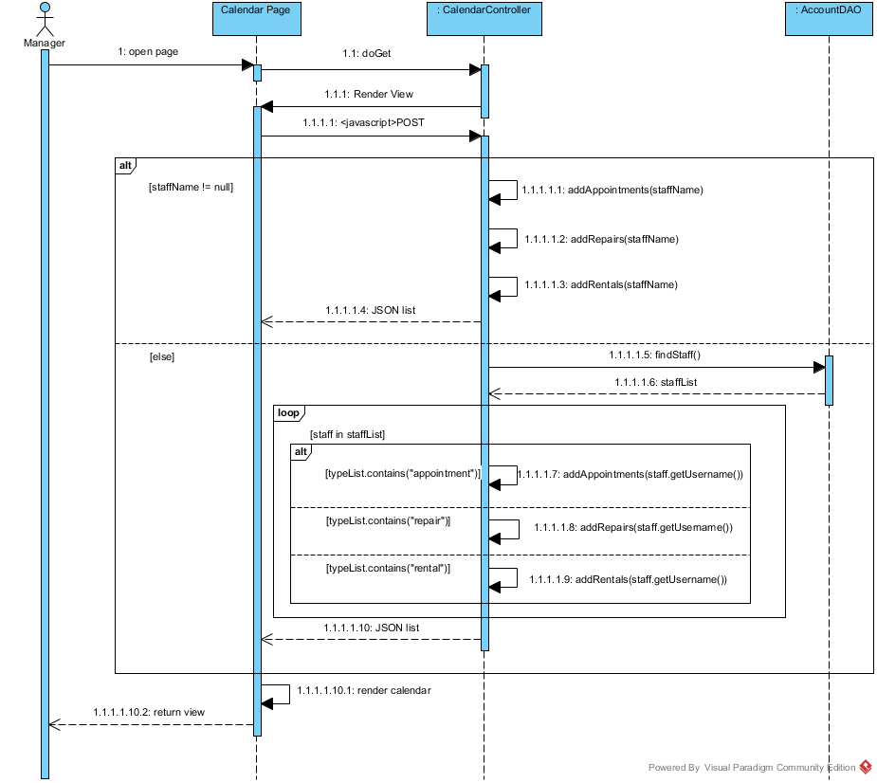

Figure : View Calendar Sequence Diagram

##### <Manager> View Staff Statistic

**Summary:** This diagram used to describe the process of system suggest request office to customer.

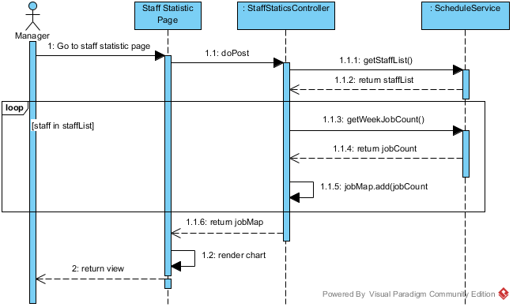

Figure : View Staff Statistic Sequence Diagram

##### <Manager> View Income Statistic

**Summary:** This diagram used to describe the process of system suggest request office to customer.

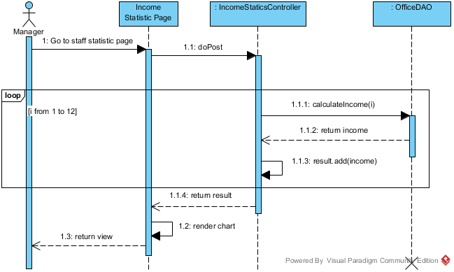

Figure : View Staff Statistic Sequence Diagram

##### <Manager, Staff> Create Rental Item

**Summary:** This diagram used to describe the process of manager or staff create rental item



Figure : Create Rental Item Sequence Diagram

##### <Manager, Staff> Edit Rental Item

**Summary:** This diagram used to describe the process of manager or staff edit rental item

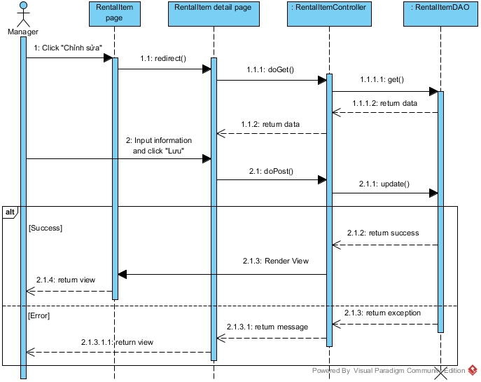

Figure : Edit Rental Item Sequence Diagram

##### <Manager, Staff> View Rental Item List

**Summary:** This diagram used to describe the process of manager or staff view rental item list

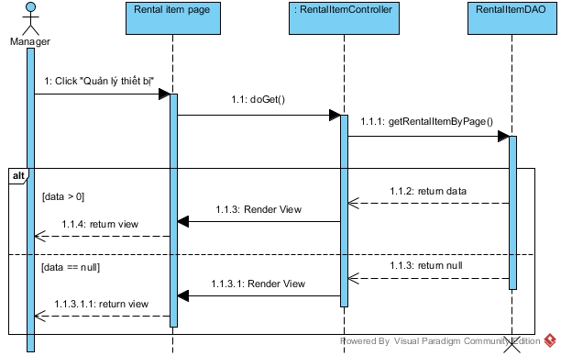

Figure : View Rental Item List Sequence Diagram

##### <Manager, Staff, Admin> Logout

**Summary:** This diagram used to describe the process of manager, staff or admin logout

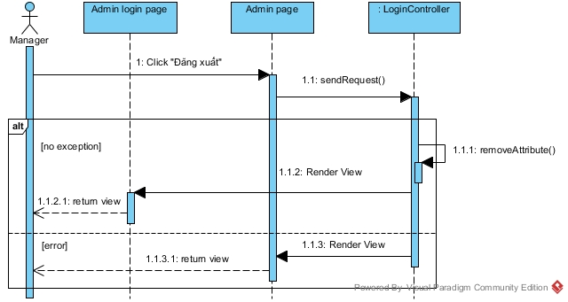

Figure : Logout Sequence Diagram

#### Admin Sequence Diagram

##### <Admin> View Account List

**Summary:** This diagram used to describe the process admin view account list.

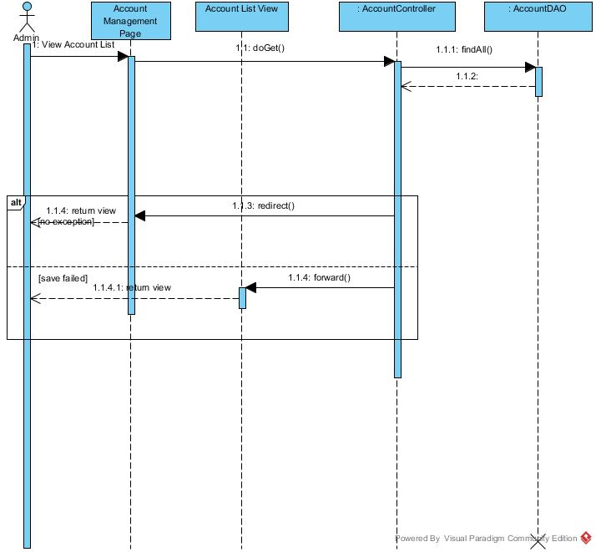

Figure : View Account List Sequence Diagram

##### <Admin> Create Account

**Summary:** This diagram used to describe the process of admin creates account.

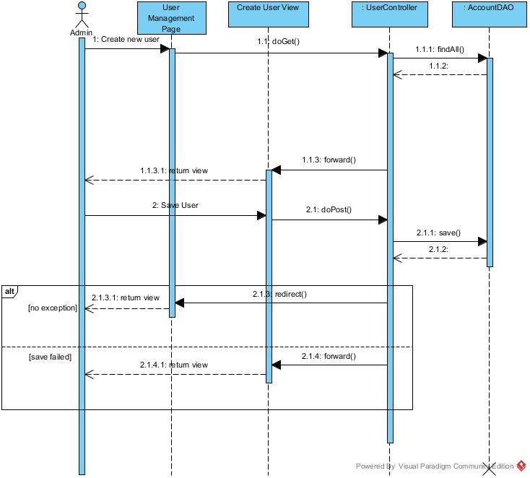

Figure : Create Account Sequence Diagram

##### <Admin> Delete Account

**Summary:** This diagram used to describe the process of manager delete account user.

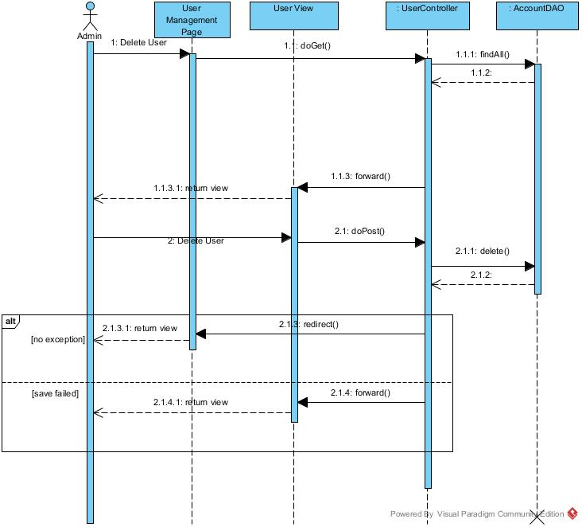

Figure : Delete Account Sequence Diagram

##### <Admin> Edit Account

**Summary:** This diagram used to describe the process of manager edit account

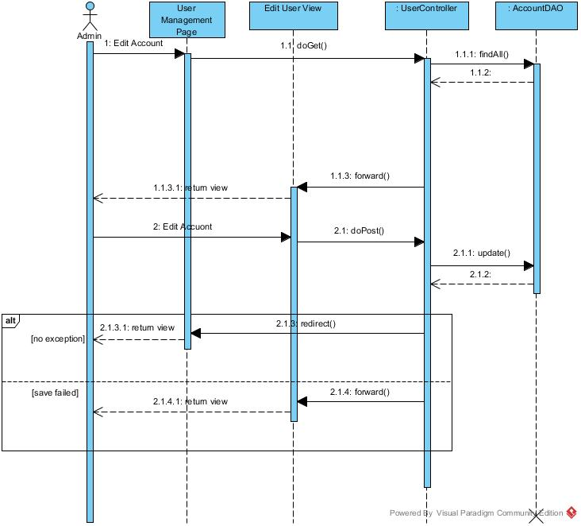

Figure : Edit Account Sequence Diagram

##### <Admin> Ban Account

**Summary:** This diagram used to describe the process of admin ban an account.

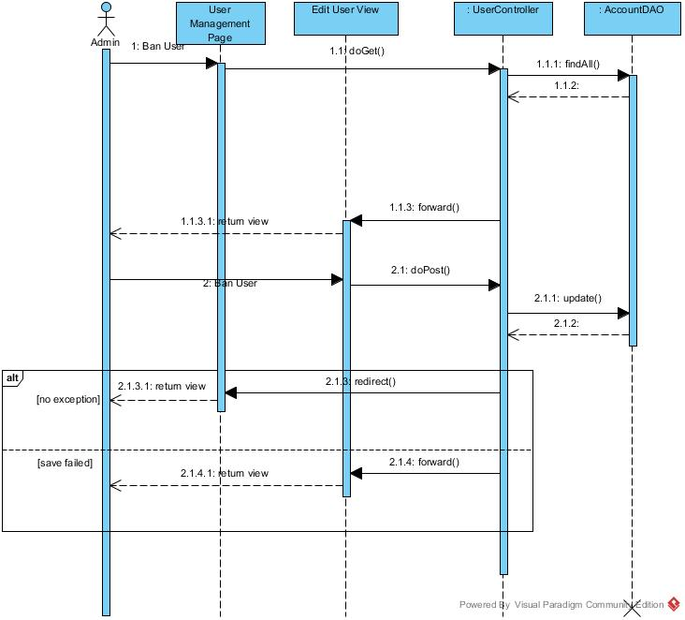

Figure : Ban Account Sequence Diagram

##### <Admin> Unban Account

**Summary:** This diagram used to describe the process of admin unbans account.

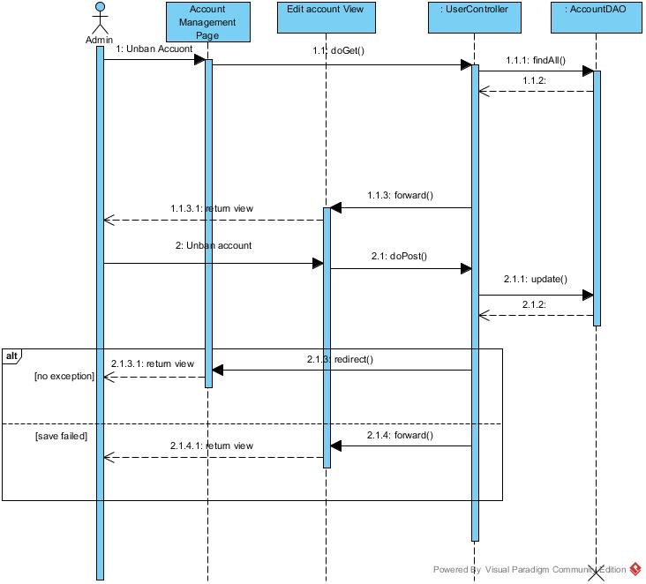

Figure : Unban Account Sequence Diagram

#### System Sequence Diagram

##### <System> Check Contract Due Date

**Summary:** This diagram used to describe the process of system check contract due date.



Figure : Check Contract Due Date Sequence Diagram

##### <System> Suggest Request Office

**Summary:** This diagram used to describe the process of system suggest request office to customer.



Figure : Suggest Request Office Sequence Diagram

##### <System> Clustering Office

**Summary:** This diagram used to describe the process of system clustering the office to group. The trigger of this is an office created or updated

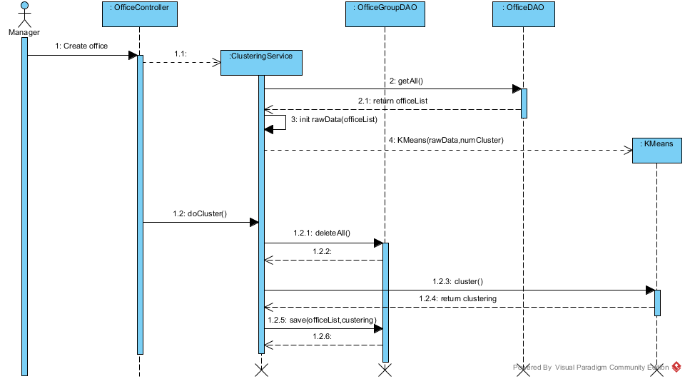

Figure : Clustering Office Sequence Diagram

##### <System> Suggest Assign Job

**Summary:** This diagram used to describe the process of system suggest request office to customer.

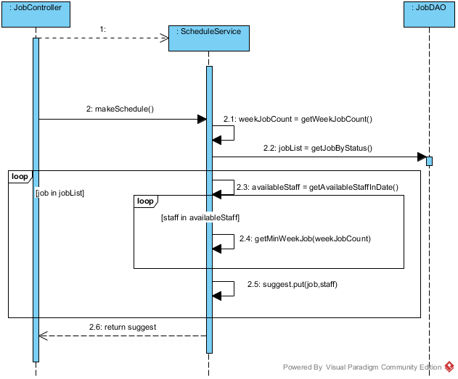

Figure : Suggest Assign Job Sequence Diagram

## User Interface Design

### Guest Interface Design

#### Login

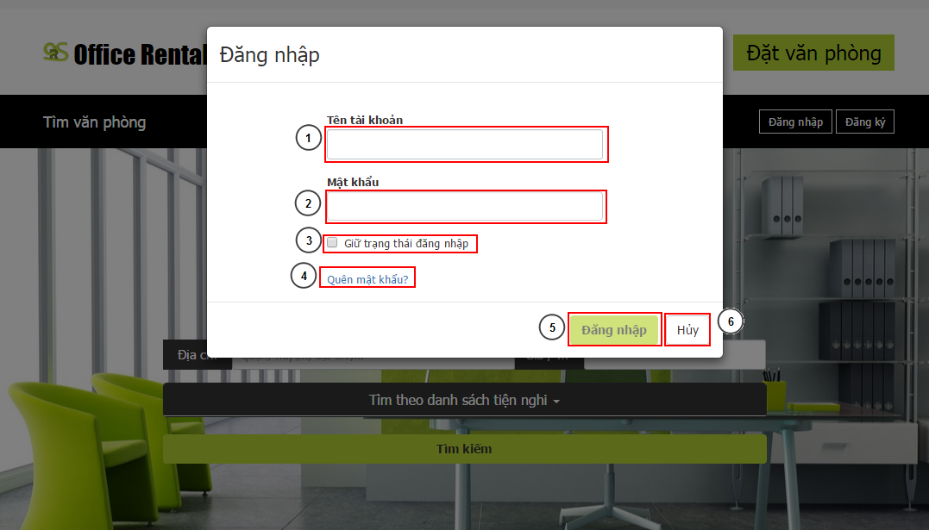

Figure 182: Login

**Fields**

|  |  |  |  |  |  |  |  |
| --- | --- | --- | --- | --- | --- | --- | --- |
| **No** | **Field Name** | **Description** | **Read only** | **Mandatory** | **Control Type** | **Data Type** | **Length** |
| 1 | Username | Username for customer to login | No | Yes | Textbox | String | [3-50] |
| 2 | Password | Password for login | No | Yes | Password | String | [1-50] |

**Buttons/Hyperlinks**

|  |  |  |  |  |
| --- | --- | --- | --- | --- |
| **No** | **Function** | **Description** | **Validation** | **Outcome** |
| 3 | Remember me | Store the login info to client to remember next login | N/A | Choose to remember the login info for the next time user go to website |
| 4 | Forget password | Link to forget password page | N/A | Go to forget password page |
| 5 | Login | Login to website | Yes | Login and close popup |
| 5 | Back | Cancel login and back | N/A | Close login popup |

#### Register

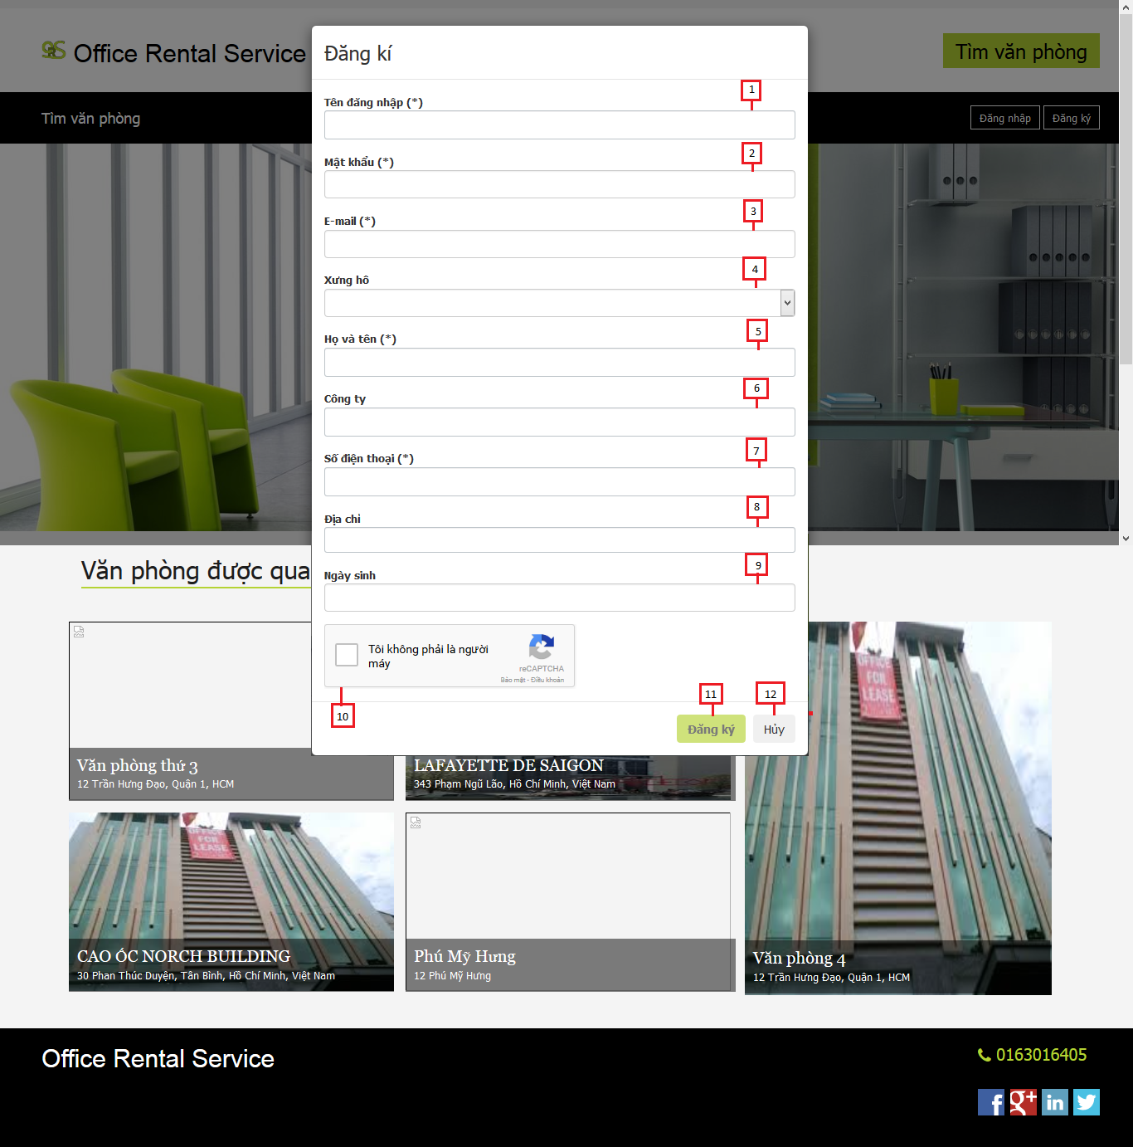

Figure 183: Register

**Fields**

|  |  |  |  |  |  |  |  |
| --- | --- | --- | --- | --- | --- | --- | --- |
| **No** | **Field Name** | **Description** | **Read only** | **Mandatory** | **Control Type** | **Data Type** | **Length** |
| 1 | Username | Fill username | No | Yes | Textbox | String | [3-50] |
| 2 | Password | Fill password | No | Yes | Password | String | [8-20] |
| 3 | Email | Fill user email | No | Yes | Textbox | String | 30 |
| 4 | Title | Fill user title | No | Yes | Drop-down list | String | N/A |
| 5 | Full name | Fill user full name | No | Yes | Textbox | String | [6-50] |
| 6 | Company | Fill user company | No | Yes | Textbox | String | 50 |
| 7 | Phone | Fill user phone | No | Yes | Textbox | String | [10-11] |
| 8 | Address | Fill user address | No | Yes | Textbox | String | 100 |
| 9 | Birthday | Fill user birthday | No | Yes | Date time picker | Date | N/A |

**Buttons/Hyperlinks**

|  |  |  |  |  |
| --- | --- | --- | --- | --- |
| **No** | **Function** | **Description** | **Validation** | **Outcome** |
| 10 | Captcha | Avoid spam | Yes | Can click register button |
| 11 | Register | Register new account | Yes | Close pop-up and show message |
| 12 | Cancel | Cancel register new account | N/A | Close pop-up |

#### Home



Figure 184: Home

**Fields**

|  |  |  |  |  |  |  |  |
| --- | --- | --- | --- | --- | --- | --- | --- |
| **No** | **Field Name** | **Description** | **Read only** | **Mandatory** | **Control Type** | **Data Type** | **Length** |
| 4 | Address | Address of office for searching | No | Yes | Textbox | String | N/A |
| 5 | Price | Price of office for searching | No | Yes | Dropdown list | String | N/A |

**Buttons/Hyperlinks**

|  |  |  |  |  |
| --- | --- | --- | --- | --- |
| **No** | **Function** | **Description** | **Validation** | **Outcome** |
| 1 | N/A | Link to homepage | N/A | Transfer to home page |
| 2 | Login | Click to login into the system | Yes | Transfer to home page |
| 3 | Register | Click to register a new account | N/A | Transfer to register page |
| 6 | Search | Click to find office base on address and price | Yes | Transfer to office list page |
| 7 | Request Office | Click to create request office | N/A | Transfer to request office page |
| 8 | Office detail | Click to see office detail | N/A | Transfer to office detail page |

#### Search Office list



Figure 185: Search office list

**Fields**

|  |  |  |  |  |  |  |  |
| --- | --- | --- | --- | --- | --- | --- | --- |
| **No** | **Field Name** | **Description** | **Read only** | **Mandatory** | **Control Type** | **Data Type** | **Length** |
| 1 | Address | Address for search | No | Yes | Textbox | String | N/A |
| 2 | Price Range | Price range for search | No | No | Textbox number | Long | N/A |
| 4 | Office Info | Information of office | Yes | No | Image + Text field | N/A | N/A |

**Buttons/Hyperlinks**

|  |  |  |  |  |
| --- | --- | --- | --- | --- |
| **No** | **Function** | **Description** | **Validation** | **Outcome** |
| 3 | Search | Do the search again | Yes | Refresh the search list with the input info |
| 4 | Office Info | Link to office detail | N/A | Click on image, the title of office, “Chi tiết” button will transfer to office detail page |
| 5 | Paging | Paging for office list | N/A | Transfer between pages in office search list |

#### Office detail



Figure 186: Office detail

**Fields**

|  |  |  |  |  |  |  |  |
| --- | --- | --- | --- | --- | --- | --- | --- |
| **No** | **Field Name** | **Description** | **Read only** | **Mandatory** | **Control Type** | **Data Type** | **Length** |
| 1 | Office image | The image of the office | Yes | Yes | Image | N/A | N/A |
| 2 | Office name | The name of the office | Yes | Yes | Label | String | N/A |
| 3 | Category | The category of the office | Yes | Yes | Label | String | N/A |
| 4 | Price | The rent cost of the office in a month | Yes | Yes | Label | Integer | N/A |
| 5 | Floor | Number of floor in the office | Yes | Yes | Label | Integer | N/A |
| 6 | Area | Total area of the office | Yes | Yes | Label | Integer | N/A |
| 7 | Address | The address of the office | Yes | Yes | Label | String | N/A |
| 8 | Amenity | The amenity of the office | Yes | Yes | List | N/A | N/A |
| 9 | Description | The description of the office | Yes | Yes | Paragraph | String | N/A |
| 11 | Maps | Show office address on maps | Yes | Yes | Google map | N/A | N/A |
| 12 | Suggest office | List office that are the same this office | Yes | Yes | List | N/A | N/A |

**Buttons/Hyperlinks**

|  |  |  |  |  |
| --- | --- | --- | --- | --- |
| **No** | **Function** | **Description** | **Validation** | **Outcome** |
| 10 | Request appointment | Click to request appointment | N/A | Transfer to request appointment page |

**Suggest office include**

|  |  |  |  |  |  |
| --- | --- | --- | --- | --- | --- |
| **Field Name** | **Description** | **Read only** | **Control Type** | **Data Type** | **Length** |
| Office name | The name of the office | Yes | Textview | String | N/A |
| Description | The description of the office | Yes | Textview | String | N/A |
| Price | The rent cost of the office | Yes | Textview | Integer | N/A |

### Customer Interface Design

#### Request appointment

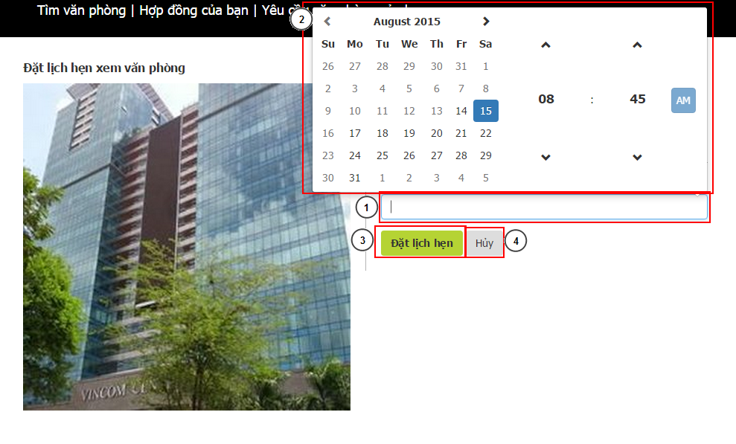

Figure 187: Request appointment

**Fields**

|  |  |  |  |  |  |  |  |
| --- | --- | --- | --- | --- | --- | --- | --- |
| **No** | **Field Name** | **Description** | **Read only** | **Mandatory** | **Control Type** | **Data Type** | **Length** |
| 1 | DateTime | Date and time for appointment | No | Yes | Textbox | DateTime | N/A |

**Buttons/Hyperlinks**

|  |  |  |  |  |
| --- | --- | --- | --- | --- |
| **No** | **Function** | **Description** | **Validation** | **Outcome** |
| 2 | DateTime Selection | The selection for date and time | Yes: valid date | Change the value of DateTime textbox |
| 3 | Request | Request new appointment | Yes: valid date | Request a new appointment on current office at the selected time |
| 4 | Cancel | Cancel the request | N/A | Go back to office detail page |

#### Contract list



Figure 188: Contract list

**Fields**

|  |  |  |  |  |  |  |  |
| --- | --- | --- | --- | --- | --- | --- | --- |
| **No** | **Field Name** | **Description** | **Read only** | **Mandatory** | **Control Type** | **Data Type** | **Length** |
| 4 | List contract | List contract of customer. | Yes | Yes | Table | N/A | N/A |

**Buttons/Hyperlinks**

|  |  |  |  |  |
| --- | --- | --- | --- | --- |
| **No** | **Function** | **Description** | **Validation** | **Outcome** |
| 1 | Contract detail | View contract detail of customer. | N/A | Transfer to contract detail page |
| 2 | List request repair | View list request repair of customer. | N/A | Transfer to list request repair page |
| 3 | List request rental | View list request rental of customer. | N/A | Transfer to list request rental page |

**List contract include**

|  |  |  |  |  |  |
| --- | --- | --- | --- | --- | --- |
| **Field Name** | **Description** | **Read only** | **Control Type** | **Data Type** | **Length** |
| Office name | Name of current office. | Yes | Label | String | N/A |
| Start date | The effect date of the contract | Yes | Label | Date | N/A |
| End date | The date that the contract expire | Yes | Label | Date | N/A |
| Price | The price that customer paid in one month | Yes | Label | Integer | N/A |
| Price term | The time that customer paid cyclically | Yes | Label | String | N/A |

#### Contract detail



Figure 189: Contract detail

**Fields**

|  |  |  |  |  |  |  |  |
| --- | --- | --- | --- | --- | --- | --- | --- |
| **No** | **Field Name** | **Description** | **Read only** | **Mandatory** | **Control Type** | **Data Type** | **Length** |
| 1 | Office name | Name of current office. | Yes | Yes | Label | String | N/A |
| 3 | Start date | The effect date of the contract | Yes | Yes | Label | Date | N/A |
| 6 | End date | The date that the contract expire | Yes | Yes | Label | Date | N/A |
| 7 | Price | The price that customer paid in one month | Yes | Yes | Label | Integer | N/A |
| 8 | List rental item | List rental item that customer are hiring | Yes | Yes | Table | N/A | N/A |

**Buttons/Hyperlinks**

|  |  |  |  |  |
| --- | --- | --- | --- | --- |
| **No** | **Function** | **Description** | **Validation** | **Outcome** |
| 2 | Request repair | Click to send request repair | N/A | Transfer to request repair page |
| 4 | Request return contract | Click to send request return contract | Yes | Show pop-up request return contract |
| 5 | Request extend contract | Click to send request extend contract | Yes | Show pop-up request extend contract |
| 9 | Request rental | Click to send request rental item | N/A | Transfer to request rental item page |

**List rental item include**

|  |  |  |  |  |  |
| --- | --- | --- | --- | --- | --- |
| **Field Name** | **Description** | **Read only** | **Control Type** | **Data Type** | **Length** |
| Rental item name | The name of the rental item | Yes | Textview | String | N/A |
| Description | Describe request repair of customer | Yes | Textview | String | N/A |
| Unit price | Rent cost of one item | Yes | Textview | Integer | N/A |
| Quantity | The number of item is hiring | Yes | Textview | Integer | N/A |
| Item price | The price of all hired item | Yes | Textview | Integer | N/A |
| Total price | The sum of item price | Yes | Textview | Integer | N/A |

#### Extend contract

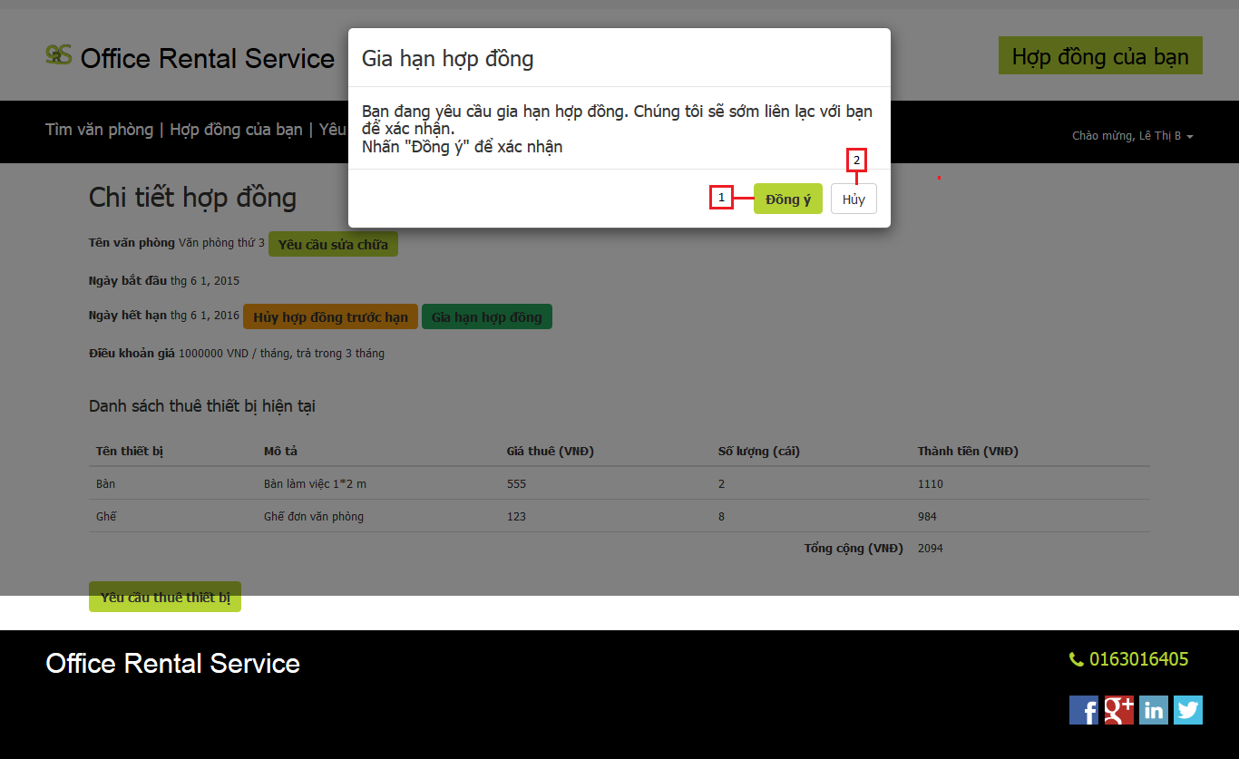

Figure 190: Extend Contract

**Buttons/Hyperlinks**

|  |  |  |  |  |
| --- | --- | --- | --- | --- |
| **No** | **Function** | **Description** | **Validation** | **Outcome** |
| 1 | Extend contract | Send request extend contract | N/A | Close pop-up and show message |
| 2 | Cancel | Cancel request extend contract | N/A | Close pop-up |

#### Return contract

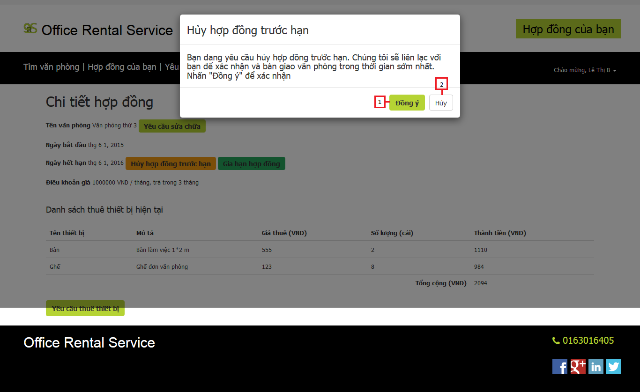

Figure 191: Return contract

**Buttons/Hyperlinks**

|  |  |  |  |  |
| --- | --- | --- | --- | --- |
| **No** | **Function** | **Description** | **Validation** | **Outcome** |
| 1 | Return contract | Send request return contract | N/A | Close pop-up and show message |
| 2 | Cancel | Cancel request return contract | N/A | Close pop-up |

#### List request repair history

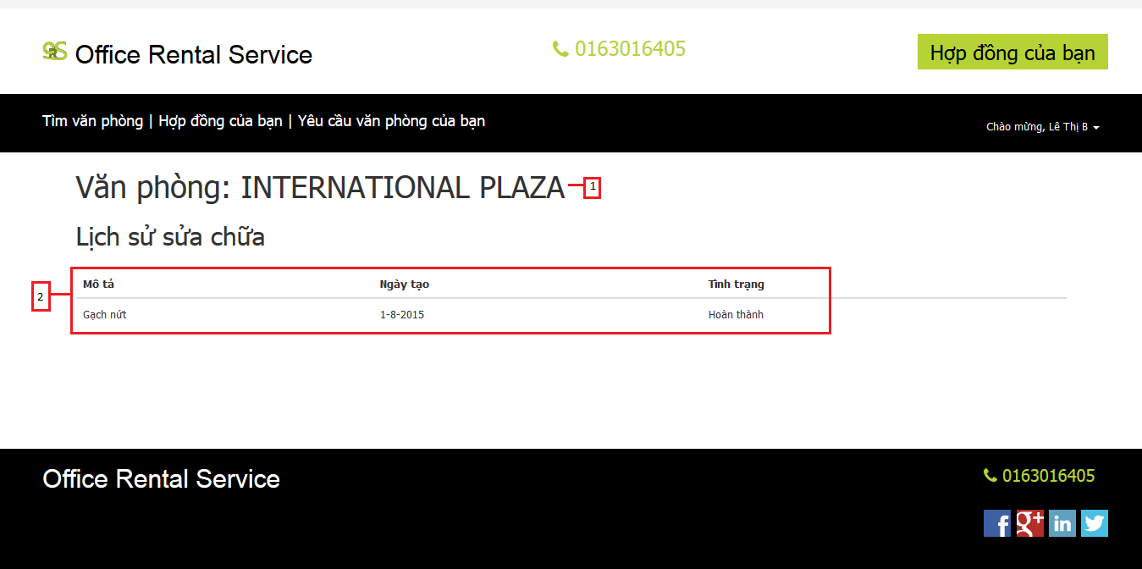

Figure 192: List request repair history

**Fields**

|  |  |  |  |  |  |  |  |
| --- | --- | --- | --- | --- | --- | --- | --- |
| **No** | **Field Name** | **Description** | **Read only** | **Mandatory** | **Control Type** | **Data Type** | **Length** |
| 1 | Office name | Name of the office | Yes | Yes | Label | String | N/A |
| 2 | List repair history detail | List all request repair that had completed or cancel. | Yes | Yes | Table | N/A | N/A |

**List repair history detail include**

|  |  |  |  |  |  |
| --- | --- | --- | --- | --- | --- |
| **Field Name** | **Description** | **Read only** | **Control Type** | **Data Type** | **Length** |
| Description | Describe request repair of customer | Yes | Textview | String | N/A |
| Create time | The time that customer create request | Yes | Textview | Date | N/A |
| Status | The status of request repair | Yes | Textview | String | N/A |

#### List request repair

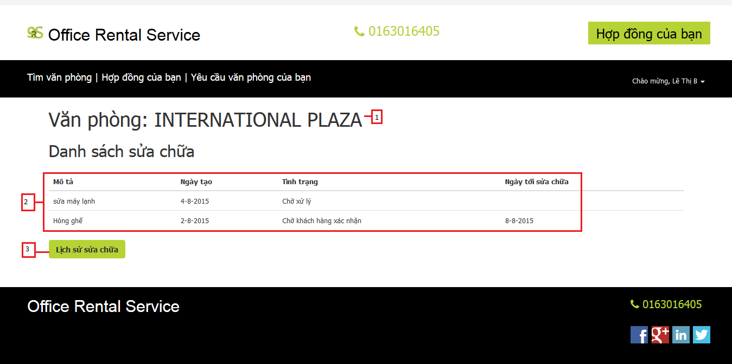

Figure 193: List request repair

**Fields**

|  |  |  |  |  |  |  |  |
| --- | --- | --- | --- | --- | --- | --- | --- |
| **No** | **Field Name** | **Description** | **Read only** | **Mandatory** | **Control Type** | **Data Type** | **Length** |
| 1 | Office name | The name of the office | Yes | Yes | Label | String | N/A |
| 2 | List repair detail | List request repair that wasn’t fixed. | Yes | Yes | Table | N/A | N/A |

**Buttons/Hyperlinks**

|  |  |  |  |  |
| --- | --- | --- | --- | --- |
| **No** | **Function** | **Description** | **Validation** | **Outcome** |
| 3 | Repair history | View list request repair that had completed or cancel. | N/A | Transfer to repair history page |

**List repair detail include**

|  |  |  |  |  |  |
| --- | --- | --- | --- | --- | --- |
| **Field Name** | **Description** | **Read only** | **Control Type** | **Data Type** | **Length** |
| Description | Describe request repair of customer | Yes | Textview | String | N/A |
| Create time | The time that customer create request | Yes | Textview | Date | N/A |
| Status | The status of request repair | Yes | Textview | String | N/A |
| Assigned time | The time that staff will come to fix | Yes | Textview | Date | N/A |

#### Profile

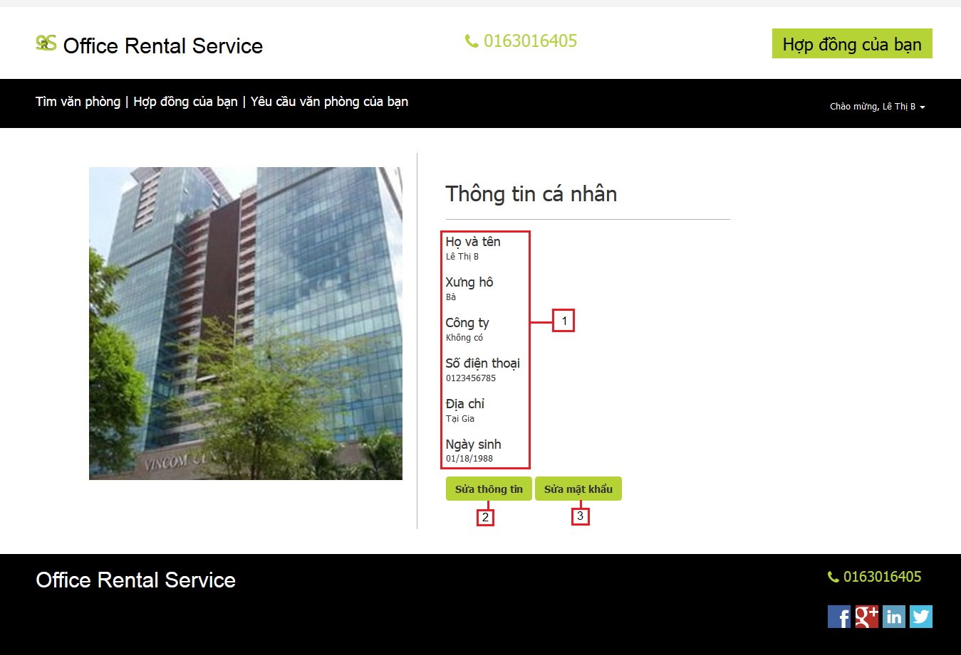

Figure 194: Profile

**Fields**

|  |  |  |  |  |  |  |  |
| --- | --- | --- | --- | --- | --- | --- | --- |
| **No** | **Field Name** | **Description** | **Read only** | **Mandatory** | **Control Type** | **Data Type** | **Length** |
| 1 | Information profile | Description information about customer | Yes | Yes | Label | String | N/A |

**Buttons/Hyperlinks**

|  |  |  |  |  |
| --- | --- | --- | --- | --- |
| **No** | **Function** | **Description** | **Validation** | **Outcome** |
| 2 | Edit information | Update profile of customer | N/A | Transfer to edit information page |
| 3 | Change password | Update password of customer | N/A | Transfer to change password page |

#### Profile detail

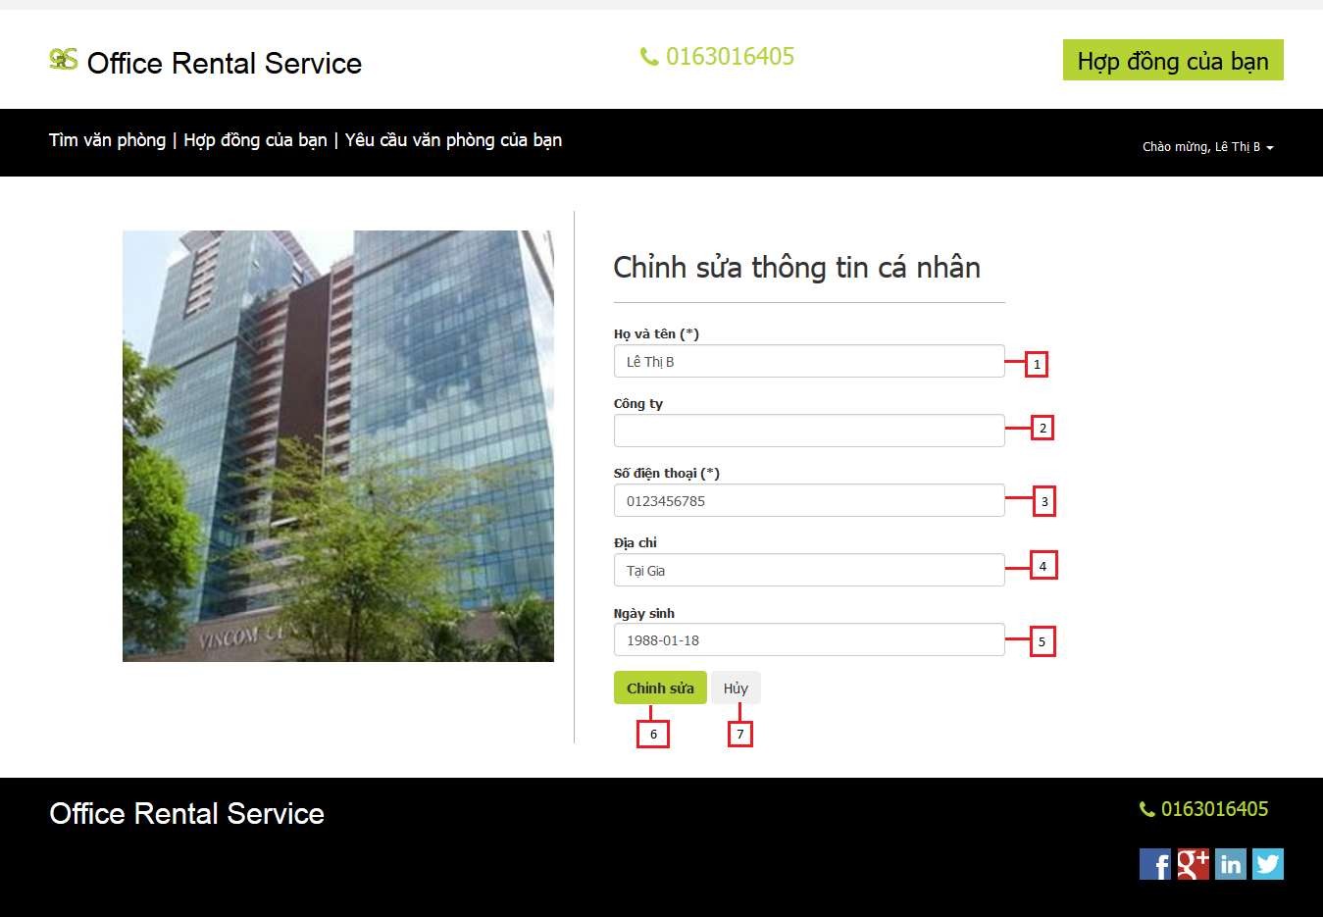

Figure 195: Profile detail

**Fields**

|  |  |  |  |  |  |  |  |
| --- | --- | --- | --- | --- | --- | --- | --- |
| **No** | **Field Name** | **Description** | **Read only** | **Mandatory** | **Control Type** | **Data Type** | **Length** |
| 1 | Full name | Fill user full name | No | Yes | Textbox | String | [6-50] |
| 2 | Company | Fill user company | No | Yes | Textbox | String | 50 |
| 3 | Phone | Fill user phone | No | Yes | Textbox | String | [10-11] |
| 4 | Address | Fill user address | No | Yes | Textbox | String | 100 |
| 5 | Birthday | Fill user birthday | No | Yes | Date time picker | Date | N/A |

**Buttons/Hyperlinks**

|  |  |  |  |  |
| --- | --- | --- | --- | --- |
| **No** | **Function** | **Description** | **Validation** | **Outcome** |
| 6 | Edit profile | Update profile of customer | Yes | Return profile page and show message |
| 7 | Cancel | Cancel edit profile | N/A | Return profile page |

#### Change password

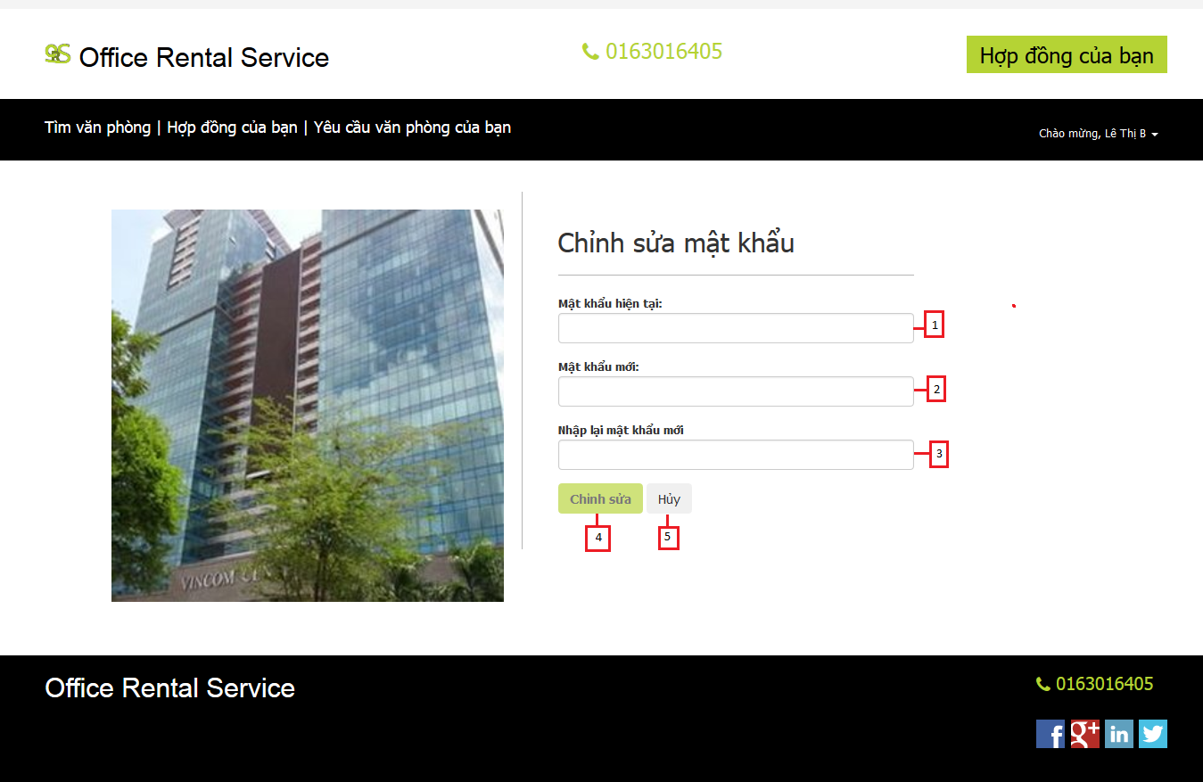

Figure 196: Change password

**Fields**

|  |  |  |  |  |  |  |  |
| --- | --- | --- | --- | --- | --- | --- | --- |
| **No** | **Field Name** | **Description** | **Read only** | **Mandatory** | **Control Type** | **Data Type** | **Length** |
| 1 | Password | Fill user password | No | Yes | Textbox | String | [8-20] |
| 2 | New password | Input new password | No | Yes | Textbox | String | [8-20] |
| 3 | Re-password | Retype new password | No | Yes | Textbox | String | [8-20] |

**Buttons/Hyperlinks**

|  |  |  |  |  |
| --- | --- | --- | --- | --- |
| **No** | **Function** | **Description** | **Validation** | **Outcome** |
| 6 | Edit password | Update new password of customer | Yes | Return profile page and show message |
| 7 | Cancel | Cancel edit password | N/A | Return profile page |

#### Request repair

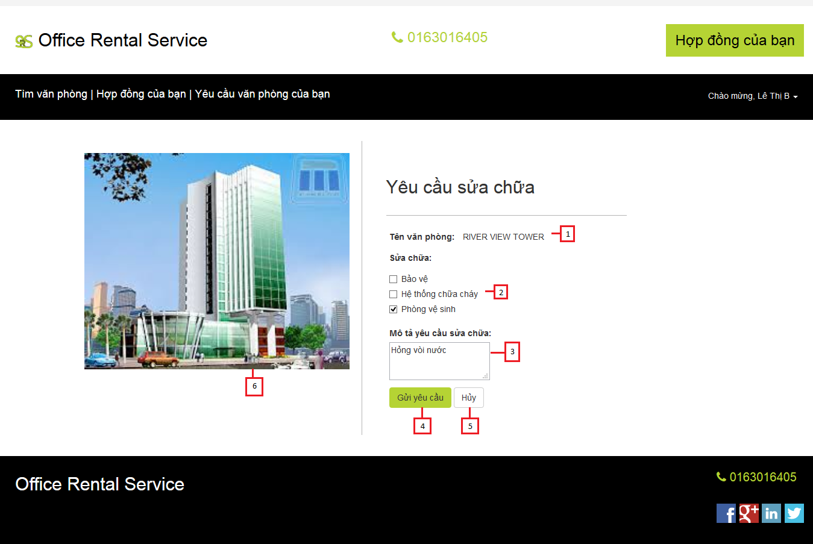

Figure 197: Request repair

**Fields**

|  |  |  |  |  |  |  |  |
| --- | --- | --- | --- | --- | --- | --- | --- |
| **No** | **Field Name** | **Description** | **Read only** | **Mandatory** | **Control Type** | **Data Type** | **Length** |
| 1 | Office name | The name of the office | Yes | Yes | Label | String | N/A |
| 2 | Amenity | The amenity of the office | No | Yes | Checkbox | N/A | N/A |
| 3 | Description | The description of the request repair | No | Yes | Textarea | String | N/A |
| 6 | Office image | The image of the office | Yes | Yes | Image | N/A | N/A |

**Buttons/Hyperlinks**

|  |  |  |  |  |
| --- | --- | --- | --- | --- |
| **No** | **Function** | **Description** | **Validation** | **Outcome** |
| 4 | Request repair | Click to send request repair | Yes | Show message and transfer to contract list page |
| 5 | Cancel | Cancel request office | N/A | Transfer to contract detail |

#### Rental page



Figure 198: Rental page

**Fields**

|  |  |  |  |  |  |  |  |
| --- | --- | --- | --- | --- | --- | --- | --- |
| **No** | **Field Name** | **Description** | **Read only** | **Mandatory** | **Control Type** | **Data Type** | **Length** |
| 1 | Cart | Show cart of customer | Yes | No | Textbox | String | N/A |
| 2 | Price | Price of rental item | Yes | No | Textview | String | N/A |
| 3 | Quantity | Number items customer buy | No | Yes | Textbox | Int | N/A |
| 4 | Image | Image of the rental item | Yes | Yes | Image | String | N/A |

**Buttons/Hyperlinks**

|  |  |  |  |  |
| --- | --- | --- | --- | --- |
| **No** | **Function** | **Description** | **Validation** | **Outcome** |
| 5 | AddToCart | Add item with quantity to customer’s cart | N/A | Show successful message |
| 6 | viewCart | Open rental cart page | N/A | Transfer to rental cart page |

#### Rental cart page



Figure 199: Rental cart page

**Fields**

|  |  |  |  |  |  |  |  |
| --- | --- | --- | --- | --- | --- | --- | --- |
| **No** | **Field Name** | **Description** | **Read only** | **Mandatory** | **Control Type** | **Data Type** | **Length** |
| 1 | Name | Name of items | Yes | Yes | Textview | String | N/A |
| 2 | Description | Description of items | Yes | No | Textview | String | N/A |
| 3 | Price | Price of one item | Yes | Yes | Textview | Int | N/A |
| 4 | Quantity | Number items customer buy | No | Yes | Textbox | String | N/A |
| 5 | Total price | Total price of items | Yes | Yes | Textview | Int | N/A |
| 6 | Comment | Comment of customer | No | No | Textbox | String | N/A |

**Buttons/Hyperlinks**

|  |  |  |  |  |
| --- | --- | --- | --- | --- |
| **No** | **Function** | **Description** | **Validation** | **Outcome** |
| 7 | RemoveFromCart | remove item from customer’s cart | N/A | Show successful message |
| 8 | Send Request | Send request | N/A | Transfer to home page |
| 9 | Hyperlinks | Return to rental page | N/A | Transfer to rental page |

#### Rental list page

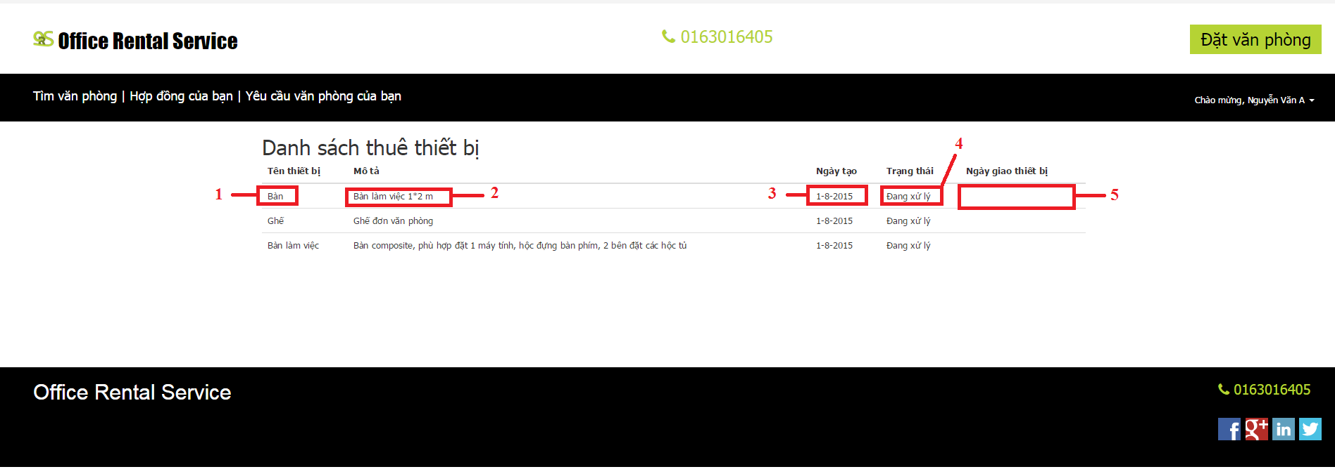

Figure 200: Rental list page

**Fields**

|  |  |  |  |  |  |  |  |
| --- | --- | --- | --- | --- | --- | --- | --- |
| **No** | **Field Name** | **Description** | **Read only** | **Mandatory** | **Control Type** | **Data Type** | **Length** |
| 1 | Name | Name of items | Yes | Yes | Textview | String | N/A |
| 2 | Description | Description of items | Yes | No | Textview | String | N/A |
| 3 | Create date | Date when customer create request | Yes | Yes | Textview | datetime | N/A |
| 4 | Status | Status of request | Yes | Yes | Textview | String | N/A |
| 5 | Assign date | Date customer receive items | Yes | Yes | Textview | datetime | N/A |

#### Request office

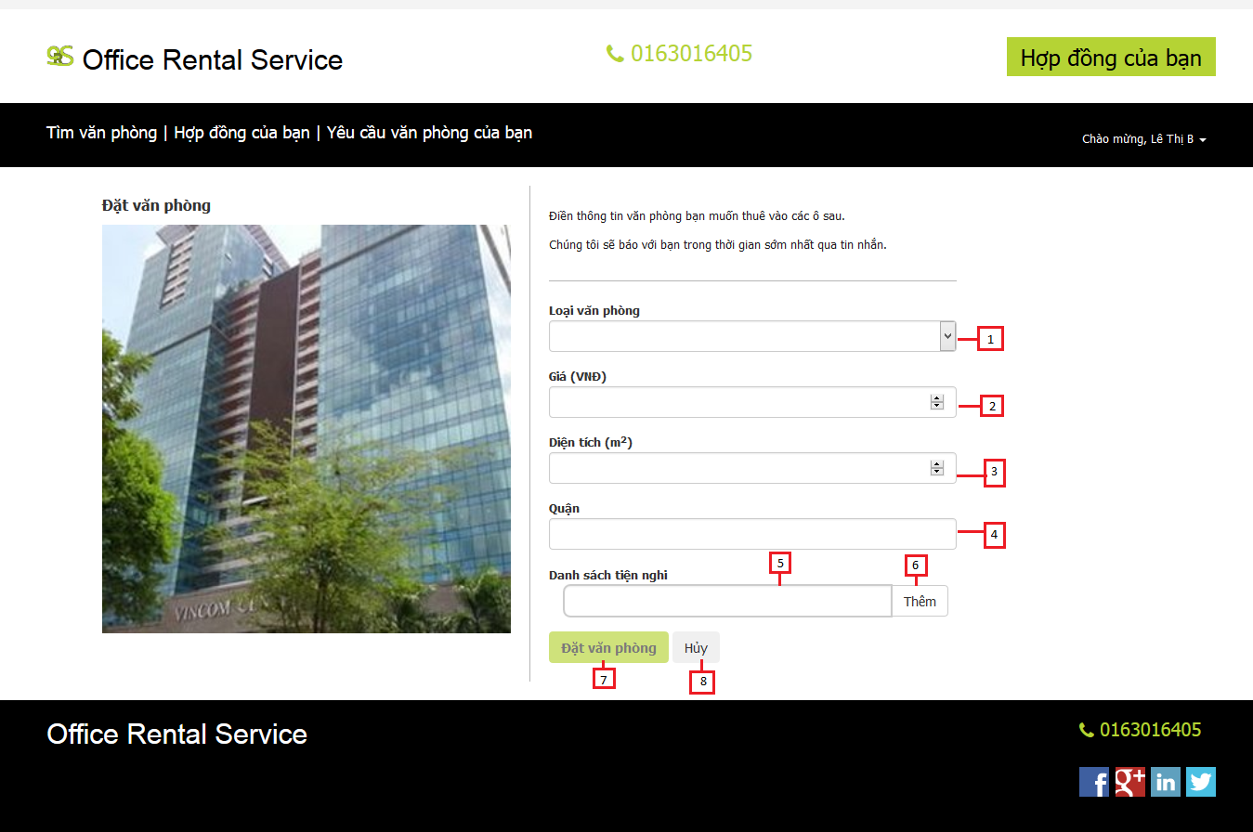

Figure 201: Request office

**Fields**

|  |  |  |  |  |  |  |  |
| --- | --- | --- | --- | --- | --- | --- | --- |
| **No** | **Field Name** | **Description** | **Read only** | **Mandatory** | **Control Type** | **Data Type** | **Length** |
| 1 | Category | The category of the office | No | Yes | Drop down list | String | N/A |
| 2 | Price | The price of the office | No | Yes | Textbox | Integer | N/A |
| 3 | Area | The area of the office | No | Yes | Textbox | Integer | N/A |
| 4 | District | The district that you want to find the office | No | Yes | Textbox | Integer | N/A |
| 5 | Amenity | The amenity of the office | No | Yes | Textbox | String | N/A |

**Buttons/Hyperlinks**

|  |  |  |  |  |
| --- | --- | --- | --- | --- |
| **No** | **Function** | **Description** | **Validation** | **Outcome** |
| 6 | Add amenity | Click to add amenity | N/A | Add amenity to the request |
| 7 | Request office | Click to send request office | Yes | Show message and transfer to home page |
| 8 | Cancel | Cancel request office | N/A | Transfer to home page |

#### Result request office page



Figure 202: Result request office page

**Fields**

|  |  |  |  |  |  |  |  |
| --- | --- | --- | --- | --- | --- | --- | --- |
| **No** | **Field Name** | **Description** | **Read only** | **Mandatory** | **Control Type** | **Data Type** | **Length** |
| 1 | Name | Name of office | Yes | Yes | Textview | String | N/A |
| 2 | Area | Area of office | Yes | No | Textview | float | N/A |
| 3 | Price | Price of office | Yes | Yes | Textview | int | N/A |
| 4 | Address | Address of office | Yes | Yes | Textbox | bigint | N/A |
| 5 | Create date | Date when customer create request | Yes | Yes | Textview | datetime | N/A |
| 6 | List office | List result office | Yes | No | Listview |  | N/A |

**Buttons/Hyperlinks**

|  |  |  |  |  |
| --- | --- | --- | --- | --- |
| **No** | **Function** | **Description** | **Validation** | **Outcome** |
| 7 | Unsubscribe | Remove request | N/A | Reload page and request has disappear |
| 8 | Office Detail | Show detail of office | N/A | Transfer to office detail page |

### Manager Interface Design

#### View amenity list

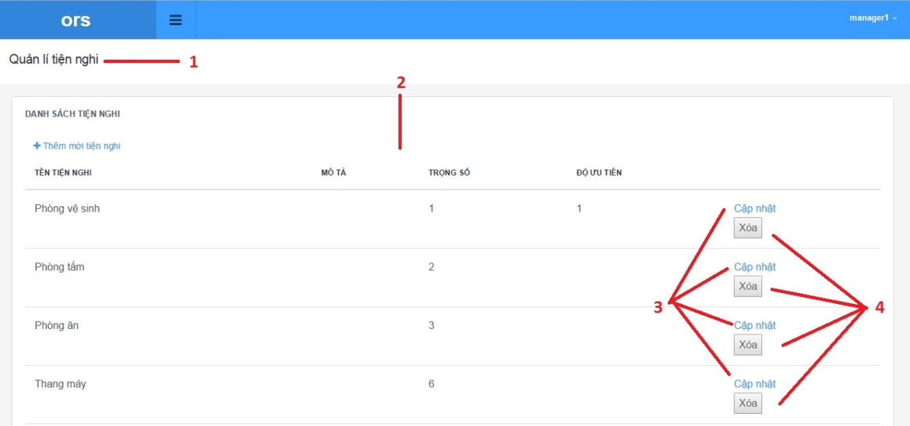

Figure 203: View amenity list

**Fields**

|  |  |  |  |  |  |  |  |
| --- | --- | --- | --- | --- | --- | --- | --- |
| **No** | **Field Name** | **Description** | **Read only** | **Mandatory** | **Control Type** | **Data Type** | **Length** |
| 1 | Page title | Title of amenity list | Yes | Yes | Label | N/A | N/A |
| 2 | Amenity list | List of amenity list has been sent | Yes | Yes | Listview | N/A | N/A |

**Buttons/Hyperlinks**

|  |  |  |  |  |
| --- | --- | --- | --- | --- |
| **No** | **Function** | **Description** | **Validation** | **Outcome** |
| 3 | Add amenity | Add amenity to amenity list | No | N/A |
| 4 | Remove amenity | Remove amenity from amenity list | No | Transfer to home page |

**Ameni list includes**

|  |  |  |  |  |  |
| --- | --- | --- | --- | --- | --- |
| **Field Name** | **Description** | **Read only** | **Control Type** | **Data Type** | **Length** |
| Amenity name | Name of amenity | Yes | Textview | String | N/A |
| Amenity description | Description of amenity | Yes | Textview | String | N/A |
| Amenity weight | Weight of amenity | Yes | Textview | Integer | N/A |
| Amenity priority | Priority of amenity | Yes | Textview | Integer | N/A |

#### Update amenity

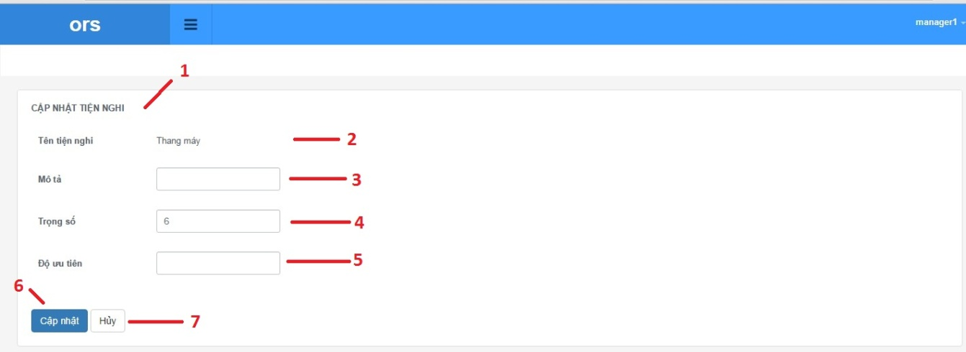

Figure 204: Update amenity

**Fields**

|  |  |  |  |  |  |  |  |
| --- | --- | --- | --- | --- | --- | --- | --- |
| **No** | **Field Name** | **Description** | **Read only** | **Mandatory** | **Control Type** | **Data Type** | **Length** |
| 1 | Page title | Title of amenity list | Yes | Yes | Label | N/A | N/A |
| 2 | Amenity name | Name of amenity | Yes | Yes | Label | N/A | N/A |
| 3 | Amenity description | Description of amenity | No | Yes | Textbox | N/A | N/A |
| 4 | Amenity weight | Weight of amenity | No | Yes | Textbox | N/A | N/A |
| 5 | Amenity priority | Priority of amenity | No | Yes | Textbox | N/A | N/A |

**Buttons/Hyperlinks**

|  |  |  |  |  |
| --- | --- | --- | --- | --- |
| **No** | **Function** | **Description** | **Validation** | **Outcome** |
| 6 | Update amenity | Add amenity to amenity list | Yes | N/A |
| 7 | Cancel | Return to amenity list | No | N/A |

**Amenity detail includes**

|  |  |  |  |  |  |
| --- | --- | --- | --- | --- | --- |
| **Field Name** | **Description** | **Read only** | **Control Type** | **Data Type** | **Length** |
| Amenity name | Name of amenity | Yes | Textview | String | N/A |
| Amenity description | Description of amenity | Yes | Textbox | String | N/A |
| Amenity weight | Weight of amenity | Yes | Textbox | Integer | N/A |
| Amenity priority | Priority of amenity | Yes | Textbox | Integer | N/A |

#### Delete amenity



Figure 205: Delete amenity

**Fields**

|  |  |  |  |  |  |  |  |
| --- | --- | --- | --- | --- | --- | --- | --- |
| **No** | **Field Name** | **Description** | **Read only** | **Mandatory** | **Control Type** | **Data Type** | **Length** |
| 1 | Page title | Title of amenity list | Yes | Yes | Label | N/A | N/A |
| 2 | Amenity list | List of amenity list has been sent | Yes | Yes | Listview | N/A | N/A |

**Buttons/Hyperlinks**

|  |  |  |  |  |
| --- | --- | --- | --- | --- |
| **No** | **Function** | **Description** | **Validation** | **Outcome** |
| 3 | Add amenity | Add amenity to amenity list | No | N/A |
| 4 | Remove amenity | Remove amenity from amenity list | No | Transfer to amenity page |

**Amenity list includes**

|  |  |  |  |  |  |
| --- | --- | --- | --- | --- | --- |
| **Field Name** | **Description** | **Read only** | **Control Type** | **Data Type** | **Length** |
| Amenity name | Name of amenity | Yes | Textview | String | N/A |
| Amenity description | Description of amenity | Yes | Textview | String | N/A |
| Amenity weight | Weight of amenity | Yes | Textview | Integer | N/A |
| Amenity priority | Priority of amenity | Yes | Textview | Integer | N/A |

#### Create amenity

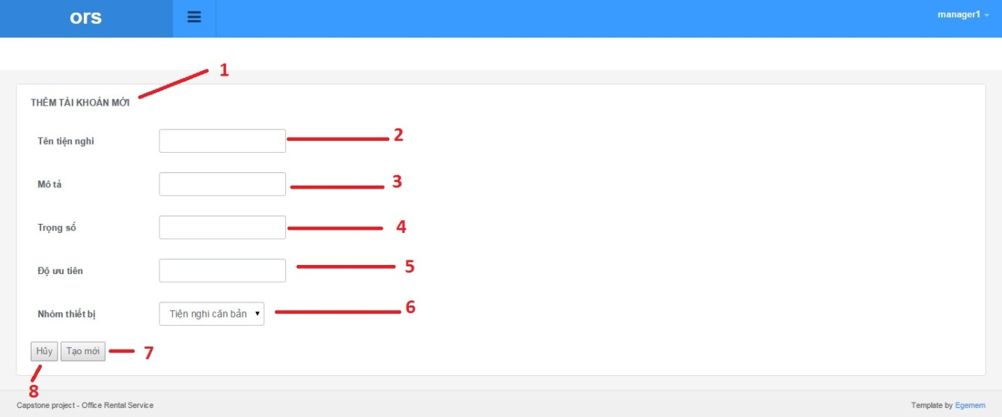

Figure 206: Create amenity

**Fields**

|  |  |  |  |  |  |  |  |
| --- | --- | --- | --- | --- | --- | --- | --- |
| **No** | **Field Name** | **Description** | **Read only** | **Mandatory** | **Control Type** | **Data Type** | **Length** |
| 1 | Page title | Title of amenity list | Yes | Yes | Label | N/A | N/A |
| 2 | Amenity name | Fill amenity name | No | Yes | Textbox | N/A | N/A |
| 3 | Amenity description | Fill amenity description | No | Yes | Textbox | N/A | N/A |
| 4 | Amenity weight | Fill amenity weight | No | Yes | Textbox | N/A | N/A |
| 5 | Amenity priority | Fill amenity priority | No | Yes | Textbox | N/A | N/A |
| 6 | Amenity group | Fill amenity group | No | Yes | Dropbox | N/A | N/A |

**Buttons/Hyperlinks**

|  |  |  |  |  |
| --- | --- | --- | --- | --- |
| **No** | **Function** | **Description** | **Validation** | **Outcome** |
| 7 | Add amenity | Add amenity to amenity list | No | N/A |
| 8 | Cancel | Return to amenity list page | No | Transfer to amenity page |

#### View appointment request list



Figure 207: View appointment request list

**Fields**

|  |  |  |  |  |  |  |  |
| --- | --- | --- | --- | --- | --- | --- | --- |
| **No** | **Field Name** | **Description** | **Read only** | **Mandatory** | **Control Type** | **Data Type** | **Length** |
| 1 | Page title | Title of appointment request list | Yes | Yes | Label | N/A | N/A |
| 2 | Appointment list | List of request appointment list has been sent | Yes | Yes | Listview | N/A | N/A |

**Buttons/Hyperlinks**

|  |  |  |  |  |
| --- | --- | --- | --- | --- |
| **No** | **Function** | **Description** | **Validation** | **Outcome** |
| 3 | Assign staff | Auto assign staff | No | N/A |
| 4 | Information appointment request | Show information about appointment request and assign staff | No | Transfer to amenity page |

**Appointment request list includes**

|  |  |  |  |  |  |
| --- | --- | --- | --- | --- | --- |
| **Field Name** | **Description** | **Read only** | **Control Type** | **Data Type** | **Length** |
| Customer name | Name of customer | Yes | Textview | String | N/A |
| Office name | Description of office | Yes | Textview | String | N/A |
| Time meeting | Time to meet | Yes | Textview | Integer | N/A |
| Suggest staff | Suggest staff to assign | Yes | Dropbox | Integer | N/A |

#### View appointment request detail

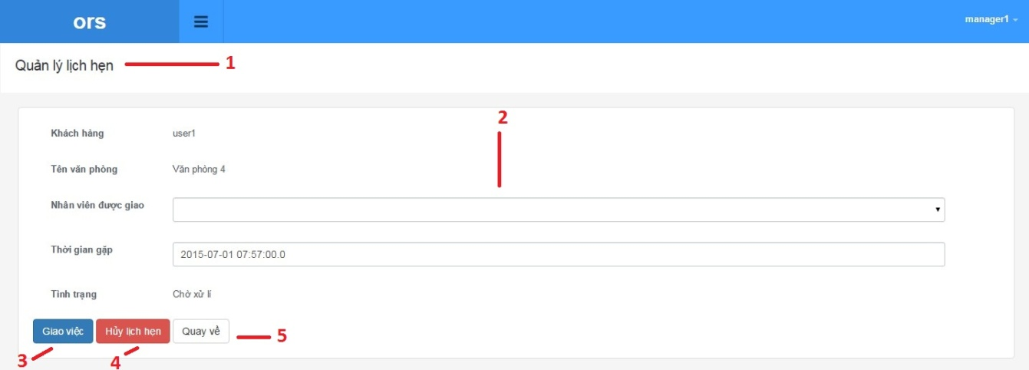

Figure 208: View appointment request detail

**Fields**

|  |  |  |  |  |  |  |  |
| --- | --- | --- | --- | --- | --- | --- | --- |
| **No** | **Field Name** | **Description** | **Read only** | **Mandatory** | **Control Type** | **Data Type** | **Length** |
| 1 | Page title | Title of appointment | Yes | Yes | Label | N/A | N/A |
| 2 | appointment information | Information of appointment | No | Yes | Textbox | N/A | N/A |

**Buttons/Hyperlinks**

|  |  |  |  |  |
| --- | --- | --- | --- | --- |
| **No** | **Function** | **Description** | **Validation** | **Outcome** |
| 3 | Assign staff | Add amenity to amenity list | Yes | N/A |
| 4 | Cancel appointment | Cancel appointment | Yes | N/A |
| 5 | Come back | Return to appointment list | No | N/A |

**Appointment detail includes**

|  |  |  |  |  |  |
| --- | --- | --- | --- | --- | --- |
| **Field Name** | **Description** | **Read only** | **Control Type** | **Data Type** | **Length** |
| Customer username | Username of customer | Yes | Textview | String | N/A |
| Office name | Description of amenity | Yes | Textview | String | N/A |
| Assigned staff | Weight of amenity | No | Dropbox | String | N/A |
| Time meeting | Priority of amenity | No | Textbox | Date time | N/A |
| Status | Status of appointment | Yes | Textview | String | N/A |

#### View amenity group list

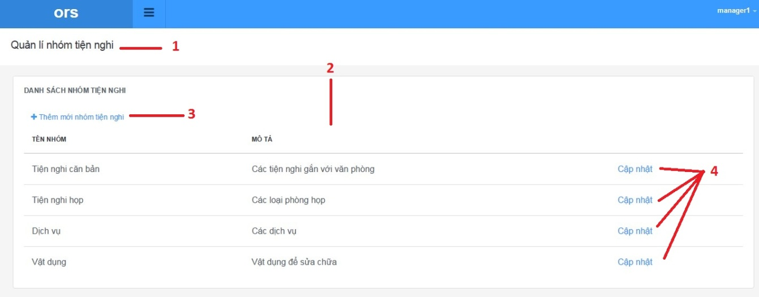

Figure 209: View amenity group list

**Fields**

|  |  |  |  |  |  |  |  |
| --- | --- | --- | --- | --- | --- | --- | --- |
| **No** | **Field Name** | **Description** | **Read only** | **Mandatory** | **Control Type** | **Data Type** | **Length** |
| 1 | Page title | Title of amenity group list | Yes | Yes | Label | N/A | N/A |
| 2 | Amenity group list infomation | Information of amenity group list | Yes | Yes | Label | N/A | N/A |

**Buttons/Hyperlinks**

|  |  |  |  |  |
| --- | --- | --- | --- | --- |
| **No** | **Function** | **Description** | **Validation** | **Outcome** |
| 3 | Add new amenity group | Add amenity group to amenity group list | No | N/A |
| 4 | Update amenity group | Update amenity group | No | N/A |

**Amenity group list includes**

|  |  |  |  |  |  |
| --- | --- | --- | --- | --- | --- |
| **Field Name** | **Description** | **Read only** | **Control Type** | **Data Type** | **Length** |
| Amenity group name | Name of amenity group | Yes | Textview | String | N/A |
| Amenity group description | Description of amenity | Yes | Textview | String | N/A |

#### Add new amenity group

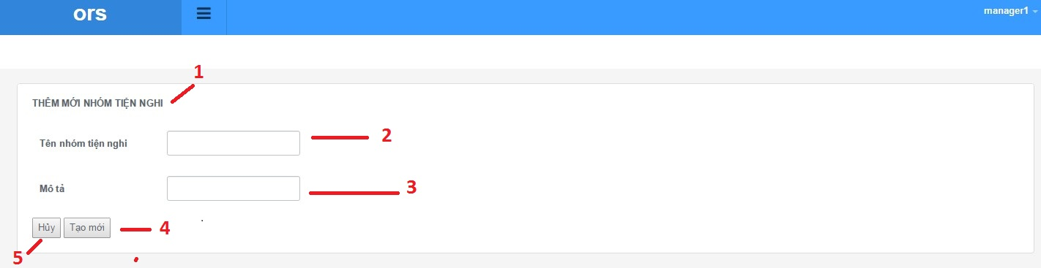

Figure 210: Add new amenity group

**Fields**

|  |  |  |  |  |  |  |  |
| --- | --- | --- | --- | --- | --- | --- | --- |
| **No** | **Field Name** | **Description** | **Read only** | **Mandatory** | **Control Type** | **Data Type** | **Length** |
| 1 | Page title | Title of amenity group | Yes | Yes | Label | N/A | N/A |
| 2 | Amenity group name | Fill amenity group name | No | Yes | Textbox | N/A | N/A |
| 3 | Amenity group description | Fill amenity group description | No | No | Textbox | N/A | N/A |

**Buttons/Hyperlinks**

|  |  |  |  |  |
| --- | --- | --- | --- | --- |
| **No** | **Function** | **Description** | **Validation** | **Outcome** |
| 4 | Add new amenity group | Add amenity group to amenity group list | Yes | N/A |
| 5 | Cancel | Go to amenity group list page | No | N/A |

#### Update amenity group

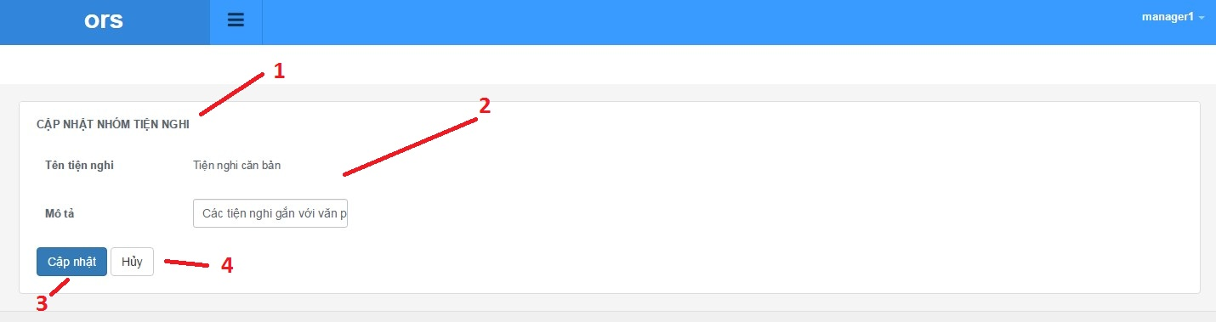

Figure 211: Update amenity group

**Fields**

|  |  |  |  |  |  |  |  |
| --- | --- | --- | --- | --- | --- | --- | --- |
| **No** | **Field Name** | **Description** | **Read only** | **Mandatory** | **Control Type** | **Data Type** | **Length** |
| 1 | Page title | Title of amenity list | Yes | Yes | Label | N/A | N/A |
| 2 | Amenity group information | Information of amenity | No | Yes | Label | N/A | N/A |

**Buttons/Hyperlinks**

|  |  |  |  |  |
| --- | --- | --- | --- | --- |
| **No** | **Function** | **Description** | **Validation** | **Outcome** |
| 3 | Update amenity | Add amenity group to amenity group list | Yes | N/A |
| 4 | Cancel | Return to amenity group list | No | N/A |

**Amenity detail includes**

|  |  |  |  |  |  |
| --- | --- | --- | --- | --- | --- |
| **Field Name** | **Description** | **Read only** | **Control Type** | **Data Type** | **Length** |
| Amenity group name | Name of amenity group | Yes | Label | String | N/A |
| Amenity group description | Description of amenity | Yes | Textbox | String | N/A |

#### View user list

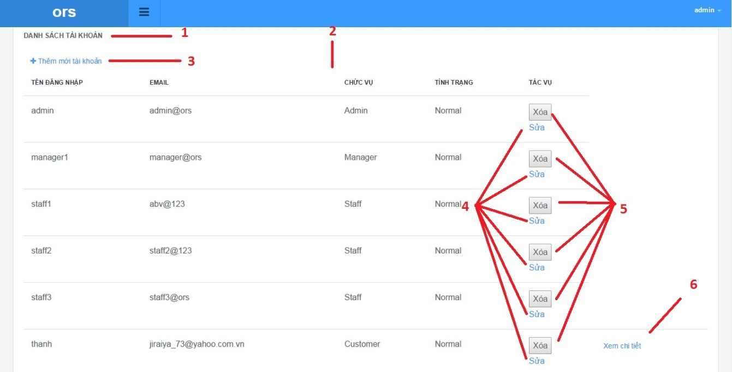

Figure 212: View user list

**Fields**

|  |  |  |  |  |  |  |  |
| --- | --- | --- | --- | --- | --- | --- | --- |
| **No** | **Field Name** | **Description** | **Read only** | **Mandatory** | **Control Type** | **Data Type** | **Length** |
| 1 | Page title | Title of user list | Yes | Yes | Label | N/A | N/A |
| 2 | User list infomation | Information of amenity group list | Yes | Yes | Label | N/A | N/A |

**Buttons/Hyperlinks**

|  |  |  |  |  |
| --- | --- | --- | --- | --- |
| **No** | **Function** | **Description** | **Validation** | **Outcome** |
| 3 | Add new user | Add amenity group to amenity group list | No | N/A |
| 4 | Update user information | Update amenity group | No | N/A |
| 5 | Delete user | Delete account user | No | N/A |
| 6 | Detail user | Show information about user | No | N/A |

**User list includes**

|  |  |  |  |  |  |
| --- | --- | --- | --- | --- | --- |
| **Field Name** | **Description** | **Read only** | **Control Type** | **Data Type** | **Length** |
| Username | Username of user | Yes | Textview | String | N/A |
| Email | Email of user | Yes | Textview | String | N/A |
| Role | Role of user | Yes | Textview | String | N/A |
| Status | Status of user | Yes | Textview | String | N/A |
| Action | Action of website | Yes | Textview | String | N/A |

#### Add new user

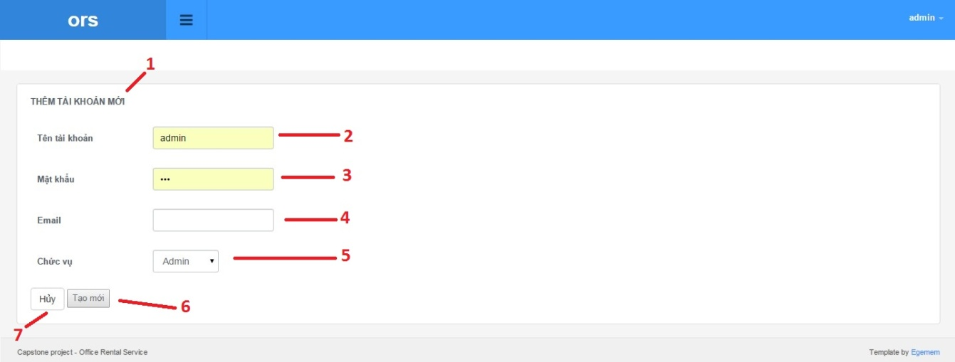

Figure 213: Add new user

**Fields**

|  |  |  |  |  |  |  |  |
| --- | --- | --- | --- | --- | --- | --- | --- |
| **No** | **Field Name** | **Description** | **Read only** | **Mandatory** | **Control Type** | **Data Type** | **Length** |
| 1 | Page title | Title of add user page | Yes | Yes | Label | N/A | N/A |
| 2 | Username | Fill username of user | No | Yes | Textbox | N/A | N/A |
| 3 | Password | Fill password of user | No | Yes | Textbox | N/A | N/A |
| 4 | Email | Fill email of user | No | No | Textbox | N/A | N/A |
| 5 | Role | Choose role of user | No | Yes | Dropbox | N/A | N/A |

**Buttons/Hyperlinks**

|  |  |  |  |  |
| --- | --- | --- | --- | --- |
| **No** | **Function** | **Description** | **Validation** | **Outcome** |
| 6 | Add new user | Add account to account list | Yes | N/A |
| 7 | Cancel | Go to user list page | No | N/A |

#### Update user

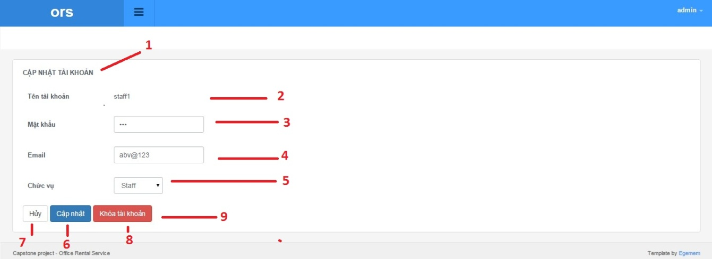

Figure 214: Update user

**Fields**

|  |  |  |  |  |  |  |  |
| --- | --- | --- | --- | --- | --- | --- | --- |
| **No** | **Field Name** | **Description** | **Read only** | **Mandatory** | **Control Type** | **Data Type** | **Length** |
| 1 | Page title | Title of add user page | Yes | Yes | Label | N/A | N/A |
| 2 | Username | Fill username of user | No | Yes | Label | N/A | N/A |
| 3 | Password | Fill password of user | No | Yes | Textbox | N/A | N/A |
| 4 | Email | Fill email of user | No | No | Textbox | N/A | N/A |
| 5 | Role | Choose role of user | No | Yes | Dropbox | N/A | N/A |

**Buttons/Hyperlinks**

|  |  |  |  |  |
| --- | --- | --- | --- | --- |
| **No** | **Function** | **Description** | **Validation** | **Outcome** |
| 6 | Update | update account infomation | Yes | N/A |
| 7 | Cancel | Go to user list page | No | N/A |
| 8 | Ban | Ban account user | Yes | N/A |
| 9 | Unban | Unban account user | Yes | N/A |

#### View user profile

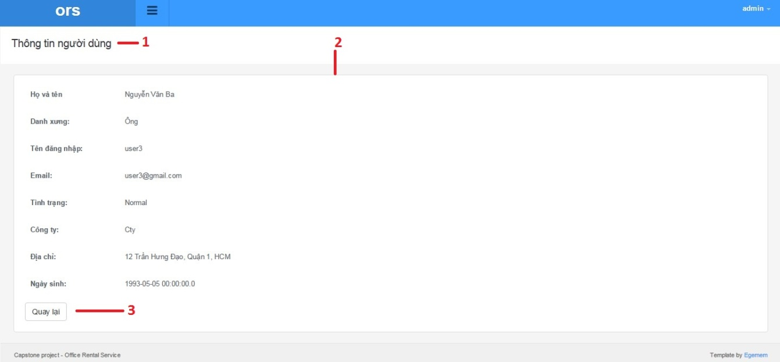

Figure 215: View user profile

**Fields**

|  |  |  |  |  |  |  |  |
| --- | --- | --- | --- | --- | --- | --- | --- |
| **No** | **Field Name** | **Description** | **Read only** | **Mandatory** | **Control Type** | **Data Type** | **Length** |
| 1 | Page title | Title of user profile | Yes | Yes | Label | N/A | N/A |
| 2 | User information | Information of amenity group list | Yes | Yes | Label | N/A | N/A |

**Buttons/Hyperlinks**

|  |  |  |  |  |
| --- | --- | --- | --- | --- |
| **No** | **Function** | **Description** | **Validation** | **Outcome** |
| 3 | Back | Go to user list page | No | N/A |

**User profile includes**

|  |  |  |  |  |  |
| --- | --- | --- | --- | --- | --- |
| **Field Name** | **Description** | **Read only** | **Control Type** | **Data Type** | **Length** |
| Full name | Full name of user | Yes | Textview | String | N/A |
| Title | Title of user | Yes | Textview | String | N/A |
| Username | Username of user | Yes | Textview | String | N/A |
| Email | Email of user | Yes | Textview | String | N/A |
| Status | Status of user | Yes | Textview | String | N/A |
| Company | Company of user | Yes | Textview | String | N/A |
| Address | Address of user | Yes | Textview | String | N/A |
| Birthday | Birthday of user | Yes | Textview | String | N/A |

#### View retal detail



Figure 216: View rental detail

**Fields**

|  |  |  |  |  |  |  |  |
| --- | --- | --- | --- | --- | --- | --- | --- |
| **No** | **Field Name** | **Description** | **Read only** | **Mandatory** | **Control Type** | **Data Type** | **Length** |
| 1 | Page title | Title of rental detail | Yes | Yes | Label | N/A | N/A |
| 2 | Rental information | Information of rental detail | Yes | Yes | Label | N/A | N/A |

**Buttons/Hyperlinks**

|  |  |  |  |  |
| --- | --- | --- | --- | --- |
| **No** | **Function** | **Description** | **Validation** | **Outcome** |
| 3 | Assign staff | Assign rental for suggest staff | Yes | N/A |
| 4 | Cancel rental | Go to rental detail page | No | N/A |
| 5 | Back | Go to rental list page | No | N/A |

**Retal detail includes**

|  |  |  |  |  |  |
| --- | --- | --- | --- | --- | --- |
| **Field Name** | **Description** | **Read only** | **Control Type** | **Data Type** | **Length** |
| Id | Id of rental | Yes | Textview | String | N/A |
| Staff | Name of assigned staff | No | Dropbox | String | N/A |
| Assigned day | Create date of rental | No | Dropbox | String | N/A |
| Description | Description of rental | Yes | Textview | String | N/A |
| Status | Tool for auto assign staff | Yes | Textview | String | N/A |
| Rental item list | Table of rental item | Yes | Textview | String | N/A |
| Retal item name | Name of rental item | Yes | Textview | String | N/A |
| Price | Price of rental item | Yes | Textview | String | N/A |
| Number | Number of rental item | Yes | Textview | String | N/A |
| Total | Total price | Yes | Textview | String | N/A |

#### View retal list

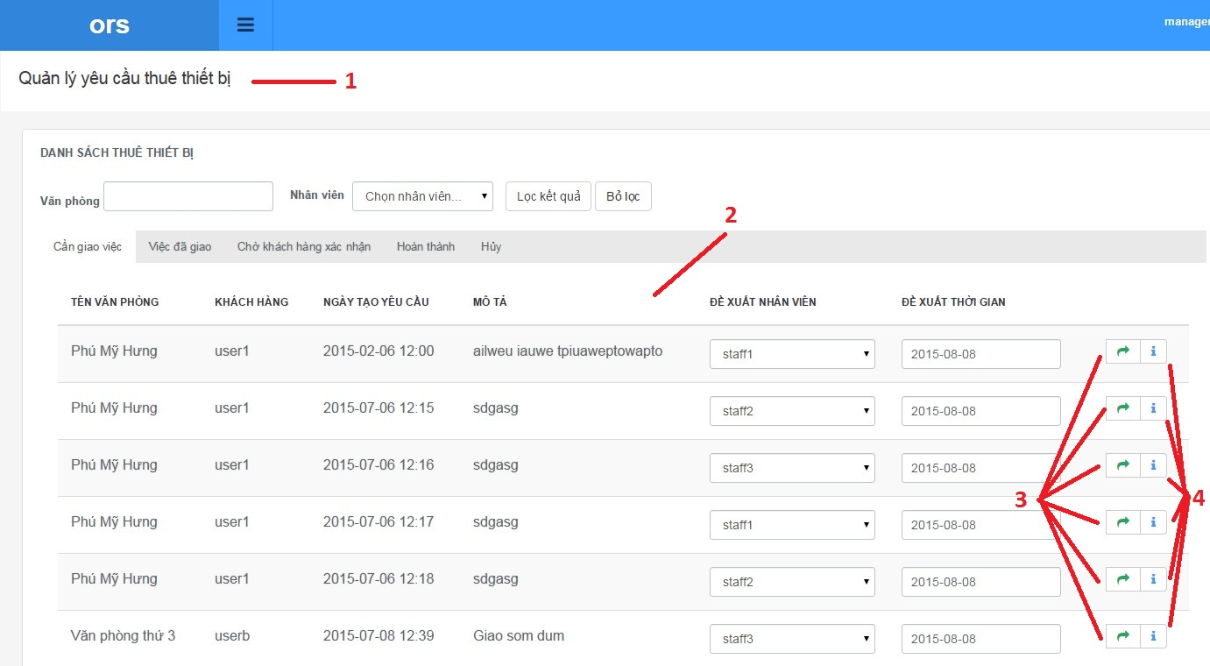

Figure 217: View rental list

**Fields**

|  |  |  |  |  |  |  |  |
| --- | --- | --- | --- | --- | --- | --- | --- |
| **No** | **Field Name** | **Description** | **Read only** | **Mandatory** | **Control Type** | **Data Type** | **Length** |
| 1 | Page title | Title of rental list | Yes | Yes | Label | N/A | N/A |
| 2 | Rental information | Information rental list | Yes | Yes | Label | N/A | N/A |

**Buttons/Hyperlinks**

|  |  |  |  |  |
| --- | --- | --- | --- | --- |
| **No** | **Function** | **Description** | **Validation** | **Outcome** |
| 3 | Assign staff | Assign rental for suggest staff | No | N/A |
| 4 | Rental detail | Go to rental detail page | No | N/A |

**Retal list includes**

|  |  |  |  |  |  |
| --- | --- | --- | --- | --- | --- |
| **Field Name** | **Description** | **Read only** | **Control Type** | **Data Type** | **Length** |
| Office name | Name of office | Yes | Textview | String | N/A |
| Customer name | Name of customer | Yes | Textview | String | N/A |
| Create date | Create date of rental | Yes | Textview | String | N/A |
| Description | Description of rental | Yes | Textview | String | N/A |
| Suggest staff | Tool for auto assign staff | Yes | Textview | String | N/A |
| Suggest time | Tool for auto assign time | Yes | Textview | String | N/A |

#### View retal item list

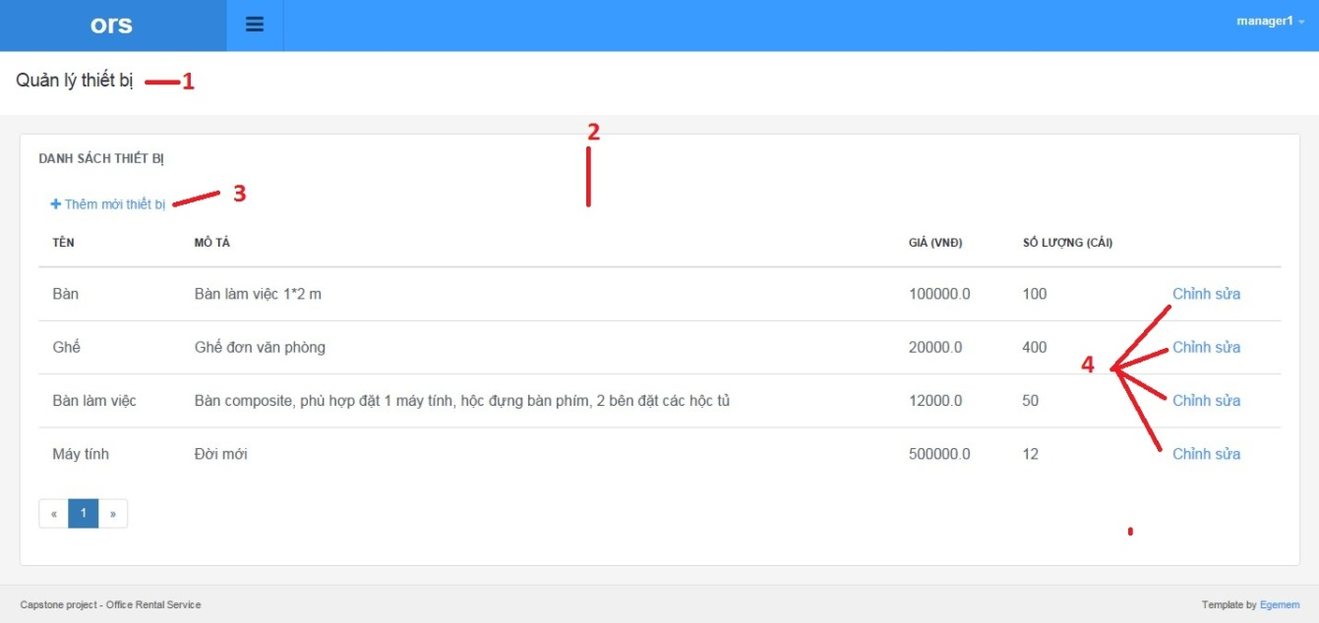

Figure 218: View rental item list

**Fields**

|  |  |  |  |  |  |  |  |
| --- | --- | --- | --- | --- | --- | --- | --- |
| **No** | **Field Name** | **Description** | **Read only** | **Mandatory** | **Control Type** | **Data Type** | **Length** |
| 1 | Page title | Title of rental item list | Yes | Yes | Label | N/A | N/A |
| 2 | Rental information | Information rental item list | Yes | Yes | Label | N/A | N/A |

**Buttons/Hyperlinks**

|  |  |  |  |  |
| --- | --- | --- | --- | --- |
| **No** | **Function** | **Description** | **Validation** | **Outcome** |
| 3 | Add new | Add new rental item | No | N/A |
| 4 | Update | Update rental item | No | N/A |

**Retal list includes**

|  |  |  |  |  |  |
| --- | --- | --- | --- | --- | --- |
| **Field Name** | **Description** | **Read only** | **Control Type** | **Data Type** | **Length** |
| Name | Name of item rental | Yes | Textview | String | N/A |
| Description | Description of item rental | Yes | Textview | String | N/A |
| Price | Price of item rental | Yes | Textview | String | N/A |
| Number | Number of item rental | Yes | Textview | String | N/A |

#### Add new rental item

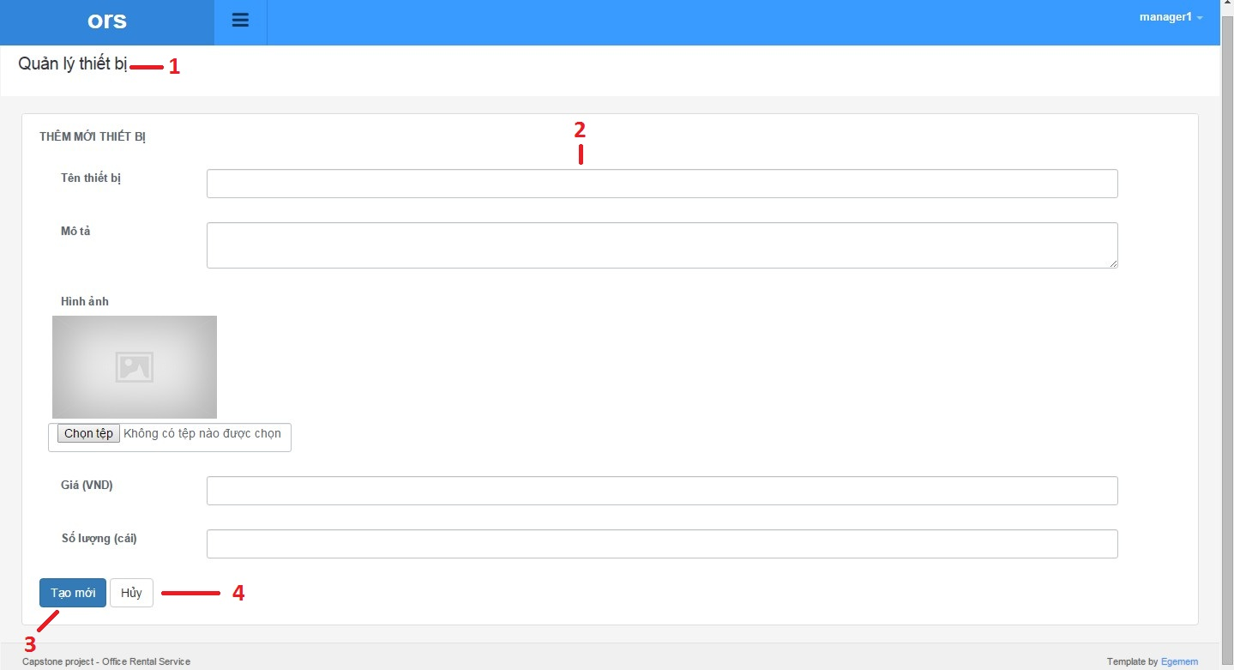

Figure 219 Add new rental item

**Fields**

|  |  |  |  |  |  |  |  |
| --- | --- | --- | --- | --- | --- | --- | --- |
| **No** | **Field Name** | **Description** | **Read only** | **Mandatory** | **Control Type** | **Data Type** | **Length** |
| 1 | Page title | Title of add rental item | Yes | Yes | Label | N/A | N/A |
| 2 | Rental information | Information rental item list | Yes | Yes | Label | N/A | N/A |

**Buttons/Hyperlinks**

|  |  |  |  |  |
| --- | --- | --- | --- | --- |
| **No** | **Function** | **Description** | **Validation** | **Outcome** |
| 3 | Add new | Add new rental item | No | N/A |
| 4 | Cancel | Cancel add new rental item | No | N/A |

**Retal list includes**

|  |  |  |  |  |  |
| --- | --- | --- | --- | --- | --- |
| **Field Name** | **Description** | **Read only** | **Control Type** | **Data Type** | **Length** |
| Name | Name of item rental | Yes | Textbox | String | N/A |
| Description | Description of item rental | Yes | Textbox | String | N/A |
| Picture | Picture of item rental | Yes | Textbox | String | N/A |
| Price | Price of item rental | Yes | Textbox | String | N/A |
| Number | Number of item rental | Yes | Textbox | String | N/A |

#### Update retal item

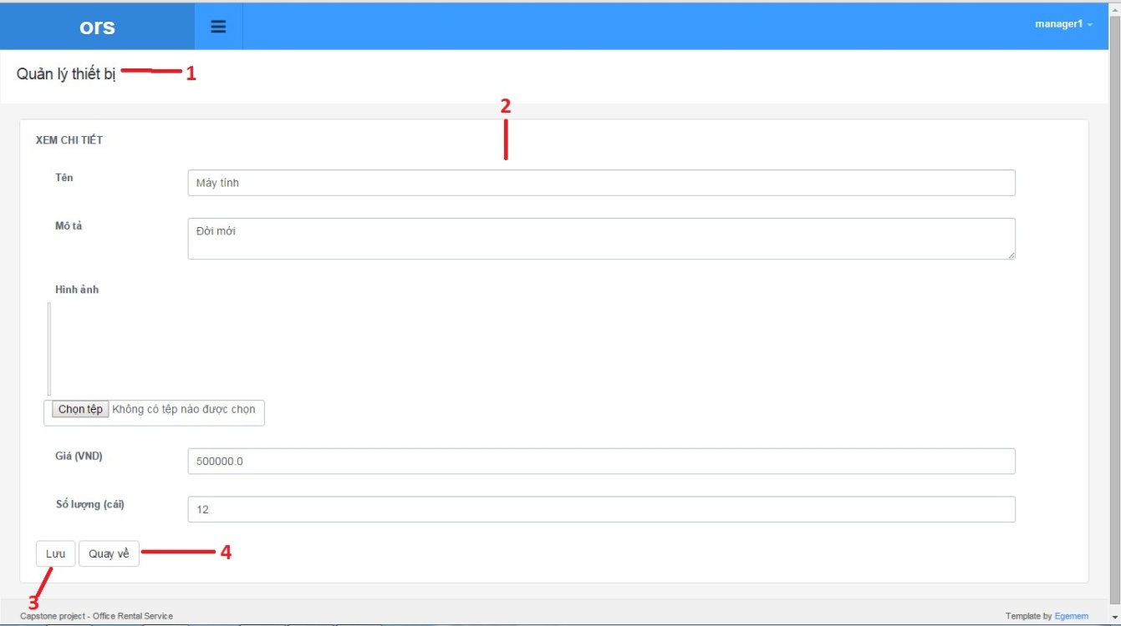

Figure 220 Update rental item

**Fields**

|  |  |  |  |  |  |  |  |
| --- | --- | --- | --- | --- | --- | --- | --- |
| **No** | **Field Name** | **Description** | **Read only** | **Mandatory** | **Control Type** | **Data Type** | **Length** |
| 1 | Page title | Title of update rental item | Yes | Yes | Label | N/A | N/A |
| 2 | Rental information | Information rental item list | Yes | Yes | Label | N/A | N/A |

**Buttons/Hyperlinks**

|  |  |  |  |  |
| --- | --- | --- | --- | --- |
| **No** | **Function** | **Description** | **Validation** | **Outcome** |
| 3 | Save | Save rental item detail | No | N/A |
| 4 | Cancel | Cancel update rental item | No | N/A |

**Retal list includes**

|  |  |  |  |  |  |
| --- | --- | --- | --- | --- | --- |
| **Field Name** | **Description** | **Read only** | **Control Type** | **Data Type** | **Length** |
| Name | Name of item rental | Yes | Textbox | String | N/A |
| Description | Description of item rental | Yes | Textbox | String | N/A |
| Picture | Picture of item rental | Yes | Textbox | String | N/A |
| Price | Price of item rental | Yes | Textbox | String | N/A |
| Number | Number of item rental | Yes | Textbox | String | N/A |

#### Repair list

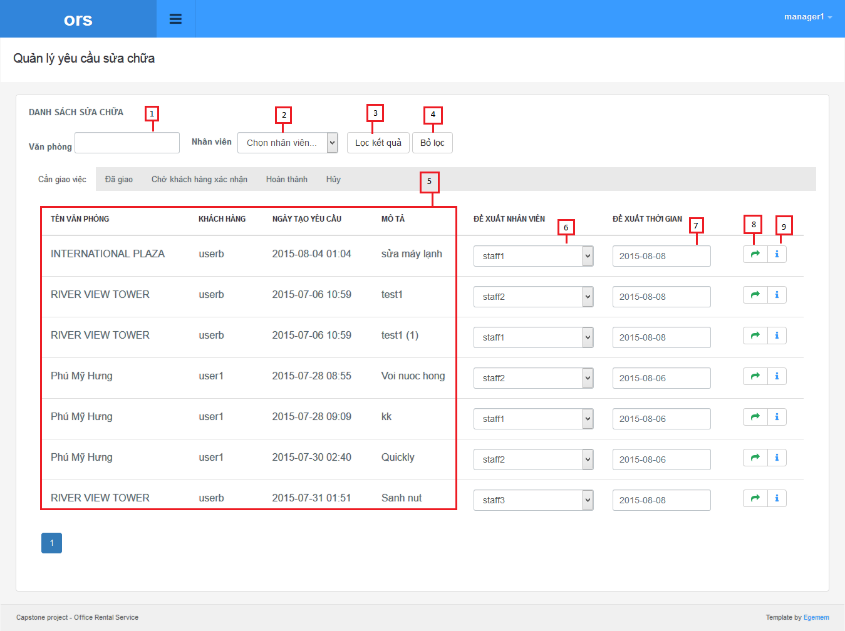

Figure 221: Repair list

**Fields**

|  |  |  |  |  |  |  |  |
| --- | --- | --- | --- | --- | --- | --- | --- |
| **No** | **Field Name** | **Description** | **Read only** | **Mandatory** | **Control Type** | **Data Type** | **Length** |
| 1 | Office name | The name of the office | No | Yes | Textbox | String | N/A |
| 2 | Staff name | List staff name | No | Yes | Drop down list | String | N/A |
| 5 | List repair | List request repair of customer | Yes | Yes | Table | N/A | N/A |
| 6 | Assign staff | The staff that system suggest to manager | No | Yes | Drop down list | String | N/A |
| 7 | Assign time | The date that system suggest to manager | No | Yes | Date time picker | Date | N/A |

**Buttons/Hyperlinks**

|  |  |  |  |  |
| --- | --- | --- | --- | --- |
| **No** | **Function** | **Description** | **Validation** | **Outcome** |
| 3 | Filter | Filter list repair by office name or staff name | N/A | Show list repair after filter |
| 4 | Cancel filter | Click to cancel filter | N/A | Return list repair to entry |

**List repair include**

|  |  |  |  |  |  |
| --- | --- | --- | --- | --- | --- |
| **Field Name** | **Description** | **Read only** | **Control Type** | **Data Type** | **Length** |
| Office name | The name of the office | Yes | Textview | String | N/A |
| Username | Username of customer | Yes | Textview | String | N/A |
| Create time | The time that customer create request | Yes | Textview | Date | N/A |
| Description | Describe request repair of customer | Yes | Textview | String | N/A |

#### Repair detail

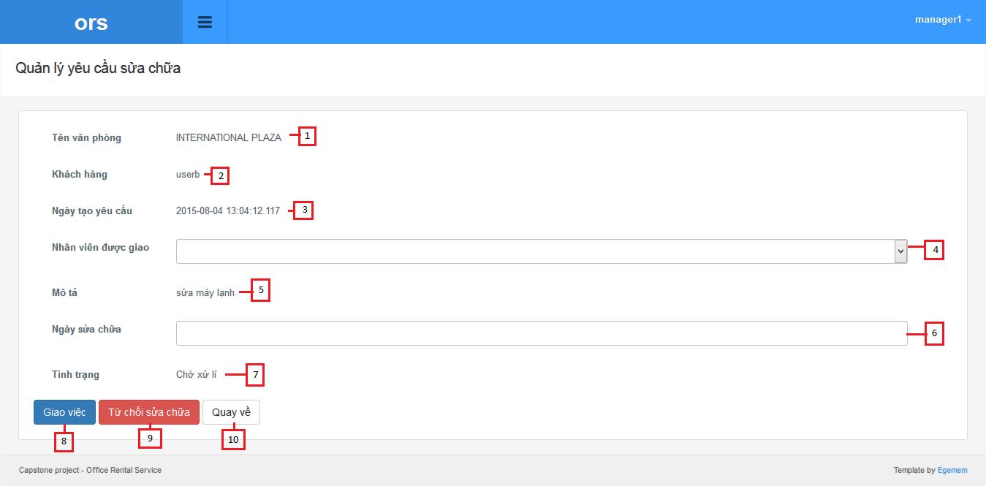

Figure 222: Repair detail

**Fields**

|  |  |  |  |  |  |  |  |
| --- | --- | --- | --- | --- | --- | --- | --- |
| **No** | **Field Name** | **Description** | **Read only** | **Mandatory** | **Control Type** | **Data Type** | **Length** |
| 1 | Office name | The name of the office | Yes | Yes | Label | String | N/A |
| 2 | Username | Username of customer | Yes | Yes | Label | String | N/A |
| 3 | Create time | The time that customer create request | Yes | Yes | Label | Date | N/A |
| 4 | Staff | List all of staff | No | Yes | Drop down list | String | N/A |
| 5 | Description | Describe request repair of customer | Yes | Yes | Label | String | N/A |
| 6 | Assign time | The date that staff come to repair | No | Yes | Drop down list | String | N/A |
| 7 | Status | The status of the request repair | Yes | Yes | Label | String | N/A |

**Buttons/Hyperlinks**

|  |  |  |  |  |
| --- | --- | --- | --- | --- |
| **No** | **Function** | **Description** | **Validation** | **Outcome** |
| 8 | Assign | Accept request and assign staff to repair | N/A | Return to repair page |
| 9 | Reject | Reject request | N/A | Return to repair page |
| 10 | Cancel | Click to cancel filter | N/A | Return to repair page |

#### View Calendar



Figure 223: View calendar

**Fields**

|  |  |  |  |  |  |  |  |
| --- | --- | --- | --- | --- | --- | --- | --- |
| **No** | **Field Name** | **Description** | **Read only** | **Mandatory** | **Control Type** | **Data Type** | **Length** |
| 3 | Current time | The current selection time | Yes | N/A | Label | String | N/A |
| 5 | Legends | The legends for staff with color | Yes | N/A | Label with color | String | N/A |

**Buttons/Hyperlinks**

|  |  |  |  |  |
| --- | --- | --- | --- | --- |
| **No** | **Function** | **Description** | **Validation** | **Outcome** |
| 1 | Navigation | Navigation the calendar | N/A | Go to next or previous period of time (select by (4) ) on calendar |
| 4 | Time period | The period to display the calendar in | N/A | Change the value will display the calendar with selected period of time |
| 6 | Job link | Link to selected job | N/A | Go to the job (appointment/ repair/rental) detail |

#### View office list

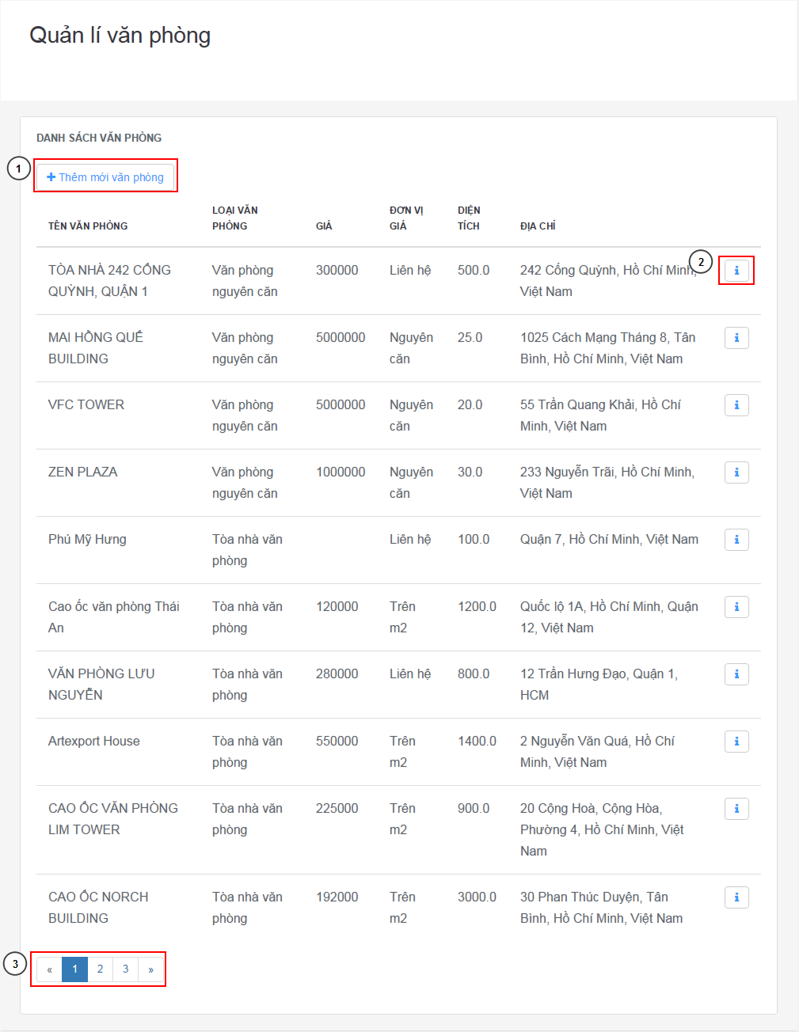

Figure 224: View office list

**Fields**

|  |  |  |  |  |  |  |  |
| --- | --- | --- | --- | --- | --- | --- | --- |
| **No** | **Field Name** | **Description** | **Read only** | **Mandatory** | **Control Type** | **Data Type** | **Length** |
| 0 | Office Table | Abstract information of the office | Yes | N/A | Table | String | N/A |

**Buttons/Hyperlinks**

|  |  |  |  |  |
| --- | --- | --- | --- | --- |
| **No** | **Function** | **Description** | **Validation** | **Outcome** |
| 1 | New office | Link to new office page | N/A | Go to add new office page |
| 2 | Office detail | Link to office detail | N/A | Go to current office detail page |
| 3 | Paging | Paging of office table page | N/A | Change the page of office table |

#### Add new office





Figure 225: Add new office

**Fields**

|  |  |  |  |  |  |  |  |
| --- | --- | --- | --- | --- | --- | --- | --- |
| **No** | **Field Name** | **Description** | **Read only** | **Man-datory** | **Control Type** | **Data Type** | **Length** |
| 1 | Office name | Name of the office | No | Yes | Textbox | String | [5-150] |
| 2 | Address | Address of the office | No | Yes | Textbox | String | [5-150] |
| 3 | Address detail | The district and city of input address | No | Yes | Textbox | String | N/A |
| 5 | Description | Description of the office | No | Yes | Text area | String | Unlimited |
| 7 | Amenity input | Input the amenity | No | No | Textbox | String | [1-150] |
| 8 | Office type | Type of the office | No | Yes | Drop-down | String | N/A |
| 9 | Floor number | Number of floor | No | Yes | Textbox number | Integer | [1-3] |
| 10 | Area | Total area of office | No | Yes | Textbox number | Float | [1-9] |
| 11 | Min area | The minimum area customer can rental | No | Yes (only building office type) | Textbox number | Float | [1-9] |
| 12 | Min time | Minimum time customer can rental in month | No | Yes | Textbox number | Integer | [1-3] |
| 13 | Price | The price of the office | No | Yes when price term is not call | Textbox number | Long | [0-15] |
| 14 | Is percent | Will company take income as percent of rental price or by offer price | No | Yes | Check box | N/A | N/A |
| 15 | Base price | Base price, will display when Is percent is set to off | No | Yes | Textbox number | Long | [0-15] |
| 16 | Price term | The term of the price (by all office, in m2 or call) | No | Yes | Drop down box | N/A | N/A |
| 17 | Owner name | Name of owner of the office | No | Yes | Textbox | String | [5-150] |
| 18 | Owner phone | Phone of owner of office | No | Yes | Textbox | String | [9-11] |
| 19 | Owner address | Address of owner of office | No | No | Textbox | String | [5-150] |

**Buttons/Hyperlinks**

|  |  |  |  |  |
| --- | --- | --- | --- | --- |
| **No** | **Function** | **Description** | **Validation** | **Outcome** |
| 4 | Map | The map for current address | N/A | Change when the address change |
| 6 | Images | Button for upload images | Yes, image type only | Open upload windows. Add image at above, each has remove button |
| 7 | Add amenity | Press enter or button “+” to add amenity | N/A | Add new amenity based on info in textbox |
| 20 | Create | Create new office | Yes | Validate and create new office |
| 21 | Cancel | Cancel create office | N/A | Cancel and go back to office manage page |

#### Office detail

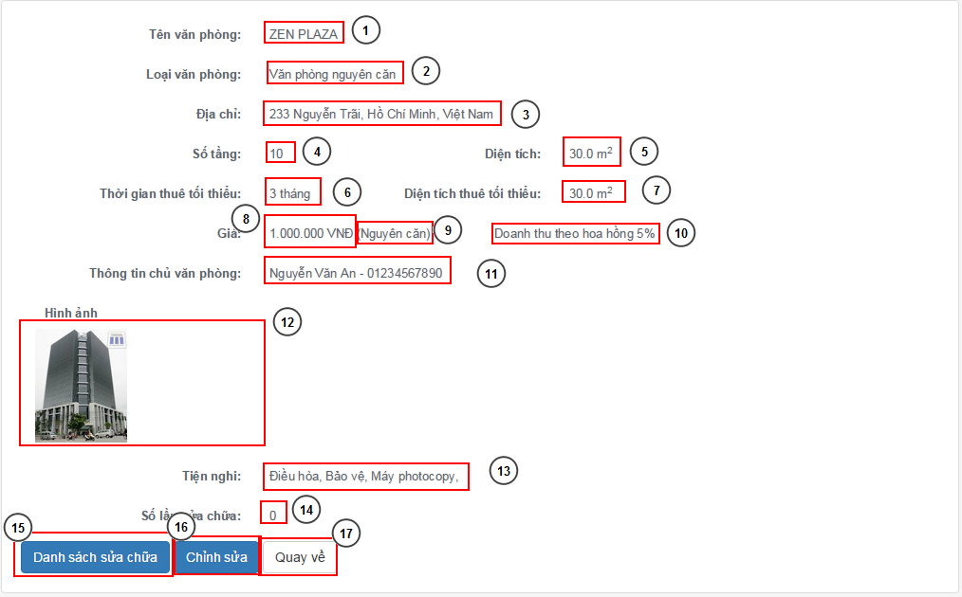

Figure 226: Office detail

**Fields**

|  |  |  |  |  |  |  |  |
| --- | --- | --- | --- | --- | --- | --- | --- |
| **No** | **Field Name** | **Description** | **Read only** | **Mandatory** | **Control Type** | **Data Type** | **Length** |
| 1 | Office name | Name of office | Yes | N/A | Text field | String | N/A |
| 2 | Office type | Type of the office | Yes | N/A | Text field | String | N/A |
| 3 | Address | Address of the office | Yes | N/A | Text field | String | N/A |
| 4 | Floor number | Number of floor | Yes | N/A | Text field | Integer | N/A |
| 5 | Area | Area of the office | Yes | N/A | Text field | Float | N/A |
| 6 | Min time | Minimum month for rental | Yes | N/A | Text field | Integer | N/A |
| 7 | Min area | Minimum area for rental | Yes | N/A | Text field | Float | N/A |
| 8 | Price | Price of rental | Yes | N/A | Text field | Long | N/A |
| 9 | Price term | Term of rental price | Yes | N/A | Text field | Integer | N/A |
| 10 | Income type | Type of income | Yes | N/A | Text field | Integer | N/A |
| 11 | Owner info | Information of office owner | Yes | N/A | Text field | Integer | N/A |
| 12 | Images | Images of office | Yes | N/A | Text field | Image | N/A |
| 13 | Amenity list | List of amenity | Yes | N/A | Text field | String | N/A |
| 14 | Repair count | Count of repair of the office | Yes | N/A | Text field | Integer | N/A |

**Buttons/Hyperlinks**

|  |  |  |  |  |
| --- | --- | --- | --- | --- |
| **No** | **Function** | **Description** | **Validation** | **Outcome** |
| 1 | Repair list | Repair list of current office | N/A | Go to the repair list for current office |
| 2 | Edit | Edit information of current office | N/A | Go to edit page of office |
| 3 | Back | Go back | N/A | Back to office list page |

#### Contract page

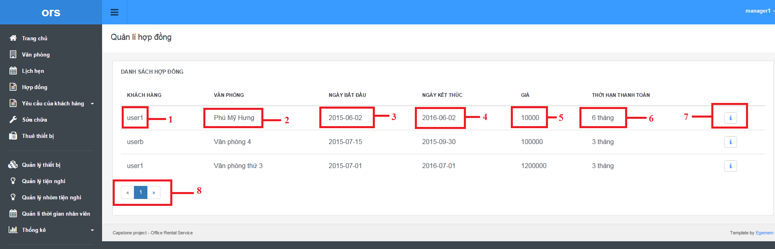

Figure 227: Contract page

**Fields**

|  |  |  |  |  |  |  |  |
| --- | --- | --- | --- | --- | --- | --- | --- |
| **No** | **Field Name** | **Description** | **Read only** | **Mandatory** | **Control Type** | **Data Type** | **Length** |
| 1 | Customer username | Name of customer | Yes | Yes | Textview | String | N/A |
| 2 | Office | Name of office | Yes | Yes | Textview | String | N/A |
| 3 | Start Date | Date when contract start | Yes | Yes | Textview | datetime | N/A |
| 4 | End Date | Date when contract end | Yes | Yes | Textview | datetime | N/A |
| 5 | Price | Price of contract | Yes | Yes | Textview | Int | N/A |
| 6 | Payment Term | Term of Payment | Yes | Yes | Textview | Int | N/A |

**Buttons/Hyperlinks**

|  |  |  |  |  |
| --- | --- | --- | --- | --- |
| **No** | **Function** | **Description** | **Validation** | **Outcome** |
| 7 | Detail | Show detail of the contract | N/A | Transfer to contract detail |
| 8 | Pagination | Page number for contract page | N/A | Transfer to another page in contract page |

#### New contract page

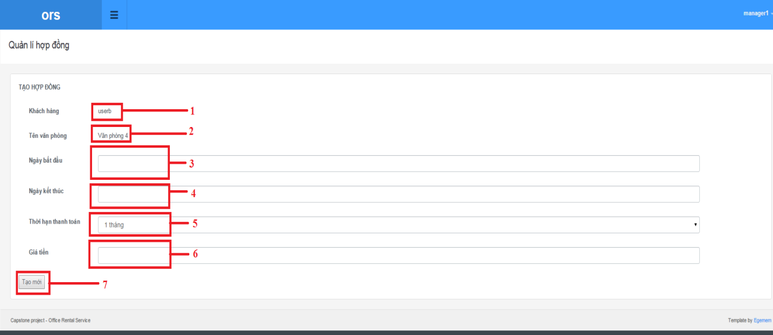

Figure 228: New contract page

**Fields**

|  |  |  |  |  |  |  |  |
| --- | --- | --- | --- | --- | --- | --- | --- |
| **No** | **Field Name** | **Description** | **Read only** | **Mandatory** | **Control Type** | **Data Type** | **Length** |
| 1 | Customer username | Name of customer | Yes | Yes | Textview | String | N/A |
| 2 | Office | Name of office | Yes | Yes | Textview | String | N/A |
| 3 | Start Date | Date when contract start | No | Yes | Textbox | datetime | N/A |
| 4 | End Date | Date when contract end | No | Yes | Textbox | datetime | N/A |
| 5 | Payment Term | Term of Payment | No | Yes | Dropdown list | Int | N/A |
| 6 | Price | Price of contract | No | Yes | Textbox | Int | N/A |

**Buttons/Hyperlinks**

|  |  |  |  |  |
| --- | --- | --- | --- | --- |
| **No** | **Function** | **Description** | **Validation** | **Outcome** |
| 7 | Create contract | Create new contract in database | Yes | Transfer to contract page |

#### Contract detail page

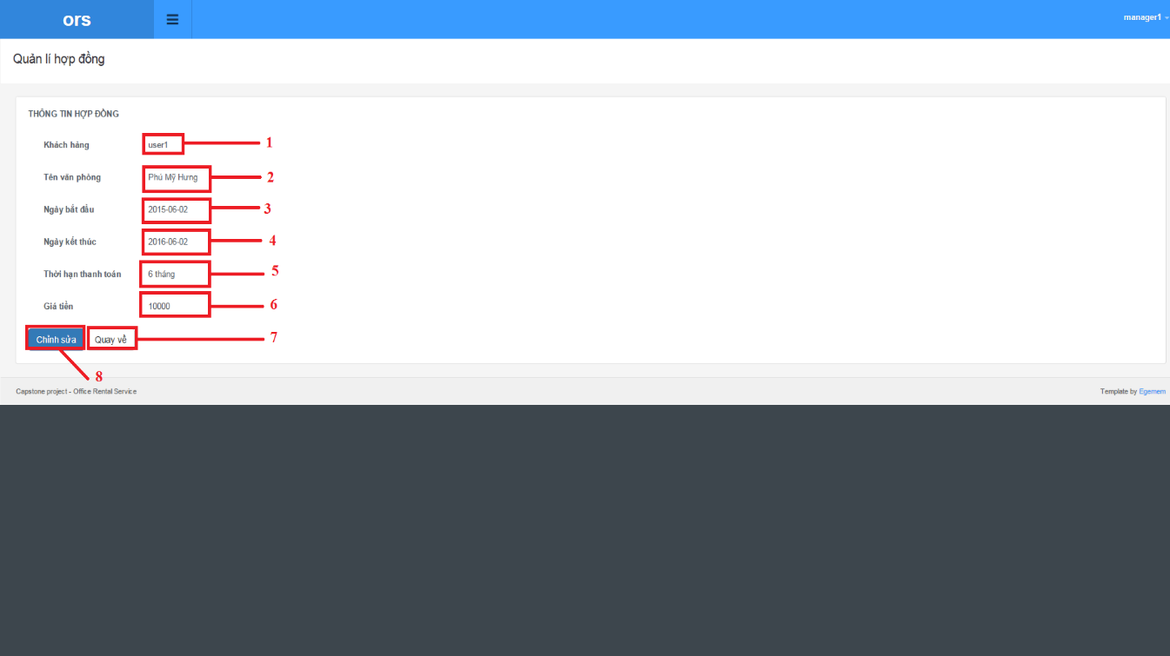

Figure 229: Contract detail page

**Fields**

|  |  |  |  |  |  |  |  |
| --- | --- | --- | --- | --- | --- | --- | --- |
| **No** | **Field Name** | **Description** | **Read only** | **Mandatory** | **Control Type** | **Data Type** | **Length** |
| 1 | Customer username | Name of customer | Yes | Yes | Textview | String | N/A |
| 2 | Office | Name of office | Yes | Yes | Textview | String | N/A |
| 3 | Start Date | Date when contract start | Yes | Yes | Textview | datetime | N/A |
| 4 | End Date | Date when contract end | Yes | Yes | Textview | datetime | N/A |
| 5 | Payment Term | Term of Payment | Yes | Yes | Textview | Int | N/A |
| 6 | Price | Price of contract | Yes | Yes | Textview | Int | N/A |

**Buttons/Hyperlinks**

|  |  |  |  |  |
| --- | --- | --- | --- | --- |
| **No** | **Function** | **Description** | **Validation** | **Outcome** |
| 7 | Return | Return to contract page | N/A | Transfer to contract page |
| 8 | Edit | Go to edit contract page | N/A | Transfer to edit contract page |

#### Edit contract page

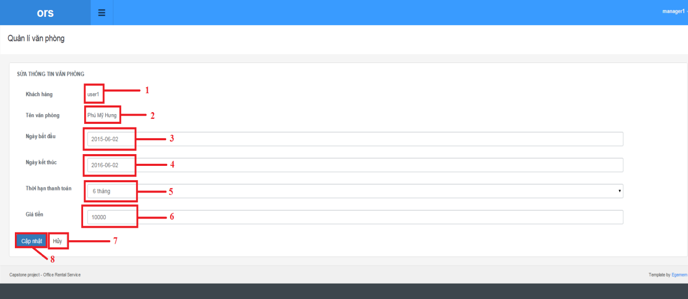

Figure 230: Edit contract page

**Fields**

|  |  |  |  |  |  |  |  |
| --- | --- | --- | --- | --- | --- | --- | --- |
| **No** | **Field Name** | **Description** | **Read only** | **Mandatory** | **Control Type** | **Data Type** | **Length** |
| 1 | Customer username | Name of customer | Yes | Yes | Textview | String | N/A |
| 2 | Office | Name of office | Yes | Yes | Textview | String | N/A |
| 3 | Start Date | Date when contract start | No | Yes | Textbox | datetime | N/A |
| 4 | End Date | Date when contract end | No | Yes | Textbox | datetime | N/A |
| 5 | Payment Term | Term of Payment | No | Yes | Dropdown list | Int | N/A |
| 6 | Price | Price of contract | No | Yes | Textbox | Int | N/A |

**Buttons/Hyperlinks**

|  |  |  |  |  |
| --- | --- | --- | --- | --- |
| **No** | **Function** | **Description** | **Validation** | **Outcome** |
| 7 | Cancel | Return to contract page | N/A | Transfer to contract page |
| 8 | Update | Update contract | Yes | Transfer to contract page |

#### View request contract page

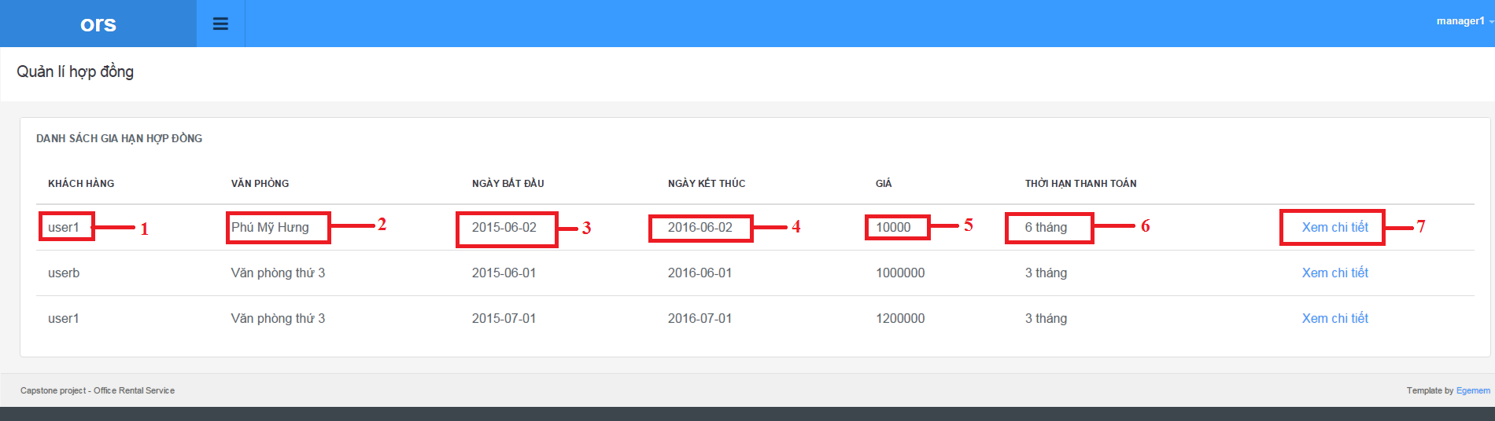

Figure 231: View request contract page

**Fields**

|  |  |  |  |  |  |  |  |
| --- | --- | --- | --- | --- | --- | --- | --- |
| **No** | **Field Name** | **Description** | **Read only** | **Mandatory** | **Control Type** | **Data Type** | **Length** |
| 1 | Customer username | Name of customer | Yes | Yes | Textview | String | N/A |
| 2 | Office | Name of office | Yes | Yes | Textview | String | N/A |
| 3 | Start Date | Date when contract start | Yes | Yes | Textview | datetime | N/A |
| 4 | End Date | Date when contract end | Yes | Yes | Textview | datetime | N/A |
| 5 | Price | Price of contract | Yes | Yes | Textview | Int | N/A |
| 6 | Payment Term | Term of Payment | Yes | Yes | Textview | Int | N/A |

**Buttons/Hyperlinks**

|  |  |  |  |  |
| --- | --- | --- | --- | --- |
| **No** | **Function** | **Description** | **Validation** | **Outcome** |
| 7 | Detail | Show detail of the contract | N/A | Transfer to contract detail |
|  |  |  |  |  |

#### Extend contract page

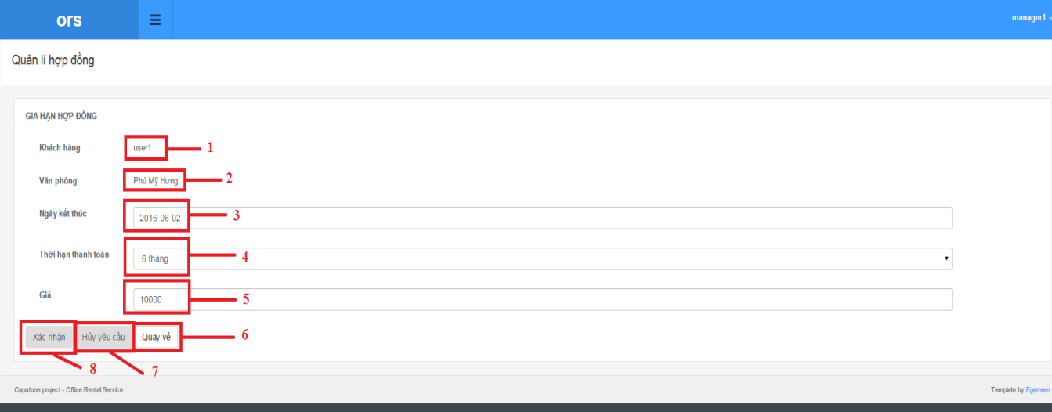

Figure 232: Extend contract page

**Fields**

|  |  |  |  |  |  |  |  |
| --- | --- | --- | --- | --- | --- | --- | --- |
| **No** | **Field Name** | **Description** | **Read only** | **Mandatory** | **Control Type** | **Data Type** | **Length** |
| 1 | Customer username | Name of customer | Yes | Yes | Textview | String | N/A |
| 2 | Office | Name of office | Yes | Yes | Textview | String | N/A |
| 3 | End Date | Date when contract end | No | Yes | Textview | datetime | N/A |
| 4 | Payment Term | Term of Payment | No | Yes | Textview | Int | N/A |
| 5 | Price | Price of contract | No | Yes | Textview | Int | N/A |

**Buttons/Hyperlinks**

|  |  |  |  |  |
| --- | --- | --- | --- | --- |
| **No** | **Function** | **Description** | **Validation** | **Outcome** |
| 6 | Return | Return to request contract page | N/A | Transfer to request contract page |
| 7 | Cancel request | Cancel the request | N/A | Transfer to request contract page |
| 8 | Update | Extend the contract | N/A | Transfer to request contract page |

#### Return contract page

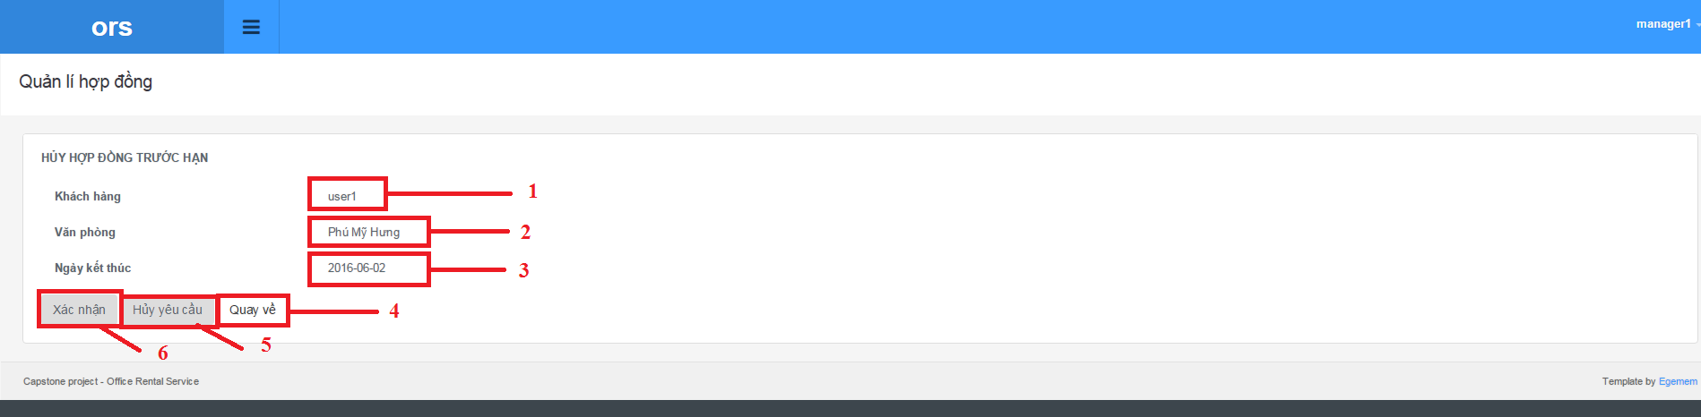

Figure 233: Return contract page

**Fields**

|  |  |  |  |  |  |  |  |
| --- | --- | --- | --- | --- | --- | --- | --- |
| **No** | **Field Name** | **Description** | **Read only** | **Mandatory** | **Control Type** | **Data Type** | **Length** |
| 1 | Customer username | Name of customer | Yes | Yes | Textview | String | N/A |
| 2 | Office | Name of office | Yes | Yes | Textview | String | N/A |
| 3 | End Date | Date when contract end | No | Yes | Textview | datetime | N/A |

**Buttons/Hyperlinks**

|  |  |  |  |  |
| --- | --- | --- | --- | --- |
| **No** | **Function** | **Description** | **Validation** | **Outcome** |
| 4 | Return | Return to request contract page | N/A | Transfer to request contract page |
| 5 | Cancel request | Cancel the request | N/A | Transfer to request contract page |
| 6 | Update | Expired the contract | N/A | Transfer to request contract page |

#### Income statistic

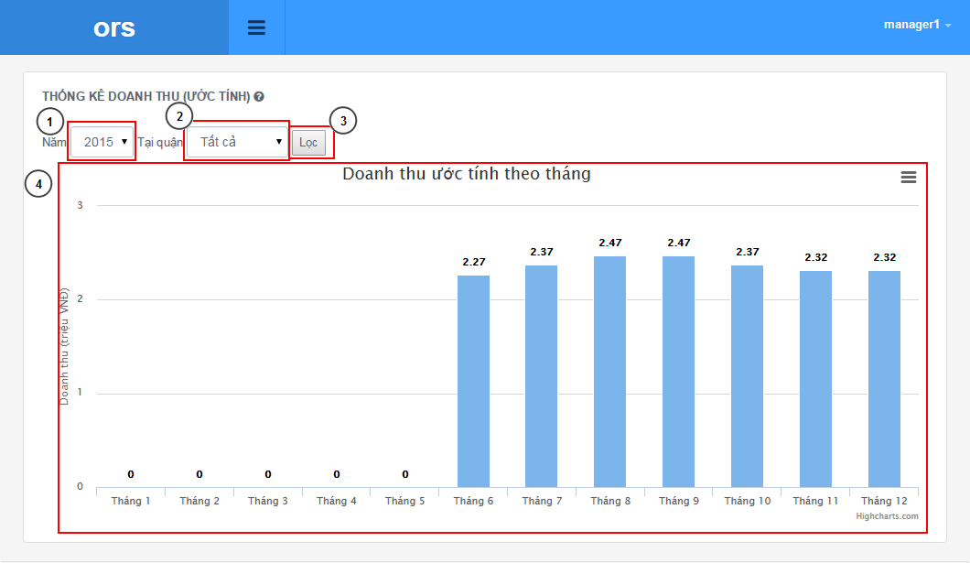

Figure 234: Income statistic

**Fields**

|  |  |  |  |  |  |  |  |
| --- | --- | --- | --- | --- | --- | --- | --- |
| **No** | **Field Name** | **Description** | **Read only** | **Mandatory** | **Control Type** | **Data Type** | **Length** |
| 1 | Year | The year of statistic | Yes | Yes | Drop down | Integer | N/A |
| 2 | District | District for statistic | Yes | Yes | Drop down | String | N/A |
| 4 | Chart | Chart of statistic | Yes | N/A | Chart | Chart | N/A |

**Buttons/Hyperlinks**

|  |  |  |  |  |
| --- | --- | --- | --- | --- |
| **No** | **Function** | **Description** | **Validation** | **Outcome** |
| 3 | Filter | Filter with selected year and district | Yes | Construct the chart for the selected filter |

#### Staff statistic

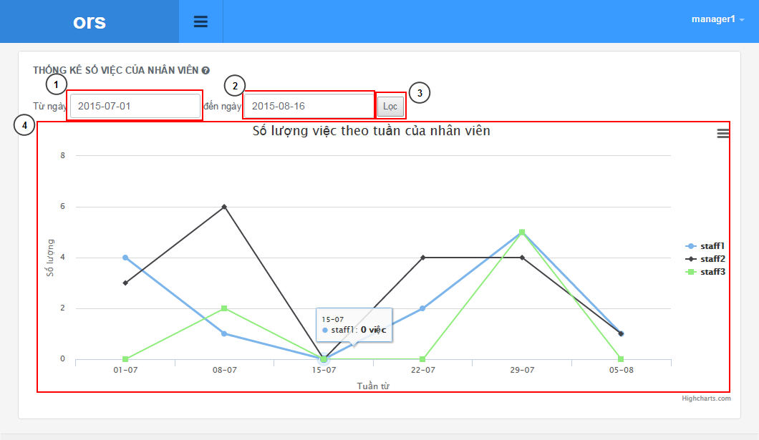

Figure 235: Staff statistic

**Fields**

|  |  |  |  |  |  |  |  |
| --- | --- | --- | --- | --- | --- | --- | --- |
| **No** | **Field Name** | **Description** | **Read only** | **Mandatory** | **Control Type** | **Data Type** | **Length** |
| 1 | From date | The date for begin of statistic | No | Yes | Textbox date | Date | N/A |
| 2 | To date | The date for end of statistic | No | Yes | Textbox date | Date | N/A |
| 4 | Chart | Chart of statistic | Yes | N/A | Chart | Chart | N/A |

**Buttons/Hyperlinks**

|  |  |  |  |  |
| --- | --- | --- | --- | --- |
| **No** | **Function** | **Description** | **Validation** | **Outcome** |
| 3 | Filter | Filter with selected year and district | Yes | Construct the chart for the selected filter |

### Mobile Interface Design

#### Login



Figure 236: Login

**Fields**

|  |  |  |  |  |  |  |  |
| --- | --- | --- | --- | --- | --- | --- | --- |
| **No** | **Field Name** | **Description** | **Read only** | **Mandatory** | **Control Type** | **Data Type** | **Length** |
| 1 | Username | Username for staff to login | No | Yes | Textbox | String | [3-50] |
| 2 | Password | Password for login | No | Yes | Password | String | [1-50] |

**Buttons/Hyperlinks**

|  |  |  |  |  |
| --- | --- | --- | --- | --- |
| **No** | **Function** | **Description** | **Validation** | **Outcome** |
| 5 | Login | Login to app | Yes | Login and go to job page |

#### Home



Figure 237: Home

**Buttons/Hyperlinks**

|  |  |  |  |  |
| --- | --- | --- | --- | --- |
| **No** | **Function** | **Description** | **Validation** | **Outcome** |
| 1 | Appointment list | Go to the appointment list | N/A | Go to the appointment list |
| 2 | Repair list | Go to the repair list | N/A | Go to the repair list |
| 3 | Rental list | Go to the rental list | N/A | Go to the rental list |

#### Job list

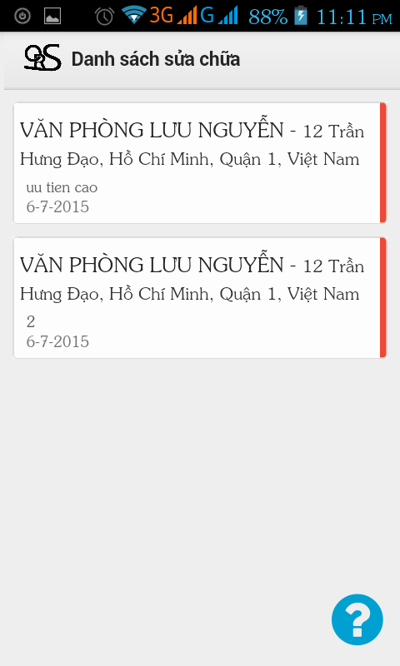

Figure 238: Job list

**Fields**

|  |  |  |  |  |  |  |  |
| --- | --- | --- | --- | --- | --- | --- | --- |
| **No** | **Field Name** | **Description** | **Read only** | **Mandatory** | **Control Type** | **Data Type** | **Length** |
| 1 | Title | Kind of job | Yes | N/A | Label | String | N/A |

**Buttons/Hyperlinks**

|  |  |  |  |  |
| --- | --- | --- | --- | --- |
| **No** | **Function** | **Description** | **Validation** | **Outcome** |
| 2 | Job detail | Go the job detail | N/A | Go to the job detail |
| 3 | Help | Help with status of job | N/A | Open a popup with color and status of job |

#### Job detail



Figure 239: Job detail

**Fields**

|  |  |  |  |  |  |  |  |
| --- | --- | --- | --- | --- | --- | --- | --- |
| **No** | **Field Name** | **Description** | **Read only** | **Mandatory** | **Control Type** | **Data Type** | **Length** |
| 1 | Job info | Information of the job | Yes | N/A | Text field | String | N/A |

**Buttons/Hyperlinks**

|  |  |  |  |  |
| --- | --- | --- | --- | --- |
| **No** | **Function** | **Description** | **Validation** | **Outcome** |
| 2 | Action 1 | Change the status of job based on real status | N/A | Change the status and back to the job list page |
| 3 | Action 2 | Change the status of job based on real status | N/A | Change the status and back to the job list page |
| 4 | Map link | Link to map for current address | N/A | Open map for office address |

## Database Design

### Logical Diagram

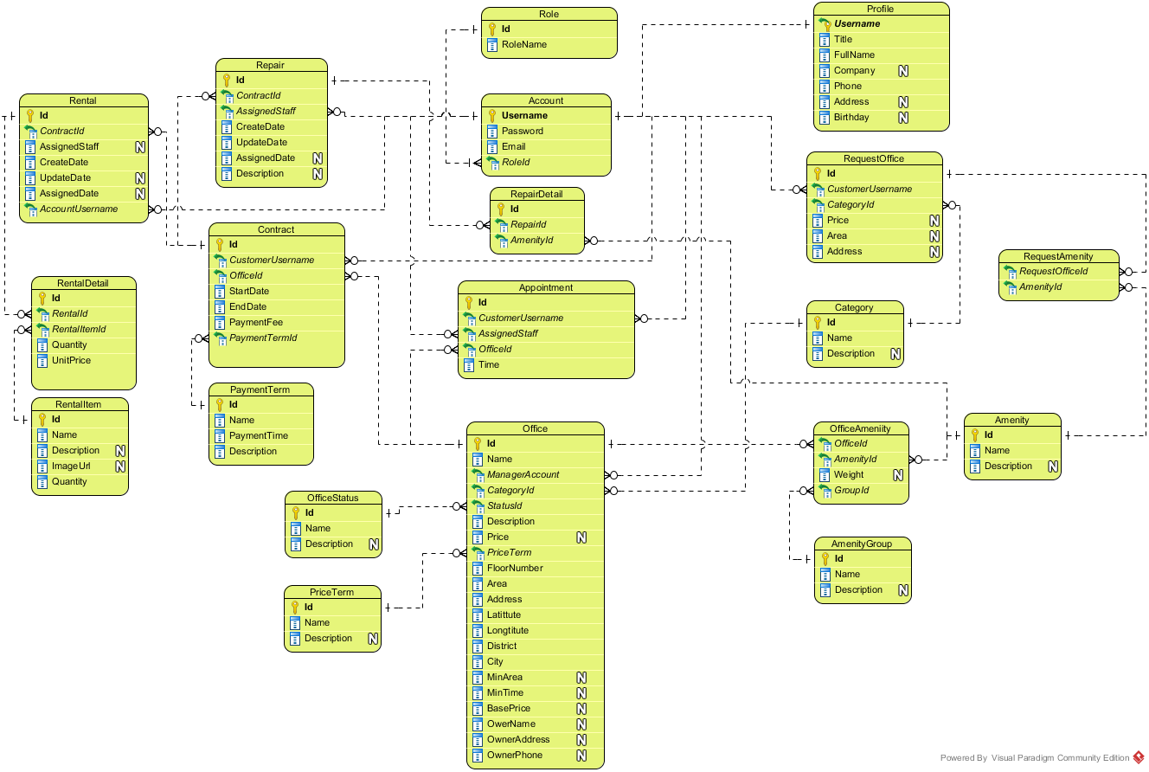

Figure : Logical Database Diagram

### Data Dictionary

|  |  |
| --- | --- |
| **Entity Data dictionary: describe content of all entities** | |
| **Entity Name** | **Description** |
| Account | Describe all accounts of users in the system. |
| Account Status | Describe status of account. One account has only one status. |
| Amenity | Describe all amenities in system. |
| Amenity Group | Describe groups of amenity. One amenity is only in one group. |
| Appointment | Describe all appointment requests of customer. |
| Appointment Status | Describe status of appointment request. One appointment has only one status. |
| Category | Describe category of office. One office is only in one category. |
| Contract | Describe all contracts in the system. |
| Contract Status | Describe status of contract. One contract has only one status. |
| Email Queue | Describe all emails have to send to customer in the system. |
| Office | Describe all offices in the system. |
| Office Amenity | Describe all amenities in one office. One office can have more than one amenity. |
| Office Group | Describe group of the office for searching office. One office is only in one group |
| Office Status | Describe status of the office. One office has only one status. |
| Payment Term | Describe time for the payment |
| Price Term | Describe the way that money is calculated base on. |
| Profile | Describe information of the account |
| Rental | Describe all rental requests from customer |
| Rental Detail | Describe all rental items for one rental request |
| Rental Item | Describe all rental items in system |
| Rental Status | Describe status of rental request. One rental request has only one status. |
| Repair | Describe all repair requests from customer |
| Repair Detail | Describe all amenities need to repair for one repair request |
| Repair Status | Describe status of repair request. One repair request has only one status. |
| Request Amenity | Describe all amenities in one request office |
| Request Office | Describe all requests office from customer |
| Role | Describe role of account. One account has only one role. |

#### Table Account

|  |  |  |  |  |
| --- | --- | --- | --- | --- |
| **Entity name** | **Attributes** | **Description** | **Type** | **Null** |
| Account | Username{PK} | Unique identifier of an account, username for login to system | nvarchar(50) | No |
| Password | Password for login to system | varchar(50) | No |
| Email | Email of this account | varchar(50) | No |
| RoleId{FK} | Role of this account. | int | No |
| StatusId{FK} | Status of this account. | int | No |
| Unique Key: Email | | | | |
| Foreign key:   * RoleId: Foreign key references to table Role * StatusId: Foreign key references to table Account Status | | | | |

#### Table Account Status

|  |  |  |  |  |
| --- | --- | --- | --- | --- |
| **Entity name** | **Attributes** | **Description** | **Type** | **Null** |
| Account Status | Id{PK} | Unique identifier of an account status, automatically increase | int | No |
| Name | Name of this status | nvarchar(50) | No |
| Description | Description for this status | nvarchar(50) | Yes |

#### Table Amenity

|  |  |  |  |  |
| --- | --- | --- | --- | --- |
| **Entity name** | **Attributes** | **Description** | **Type** | **Null** |
| Amenity | Id{PK} | Unique identifier of an amenity, automatically increase | int | No |
| Name | Name of this amenity | nvarchar(50) | No |
| Description | Description for this amenity | nvarchar(250) | Yes |
| Weight | Weight of amenity in one group | int | Yes |
| AmenityGroupId{FK} | Group of this amenity. | int | Yes |
| Priority | Priority of amenity in one group | int | Yes |
| Unique Key: Name | | | | |
| Foreign key:   * AmenityGroupId: Foreign key references to table Amenity Group | | | | |

#### Table Amenity Group

|  |  |  |  |  |
| --- | --- | --- | --- | --- |
| **Entity name** | **Attributes** | **Description** | **Type** | **Null** |
| Amenity Group | Id{PK} | Unique identifier of an amenity group, automatically increase | int | No |
| Name | Name of amenity group | nvarchar(50) | No |
| Description | Description for amenity group | nvarchar(250) | Yes |

#### Table Appointment

|  |  |  |  |  |
| --- | --- | --- | --- | --- |
| **Entity name** | **Attributes** | **Description** | **Type** | **Null** |
| Appointment | Id{PK} | Unique identifier of an appointment, automatically increase | int | No |
| CustomerUsername{FK} | Username of customer. | nvarchar(50) | No |
| AssignedStaff{FK} | Staff who is responsibility for the appointment. | nvarchar(250) | Yes |
| OfficeId{FK} | Office where customer want to make appointment. | int | No |
| Time | Time for appointment | datetime | No |
| StatusId{FK} | Status of the appointment. | int | No |
| CreateTime | Time when customer create appointment | datetime | No |
| UpdateTime | Time when manager update the appointment | datetime | Yes |
| Comment | Comment for the appointment | nvarchar(250) | Yes |
| Foreign key:   * CustomerUsername: Foreign key references to table Account. * AssignedStaff: Foreign key references to table Account. * OfficeId: Foreign key references to table Office. * StatusId: Foreign key references to table appointment status. | | | | |

#### Table Appointment Status

|  |  |  |  |  |
| --- | --- | --- | --- | --- |
| **Entity name** | **Attributes** | **Description** | **Type** | **Null** |
| Appointment Status | Id{PK} | Unique identifier of an appointment status, automatically increase | int | No |
| Name | Name of appointment status | nvarchar(50) | No |
| Description | Description for appointment status | nvarchar(50) | Yes |
| Unique Key: Name | | | | |

#### Table Category

|  |  |  |  |  |
| --- | --- | --- | --- | --- |
| **Entity name** | **Attributes** | **Description** | **Type** | **Null** |
| Category | Id{PK} | Unique identifier of a category for office, automatically increase | int | No |
| Name | Name of category | nvarchar(50) | No |
| Description | Description for category | nvarchar(250) | No |
| Unique Key: Name | | | | |

#### Table Contract

|  |  |  |  |  |
| --- | --- | --- | --- | --- |
| **Entity name** | **Attributes** | **Description** | **Type** | **Null** |
| Contract | Id{PK} | Unique identifier of a contract, automatically increase | int | No |
| CustomerUsername{FK} | Username of customer. | nvarchar(50) | No |
| OfficeId{FK} | Office where customer want to make contract. | int | No |
| StartDate | Date when contract starts. | date | No |
| EndDate | Date when contract ends. | date | No |
| PaymentFee | Fee for the contract | int | No |
| PaymentTerm{FK} | Payment term for the contract. | int | No |
| StatusId{FK} | Status of the contract. | int | No |
| Comment | Comment for the appointment | nvarchar(250) | Yes |
| Deposit | Money for deposit of contract | bigint | Yes |
| CancelDate | Time when contract has been accepted to cancel | date | Yes |
| ImageUrl | Image for contract | nvarchar(150) | Yes |
| CancelFee | Fee return when contract return | bigint | Yes |
| Foreign key:   * CustomerUsername: Foreign key references to table Account. * OfficeId: Foreign key references to table Office. * PaymentTerm: Foreign key references to table Payment Term. * StatusId: Foreign key references to table contract status. | | | | |

#### Table Contract Status

|  |  |  |  |  |
| --- | --- | --- | --- | --- |
| **Entity name** | **Attributes** | **Description** | **Type** | **Null** |
| Contract Status | Id{PK} | Unique identifier of a contract status, automatically increase | int | No |
| Name | Name of contract status | nvarchar(50) | No |
| Description | Description for contract status | nvarchar(50) | Yes |
| Unique key: Name | | | | |

#### Table Email Queue

|  |  |  |  |  |
| --- | --- | --- | --- | --- |
| **Entity name** | **Attributes** | **Description** | **Type** | **Null** |
| Email Queue | Id{PK} | Unique identifier of an email queue, automatically increase | int | No |
| Username{FK} | Username of the customer. Foreign key references to table Account. | nvarchar(50) | No |
| OfficeIds | List office that system suggests to customer | nvarchar(50) | Yes |
| CreateTime | Time when customer create request | datetime | Yes |
| Foreign key:   * Username: Foreign key references to table Account. | | | | |

#### Table Office

|  |  |  |  |  |
| --- | --- | --- | --- | --- |
| **Entity name** | **Attributes** | **Description** | **Type** | **Null** |
| Office | Id{PK} | Unique identifier of an office, automatically increase | int | No |
| Name | Name of the office. | nvarchar(50) | No |
| CategoryId{FK} | Category of the office. | int | No |
| StatusId | Status of the office. Foreign key references to table Office Status. | int | No |
| Description | Description for the office | ntext | No |
| Price | Price of the office | bigint | Yes |
| PriceTerm{FK} | Price term of the office. | int | No |
| FloorNumber | Number of floor in the office | int | No |
| Area | Area of the office | float | No |
| ImageUrls | Link of the images of office | text | Yes |
| OtherDetail | Some detail of the office | ntext | Yes |
| Address | Address of the office | nvarchar(150) | No |
| Latitude | Latitude of the office | float | Yes |
| Longitude | Longitude of the office | float | Yes |
| District | District of the office | nvarchar(50) | Yes |
| City | City of the office | nvarchar(50) | Yes |
| ParentOfficeId{FK} | Parent Office ID of the office. | int | Yes |
| CreateDate | Date when office create in database | datetime | No |
| ViewCount | Number views when customer see detail of office | int | Yes |
| BasePrice | Base price for the office | bigint | Yes |
| MinArea | Minimum area when customer rent | float | Yes |
| MinTime | Minimum time when customer rent | int | Yes |
| OwnerName | Office’s owner name | nvarchar(150) | Yes |
| OwnerPhone | Office’s owner phone | nvarchar(15) | Yes |
| OwnerAddress | Office’s owner address | nvarchar(150) | Yes |
| Foreign key:   * CategoryId: Foreign key references to table Category. * PriceTerm: Foreign key references to table Price Term. * ParentOfficeId: Foreign key references to table Office. | | | | |

#### Table Office Amenity

|  |  |  |  |  |
| --- | --- | --- | --- | --- |
| **Entity name** | **Attributes** | **Description** | **Type** | **Null** |
| Office Amenity | Id{PK} | Unique identifier of a contract status, automatically increase | int | No |
| OfficeId{FK} | Id of the office. | int | No |
| AmenityId{FK} | Amenity of this office | int | No |
| Foreign key:   * OfficeId: Foreign key references to table Office. * AmenityId: Foreign key references to table Amenity. | | | | |

#### Table Office Group

|  |  |  |  |  |
| --- | --- | --- | --- | --- |
| **Entity name** | **Attributes** | **Description** | **Type** | **Null** |
| Office Group | OfficeId{PK, FK} | Id of office | int | No |
| OfficeGroup | Group after system run algorithm of this office | int | No |
| Foreign key:   * OfficeId: Foreign key references to table Office. | | | | |

#### Table Office Status

|  |  |  |  |  |
| --- | --- | --- | --- | --- |
| **Entity name** | **Attributes** | **Description** | **Type** | **Null** |
| Office Status | Id{PK} | Unique identifier of an office status, automatically increase | int | No |
| Name | Name of office status | nvarchar(50) | No |
| Description | Description for office status | nvarchar(250) | Yes |

#### Table Payment Term

|  |  |  |  |  |
| --- | --- | --- | --- | --- |
| **Entity name** | **Attributes** | **Description** | **Type** | **Null** |
| Payment Term | Id{PK} | Unique identifier of a payment term, automatically increase | int | No |
| Name | Name of term for payment | nvarchar(50) | No |
| PaymentTime | Number months of the payment | int | No |
| Description | Description for payment term | nvarchar(100) | Yes |
| Unique Key: Name | | | | |

#### Table Price Term

|  |  |  |  |  |
| --- | --- | --- | --- | --- |
| **Entity name** | **Attributes** | **Description** | **Type** | **Null** |
| Price Term | Id{PK} | Unique identifier of a price term, automatically increase | int | No |
| Name | Name of term for price | nvarchar(50) | No |
| Description | Description for price term | nvarchar(250) | Yes |
| Unique Key: Name | | | | |

#### Table Profile

|  |  |  |  |  |
| --- | --- | --- | --- | --- |
| **Entity name** | **Attributes** | **Description** | **Type** | **Null** |
| Profile | Username{PK, FK} | Unique identifier of an account. | nvarchar(50) | No |
| Title | Gender of the profile | char(4) | No |
| FullName | Full name of this profile | nvarchar(50) | No |
| Company | Company of this profile | nvarchar(100) | Yes |
| Phone | Phone of this profile | varchar(15) | No |
| Address | Address of this profile | nvarchar(150) | Yes |
| Birthday | Birthday of this profile | datetime | Yes |
| Foreign key:   * Username: Foreign key references to table Account. | | | | |

#### Table Rental

|  |  |  |  |  |
| --- | --- | --- | --- | --- |
| **Entity name** | **Attributes** | **Description** | **Type** | **Null** |
| Rental | Id{PK} | Unique identifier of a rental request, automatically increase | int | No |
| ContractId{FK} | Contract which customer send rental request. | int | No |
| AssignStaff{FK} | Username of staff who responsibility for this rental request. | nvarchar(50) | Yes |
| StatusId{FK} | Status of this rental request. | int | No |
| Description | Description of rental | ntext | Yes |
| CreateTime | Time when customer create this rental request | datetime | No |
| UpdateTime | Time when manger or staff change status | datetime | Yes |
| AssignedTime | Time when manager assign to staff | datetime | Yes |
| Foreign key:   * ContractId: Foreign key references to table Contract. * AssignStaff: Foreign key references to table Account. * StatusId: Foreign key references to table Rental Status. | | | | |

#### Table Rental Detail

|  |  |  |  |  |
| --- | --- | --- | --- | --- |
| **Entity name** | **Attributes** | **Description** | **Type** | **Null** |
| Rental Detail | Id{PK} | Unique identifier of a rental detail, automatically increase | int | No |
| RentalItemId{FK} | Item rental for the rental request. | int | No |
| RentalId{FK} | Id of Request rental. | int | No |
| UnitPrice | Price of one item | float | Yes |
| Quantity | Quantity of rental item for the rental request | int | Yes |
| Foreign key:   * RentalItemId: Foreign key references to table Rental Item. * RentalId: Foreign key references to table Rental. | | | | |

#### Table Rental Item

|  |  |  |  |  |
| --- | --- | --- | --- | --- |
| **Entity name** | **Attributes** | **Description** | **Type** | **Null** |
| Rental Item | Id{PK} | Unique identifier of a rental item, automatically increase | int | No |
| Name | Name of the item | nvarchar(150) | No |
| Description | Description for the item | ntext | Yes |
| Price | Price of the item | float | Yes |
| Quantity | Quantity of the item | int | Yes |
| ImageUrl | Link image of the item | nvarchar(250) | Yes |
| Unique key: Name | | | | |

#### Table Rental Status

|  |  |  |  |  |
| --- | --- | --- | --- | --- |
| **Entity name** | **Attributes** | **Description** | **Type** | **Null** |
| Rental Status | Id{PK} | Unique identifier of a rental status, automatically increase | int | No |
| Name | Name of rental status | nvarchar(50) | No |
| Description | Description for rental status | nvarchar(50) | Yes |
| Unique key: Name | | | | |

#### Table Repair

|  |  |  |  |  |
| --- | --- | --- | --- | --- |
| **Entity name** | **Attributes** | **Description** | **Type** | **Null** |
| Repair | Id{PK} | Unique identifier of a repair request, automatically increase | int | No |
| ContractId{FK} | Contract which customer send repair request. | int | No |
| AssignStaff{FK} | Username of staff who responsibility for this repair request. | nvarchar(50) | Yes |
| RepairStatusId{FK} | Status of this repair request. | int | No |
| Description | Description of repair | ntext | Yes |
| CreateTime | Time when customer create this repair request | datetime | No |
| UpdateTime | Time when manger or staff change status | datetime | Yes |
| AssignedTime | Time when manager assign to staff | datetime | Yes |
| Foreign key:   * ContractId: Foreign key references to table Contract. * AssignStaff: Foreign key references to table Account. * RepairStatusId: Foreign key references to table Repair Status. | | | | |

#### Table Repair Detail

|  |  |  |  |  |
| --- | --- | --- | --- | --- |
| **Entity name** | **Attributes** | **Description** | **Type** | **Null** |
| Repair Detail | Id{PK} | Unique identifier of a repair detail, automatically increase | int | No |
| RepairId {FK} | Id of repair request. | int | No |
| AmenityId{FK} | Amenity of this repair request. | int | No |
| Foreign key:   * RepairId: Foreign key references to table Repair. * AmenityId: Foreign key references to table Amenity. | | | | |

#### Table Repair Status

|  |  |  |  |  |
| --- | --- | --- | --- | --- |
| **Entity name** | **Attributes** | **Description** | **Type** | **Null** |
| Repair Status | Id{PK} | Unique identifier of a repair status, automatically increase | int | No |
| Name | Name of repair status | nvarchar(50) | No |
| Description | Description for repair status | nvarchar(50) | Yes |
| Unique key: Name | | | | |

#### Table Request Amenity

|  |  |  |  |  |
| --- | --- | --- | --- | --- |
| **Entity name** | **Attributes** | **Description** | **Type** | **Null** |
| Request Amenity | Id{PK} | Unique identifier of a request amenity, automatically increase | int | No |
| RequestOfficeId{FK} | Id of request office. | int | No |
| AmenityId{FK} | Amenity of this request. | int | No |
| Foreign key:   * RequestOfficeId: Foreign key references to table Request Office. * AmenityId: Foreign key references to table Amenity. | | | | |

#### Table Request Office

|  |  |  |  |  |
| --- | --- | --- | --- | --- |
| **Entity name** | **Attributes** | **Description** | **Type** | **Null** |
| Request Office | Id{PK} | Unique identifier of a request office, automatically increase | int | No |
| CustomerUsername {FK} | Username of customer. | nvarchar(50) | No |
| CategoryId{FK} | Category of the office. | int | Yes |
| Price | Price of the office. | int | Yes |
| Area | Area of the office | float | Yes |
| District | District of the office | nvarchar(50) | Yes |
| CreateDate | Time when customer create this request. | datetime | No |
| ScheduleDate | Date when system check this request | datetime | Yes |
| OfficeSuggested | List offices that are suitable with request | nvarchar(250) | Yes |
| Foreign key:   * CustomerUsername: Foreign key references to table Account * CategoryId: Foreign key references to table Category. | | | | |

#### Table Role

|  |  |  |  |  |
| --- | --- | --- | --- | --- |
| **Entity name** | **Attributes** | **Description** | **Type** | **Null** |
| Role | Id{PK} | Unique identifier of a role, automatically increase | int | No |
| RoleName | Name of role | nvarchar(50) | No |
| Unique Key: RoleName | | | | |

## Algorithms

### Clustering data

#### Definition

K-means is a prototype based clustering technique defining the prototype in terms of a centroid which is considered to be the mean of a group of points and is applicable to objects in a continuous n-dimensional space. (Refer website http://www.hypertextbookshop.com)

#### Define Problem

* Office in near location may have similarity in price range. But the location may vary and hard to define all location.
* Group the office by location and price range will make the user easier to find the similarity offices

#### Solution

To solve the problem, we use the well-known K-Means algorithm.

The step to perform the algorithm:

1. Defined the k number (number of cluster)
   * The k number is calculate by the square root of total of data (n). This make sure that there is $\sqrt{n}$ group, and each group has about $\sqrt{n}$ data
2. Normalize the data into the n-dimensions Euclidean space, all data based on [0, 1] distance. Each of office data is called “point”
   * In this problem, we use 3 statics: latitude, longitude and price range of the office for 3-dimensions
   * The price range is divided into 5 range: Call as 0, 100.000 VND – 200.000 VND as 1, etc., larger than 500.000 VND as 5
   * In each dimension, calculate the min and max. Then the normalize dimension data is calculate by:

$$\text{normalized}=\frac{data-min}{max-min}$$

normalize: dimension normalized data

data: the raw data in dimension

1. Select random point into k group, each group has at least 1 point
2. Calculate the mean points of each group
3. Calculate the distance of each data point to each group’s mean point, and change the group of data point to the group that has the nearest mean
   * The distance between A(a1, a2, … an) and X(x1, x2, … xn) is calculate by Euclidean distance:

$$d=\sqrt{{\left(a_{1}-x_{1}\right)}^{2}+{\left(a_{2}-b_{2}\right)}^{2}+…+{\left(a_{n}-b_{n}\right)}^{2}}$$

Where n is the number of dimension

1. Repeat step 4 until the group in step 5 is unchanged

#### Complexity

* In total, the complexity of this algorithm is NP-hard. But with current algorithm maximum complexity limit to n*10 (n is total of data)

#### Flow chart

Calculate K

Normalize data

Group data in K groups

Calculate the mean of each group

Group based on minimum distance to mean

Group changed?

End

Start

Yes

No

### Matching data

#### Definition

K-Nearest Neighbor algorithm (KNN) is a method for classifying objects based on the closest training examples in the feature space.  KNN is a type of instance-based learning, or lazy learning where the function is only approximated locally and all computation is deferred until classification. (Refer website http://www.datasciencecentral.com)

#### Define Problem

* The search office may be different from all of the office in system, and user want to make their decision with vary of result.

#### Solution

With the clustering data using K-Means, the best solution is KNN (K-Nearest-Neighbor) algorithm.

The steps to perform the algorithm:

1. Define k number. In this solution, we choose k at least by haft of the average office in each group of K-Means algorithm. Particular 2 $\sqrt{n}$* .
2. Normalize the query point (input data) to the same dimension of sample data (by above function)
3. Calculate the distance between query point and each of data in sample (all office) by Euclidean distance (as above).
4. Sort the calculated distance, select the minimum k distances for comparison.
5. The group of query point will be group that have the most frequent existence in above k distances. If there is more than 1 group that have largest existence, the selected group will be the group that have minimum total distance (in the k selected distances only)

#### Complexity

* In total, the complexity of this algorithm is O(n)

# System Implementation & Test (SIT)

## Introduction

### System Overview

This section provides in detail all necessary information about test plans, test cases, test result, test environments, pass/fail criteria and risks estimations as well as a checklist to cover all possible cases of ORS system.

### Test Approach

Goal: Check all the features in ORS system and record remain bug to fix.

Type:

* Algorithms: use white box testing
* Others: use black box testing

Size: System Component.

Technique: Check list.

## Database Relationship Diagram

### Physical Diagram



Figure : Physical Database Diagram

### Data Dictionary

<*Reference Section 6.2 – Logical Data Dictionary*>

## Performance Measures

### Clustering Performance

* Clustering is performed by running K Mean Algorithm which has complexity of : O(n * k * i * d)
  + n : number of points
  + k : number of cluster ($\sim \sqrt{n}$)
  + i : number of iteration
  + d : number of attributes (3)
* Clustering take almost the time of process that we can ignore the time needed to load data from database, digitalize data. With current sample data of 30 offices, the average run time is about 1 second
* The speed of clustering will vary and increase dramatically when n increase. However, we will improve the performance by do the clustering periodically after create new office

### Matching Performance

* Matching is performed by running K Nearest Neighbor Algorithm which has complexity of O(n)
  + n : number of points
* Matching is performed each time user search for offices. With sample data of 30 offices, the average run time is less than 1 second

## Test Plan

The purpose of this section is to verify and ensure that ORS system will ensure the design specification and other requirements. The following part will describe which features to be tested and which will not.

### Features to be tested

We will carry out test based on core workflow of system. All main functions will be tested carefully and clearly following phases.

* Guest: Search office
* Customer: View office detail, Make appointment, Request repair/rental, Request return/extend contract, Request office
* Manager: Create/Edit office, Assign appointment/repair/rental, Cancel appointment/repair/rental, Create/edit contract, Extend/return contract, Create rental item, Statistics, Calendar
* Staff: Confirm appointment/rental/repair, Accept rental/repair
* System: Send email, Check expire contract, Check send SMS, Check request office

### Features not to be tested

* Login, Logout, Manage rental, Manage amenity, Manage user, View profile, Edit profile, Change password

## System Testing Test Case



HomePage

Office detail

Request

Search

1.1 View home page

1.2b Search office

1.2c View office detail

2.3b Request appointment



2.1 View home page

1.3b View office detail

ContractPage

3.1 View contract page

Request office

2.2a Send request office

Contract detail

3.2a View contract detail

Request repair

Request rental

View rental cart

3.3a-a Send request rental

3.3a-b Send

request repair

3.4a-a Add item

ResultRequestOffice page

4.1 View list requestOffice

Figure : Guest and Customer main flow

Figure : Manager main flow



SystemPage

List contract

List office

New office

3.2b View office list

3.3b-a Add office

Repair list

Assign/Cancel repair

3.3c View repair detail

3.2c View repair list

Rental list

3.2d View rental list

3.3d View rental detail

Appointment list

3.2e View appointment list

Assign/Cancel Appointment

3.3e-b View appointment detail

Rental item list

3.2f View rental item list

New rental item

3.3f-b Add rental item

Request return contract list

Return contract

3.3g View request return contract detail

3.2g View request return contract

Request extend contract list

Extend contract

3.2h View request extend contract

3.3h View request extend contract detail

New Contract

3.3e-a New contract

Assign/Cancel rental

3.2b View contract list

View calendar

View income statistic

View staff statistic

3.2i View calendar

3.2j View calendar

3.2k View calendar

3.2 Login

Mobile

Repair list

Assign/Cancel repair

3.3c View repair detail

3.2c View repair list

Rental list

3.2d View rental list

3.3d View rental detail

Appointment list

3.2e View appointment list

Confirm Appointment

3.3e-b View appointment detail

Accept/Reject rental



Confirm repair

Confirm rental

Figure : Staff main flow

Schedule

1.1 Run schedule

1.1a Check contract

Send email

Check send SMS



Check expire contract

Check request office

System

1.1b Check appointment

1.1c Check request office

1.1c-a Send email

Figure : System main flow

### Guest Test Case

#### Search office

|  |  |  |  |  |  |  |  |
| --- | --- | --- | --- | --- | --- | --- | --- |
| **ID** | **Test Case Description** | **Test Case Procedure** | **Expected output** | **Inter-test Case Dependence** | **Result** | **Test Date** | **Note** |
| S01 | Search office information with valid information | 1. Go to home page  2. Enter information  - Địa chỉ: Quận 12, then select “Quận 12, Hồ Chí Minh, Việt Nam” from drop down  - Khoảng giá: 200000  - Danh sách tiện nghi: Select “Bãi giữ xe, Cáp quang”  3. Click “Tìm kiếm” | When enter address into Địa chỉ textbox, should display exact address information where user can select.  Display search result page with office which have the information relate to the enter information. | N/A | Passed | 20/07/2015 |  |
| S02 | Search office information with invalid information | 1. Go to home page  2. Enter information  - Địa chỉ: “abc”  - Khoảng giá: NaN  - Danh sách tiện nghi: select “Cáp quang”  - Click tìm kiếm | Display error: “Mời nhập vào địa chỉ chính xác” and “Khoảng giá không hợp lệ” . | N/A | Passed | 20/07/2015 |  |

Table : Search office Test Case

### Customer Test Case

#### Make appointment

|  |  |  |  |  |  |  |  |
| --- | --- | --- | --- | --- | --- | --- | --- |
| **ID** | **Test Case Description** | **Test Case Procedure** | **Expected output** | **Inter-test Case Dependence** | **Result** | **Test Date** | **Note** |
| S01 | Make valid appointment | 1. Login as customer role  2. Go to an office detail page  3. Click “Đặt lịch hẹn xem văn phòng”  4. Enter date: 13/07/2015 10:07 AM  5. Click “Đặt lịch hẹn” | Cannot select date before today, not on Sunday and from 7AM to 6PM  Display message “Đặt lịch hẹn thành công” then go to home page. | N/A | Passed | 20/07/2015 |  |
| S02 | Make no time appointment | 1. Login as customer role  2. Go to an office detail page  3. Click “Đặt lịch hẹn xem văn phòng”  4. Click “Đặt lịch hẹn” | Display error: “Thời gian không hợp lệ” . | N/A | Passed | 20/07/2015 |  |
| S02 | Make invalid time appointment | 1. Login as customer role  2. Go to an office detail page  3. Click “Đặt lịch hẹn xem văn phòng”  4. Enter “aaa”  5. Click “Đặt lịch hẹn” | Auto correct to valid date, default 1 hour from current time | N/A | Passed | 20/07/2015 |  |

Table : Make appointment Test Case

#### Request Return Contract

|  |  |  |  |  |  |  |  |
| --- | --- | --- | --- | --- | --- | --- | --- |
| **ID** | **Test Case Description** | **Test Case Procedure** | **Expected output** | **Inter-test Case Dependence** | **Result** | **Test Date** | **Note** |
| RRC01 | Custom request return contract | 1 – On home page, click “**Hợp đồng của bạn**”  2 – Click “**Chi tiết**” on the screen  3 – Click “**Hủy hợp đồng trước hạn**” button  4 – Click “**Đồng ý**” button | - After step 1, go to list contract page  - After step 2, go to contract detail page  - After step 4, show message “**Đã gửi yêu cầu hủy hợp đồng trước hạn**” | N/A | Passed | 24/07/2015 |  |
| RRC02 | Custom can’t request return contract when contract expire | 1 – On home page, click “**Hợp đồng của bạn**” | - After step 1, go to list contract page  - The contract has expired will not appear in the list | N/A | Passed | 24/07/2015 |  |
| RRC03 | Custom can’t request return contract when contract is in the condition of being requested for return | 1 – On home page, click “**Hợp đồng của bạn**”  2 – Click “**Chi tiết**” on the screen | - After step 1, go to list contract page  - After step 2, go to contract detail page  - The screen show info “**Đang yêu cầu hủy hợp đồng trước hạn”** | N/A | Passed | 24/07/2015 |  |

Table : Request Return Contract Test Case

#### Request Extend Contract

|  |  |  |  |  |  |  |  |
| --- | --- | --- | --- | --- | --- | --- | --- |
| **ID** | **Test Case Description** | **Test Case Procedure** | **Expected output** | **Inter-test Case Dependence** | **Result** | **Test Date** | **Note** |
| REC01 | Custom request extend contract | 1 – On home page, click “**Hợp đồng của bạn**”  2 – Click “**Chi tiết**” on the screen  3 – Click “**Gia hạn hợp đồng**” button  4 – Click “**Đồng ý**” button | - After step 1, go to list contract page  - After step 2, go to contract detail page  - After step 4, show message “**Đã gửi yêu cầu gia hạn hợp đồng**” | N/A | Passed | 24/07/2015 |  |
| REC02 | Custom can’t request extend contract when contract expire | 1 – On home page, click “**Hợp đồng của bạn**” | - After step 1, go to list contract page  - The contract has expired will not appear in the list | N/A | Passed | 24/07/2015 |  |
| REC03 | Custom can’t request extend contract when contract is in the condition of being requested for extend | 1 – On home page, click “**Hợp đồng của bạn**”  2 – Click “**Chi tiết**” on the screen | - After step 1, go to list contract page  - After step 2, go to contract detail page  - The screen show info “**Đang yêu cầu gia hạn hợp đồng”** | N/A | Passed | 24/07/2015 |  |

Table : Request Extend Contract Test Case

#### Request Repair

|  |  |  |  |  |  |  |  |
| --- | --- | --- | --- | --- | --- | --- | --- |
| **ID** | **Test Case Description** | **Test Case Procedure** | **Expected output** | **Inter-test Case Dependence** | **Result** | **Test Date** | **Note** |
| RRP01 | Custom request repair | 1 – On home page, click “**Hợp đồng của bạn**”  2 – Click “**Chi tiết**” on the screen  3 – Click “**Yêu cầu sửa chữa**” button  4 – Fill in infomartion:   * Sửa chữa * Mô tả yêu cầu sửa chữa   5 – Click “**Gửi yêu cầu**” button | - After step 1, go to list contract page  - After step 2, go to contract detail page  - After step 3, go to request repair page  - After step 5, show message “**Đã gửi yêu cầu sửa chữa**” and return to contract detail page | N/A | Passed | 24/07/2015 |  |
| RRP02 | Custom can’t request repair when contract expire | 1 – On home page, click “**Hợp đồng của bạn**” | - After step 1, go to list contract page  - The contract has expired will not appear in the list | N/A | Passed | 24/07/2015 |  |
| RRP03 | Custom can’t request repair when contract is in the condition of being requested for return | 1 – On home page, click “**Hợp đồng của bạn**”  2 – Click “**Chi tiết**” on the screen | - After step 1, go to list contract page  - After step 2, go to contract detail page  - The screen doesn’t show “**Yêu cầu sửa chữa”** button. | N/A | Passed | 24/07/2015 |  |

Table : Request Repair Test Case

#### Request Rental

|  |  |  |  |  |  |  |  |
| --- | --- | --- | --- | --- | --- | --- | --- |
| **ID** | **Test Case Description** | **Test Case Procedure** | **Expected output** | **Inter-test Case Dependence** | **Result** | **Test Date** | **Note** |
| RRT01 | Custom request rental | 1 – On home page, click “**Hợp đồng của bạn**”  2 – Click “**Chi tiết**” on the screen  3 – Click “**Yêu cầu thuê thiết bị**” button  4 – Input the number  5 – Click “**Thuê**” button  6 – Click “**Xem giỏ hàng**” button  7 – Input request in “**Yêu cầu của khách hàng**”  8 – Click “**Gửi yêu cầu**” button | - After step 1, go to list contract page  - After step 2, go to contract detail page  - After step 3, go to rental item page  - After step 5, box “**Giỏ hàng**” will show information  - After step 6, go to request rental page  - After step 8, show message “**Gửi yêu cầu thành công**” and return to home page | N/A | Passed | 24/07/2015 |  |
| RRT02 | Custom can’t request rental when contract expire | 1 – On home page, click “**Hợp đồng của bạn**” | - After step 1, go to list contract page  - The contract has expired will not appear in the list | N/A | Passed | 24/07/2015 |  |
| RRT03 | Custom can’t request rental when contract is in the condition of being requested for return | 1 – On home page, click “**Hợp đồng của bạn**”  2 – Click “**Chi tiết**” on the screen | - After step 1, go to list contract page  - After step 2, go to contract detail page  - The screen doesn’t show “**Yêu cầu thuê thiết bị”** button. | N/A | Passed | 24/07/2015 |  |

Table : Request Rental Test Case

#### Request Office

|  |  |  |  |  |  |  |  |
| --- | --- | --- | --- | --- | --- | --- | --- |
| **ID** | **Test Case Description** | **Test Case Procedure** | **Expected output** | **Inter-test Case Dependence** | **Result** | **Test Date** | **Note** |
| RO01 | Send request office | 1. Choose “Đặt yêu cầu văn phòng” on home page. 2. Login as role customer. 3. Select “Loại văn phòng” is: “Tòa nhà văn phòng”. 4. Input “Giá” “310000” 5. Input “Diện tích”: 12 6. Input “Quận”: Quận 4 7. Input “Danh sách tiện nghi”: Thang máy 8. Click “Đặt văn phòng” button | * Show successful message ” 'Đặt yêu cầu thành công” * Transform to home page * Click to “Yêu cầu văn phòng của bạn” and request has been shown | * N/A | Passed | 8/8/2015 |  |

Table : Request Office Test Case

### Manager Test Case

#### Create office

|  |  |  |  |  |  |  |  |
| --- | --- | --- | --- | --- | --- | --- | --- |
| **ID** | **Test Case Description** | **Test Case Procedure** | **Expected output** | **Inter-test Case Dependence** | **Result** | **Test Date** | **Note** |
| 01 | Create office with valid inputted | 1- On admin page. Click ‘’văn phòng‘’  2- On ‘’Văn phòng’’ page. Click ‘Thêm mới văn phòng’’ icon  3- On “Thêm mới văn phòng” page, input valid data in the fields. | After step 3: office was created and display dialog message “Thêm văn phòng mới thành công” | N/A | Passed | 11/08/2015 |  |
| 02 | Create office with wrong inputted | 1- On admin page. Click ‘’văn phòng‘’  2- On ‘’Văn phòng’’ page. Click ‘Thêm mới văn phòng’’ icon  3- On “Thêm mới văn phòng” page, input wrong data in the fields. | After step 3: office was not created and display warning dialog message in wrong fields | N/A | Not Pass | 11/08/2015 |  |
| 03 | Create office with empty inputted | 1- On admin page. Click ‘’văn phòng‘’  2- On ‘’Văn phòng’’ page. Click ‘Thêm mới văn phòng’’ icon  3- On “Thêm mới văn phòng” page, do not input data in the fields. | After step 3: office was not created and display warning dialog message in wrong fields | N/A | Passed | 11/08/2015 |  |

Table : Create Office Test Case

#### Edit office

|  |  |  |  |  |  |  |  |
| --- | --- | --- | --- | --- | --- | --- | --- |
| **ID** | **Test Case Description** | **Test Case Procedure** | **Expected output** | **Inter-test Case Dependence** | **Result** | **Test Date** | **Note** |
| 01 | Manager edits office when office has existed in database | 1- On admin page. Click ‘’văn phòng‘’  2- On ‘’Văn phòng’’ page. Click ‘’Chi tiết’’ icon  3- On ‘’Chi tiết văn phòng’’ page. Click ‘’Chỉnh sửa’’  4- On “Chỉnh sửa’’ page, manager edit information about office  5- Manager clicks ‘’Cập nhật’’ button | After step 5: office was updated and display dialog message “Cập nhật thành công” | Create office test case | Passed | 11/08/2015 |  |
| 02 | Staff edits office when office has existed in database | 1- On admin page. Click ‘’văn phòng‘’  2- On ‘’Văn phòng’’ page. Click ‘’Chi tiết’’ icon  3- On ‘’Chi tiết văn phòng’’ page. Click ‘’Chỉnh sửa’’  4- On “Chỉnh sửa’’ page, manager edit information about office  5- Staff clicks ‘’Cập nhật’’ button | After step 5: office was updated and display dialog message “Cập nhật thành công” | Create office test case | Passed | 11/08/2015 |  |

Table : Edit Office Test Case

#### Create Contract

|  |  |  |  |  |  |  |  |
| --- | --- | --- | --- | --- | --- | --- | --- |
| **ID** | **Test Case Description** | **Test Case Procedure** | **Expected output** | **Inter-test Case Dependence** | **Result** | **Test Date** | **Note** |
| 01 | Create contract | 1. Login as manager role 2. Click to “Lịch hẹn mới” on home page 3. Click to tab “chấp nhận” on tab bar 4. Click button “Đến ký/ Hủy hợp đồng” 5. Click “Tạo hợp đồng” button 6. Input “Ngày bắt đầu”: 08-08-2015 7. Input “Thời gian thuê”: 6 8. Select “Kỳ hạn thanh toán”: 3 tháng 9. Input “Giá thuê”: 250000 10. Input “Tiền đặt cọc”: 5000000 11. Click “Tạo mới” button | After step 4: Show detail appointment.  Transform to contract list page.  New contract has been shown in contract list page. | Confirm appointment | Passed | 8/8/2015 |  |

Table : Create contract Test Case

#### Edit Contract

|  |  |  |  |  |  |  |  |
| --- | --- | --- | --- | --- | --- | --- | --- |
| **ID** | **Test Case Description** | **Test Case Procedure** | **Expected output** | **Inter-test Case Dependence** | **Result** | **Test Date** | **Note** |
| 01 | Edit Contract | 1. Login as manager role 2. Click to “Tổng hợp đồng” on home page 3. Click to button “chi tiết” 4. Click “Chỉnh sửa” button 5. Click to tab “chấp nhận” on tab bar 6. Click button “Đến ký/ Hủy hợp đồng” 7. Click “Tạo hợp đồng” button 8. Input “Ngày bắt đầu”: 09-09-2015 9. Input “Thời gian thuê”: 12 10. Select “Kỳ hạn thanh toán”: 3 tháng 11. Input “Giá thuê”: 250000 12. Input “Tiền đặt cọc”: 7500000 13. Click “Tạo mới” button | * After step 3: show detail of the contract * Transform to contract list page * The contract has been update | * Create contract | Passed | 8/8/2015 |  |

Table : Edit contract Test Case

#### Assign Appointment

|  |  |  |  |  |  |  |  |
| --- | --- | --- | --- | --- | --- | --- | --- |
| **ID** | **Test Case Description** | **Test Case Procedure** | **Expected output** | **Inter-test Case Dependence** | **Result** | **Test Date** | **Note** |
| AA01 | Manager assign task appointment for staff (system suggest staff) | 1 – On admin page, click “**Lịch hẹn**”  2 – Click icon “**Giao việc**” on first task | - After step 1, go to appointment page  - After step 2, the page reload and that first task doesn’t appear in tab “**Cần giao việc**” and customer receive message “Lich hen cua ban da duoc chap nhan. Hen ban vao thoi gian: “ | N/A | Passed | 24/07/2015 |  |
| AA02 | Manager assign task appointment for staff (manger choose staff) | 1 – On admin page, click “**Lịch hẹn**”  2 – Click icon “**Chi tiết**” on first task  3 – Choose staff  4 – Choose date and time  5 – Click “**Giao việc**” button | - After step 1, go to appointment page  - After step 2, go to appointment detail page  - After step 5, go to appointment page and that first task doesn’t appear in tab “**Cần giao việc**” and customer receive message “Lich hen cua ban da duoc chap nhan. Hen ban vao thoi gian: “ | N/A | Passed | 24/07/2015 |  |
| AA03 | Manager reassign task appointment for staff | 1 – On admin page, click “**Lịch hẹn**”  2 – Click tab “**Đã giao**”  2 – Click icon “**Chi tiết**” on first task  3 – Choose staff  4 – Choose date and time  5 – Click “**Giao việc lại**” button | - After step 1, go to appointment page  - After step 2, show list assigned task  - After step 3, go to appointment detail page  - After step 5, go to appointment page, tab “**Đã giao**” and that task was updated time or staff and customer receive message “Lich hen cua ban da duoc chap nhan. Hen ban vao thoi gian: “ | N/A | Passed | 24/07/2015 |  |
| AA04 | Manager reassign task appointment for staff by view calendar | 1 – On home page, click “**Quản lý thời gian nhân viên**”  2 – Click “**Xem văn phòng**” on screen  3 – Choose staff  4 – Choose date and time  5 – Click “**Giao việc lại**” button | - After step 1, go to list calendar page  - After step 2, go to contract detail page  - After step 5, go to appointment page, tab “**Đã giao**” and that task was updated time or staff and customer receive message “Lich hen cua ban da duoc chap nhan. Hen ban vao thoi gian: “ | N/A | Passed | 24/07/2015 |  |

Table : Assign Appointment Test Case

#### Cancel Appointment

|  |  |  |  |  |  |  |  |
| --- | --- | --- | --- | --- | --- | --- | --- |
| **ID** | **Test Case Description** | **Test Case Procedure** | **Expected output** | **Inter-test Case Dependence** | **Result** | **Test Date** | **Note** |
| CA01 | Manager cancel task appointment | 1 – On admin page, click “**Lịch hẹn**”  2 – Click icon “**Chi tiết**” on first task  3 – Click “**Hủy lịch hẹn**” button  4 – Fill in “**Nhập lý do hủy**”  5 – Click “**Xác nhận hủy”** button | - After step 1, go to appointment page  - After step 2, go to appointment detail page  - After step 5, go to appointment page and that task appointment in tab “**Hủy**” and customer receive message “Lich hen cua ban khong duoc chap nhan. Ly do: " | N/A | Passed | 24/07/2015 |  |

Table : Cancel Appointment Test Case

#### Assign Repair

|  |  |  |  |  |  |  |  |
| --- | --- | --- | --- | --- | --- | --- | --- |
| **ID** | **Test Case Description** | **Test Case Procedure** | **Expected output** | **Inter-test Case Dependence** | **Result** | **Test Date** | **Note** |
| ARP01 | Manager assign task repair for staff (system suggest staff and time) | 1 – On admin page, click “**Sửa chữa**”  2 – Click icon “**Giao việc**” on first task | - After step 1, go to repair page  - After step 2, the page reload and that first task doesn’t appear in tab “**Cần giao việc**” | N/A | Passed | 24/07/2015 |  |
| ARP02 | Manager assign task repair for staff (manger choose staff and time) | 1 – On admin page, click “**Sửa chữa**”  2 – Click icon “**Chi tiết**” on first task  3 – Choose staff  4 – Choose date to repair  5 – Click “**Giao việc**” button | - After step 1, go to repair page  - After step 2, go to repair detail page  - After step 5, go to repair page and that first task doesn’t appear in tab “**Cần giao việc**” and customer receive message "Yeu cau sua chua cua ban da duoc chap nhan. Thoi gian du kien:” | N/A | Passed | 24/07/2015 |  |
| ARP03 | Manager reassign task repair for staff | 1 – On admin page, click “**Sửa chữa**”  2 – Click tab “**Đã giao**”  2 – Click icon “**Chi tiết**” on first task  3 – Choose staff  4 – Choose date to repair  5 – Click “**Giao việc lại**” button | - After step 1, go to repair page  - After step 2, show list assigned task  - After step 3, go to repair detail page  - After step 5, go to repair page, tab “**Đã giao**” updated time or staff and customer receive message "Yeu cau sua chua cua ban da duoc chap nhan. Thoi gian du kien:” | N/A | Passed | 24/07/2015 |  |
| ARP04 | Manager reassign task repair for staff by view calendar | 1 – On home page, click “**Quản lý thời gian nhân viên**”  2 – Click “**Sửa chữa**” on screen  3 – Choose staff  4 – Choose date to repair  5 – Click “**Giao việc lại**” button | - After step 1, go to list calendar page  - After step 2, go to contract detail page  - After step 5, go to repair page, tab “**Đã giao**” updated time or staff, and customer receive message "Yeu cau sua chua cua ban da duoc chap nhan. Thoi gian du kien:” | N/A | Passed | 24/07/2015 |  |

Table : Assign Repair Test Case

#### Cancel Repair

|  |  |  |  |  |  |  |  |
| --- | --- | --- | --- | --- | --- | --- | --- |
| **ID** | **Test Case Description** | **Test Case Procedure** | **Expected output** | **Inter-test Case Dependence** | **Result** | **Test Date** | **Note** |
| CRP01 | Manager cancel task repair | 1 – On admin page, click “**Sửa chữa**”  2 – Click icon “**Chi tiết**” on first task  3 – Click “**Từ chối sửa chữa**” button | - After step 1, go to repair page  - After step 2, go to repair detail page  - After step 3, go to repair page and that task repair in tab “**Hủy**” and customer receive message "Yeu cau sua chua cua ban khong duoc chap nhan” | N/A | Passed | 24/07/2015 |  |

Table : Cancel Repair Test Case

#### Assign Rental

|  |  |  |  |  |  |  |  |
| --- | --- | --- | --- | --- | --- | --- | --- |
| **ID** | **Test Case Description** | **Test Case Procedure** | **Expected output** | **Inter-test Case Dependence** | **Result** | **Test Date** | **Note** |
| ART01 | Manager assign task rental for staff (system suggest staff and time) | 1 – On admin page, click “**Thuê thiết bị**”  2 – Click icon “**Giao việc**” on first task | - After step 1, go to rental page  - After step 2, the page reload and that first task doesn’t appear in tab “**Cần giao việc**” and customer receive message "Yeu cau thue vat dung cua ban da duoc chap nhan. Thoi gian du kien: " | N/A | Passed | 24/07/2015 |  |
| ART02 | Manager assign task rental for staff (manger choose staff and time) | 1 – On admin page, click “**Thuê thiết bị**”  2 – Click icon “**Chi tiết**” on first task  3 – Choose staff  4 – Choose date  5 – Click “**Giao việc**” button | - After step 1, go to rental page  - After step 2, go to rental detail page  - After step 5, go to rental page and that first task doesn’t appear in tab “**Cần giao việc**” and customer receive message "Yeu cau thue vat dung cua ban da duoc chap nhan. Thoi gian du kien: " | N/A | Passed | 24/07/2015 |  |
| ART03 | Manager reassign task rental for staff | 1 – On admin page, click “**Thuê thiết bị**”  2 – Click tab “**Việc đã giao**”  2 – Click icon “**Chi tiết**” on first task  3 – Choose staff  4 – Choose date  5 – Click “**Giao việc lại**” button | - After step 1, go to rental page  - After step 2, show list assigned task  - After step 3, go to rental detail page  - After step 5, go to rental page, tab “**Việc đã giao**”, updated time or staff and customer receive message "Yeu cau thue vat dung cua ban da duoc chap nhan. Thoi gian du kien: " | N/A | Passed | 24/07/2015 |  |
| ART04 | Manager reassign task rental for staff by view calendar | 1 – On home page, click “**Quản lý thời gian nhân viên**”  2 – Click “**Thuê thiết bị**” on screen  3 – Choose staff  4 – Choose date to rental  5 – Click “**Giao việc lại**” button | - After step 1, go to list calendar page  - After step 2, go to contract detail page  - After step 5, go to rental page, tab “**Việc đã giao**”, updated time or staff and customer receive message "Yeu cau thue vat dung cua ban da duoc chap nhan. Thoi gian du kien: " | N/A | Passed | 24/07/2015 |  |

Table : Assign Rental Test Case

#### Cancel Rental

|  |  |  |  |  |  |  |  |
| --- | --- | --- | --- | --- | --- | --- | --- |
| **ID** | **Test Case Description** | **Test Case Procedure** | **Expected output** | **Inter-test Case Dependence** | **Result** | **Test Date** | **Note** |
| CRT01 | Manager cancel task rental | 1 – On admin page, click “**Thuê thiết bị**”  2 – Click icon “**Chi tiết**” on first task  3 – Click “**Từ chối**” button | - After step 1, go to rental page  - After step 2, go to rental detail page  - After step 3, go to rental page and that task rental in tab “**Hủy**” and customer receive message "Yeu cau thue vat dungcua ban khong duoc chap nhan” | N/A | Passed | 24/07/2015 |  |

Table : Cancel Rental Test Case

#### Extend contract

|  |  |  |  |  |  |  |  |
| --- | --- | --- | --- | --- | --- | --- | --- |
| **ID** | **Test Case Description** | **Test Case Procedure** | **Expected output** | **Inter-test Case Dependence** | **Result** | **Test Date** | **Note** |
| 01 | Extend rent time of office | 1- On “Hợp đồng” page, customer click contract that want to extend rent time  2- Customer click “gia hạn hợp đồng” button  3- Customer click “đồng ý” popup | -After step 3: Display dialog message “Đang yêu cầu gia hạn hợp đồng” | Crate contract test case | Passed | 11/08/2015 |  |

Table : Extend Contract Test Case

#### Return contract

|  |  |  |  |  |  |  |  |
| --- | --- | --- | --- | --- | --- | --- | --- |
| **ID** | **Test Case Description** | **Test Case Procedure** | **Expected output** | **Inter-test Case Dependence** | **Result** | **Test Date** | **Note** |
| 01 | Return contract of office | 1- On “Hợp đồng” page, customer click contract that want to extend rent time  2- Customer click “Huỷ hợp hợp đồng trước hạn” button  3- Customer click “đồng ý” popup | -After step 3: Display dialog message “Đang yêu cầu huỷ hợp đồng” | Crate contract test case | Passed | 11/08/2015 |  |

Table : Return Contract Test Case

#### Create rental item

|  |  |  |  |  |  |  |  |
| --- | --- | --- | --- | --- | --- | --- | --- |
| **ID** | **Test Case Description** | **Test Case Procedure** | **Expected output** | **Inter-test Case Dependence** | **Result** | **Test Date** | **Note** |
| 01 | Create rental item with valid inputted | 1- On admin page. Click ‘Quản lí thiết bị‘’  2- On ‘Quản lí thiết bị” page. Click ‘Thêm mới thiết bị’’ icon  3- On “Thêm mới thiết bị” page, input valid data in the fields. | After step 3: rental item was created and display dialog message “Thêm thiết bị mới thành công” | N/A | Passed | 11/08/2015 |  |
| 02 | Create rental item with wrong inputted | 1- On admin page. Click ‘Quản lí thiết bị‘’  2- On ‘Quản lí thiết bị” page. Click ‘Thêm mới thiết bị’’ icon  3- On “Thêm mới thiết bị” page, input wrong data in the fields. | After step 3: rental item was not created and display warning dialog message in wrong fields | N/A | Not Pass | 11/08/2015 |  |
| 03 | Create retal item with empty inputted | 1- On admin page. Click ‘Quản lí thiết bị‘’  2- On ‘Quản lí thiết bị” page. Click ‘Thêm mới thiết bị’’ icon  3- On “Thêm mới thiết bị” page, do not input data in the fields. | After step 3: rental item was not created and display warning dialog message in wrong fields | N/A | Passed | 11/08/2015 |  |

Table : Create Rental Item Test Case

#### Income statistic

|  |  |  |  |  |  |  |  |
| --- | --- | --- | --- | --- | --- | --- | --- |
| **ID** | **Test Case Description** | **Test Case Procedure** | **Expected output** | **Inter-test Case Dependence** | **Result** | **Test Date** | **Note** |
| 01 | Make income statistic with all district | 1- On admin page. Click ‘Thống kê‘’  2- On ‘Thống kê” submenu. Click “Doanh thu” icon  3- On “Thống kê doanh thu” page, choose make statistic income with all district | After step 3: display income statistic chart follow all district | N/A | Passed | 11/08/2015 |  |
| 02 | Make income statistic with random district | 1- On admin page. Click ‘Thống kê‘’  2- On ‘Thống kê” submenu. Click “Doanh thu” icon  3- On “Thống kê doanh thu” page, choose make statistic income with random district | After step 3: display income statistic chart follow random district | N/A | Passed | 11/08/2015 |  |

Table : Income Statistic Test Case

#### Staff statistic

|  |  |  |  |  |  |  |  |
| --- | --- | --- | --- | --- | --- | --- | --- |
| **ID** | **Test Case Description** | **Test Case Procedure** | **Expected output** | **Inter-test Case Dependence** | **Result** | **Test Date** | **Note** |
| 01 | Make staff statistic with all staff | 1- On admin page. Click ‘Thống kê‘’  2- On ‘Thống kê” submenu. Click “Doanh thu” icon  3- On “Thống kê công việc nhân viên” page, choose make statistic staff with all staff | After step 3: display staff statistic chart follow works of staff | N/A | Passed | 11/08/2015 |  |

Table : Staff Statistic Test Case

#### Calendar

|  |  |  |  |  |  |  |  |
| --- | --- | --- | --- | --- | --- | --- | --- |
| **ID** | **Test Case Description** | **Test Case Procedure** | **Expected output** | **Inter-test Case Dependence** | **Result** | **Test Date** | **Note** |
| 01 | Make calendar follow day | 1- On admin page. Click ‘Quản lí thời gian nhân viên‘’  2- On ‘Quản lí thời gian nhân viên” page. Click “Ngày” icon | After step 2: display calendar follow number of works of staff | Assigned staff test case | Passed | 11/08/2015 |  |
| 02 | Make calendar follow week | 1- On admin page. Click ‘Quản lí thời gian nhân viên‘’  2- On ‘Quản lí thời gian nhân viên” page. Click “Tuần” icon | After step 2: display calendar follow number of works of staff | Assigned staff test case | Passed | 11/08/2015 |  |
| 03 | Make calendar follow month | 1- On admin page. Click ‘Quản lí thời gian nhân viên‘’  2- On ‘Quản lí thời gian nhân viên” page. Click “Tháng” icon | After step 2: display calendar follow number of works of staff | Assigned staff test case | Passed | 11/08/2015 |  |

Table : Calendar Test Case

### System

#### Check request office

|  |  |  |  |  |  |  |  |
| --- | --- | --- | --- | --- | --- | --- | --- |
| **ID** | **Test Case Description** | **Test Case Procedure** | **Expected output** | **Inter-test Case Dependence** | **Result** | **Test Date** | **Note** |
| 01 | Check request office | 1. Create request office on customer role 2. Login as customer role 3. Select “Tòa nhà văn phòng” on “Loại văn phòng” 4. Input “Giá”: 350000 5. Input “Diện tích”: 150 6. Input “Quận”: Quận 10 7. Input “Danh sách tiện nghi”: Phòng vệ sinh 8. Click “Đặt văn phòng” | After one day, click to “Yêu cầu văn phòng của bạn”. The request has been shown and the office “RIVER VIEW TOWER” will be list at the bottom page | Create request office | Passed | 8/8/2015 |  |

Table : Check request office

#### Check contract due date

|  |  |  |  |  |  |  |  |
| --- | --- | --- | --- | --- | --- | --- | --- |
| **ID** | **Test Case Description** | **Test Case Procedure** | **Expected output** | **Inter-test Case Dependence** | **Result** | **Test Date** | **Note** |
| 01 | Check contract due date | 1. Change time of window to 01/05/2015 2. Create contract with “thời gian thuê”: 3 tháng 3. Click ”Tạo mới” button in new contract page 4. Change time of window to now | * After step 3: new contract has been created. * After one day, mail has been sent and contract has change status | * Create contract | Passed | 8/8/2015 |  |

Table : Check contract due date

#### Check send SMS

|  |  |  |  |  |  |  |  |
| --- | --- | --- | --- | --- | --- | --- | --- |
| **ID** | **Test Case Description** | **Test Case Procedure** | **Expected output** | **Inter-test Case Dependence** | **Result** | **Test Date** | **Note** |
| 01 | Check send SMS | 1. Change time of window to 04/08/2015 2. Create appointment with time: 10/08/2015 3. Click ”Gửi yệu cầu” button 4. Login admin page with manager role 5. Click “Lịch hẹn” on menu 6. Select “staff1” and assign to staff1 7. Change time of window to now | * After step 3: new appointment has been created. * After step 6: appointment request has change status and assign to staff1 * Customer will receive SMS about the appointment request | * Create appointment or rental or repair request | Passed | 8/8/2015 |  |

Table : Check send SMS

# Software User’s Manual

## Installation Guide

### Setting up environment at server side

The following software must be installed into the server machine:

#### Hardware requirements

Server computer for deploying with the minimum requirement:

* CPU Intel® Core 2 Duo
* 2GB RAM.
* 30GB of hard disk.
* Internet

#### Software requirements

* JDK version: 1.7 or above
* Web Server: Apache tomcat, version 7.0 or above.
* Operating system: Windows Server 2008 or above, or Ubuntu Linux 10.04 or above
* SQL Server 2008 or above instace: used to create and manage database of web application.

### Deployment at server side

#### Prepare deployment package

* Extract the deployment package to a folder on the server.
* For example: C:\Deploy (Windows) or /home/ubuntu/ORS_war_explode (Linux)



**Figure 246: Extract Deployment Package (Windows)**



**Figure 247: Extract Deployment Package (Linux)**

#### Database Deployment

* Open Microsoft SQL Server Management Studio and login with administration account.



**Figure 248: Extract Deployment Package (Linux)**

* Open “ORS_script.sql” in Microsoft SQL Server Management
* Change FILENAME to the directory of SQL Server Instance in your server.



**Figure 249: Open database script**

* Execute the script

#### Server configuration

* Check the Java and Tomcat version if meeting the minimum requirement version
  + On Windows:
    - Go to Tomcat Home folder, type input ‘java.exe -cp lib\catalina.jar org.apache.catalina.util.ServerInfo' and enter for Tomcat version
    - Enter ‘java.exe –version' for java version



**Figure 250: Configure Server (Windows)**

* + On Windows:
    - Go to Tomcat User (/usr/share/tomcat7) Share folder, type input ‘java -cp lib/catalina.jar org.apache.catalina.util.ServerInfo' and enter for Tomcat version
    - Enter ‘java.exe –version' for java version



**Figure 251: Configure Server (Linux)**

* + On Windows: If the server configuration does not meet minimum requirement, reinstall the Java and Tomcat

#### Deploy

* Change the user ID, password and data source parts of connection string in ‘WEB-INF\classes\hibernate.cfg.xml’ with installed sql server connection string



**Figure 252: Configure hibernate.cfg.xml**

* Copy unpacked folder to Tomcat Home -> webapps -> ROOT folder
  + On Windows:



**Figure 253: Copy Unpacked Folder (Windows)**

* + On Linux: Note: change the permission of deployment package after deploy to enable uploading image to server



**Figure 254: Copy Unpacked Folder (Linux)**

* Restart server
  + Windows: run command
    - net stop tomcat7
    - net start tomcat7



**Figure 255: Restart Server (Linux)**

* + Linux: run command
    - service tomcat7 restart



**Figure 256: Restart Server (Linux)**

* Open in <http://localhost:8080/>



**Figure 257: Deploy Web Application On Server**

* Configure firewall setting (Windows): Enable the installed port of tomcat (80 or 8080)
  + Open Windows Firewall with Advanced Security -> Inbound Rules -> New rule… -> Choose Port -> Press Next -> Choose TCP and type Specific local ports: (Example 80, 8080) -> Press Next -> Allow the connection -> Next -> Select all (default) -> Next -> Enter the name (example Web port 80) -> Finish



**Figure 258: Configure firewall setting**

### Client side environment setting

#### Setting up for computer

Client side should have one of these following browser that support HTML5 and CSS3:

* Safari 5 or above
* Google Chrome 25 or above
* Firefox 15 or above
* Opera 12 or above
* Internet Explorer 10 or above

#### Setting up for mobile application

* Enable install from Unknown sources: From Phone setting -> Security -> Accept Unknown sources install



Figure : Enable install from Unknown sources

* Copy the install package to phone



Figure : Enable install from Unknown sources

* Install the application



Figure : Enable install from Unknown sources

## User Guide

### Guide for customer

#### Login



**Figure 262: Customer Login Page**

|  |  |
| --- | --- |
| **Step** | **Description** |
| 1 | Enter “Tên tài khoản” and “Mật khẩu”  (E.g: Tên tài khoản: usera. Mật khẩu: 12345678) |
| 2 | Click “Đăng nhập” |

**Table 120: Login Step**

#### Search office



**Figure 263 : Search office**



**Figure 264 : Search office**

|  |  |
| --- | --- |
| **Step** | **Description** |
| 1 | Fill “Địa chỉ” or “Khoảng giá” or both. |
| 2 | Click “Tìm kiếm” button. |
| 3 | Show result |

**Table 121: Search office**

#### View office detail



**Figure 265 : View office detail**



**Figure 266 : View office detail**

|  |  |
| --- | --- |
| **Step** | **Description** |
| 1 | Click “Chi tiết” on office. |
| 2 | Show detail |

**Table 122: View office detail**

#### Create appointment



**Figure 267 : Create appointment**



**Figure 268 : Create appointment**

|  |  |
| --- | --- |
| **Step** | **Description** |
| 1 | Click “Gửi yêu cầu” on office detail page. |
| 2 | Fill “thời gian” information |
| 3 | Click “Đặt lịch hẹn” |

**Table 123: Create appointment**

#### Request office

##### Request Office – step 1



**Figure 269 : Request Office – step 1**

|  |  |
| --- | --- |
| **Step** | **Description** |
| 1 | Click “Đặt văn phòng” on menu bar |

**Table 124: Request Office – step 1**

##### Request Office – step 2



**Figure 270 : Request Office – step 2**

|  |  |
| --- | --- |
| **Step** | **Description** |
| 1 | Input info about “Loại văn phòng”, “Giá”, “Diện tích”, “Quận”, “Danh sách tiện nghi”. |
| 2 | Click “Đặt văn phòng” button |

**Table 125: Request Office – step 2**

#### Request repair



**Figure 271: Request Repair UI**

|  |  |
| --- | --- |
| **Step** | **Description** |
| 1 | Click the amenity tile that you want to repair  (E.g: Click “Phòng tắm”) |
| 2 | Fill in “Mô tả yêu cầu sửa chữa”  (E.g: Vòi nước hỏng) |
| 2 | Click “Gửi yêu cầu” |

**Table 126: Request Repair Step**

### Guide for manager on web application

#### Create contract

##### Create Contract – step 1



**Figure 272 : Create Contract – step 1**

|  |  |
| --- | --- |
| **Step** | **Description** |
| 1 | Click “Lịch hẹn mới” on admin home page |

**Table 127: Create Contract – step 1**

##### Create Contract – step 2



**Figure 273 : Create Contract – step 2**

|  |  |
| --- | --- |
| **Step** | **Description** |
| 1 | Click “Chấp nhận” tab on tab bar |
| 2 | Click Edit button on each row |

**Table 128: Create Contract – step 2**

##### Create Contract – step 3



**Figure 274 : Create Contract – step 3**

|  |  |
| --- | --- |
| **Step** | **Description** |
| 1 | Click “Tạo hợp đồng” button |

**Table 129: Create Contract – step 3**

##### Create Contract – step 4



**Figure 275 : Create Contract – step 4**

|  |  |
| --- | --- |
| **Step** | **Description** |
| 1 | Input info for new contract |
| 2 | Click “Tạo mới” button |

**Table 130: Create Contract – step 4**

#### Assign Appointment



**Figure 276 : Assign Appointment**

|  |  |
| --- | --- |
| **Step** | **Description** |
| 1 | Select staff or let it default |
| 2 | Click assign button |

**Table 131: Assign Appointment**

#### Assign Repair



**Figure 277 : Assign Repair**

|  |  |
| --- | --- |
| **Step** | **Description** |
| 1 | Select staff or let it default |
| 2 | Choose date for repairing |
| 3 | Click assign button |

**Table 132: Assign Repair**

### Guide for staff on mobile application

#### Login



**Figure 278 : Login on mobile**

|  |  |
| --- | --- |
| **Step** | **Description** |
| 1 | Open mobile app |
| 2 | Enter username, example ‘staff1’ |
| 3 | Enter password, example ‘123’ |
| 4 | Click “Đăng nhập” |

**Table 133: Staff login on mobile**

#### Check task detail

 

**Figure 279 : Check task list on mobile**

|  |  |
| --- | --- |
| **Step** | **Description** |
| 1 | Select a job category, example “Danh sách lịch hẹn” |
| 2 | Select a job detail |

**Table 134: Staff login on mobile**

#### Change status of appoinment

 

**Figure 280 : Change status of appoinment**

|  |  |
| --- | --- |
| **Step** | **Description** |
| 1 | Click “Mở trên ứng dụng bản đồ” to open the map application for current address |
| 2 | Click “Khách hàng muốn kí hợp đồng” |
| 2’ | (Alternative) Click “Không đông ý” |
| 3 | Enter customer comment |
| 4 | Click OK to accept change the status |

**Table 135: Change status of appoinment**

#### Change status of rental/repair

 

**Figure 281 : Change status of repair/rental**

|  |  |
| --- | --- |
| **Step** | **Description** |
| 1 | Click “Mở trên ứng dụng bản đồ” to open the map application for current address |
| 2 | Click “Đồng ý sửa chữa” if staff can effort the repair/rental request |
| 2’ | (Alternative) Click “Không đồng ý sửa chữa” if staff cannot effort the repair/rental request |
| 3 | After confirm, application will go back to task list. If staff has choosen accept repair/rental select the task again |
| 4 | Click “Khách hàng hài lòng” if customer sastisfied with the service |
| 4’ | Click “Khách hàng không hài lòng” if customer does not sastisfied with the service |

**Table 136: Change status of appoinment**

# Appendix

1. Code Conventions for the Java TM Programming Language. [Online] <http://www.oracle.com/technetwork/java/codeconvtoc-136057.html>
2. Java SE Application Design With MVC. [Online] <http://www.oracle.com/technetwork/articles/javase/index-142890.html>
3. SDLC - Waterfall Model. [Online] <http://www.tutorialspoint.com/sdlc/sdlc_waterfall_model.htm>
4. Cluster Analysis, Session 2 K-Means. [Online] <http://www.hypertextbookshop.com/dataminingbook/public_version/contents/chapters/chapter004/section002/blue/page001.html>
5. Introduction to the K-Nearest Neighbor (KNN) algorithm. [Online] <http://www.datasciencecentral.com/profiles/blogs/introduction-to-the-k-nearest-neighbor-knn-algorithm>
6. Thuật toán K-Means với bài toán phân cụm dữ liệu. [Online] <http://bis.net.vn/forums/p/374/822.aspx>
7. Thuật toán K láng giềng gần nhất. [Online] <http://bis.net.vn/forums/t/370.aspx>
8. Documents Associated With UML Version 2.0 . [Online] <http://www.omg.org/spec/UML/2.0/>